执 笔
授课 148
班级 149
审 核
授课时间
课 型 课 时
姓 名 学案编号
1

No.1

【课 Unit 1 Where did you go on vacation?
题】 Section A 1a—1c
教师复备栏或学生笔记栏

【学习 1、学会谈论过去发生的事件—学习一般过去时的用法

目标】
2、掌握规则动词的变换规则
3、熟记一些常用的不规则动词

【学习 复习一般过去时态的构成及用法；

重点难点】
进一步学习一般过去时态针对地点的提问及回答；

【学法 1、能向小组成员用英语介绍生活中的日常活动，如：stay at home , go to the

指导】
beach, do my home work, watch TV, visit my uncle, go to New York, etc. 2、运用一般过去时谈论过去的一天或一次旅行。
3.不规则动词过去式的归类记忆
一、 导入（启发探究 3 分钟）
StepA、试一试你能写出下列各词的过去式吗？

stay is

go
do buy
stop play have

like StepB、快乐译一译
visit
are
carry

【教学
stay at home
go to New York city visit my uncle visit museums
Step C、考考你的迁移能力
go to summer camp
go to the mountains go to the beach



过程】
1. Lucy usually to school early. But today she to school late. (go) 2 一 What you (do) on your vacation last year?
--–We (play) on the beach.
3.I (call) you just now. But there (be) no answer.
- Where you(study) at home las night? 一 No, I (help)my mother (clean) the room.
- The students of Class One go to see the old woman (one) a month. Step D、 answer the questions:
How was your summer vacation ?
Where did you go on vacation? Who did you go there with ?
What did you do there ?
二、自学（自主探究 6 分钟）
Step 1c
师生、生生操练

Where did you go on vacation? I went to New York City.
Did you go out with anyone? No, No one was here. Everyone was on vacation. Did you buy anything special? Yes, I bought something for my father. How was the food? Everything tasted really good.
Did everyone have a good time? Oh，yes. Everything was excellent.
三、交流（合作探究 10 分钟）
Step 1a Reciting
  - Read the phrases and know their meanings.

stay at home
go to New York city visit my uncle visit museums
go to summer camp go to the mountains go to the beach

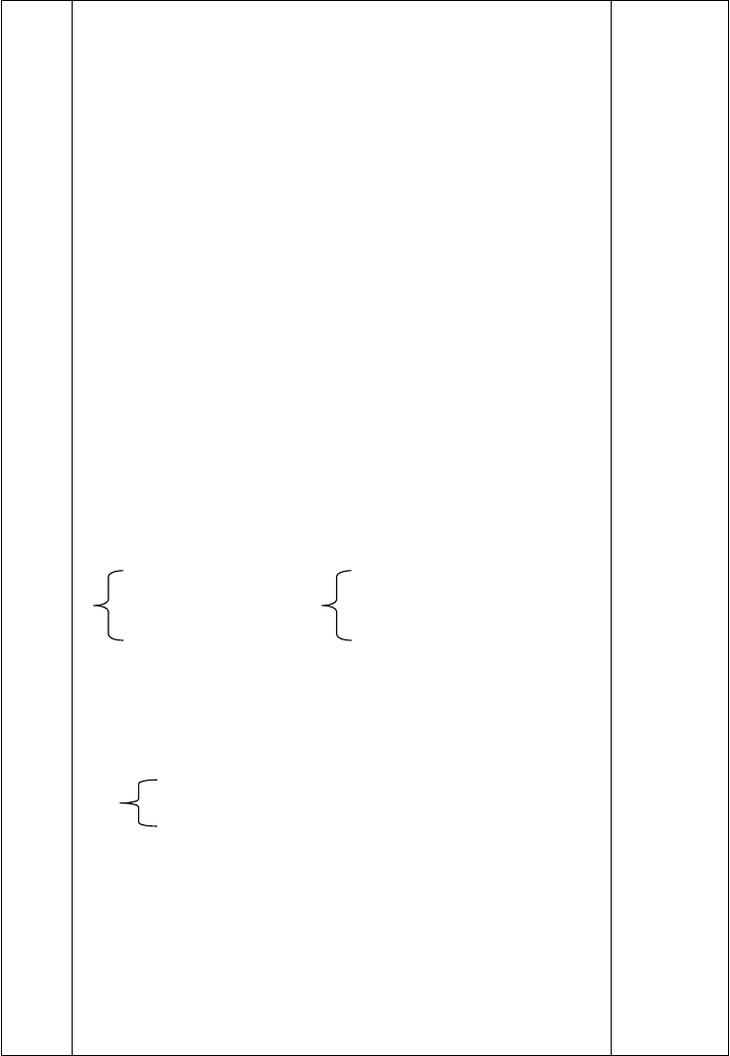

【教学过程】
  - finish the task:match the activities with the pictures. 3.check the answers.
4. students read and remember the phrases. Step 1b Listening
- students read the names.
- students guess their activities.
- finish the task:
- check the answers.
- students read and know the mmeaning of this passage.
四、总结（引深探究 15 分钟）
I、语法：一般过去时态的运用
1.带有确定的过去时间状语时，要用过去时
如： two days ago…、 last year in the old days just now
when I was 8 years old yesterday Did you have a party yesterday？
- 表示过去连续发生的动作时，要用过去时
这种情况下，往往没有表示过去的时间状语，而通过上下文来表示。 The boy opened his eyes for a moment，looked at the captain，and then died. 那男孩把眼睛张开了一会儿，看看船长，然后就去世了。
- 表示过去一段时间内经常或反复的动作常与 always，
never 等连用。
Mrs. Peter always carried an umbrella.彼得太太过去老是带着一把伞。及时练习：用 be 动词的适当形式填空
①I at school just now.
② He at the camp last week.
③ We students two years ago.
④They on the farm a moment ago.
⑤Yang Ling eleven years old last year.
⑥ There an apple on the plate yesterday.
⑦There some milk in the fridge on Sunday.
⑧The mobile phone on the sofa yesterday evening.


II、词语运用
—Where did he go on vacation?他去哪儿度假的？
—He stayed at home.他呆在家里。
stay at home“呆在家里”是一固定短语，类似的还有： stay in bed“卧床”，
be at home“在家”， be at school“在上学”，
be at work“在工作”等等。
五、练评（包含“考点链接” 应用探究 6 分钟）

用动词的适当形式填空：
- Tom and Mary (come) to China last month.
- Mike (not go) to bed until 12 o’clock last night. So I (get ) up late.
- Mary (read) English yesterday morning. 4.There (be) no one here a moment ago.
5.I (call) Mike this morning.
6.I listened but (hear) nothing.
7.Tom (begin) to learn Chinese last year. 8.Last week we (pick) many apples on the farm.
- My mother (not do) housework yesterday.
- She watches TV every evening. But she (not watch) TV last night.

用括号内动词的正确形式填空
Last year Mr. Smith (go ) to China and Japan. He (have) a wonderful time. He (do) a lot of different things and (talk) to
a great number of different people. He (eat) Chinese and Japanese food and (visit) a lot of interesting places. When he (go) back to England, he (be) very tired.

【教学反思】

执 笔
授课 148
班级 149
审 核 课 型
授课时间 姓 名
课 时
学案编号
1

No.2

【 课题】
【学习目标】

Unit 1 Where did you go on vacation?
Section A 2—a 2c

1、一般过去时的特殊疑问句及答语。
Where did you/he/she/they go on vacation? She went to the beach.
教师复备栏或学生笔记栏

【学习重点 难点】
【学法指导】
重点疑点：一般过去时的用法，利用情景思维在理解句意的基础上理解词汇的用法，记忆重点词汇，句型和语法内容。

1、在谈论过去发生的事件时，动词应用 ，
2、一般问句记两点，一句首加 ，二动词变 。

一、导入（启发探究 3 分钟） I 写出下列动词的过去式。
（1）draw
（3）study
（5）begin
（7）get

（2）swim
（4）bring
（6）learn
- sleep

（9）li（e
躺）
  - enjoy

II、按要求变换句型：
    - I saw a lot of children on the p（la正yg在ro打un篮d.球）
    - Yesterday we went to the park. We had a great（t改im成e 近th义er句e.）

【教学过程】
Yesterday we went to the park. We there.
    - I paid 20 yuan for the new（b改oo成k.近义句）
I the new book.

    - My family and I visited some places o（f 变in成te疑re问st句. ）

    - We did our homewor（k.变成否定句）

II、I
快乐译一译
go with someone

go out with someone

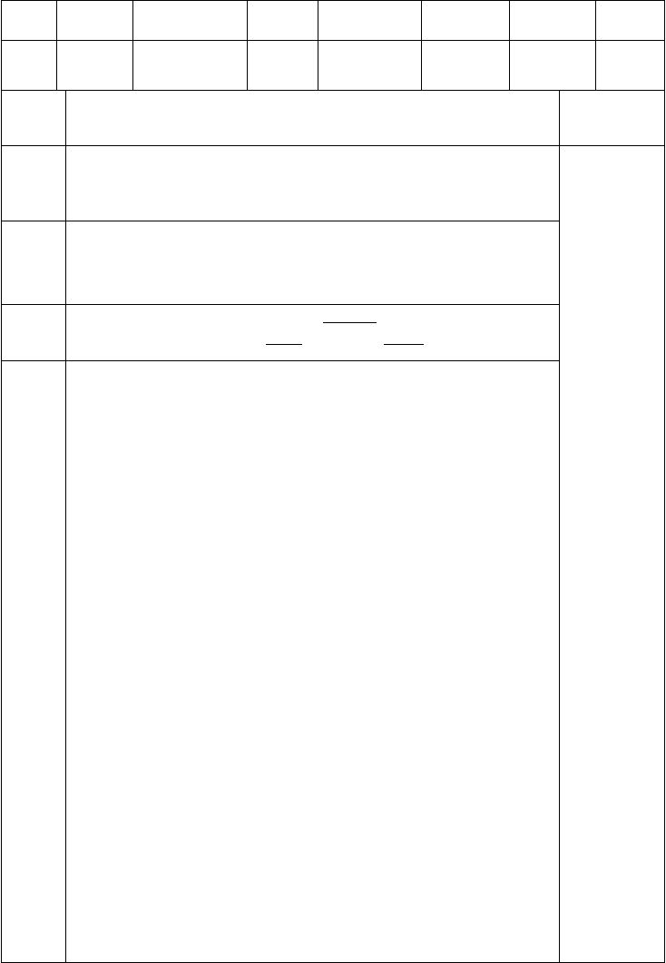go to New York city buy something special meet someone interesting study for
do something interesting
go to central park

二、自学（自主探究 6 分钟）
A 、猜一猜 Where did I go on vacati请on运? 用你学过的所有活动的名称。
同学们可这样猜：Did you go …to. ?
B 、列下你去过的一些地方，询问同伴是否去过完成下列表格。

Name Did you…… Yes, I did No, I didn’t

【教学过程】
C、看以上信息，向同学们汇报同伴去过或没去过的地方。
D 引导学生做如下练习
Grace ,where did you go last vacation ? I went to the New York City.
Oh ,really. Did you go with anyone ? Yes ,I went there with my mother.
三、交流（合作探究 10 分钟） Step 2a listening
Look at the pictrue, which people went on vacation? Who are they ?where did they go ?
Finish the task. Check the answers. Step 2b listening
Look at the form, read the words and know their meanings.

go with someone go to New York city
go out with someone
buy something special

meet someone interesting do something interesting
go to central park what did people do on their vacation? Finish the task.
Check the answers. Step 2C reading
study for

Students listen and repeat the conversation,and know the Chinese. Students read the conversation aloud.
四、总结（引深探究 15 分钟）

下面是 Anna 去海滩度假的情况表，请根据表的内容回答问题。

Place
Sun Beach
Weather Sunny
Activity Have a swim
Food Seafood

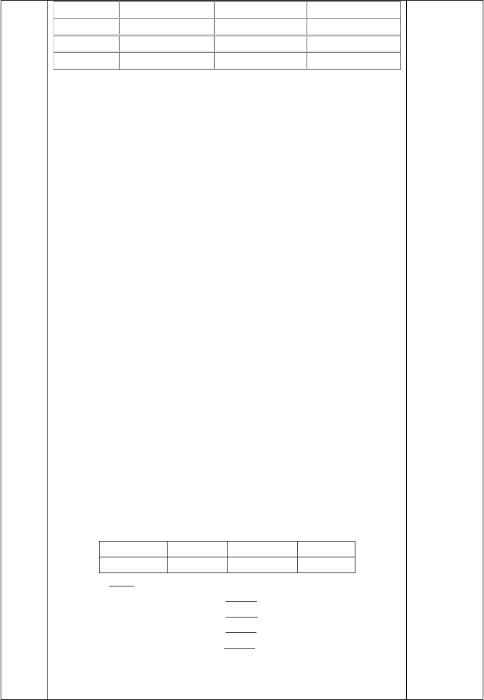
A: Hi, Tina! 1 ? B: Fine, thanks.

A: Where did you go, Tina? | B: | 2 | .
A How was the weather there? | B. | 3 | .
A: What did you do there? | B: | 4 | .
A: Did you have any fish? | B: | 5
五、练评（包含“考点链接” 应用探究 6 分钟）
I 单项选择。
- I found a small boy in the corner.

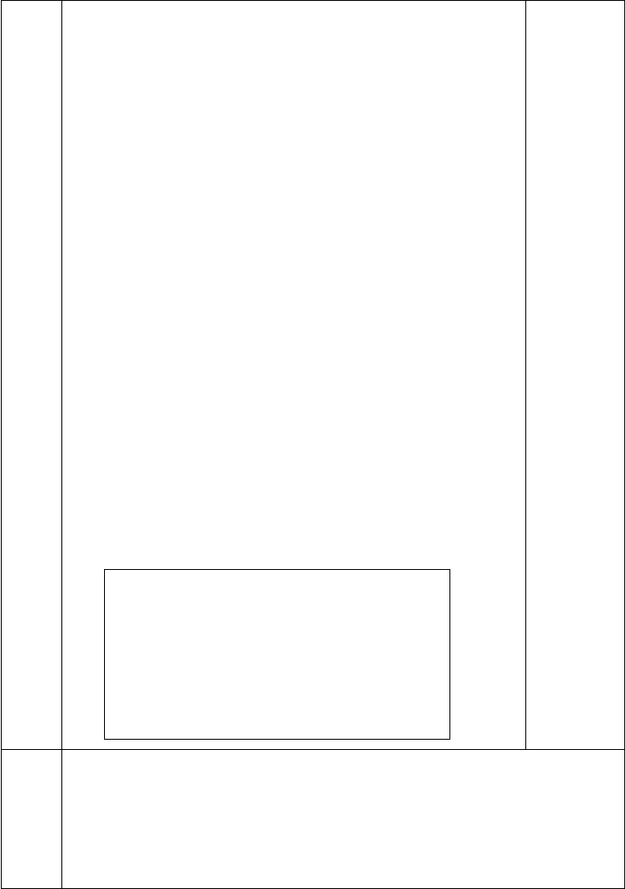
  - cries B. to cry C. cried D. crying
- We had great fun in the water.
  - playing B. plays C. played D. to play
- I didn’t have any money for a taxi I walked back to the hotel.
  - but B. or C. so D. and
- We had Sichuan food dinner.
  - at B. for C. in D. with
- He often helps me English.
  - study B. studying C. studied D. studies
- Wednesday is the day of the week.
  - third B. fourth C. second D. fifth
- Peter olives.
  - like B. don’t like C. doesn’t likes D. doesn’t like
- ―How the weather? ―It was sunny.
  - is B. are C. was D. were
- ―There is a new supermarket, isn’t there? ― .
  - Yes, it is B. Yes, they are C. Yes, there is D. Yes, there are
- I go to school by bike.
  - On every day B. Everyday C. On everyday D. Every day II、选择答语
( )1. How was your vacation?
( )2. How was the weather yesterday? ( )3. How did you spend the weekend? ( )4. How are your parents?
( )5. How is the work going?
( )6. How much are the vegetables? ( )7. How can I get there?
( )8. How many people are there on Tian’an Men Square?

    - It was great.
    - Three dollars.
    - I think there are about twenty thousand people.
    - Very humid and hot.
    - I went to the beach with my parents.
    - You can take a No. 24 bus.
    - It is going very well.
    - Fine. Thank you.

【教学反思】

执笔
授课班级

148
149
审 核

授课时间
课 型 课 时 1
姓 名 学案编号 No.3

【 课 Unit 1 Where did you go on vacation?
题】 Section A 2d
教师复备栏或
学生笔记栏

【学习
学习掌握有关复合不定代词和副词的用法；

目标】 继续学习 Where 的特殊疑问句及回答；

【学习重点 难点】
【学法指导】

学习掌握有关复合不定代词和副词的用法； 运用 Where 的特殊疑问句及回答编写对话

读对话---理解对话---编写对话 实际运用

一导入（启发探究 3 分钟） 一）、熟记下列短语并翻译
1. somewhere interesting 2. feed some hens
3. buy something for my father 4.照相
5. seem to be bored 6. Go out with someone
7. buy something special 8 写日记
- 大部分的猪
- 去度假
二）、一般过去时态检测
Dear bill,
【教学 How was your vacation? Did you do interesting? Did in the
family go with you? I went to a friend’s farm in the countryside with my family.


过程】
was great. We fed some hens and saw some baby pigs. They were so cute! The only problem was that there was much to do in the evening but read. Still
seemed to be bored. Byefor now! Mark
三）、引导学生做如下练习
Grace ,where did you go last vacation ? I went to the New York City.
Oh ,really. Did you go with anyone ? Yes ,I went there with my mother.
二、自学（自主探究 6 分 钟 ） Task1：小组成员看图画，猜测人物去过的地方及感受。Task2：小组自学课文的生词并尝试听写部分生词。
Task3：小组长带领组员正确朗读课文，注意语音语调。

Task3：小组长带领组员翻译课文，并勾画短语。 Long time no see be on vacaton Go to…with my family
Go somewhere interesting Huangguoshu waterfall
Quite a few read and relax Do something special
Most of the time
Stay at home stay at home to V Last month last year
Task4: 小组成员分角色朗读对话。并在全班表演对话。Task5: 背诵对话。
三、交流（合作探究 10 分钟） 英语中的动词分类
要学好English，理解掌握动词的意义和作用非常重要。
首先，动词有第三人称单数、原形、过去式、过去分词、现在分词、不定式等不同的形式变化，用法上各司其职。另外动词家族通常也划分成四个类别。
【教学 （1）行为动词。多表示动作、行为，有及物与不及物动词（vt与 vi）之分，其

过程】
作用特征是能够独立充当谓语。如：
We played happily（. vi）They are playing ten（nivst）.
- 连系动词。表 示事物的特征、状态变化的过程等。可组成一类句子，名叫“主+系+表”，可将其归为三类。
①表示状态的，如be（是），seem, stay, ke等ep。如： We are in Grade 7.
②表示对事物的分析过程，可译为“……起来”。像 feel, look, s（ou听nd起来），

smell（闻起来），tast（e 尝起来）等。如：
The meat tastes good.
③表示变化的，有“变得”之意。如：become, turn, grow, get, go,等c。ome 如：Soon the man grew angry.

  - 助动词。常用的有do, be, have/ has, will等/ 要动词，在句中起的作用是：
词sh，al它l
们无词义，要依靠主


①帮助构成疑问句。如：Does he live in a big city?
②帮助构成否定关系。如：We do not go to school on Sunday.
③表示时态关系。如： We are studying English.
④表示语态关系。如：The e-mail was written by him.
  - 情态动词。这类动词另有一定的词义，但也要依赖于主要的动词而存在，
它们没有人称及数的变化，它们是can, may, must, need, ought to, dare, had better 等。如： As a student, I must work hard.
四、总结（引深探究 15 分钟）
合成不定代词和不定副词的构成及其用法
- 构成：由 some, any, no, eve分ry别加上-body, -thing, -o构ne成的不定代词叫做合成不定代词；加上-where 构成副词。

用法：

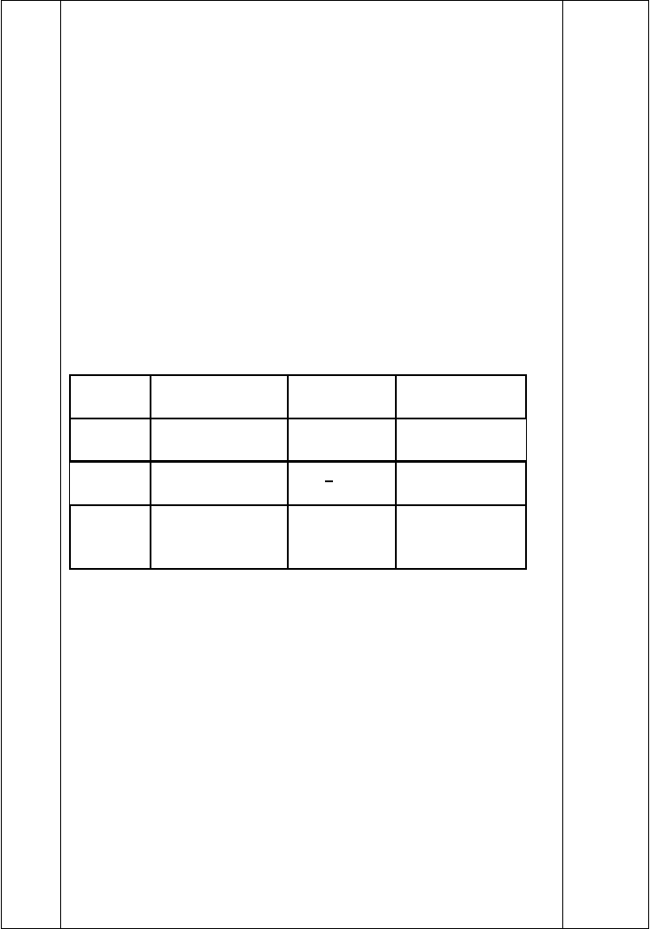
- 合成不定代词在句中可以作主语，宾语或表语等。

Nobody will listen to him. He wants something to eat.
- 不定代词作主语时，谓语动词要用单数。

There is nothing wrong with the TV. Everybody likes to be free.
- some-不定代词，通常用于肯定句中；any-不定代词则多用于否定
句、疑问句和条件状语从句中。但 some-可用于表请求、邀请、预料对方会作肯定回答时的疑问句中。

Someone called on her last week. There isn’t anyone else there. Is anybody over there?
Could you give me something to eat?
- 形容词修饰不定代词时，通常要放在不定代词之后。

There is something wrong with your eyes.
- somewhere, anywhere, nowhere, everywhere 用作副词。Trees turn green and flowers come out everywhere.

肯定句 | somebody=someone | something | somewhere
 | 某人 | 某物 | 某地
否定句  not any=no | anybody= anyone | anything | anywhere
否定意义 | nobody= no one | nothing | nowhere
（没有） |  | /^/
 | everybody=everyon e | everything  每样东西 | everywhere  每个地方 （ 到处）
 | 每人

巩固练习：用不定代词或不定副词填空：
- I can’t hear anything = I can hear .
- There is on the floor. Please pick it up.
- Did go to play basketball with you ?
- I phoned you last night, but answered it.
- I don’t think telephoned.
- Why don’t you ask to help you ?
- If you want , please let me know.
- Shall we get to drink ?
- Don’t worry. There’s wrong with your ears.
- There’s in the box. It’s empty.
- Maybe put my pencil . I can’t find it .
五、练评（包含“考点链接” 应用探究 6 分钟） 用所给词的正确形式填空。
  - Did you have fun （talk）with me?
  - My mother usually goes （shop）on Saturday afternoon.



【教学反思】
  - She （not have）any time for the housework yesterday.
  - All my （teacher）are friendly to us （student）.
  - Look at the sky. Can you find the bird （fly）there?
  - Listen! It （rain）again.
  - Is it time for us （have）an exam?

Thursday July 28th
Today I’ll go 1 our hometown. We 2 a great time here, in Hainan Province（省）. The 3 was a little hot. Every day I 4 to the beaches to play in the water. It made me 5 a bit cool. I also 6 Wanquan River（万泉河）. It was amazing.
Five days ago, I went to Sanya by 7 . Although it 8 crowded, my bus trip was full of joy. I 9 myself in the beautiful scenery（风光） 10 the bus. There were many visitor visiting “Tianya Haijiao”, I spent all day there.
（  （  （ | ）1. A. on  ）2. A. have  ）3. A. weather | B. back  B. had  B. water | C. back to  C. were  C. sky | D. to  D. spent  D. food
（ | ）4. A. go | B. walk | C. walks | D. went
（ | ）5. A. feel | B. was | C. have | D. to fell
（ | ）6. A. swam | B. played | C. visited | D. looked
（ | ）7. A. plane | B. train | C. bike | D. bus
（ | ）8. A. is | B. was | C. were | D. had
（ | ）9. A. lost | B. spent | C. enjoyed | D. thought
（ | ）10. A. in | B. on | C. outside | D. with

以上内容仅为本文档的试下载部分，为可阅读页数的一半内容。如要下载或阅读全文，请访问：https://d.book118.com/018106027053006037

