2024年上海市崇明区中考一模英语试题
（满分 140 分，考试时间 90 分钟）
考生注意：本卷有 VII 大题，共 84 小题。试题均采用连续编号，所有答案务必按照规定在答题纸上完成，做在试卷上不给分。
Part 1 Listening（一部分 听力）
I. Listening Comprehension (听力理解) (共 25 分)
Listen and choose the right picture (根据你听到的内容，选出相应的图片) (共 5 分)
A. B. 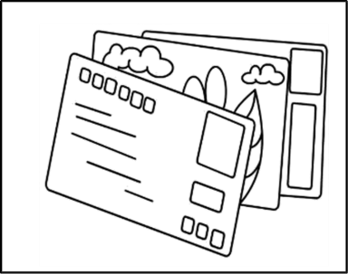C. 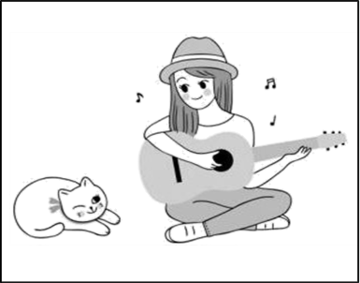
D. E. 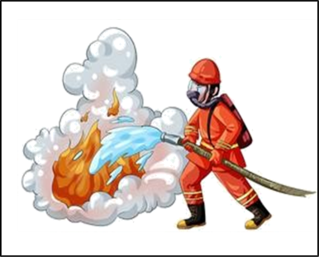F. 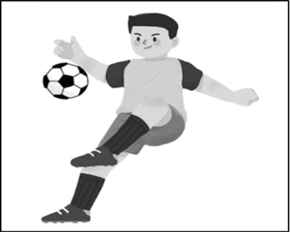
1. ________ 2. ________ 3. ________ 4. ________ 5. ________
Listen to the dialogue and choose the best answer to the question you hear (根据你听到的对话和问题，选出最恰当的答案) (共 5 分)
6. A.By bus. B. By bike. C. On foot. D. By car.
7. A. Playing tennis. B. Skating. C. Swimming. D. Playing football.
8. A. 5 yuan. B. 10 yuan. C. 15 yuan. D. 20 yuan.
9. A. Mother and son.B. Teacher and student.
C. Boss and secretary. D. Doctor and patient.
10. A. Tom didn’t pass his English test.B. Jane won’t help Tom with his English.
C. Tom is confident before the test. D. Jane gives Tom some advice.
Listen to the passage and tell whether the following statements are true or false (判断下列句子是否符合你听到的短文内容，符合的用“T”表示，不符合的用“F”表示) (共 5 分)
11. Mrs. Thompson didn’t like Teddy because he was always late for school.
12. Teddy was an excellent student before Mrs. Thompson taught him.
13. Mrs. Thompson didn’t know Teddy’s problem until she read his past records.
14. Although Mrs. Thompson often helped Teddy, he didn’t make great progress.
15. Teddy became a college student eleven years later.
Listen to the passage and complete the following sentences (听短文，用听到的单词完成下列句子。每空格限填一词) (共 10 分)
16. Tita ________ in the great city house because her parents went to the hospital.
17. Tita saw a ________ singing and beating a drum in the street.
18. Adam didn’t wear ________, but the carpet was warm to his poor feet.
19. Adam was very poor. So he had to ________ for singing from house to house.
20. Tita played games with Adam happily and they had a ________ at her home.
Part 2 Grammar and Vocabulary
（二部分 语法和词汇）
II. Choose the best answer (选择最恰当的答案) (共 15 分)
1. Learning from family members is ________ good way to get wisdom and courage.
A. a B. an C. the D. /
2. It’s wonderful to have an outing ________ such a sunny day. Let’s go now!
A. in B. on C. from D. by
3. During his stay in Germany, he learned much ________ of local customs and cultures.
A. letter B. knowledge C. idea D. map
4. Peter has two brothers. ________ of them are good at writing detective stories.
A. None B. Neither C. All D. Both
5. The cute baby looks ________ in a warm red dress. Everyone smiles at her.
A. lonely B. happily C. lovely D. beautifully
6. Sometimes riding a shared bike is ________ than driving a car on a busy road.
A. fast B. faster C. fastest D. the fastest
7. ________ great Hong Kong-Zhuhai-Macao Bridge is! I want to see it.
A. What B. What a C. What an D. How
8. ________ I borrow your dictionary? I forgot to bring mine to school today.
A. Can B. Must C. Should D. Would
9. Don’t be afraid to make mistakes, ________ you won’t make progress in your study.
A. so B. but C. or D. and
以上内容仅为本文档的试下载部分，为可阅读页数的一半内容。如要下载或阅读全文，请访问：https://d.book118.com/046021144053010102

