扬州市高邮市2021-2022学年七年级下学期期末英语试题
第一部分选择题（80分）
一、听力部分（共20小题;每小题1分, 计 20分）
A. 听下面10段对话。每段对话后有1道小题, 从题中所给的A、B、C三个选项中选出最佳选项。
1. What is the boy’s favourite sport? 【此处可播放相关音频，请去附件查看】

A. 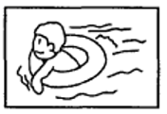 B. 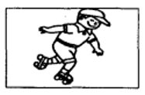 C. 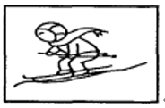
2. How will they go to the nearest shopping mall? 【此处可播放相关音频，请去附件查看】

A. 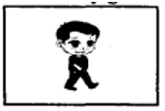 B. 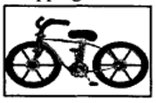 C. 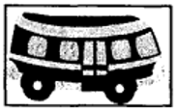
3. When do they have dinner? 【此处可播放相关音频，请去附件查看】

A. 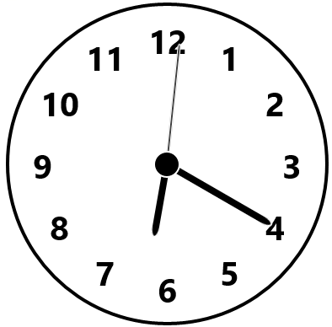 B. 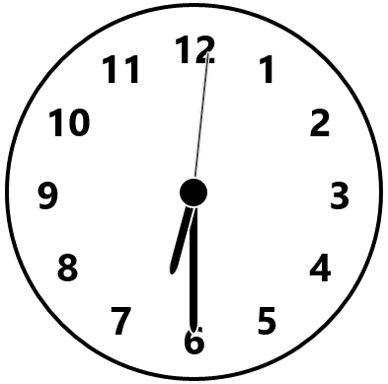 C. 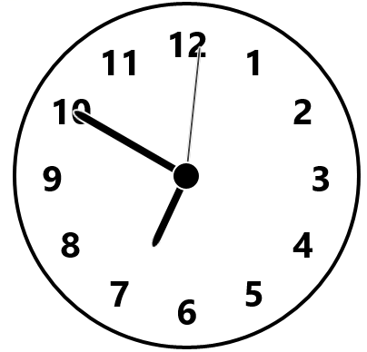
4. Where is the man from? 【此处可播放相关音频，请去附件查看】

A. 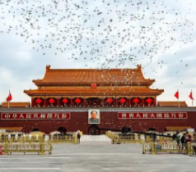 B.  C. 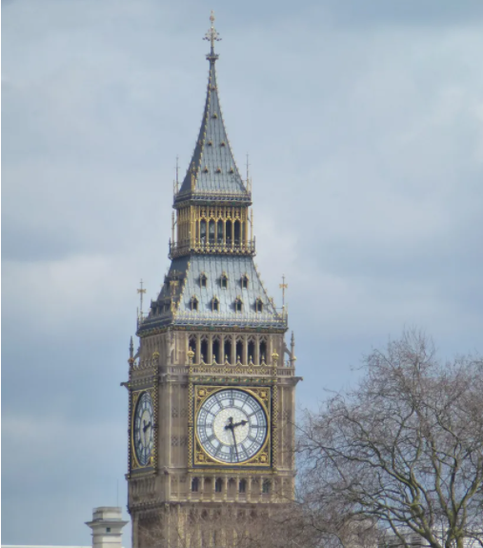
5. What would Lucy like to be when she grows up? 【此处可播放相关音频，请去附件查看】

A. A policewoman. B. A doctor. C. An office worker.
6. Where are they talking now? 【此处可播放相关音频，请去附件查看】

A. At the bus stop. B. In the library. C. In the hospital.
7. What’s in the sky? 【此处可播放相关音频，请去附件查看】

A. A man. B. A UFO. C. A kite.
8. How often does the woman go camping? 【此处可播放相关音频，请去附件查看】

A. Every day. B. Once a week. C. Twice a week.
9. What’s the weather like tomorrow? 【此处可播放相关音频，请去附件查看】

A. Windy. B. Rainy. C. Sunny.
10. What is the scarf made of? 【此处可播放相关音频，请去附件查看】

A. Cotton. B. Silk. C. Wool.
B. 听下面 3 段对话或短文。每段对话或短文后各有几道小题, 从题中所给的 A、B、C 三个选项中选出最佳选项。
听对话，回答问题。【此处可播放相关音频，请去附件查看】

11. Who will go to the fashion show?
A. Tom and Sandy. B. Sandy and Millie. C. Tom and Millie.
12. When will they meet?
A. At 7:00 p.m. B. At 1:00 p.m. C. At 7:00 a.m.
听短文，回答问题。请根据短文内容，选择正确答案，完成信息记录表。【此处可播放相关音频，请去附件查看】
My pet dog
Name | Stone.
Colour | ____13____.
Favourite food | ____14____.
What can it do for me | Bring me some ____15____.

13. A. Black and white B. Black and red C. Red and white
14. A. Meat B. Fish C. Bones
15. A. flowers B. grass C. water
听短文, 回答问题。【此处可播放相关音频，请去附件查看】

16. Which subject is Nancy interested in?
A. Maths B. History. C. Science.
17. What kind of sport is Nancy good at?
A. Swimming. B. Running. C. Basketball.
18. How does Nancy go to school?
A. On foot. B. By bike. C. By car.
19. Where does Nancy usually spend her free time?
A. On the playground. B. On her grandparents’ farm. C. At school.
20. What’s Nancy’s future plan?
A. To be a teacher. B. To be a basketball player. C. To work on the farm.
二、单项选择（共15小题, 每小题1分, 计15分）
在下列各题A、B、C、D四个选项中选择一个能填入题干空白处的最佳答案。
21. —This book on idioms is interesting. I’d like ________. Where did you buy it?
—At Dangdang Bookstore.
A. it B. this C. that D. one
22. Which of the following “ed” has a different pronunciation(发音) from the other three?
A. talked B. lived C. stopped D. danced
23. I have my own hobbies and my friends have ________.
A. his B. hers C. theirs D. ours
24. There is a lot of traffic in the street. Please drive ________.
A. careful B. careless C. carefully D. carelessly
25. —________ is your factory from here?
—It’s about one hour by car.
A. How far B. How long C. How often D. How much
26. —Would you like to go to Yangzhou China Grand Canal Museum with me tomorrow?
—I’d like to, but I ________ it the other day.
A. visit B. will visit C. visited D. am visiting
27. —I didn’t see you at your uncle’s birthday party last Monday.
—Oh, I had too much work to do that evening, so I ________ go.
A. can’t B. needn’t C. couldn’t D. mustn’t
28. —You put sugar in my tea? It ________ so bad.
—Sorry, sir. I’ll make another cup for you right away.
A. feels B. looks C. sounds D. tastes
29. The teacher told the students ________ in the river in the summer holiday. It’s too dangerous.
A. to not swim B. not to swim C. not swim D. not swimming
30. Millie, walk across the bridge ________ you will see an elephant standing over there.
A. and B. but C. so D. or
31. — What did you do last Sunday?
—My cousin Annie and I ________ our tent near a lake and had a good time there.
A. put out B. put on C. put up D. put off
32. 一Can I ask you one question? And only one.
一Sure. ________.
A. Something B. Anything C. Someone D. Anyone
33. For our safety, it’s important to ________ the traffic rules on the way to school.
A. change B. follow C. make D. turn
34. — There are no bones in the back of elephants’ feet — only fat.
—________ amazing it is!
A. How B. What C. What a D. What an
35. —Hello, who’s that speaking?
—________.
A. That’s Jane B. She is Mary C. I’m Mike D. This is William speaking
三、完形填空（共10小题, 每小题1分, 计10分）
阅读下列短文，从文后各题所给的A、B、C、D四个选项中选出一个最佳答案。
The four travelers walk and walk for a long time. Then the land ____36____, it’s no more flat （平坦）, so they have to climb many hills. That evening they sleep on the hard grass under the stars.
At that moment, the Witch is ____37____ them. She can see very far though she has only one ____38____.
“What do they want? Why are they in my country?” she says ____39____.
She takes out the ____40____. Soon, wolves come from all directions to her castle. She asks them to find the ____41____ and kill them.
The Tin Woodman and the Scarecrow aren’t asleep. They hear the noise. The Scarecrow feels nervous（紧张）, but the Woodman isn’t afraid. “This is my ____42____, my friend,” he says, “stand ____43____ me!” When the wolves arrive, he____44____ their heads with his axe（斧头）.
In the morning Dorothy sees the bodies. She’s ____45____ but the Tin Woodman explains（解释）everything.
The Witch gets angrier than before and takes out the whistle and blows again. Big birds fly to her castle and follow her words. The Scarecrow asks all his friends to lie down to ____46____ them.
At last, The Witch decides to ask the Winged Monkeys to help her. The Monkeys are very strong, and it ____47____ this time. They take Dorothy and Toto to the Witch’s castle.
The Witch watches Dorothy all the time. She ____48____ a moment—the right moment to take one of Dorothy’s ____49____. One day Dorothy slips on the wet floor and falls over. The Witch picks something up quickly and runs away.
“Give me back my silver shoe!” Dorothy says. “No! It’s mine now.” the Witch answers. The girl throws the water over the Witch. The Witch ____50____, “Water is the end of me!”
“The Witch is dead!” Dorothy shouts.
36. A. hides B. changes C. dries D. moves
37. A. watching B. waiting C. welcoming D. missing
38. A. hand B. eye C. arm D. leg
39. A. happily B. sadly C. excitedly D. angrily
40. A. stick B. whistle C. hat D. fork
41. A. strangers B. friends C. soldiers D. children
42. A. dream B. fight C. idea D. hobby
43. A. near B. on C. beside D. behind
44. A. cuts off B. gets off C. puts off D. gives off
45. A. happy B. dangerous C. afraid D. weak
46. A. protect B. stop C. hit D. catch
47. A. fails B. hides C. works D. flies
48. A. worries about B. dreams of C. waits for D. makes up
49. A. gloves B. caps C. shirts D. shoes
50. A. cries B. laughs C. smiles D. replies
四、阅读理解（共15小题, 每小题2分, 计 30分）
阅读下列内容, 从每小题所给的A、B、C、D四个选项中选出一个最佳答案。
A
If there’s one thing that people around the world share, it must be a love for sports. To find out favorite sport ranks among kids, we’ve casted a vote（投票）for:
★ Their favorite sport to watch.
★ Their favorite sport to compete in (by gender).
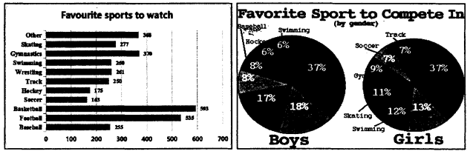
51. What are the kids’ top three favorite sports to watch?
A. Soccer, Hockey and Track.
B. Basketball, Football and Baseball.
C. Basketball, Swimming and Soccer.
D. Basketball, Football and Gymnastics.
52. What does the underline word “gender” mean ?
A. 性别 B. 年龄 C. 年级 D. 国籍
53. Which of the following is TRUE according to the passage?
A. Boys show no interest in competing in baseball.
B. Basketball is very popular with both boys and girls.
C. Kids like watching swimming better than Wrestling.
D. More boys vote for favorite sport to compete in than girls do.
B
本题为课外阅读考查，取材于扬州市“五个一百”工程课外阅读指定书目《巴斯克维尔猎犬》，请根据书本内容及问题，选择正确答案。
54. In the story, the hound is _________.
A. Holmes’s pet B. Dr. Watson’s helper C. a homeless dog D. the killer
55. Who’s the real murderer?
A. Sir Henry. B. Sir Charles. C. Stapleton. D. Selden.
56. Which of the following is NOT the clue (线索) mentioned?
A. A strange letter. B. A missing boot. C. Sir Henry’s hat. D. A portrait.
57. According to the story, which of the following shows the correct relationship?
A. Beryl is Stapleton’s sister. B. Selden is Mr. Barrymore’s brother.
C. Sir Charles is the heir of Sir Henry. D. Stapleton is one Baskerville.
C
Last week, the students from a special school in Gansu province visited a “mobile museum”, Xinhua news reports.
The students saw some pictures of things from the Museum of Gannan Tibetan Autonomous Prefecture in the school playground.
Chen Bergner, head of the museum, had the one-day show successfully (成功地). After working in the museum for more than 20 years, it was Chen’s first time to be a teacher for special children.
The special school has 158 students, including children with hearing and learning problems and autism (自闭症). Though (虽然) many of them have trouble speaking, the talk between Chen and the students went very well with the help of a sign language teacher at the school.
Huang Baoping is a Grade 7 student at the school. He has hearing problems but he likes drawing very much. He kept asking questions like, “What’s on the pottery (陶器)?” and “Why did the ancient people draw things like that thousand years ago?” Later on, Huang took part in a pottery workshop and made a lotus (莲花). Many children like Huang made works with their own understanding of things. Chen was surprised by the children’s love for art.
Ma Yujiao, a teacher at the special school, says they went to museums many times in the past, but the “mobile museum” was different and gave special children a better chance to learn about Chinese history as the first time.
“Museums are important for history, so we will have more ‘mobile museum’ to help more people to learn better about history.” Chen says.
58. Where is the passage probably from?
A. Notice. B. Textbook. C. News. D. Advertisement.
59. What can we learn from Paragraph 3-5?
A. The special students don’t like art.
B. Huang is very interested in pottery art.
C. Chen is a teacher at the special school.
D. Chen can’t talk with the special students well.
60. According to the last two paragraphs, we can infer (推断) that ________.
A. the “mobile museum” is a big success
B. they will build more history museums
C. the students like the history of museums
D. the students know nothing about museums
61. What can be the best title of the passage?
A. A new teacher B. A pottery workshop C. A mobile museum D. An art works show
D
The future of the city is here. An American company, Sidewalk Labs, won a competition to design a new neighborhood in Canada. The competition is to make the buildings, public spaces and transportation (交通) in the area of Toronto better.
The neighborhood’s name will be “Quayside”. It will have many good and new technologies (技术). Some examples are self-driving buses and shared-ride taxi robots (机器人). There will also be fewer cars and more room for parks.
The buildings will use plastic (塑料) instead of wood or steel, so they are cheaper and easier to change. People will have user accounts (账号) to get into the fitness center, or get help fixing something. They will even be able to use them to ask the neighbors to be quieter.
There are also many worries about the project. One is that there is already a housing problem in Toronto, and Quayside may not help with that. So it is important for Quayside to be made for all kinds of people, rich and poor, old and young.
Another is about data (数据) collection. People are worried about their privacy (隐私). However, Dan Doctoroff, the CEO of Sidewalk Labs says that the data will only be used to improve things in Quayside
As this kind of neighborhood is new and different, there will be many things to do. But it will be interesting to see how this future neighborhood works.
62. Where will people build the neighborhood “Quayside”?
A. In China. B. In the USA. C. In Canada. D. In France.
63. What do Paragraph 2 and 3 mainly talk about?
A. The style of Quayside design. B. The steps to building Quayside.
C. The technologies in Quayside. D. The problems with Quayside.
64. How many worries about the project “Quayside” are mentioned (涉及) in this passage?
A. One. B. Two. C. Three. D. Four.
65. What’s the writer’s attitude (态度) to the future neighborhood?
A. Pleased. B. Interested. C. Strange. D. Worried.
第二部分 非选择题（60分）
五、词汇运用（共10小题, 每小题1分, 计10分）
根据句意, 用括号中所给的汉语提示或单词的适当形式填空, 使句意完整, 每空一词。
66. Paris is the ________ of France. （首都）
67. Much to my ________, I passed the driving license test.（惊奇）
68. Go ________ the door and into the garden, you’ll see my world. （通过）
69. The police are busy ________ for the lost travelers these days. （搜寻）
70. I ________ the question, but she didn’t answer.（重复）
71. The dead ________ cover the ground in autumn. (leaf)
72. Jack will celebrate his ________ birthday this Sunday.（nine）
73. Joy cooked dinner for her family by ________ on Christmas Day. （she）
74. The city is ________ with too much traffic on the road.（noise）
75. My lovely pet never ________ (worry) because we take good care of her.
六、阅读表达（共5小题, 每小题2分, 计10分）
阅读下面短文， 用英语回答短文后的问题（每题回答字数不超过 10个词）。
You love reading. You read your favourite book a thousand times and you want to read something new, but you don’t know what you want to read. If you have the right information, it is easy to choose (选择) a good book!
Go to the library first. Answer these questions. What writers do you like? What are your interests? If the library has computers, you can use it to find a book by its writer, or keywords of your interests. If you like a certain book, search the book up and read its summary (概要). That will help you decide if (是否) the book is right for you.
Search your house next. Often good books are quietly lying somewhere in your own house. Maybe you forget about one. Maybe you will find some books that you can read, and they won’t cost you any money.
Then, ask someone to recommend a good book. You can ask your older brothers or sisters, your mom, your dad, your best friend, or your teachers. They know you well and can often make wonderful book recommendations.
Finally, read the first part of each book. Of course, if you have many books, this can take much time. But reading the first part of each book can help you know what books and genres (体裁) of books you like, and you won’t have a hard time looking for books again.
76. How many ways to choose a good book are there in the passage?
___________________________________________________________
77. How can you use the computer in the library to find a book?
___________________________________________________________
78. Who can you ask to recommend a good book?
___________________________________________________________
79. What does the underlined word “this” in the last paragraph refer to (指代)?
___________________________________________________________
80. What other way can you think of to choose a good book?
___________________________________________________________
七、缺词填空（共10小题, 每小题1分, 计10分）
根据短文内容及首字母提示，在下文空格处填入适当的词使短文完整，每空一词。

Reading is an important part of any child’s growth. B____81____can open up a new world to children. They teach them how the world works, tell them old stories and help them tell r____82____ from wrong.
A good parent always reads to the kid at an e____83____age and goes on reading as he grows up. Some children may become future book lovers and do well in some areas with the help of r____84____. They will always remember the wonderful time when they read with their loved ones.
Children’s Day is here. Maybe you can choose a book below as the g____85____for your kid. An’s Seeds is my recommendation.
An’s Seeds is a good book. It tells the story about t____86____ young men who each gets a lotus seed（种子） from their master in w____87____. They talk about their ideas. The first man d_____88_____ to plant it in the cold land right away. The second man will plant it in an expensive box. The third man An says he will w____89____for spring to plant his seed, because the nature（自然）is the best way for the plants to grow. It is a story of waiting and every child is like a “seed”. We should learn to wait while teaching them and follow their nature. Give them enough t____90____, they will grow into “lotus”.
八、书面表达（计30分）
A. 句子翻译（共5小题, 每小题2分, 计10分）
将下列句子译成英语。
91. 客厅是个聊天和看电视的好地方。
_________________________________________________________________
92. 动物园的北边是一家银行。
___________________________________________________
93. 火很危险，我们要小心。
_________________________________________________________________
94. 我的洗衣机出故障了。
_______________________________________.
95. 一直走，然后在第二个路口左转。
_________________________________________________________________
B. 写作（计20分）
96. 期末临近，你校志愿者俱乐部V-Group开展了“身边好榜样”（the Good Example Around）评选活动。假如你是 Kate。你想推荐你的同学 Lily。请根据以下图表提示，从品质、能力和志愿活动等方面用英文写一封推荐信。
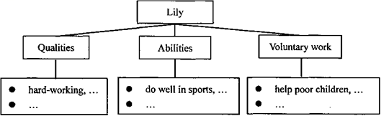
要求：
1）表达清楚，语法正确，上下文连贯；
2）必须包括提示中所有要点内容，并适当发挥；
3）词数：100词左右（开头和结尾已给出，不计入总词数）；
4）不得使用真实姓名、校名和地名等。
Dear sir/madam of V-Group,
I would like to recommend my classmate Lily to be the Good Example Around.
___________________________________________________________________________________________________________________________________________________________________________________________________________________________________________________________________________________________________________________________________________________________________________________________________________
All the students in our class think Lily deserves it. We hope to hear from you soon.
Yours,
Kate

答案与解析
第一部分选择题（80分）
一、听力部分（共20小题;每小题1分, 计 20分）
A. 听下面10段对话。每段对话后有1道小题, 从题中所给的A、B、C三个选项中选出最佳选项。
1. What is the boy’s favourite sport? 【此处可播放相关音频，请去附件查看】

A. 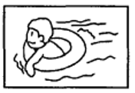 B. C. 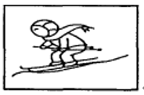
【答案】B
【解析】
【原文】略
2. How will they go to the nearest shopping mall? 【此处可播放相关音频，请去附件查看】

A. 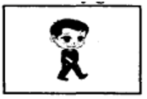 B. 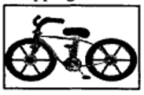 C. 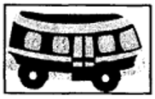
【答案】A
【解析】
【原文】略
3. When do they have dinner? 【此处可播放相关音频，请去附件查看】

A. 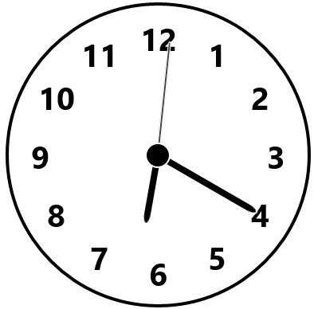 B. 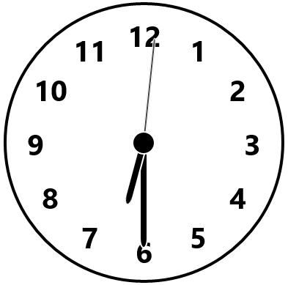 C. 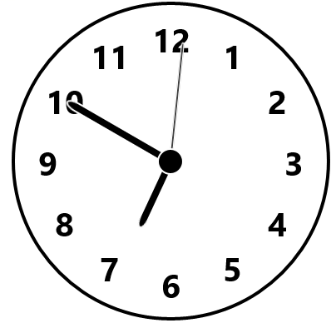
【答案】C
【解析】
【原文】略
4. Where is the man from? 【此处可播放相关音频，请去附件查看】

A. 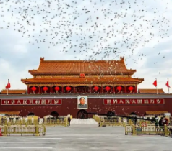 B.  C. 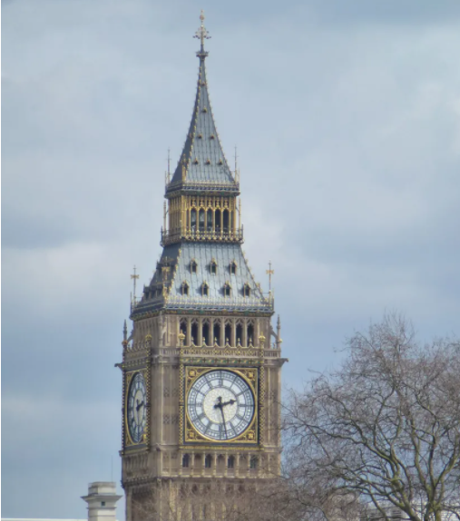
【答案】C
【解析】
【原文】略
5. What would Lucy like to be when she grows up? 【此处可播放相关音频，请去附件查看】

A. A policewoman. B. A doctor. C. An office worker.
【答案】A
【解析】
【原文】略
6. Where are they talking now? 【此处可播放相关音频，请去附件查看】

A. At the bus stop. B. In the library. C. In the hospital.
【答案】A
【解析】
【原文】略
7. What’s in the sky? 【此处可播放相关音频，请去附件查看】

A. A man. B. A UFO. C. A kite.
【答案】C
【解析】
【原文】略
8. How often does the woman go camping? 【此处可播放相关音频，请去附件查看】

A. Every day. B. Once a week. C. Twice a week.
【答案】C
【解析】
【原文】略
9. What’s the weather like tomorrow? 【此处可播放相关音频，请去附件查看】

A. Windy. B. Rainy. C. Sunny.
【答案】B
【解析】
【原文】略
10. What is the scarf made of? 【此处可播放相关音频，请去附件查看】

A. Cotton. B. Silk. C. Wool.
【答案】C
【解析】
【原文】略
B. 听下面 3 段对话或短文。每段对话或短文后各有几道小题, 从题中所给的 A、B、C 三个选项中选出最佳选项。
听对话，回答问题。【此处可播放相关音频，请去附件查看】

11. Who will go to the fashion show?
A. Tom and Sandy. B. Sandy and Millie. C. Tom and Millie.
12. When will they meet?
A. At 7:00 p.m. B. At 1:00 p.m. C. At 7:00 a.m.
【答案】11. C 12. A
【解析】
【原文】略
听短文，回答问题。请根据短文内容，选择正确答案，完成信息记录表。【此处可播放相关音频，请去附件查看】
My pet dog
Name | Stone.
Colour | ____13____.

Favourite food | ____14____.
What can it do for me | Bring me some ____15____.

13. A. Black and white B. Black and red C. Red and white
14. A. Meat B. Fish C. Bones
15. A. flowers B. grass C. water
【答案】13. A 14. B 15. C
【解析】
【原文】略
听短文, 回答问题。【此处可播放相关音频，请去附件查看】

16. Which subject is Nancy interested in?
A. Maths B. History. C. Science.
17. What kind of sport is Nancy good at?
A. Swimming. B. Running. C. Basketball.
18. How does Nancy go to school?
A. On foot. B. By bike. C. By car.
19. Where does Nancy usually spend her free time?
A. On the playground. B. On her grandparents’ farm. C. At school.
20. What’s Nancy’s future plan?
A. To be a teacher. B. To be a basketball player. C. To work on the farm.
【答案】16. B 17. A 18. C 19. B 20. A
【解析】
【原文】略
二、单项选择（共15小题, 每小题1分, 计15分）
在下列各题A、B、C、D四个选项中选择一个能填入题干空白处的最佳答案。
21. —This book on idioms is interesting. I’d like ________. Where did you buy it?
—At Dangdang Bookstore.
A. it B. this C. that D. one
【答案】D
以上内容仅为本文档的试下载部分，为可阅读页数的一半内容。如要下载或阅读全文，请访问：https://d.book118.com/177001054101006045

