Unit 5 Do you like pears

满分:100 分 时间:60 分钟 得分:

听力部分

一、听录音,判断图片与内容是(T)否(F)相符。(10 分)

( ) ( ) ( ) ( ) ( )
1.
2.
3.
4.
5.

二、听录音,连线。(10 分)

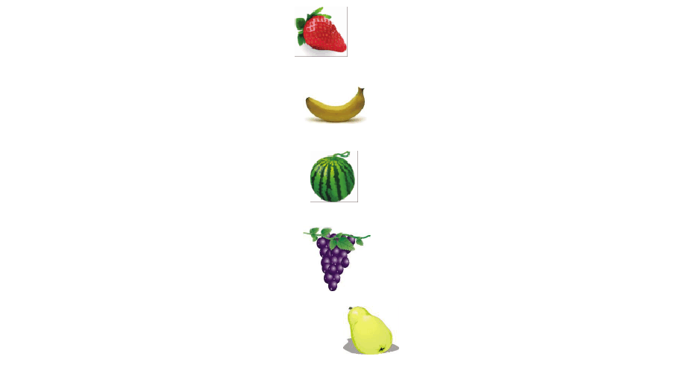三、听录音,判断下列句子与内容是(T)否(F)相符。(10 分)
Tom
Lily
Amy
Jenny
Mr Jones

( ) like apples.

( ) I have some bananas

( ) don’t like apples. I like pears. ( ) you like grapes
( ) like milk and juice.

四、听录音,给句子选择合适的答语。(10 分)

( ) I do.

, I do. don’t know.
( ) like apples.

, it is.

, you can’t.

( ) it isn’t.

, it is.

, I do.

( ) is my mother.

is my father. is my brother.
( ) from the UK.

is from the USA.

is from China.

笔试部分五、选出下列单词中不同类的一项。(10 分)
( )

( )

( )

( )

( )

六、给下列图片选择对应的单词。(10 分)


1. 2. 3.

七、选择正确的答案。(20 分)

( )1. you like oranges

( )2. I have some pears

( )3.— I don’t like grapes.
4. 5.

—
, neither. |  | too. | !
( )4.— Here you | are.
—
! |  | you. | !

( ) some .
strawberry
( )6. buy some apples!
’s ’s
( ) like .
orange
( )8.— Do you like bananas
—

, you do. , I do.
( )9.— Is it your car
以上内容仅为本文档的试下载部分，为可阅读页数的一半内容。如要下载或阅读全文，请访问：https://d.book118.com/187015105062006043

