2023-2024学年九年级上学期期末考试（盐城卷）
英语
注意事项：
1.全卷满分120分。考试时间为100分钟。试题包含选择题和非选择题。考生答题全部答在答题卡上, 答在本试卷上无效。
2.请认真核对监考教师在答题卡上所粘贴条形码的姓名、考试证号是否与本人相符合,再将自己的姓名、考试证号用0. 5毫米黑色墨水签字笔填写在答题卡及本试卷上。
3.答选择题必须用2B铅笔将答题卡上对应的答案标号涂黑。如需改动,请用橡皮擦干净后, 再选涂其他答案。答非选择题必须用0. 5毫米黑色墨水签字笔写在答题卡的指定位置,在其他位置答题一律无效。
第Ⅰ卷（选择题，共65分）
一、补全对话（共5小题，每小题2分，计10分）
阅读下面的对话，根据上下文，选择恰当的选项补全对话，使句意完整、符合逻辑。（其中有一项为多余选项）
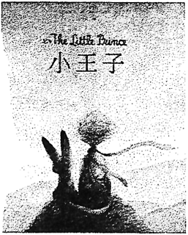
Prince: Who are you? You are very pretty to look at.
Fox: 1
Prince: Come and play with me. I am so unhappy.
Fox: 2 I am not tamed.
Prince: I am looking for men. 3
Fox: It is an act too often neglected (忽略). It means to establish ties.
Prince: To establish ties?
Fox: 4 To me, you are still nothing more than a little boy who is just like a hundred thousand other little boys. And I have no need of you. And you, on your part, have no need of me. To you, I am nothing more than a fox like a hundred thousand other foxes. But if you tame me, then we shall need each other. To me, you will be unique in all the world. To you, I shall be unique in all the world ...”
Prince: 5 There is a flower ... I think that she has tamed me...
A．Just that.
B．I am a fox.
C．What does that mean — ‘tame’?
D．I can’t agree with you more.
E．I am beginning to understand.
F．I cannot play with you.
二、完形填空（共15小题，每小题1分，计15分）
阅读下面短文，掌握文章大意，然后从所给A、B、C、D四个选项中选出最佳答案。
It was December and the snow was falling quietly outside. The four March sisters were sitting around the fire in the living room. They were knitting (织) socks for 6 . There was a war and everyone had to help.
Meg was the 7 of the four sisters. She was sixteen. She was very pretty and she loved pretty clothes. Jo was fifteen. She was very tall and thin. She was different from Meg. She didn’t 8 dresses or hairstyles. She was a tomboy (假小子). Beth was thirteen. She was very shy and 9 and she seemed to live in a happy world of her own. The youngest, Amy, looked like a snow princess with her blue eyes. She loved beautiful things and she was a little vain (虚荣的). She also thought that she was a very important person.
“Christmas isn’t Christmas without any presents,” Jo said 10 .
“I hate being unwealthy!” Meg said, looking at her old dress.
“Some girls have lots of nice things, and 11 girls have nothing at all,” said Amy. “I don’t think it’s 12 !”
“But we’ve got Father and Mother, and each other,” said Beth.
The four sisters looked happy for a moment when they remembered this.
“But we haven’t got 13 ,” said Jo. Their smiles suddenly disappeared. Mr March was far away 14 the soldiers.
“Mother says our men are suffering and we 15 spend money for pleasure,” Meg said. “That’s why we can’t have presents this year.”
“Well, each of us has a dollar to spend,” said Jo. “ 16 can the army do with four dollars? 17 !
I don’t expect anything from Mother but I’d like to buy a book for myself!” Jo was a(an) 18 .
“I want to spend mine on some new music.” said Beth. She played the piano and she loved singing.
“I’m going to buy a box of drawing pencils. I really need them!” said Amy. She wanted to be an artist.
“Mother didn’t 19 anything about spending our own money,” cried Jo. “Let’s each buy what we want and have a little fun; I’m sure we 20 hard enough to earn it.”
It was true. The two older sisters had jobs. Meg worked as a teacher for the King family and Jo looked after Aunt March, their father’s rich, bad-tempered (坏脾气的) old aunt. Beth and Amy helped with the housework.
6．A．neighbours B．sisters C．parents D．soldiers
7．A．prettiest B．oldest C．smartest D．youngest
8．A．care of B．care for C．care about D．care with
9．A．noisy B．quiet C．generous D．mean
10．A．sadly B．happily C．loudly D．gently
11．A．other B．the other C．others D．the others
12．A．fair B．right C．unfair D．necessary
13．A．parents B．Father C．Mother D．presents
14．A．for B．with C．from D．in
15．A．needn’t B．wouldn’t C．mightn’t D．mustn’t
16．A．How B．Why C．What D．Who
17．A．Everything B．Something C．Nothing D．Anything
18．A．pianist B．artist C．bookworm D．writer
19．A．say B．talk C．tell D．speak
20．A．study B．work C．save D．help
三、阅读理解（共20小题，每小题2分，计40分）
（一）阅读下列短文，从每题所给的四个选项中选出一个最佳答案。
A
3-D films are not new. They first appeared in 1903. The inventors wanted viewers to feel like they were really inside the film they were watching! When you watch a 3-D film, you feel as if the people on the screen are close enough to touch and that the airplane flying at you is flying right off the screen. To watch 3-D films, you may need to wear special glasses. Usually, people buy or borrow the glasses in the cinema. But have you ever thought of making one pair by yourself?
Here are tips for making your own 3-D glasses.
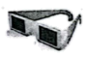
① Get some card boards. Cut out the shape of glasses. Make sure you can see through each hole when you hold it up to your eyes.
② Get some red and light blue acetate (醋酸透明塑胶片).
③ Glue the blue acetate on the right hole and the red on the left one.

Next time when you go to watch a 3-D film, don’t forget to take your own handmade glasses!
21．3-D films were invented to ________.
A．make the airplane fly right off the screen
B．make viewers touch the people on the screen
C．make the people on the screen closer to viewers
D．make viewers feel like they were really inside the film
22．According to the passage, our own 3-D glasses are made up of __________.
①glass ②cardboard ③acetate ④paper
A．①② B．②③ C．①③ D．③④
23．The passage probably comes from __________.
A．a storybook B．a film poster
C．a news report D．a science magazine
B
Throughout history, people all over the world have loved watching shows. What types of shows can we see? Let’s take a tour of the colourful world of shows.
Beijing opera is a type of musical theatre. It joins singing, dance, acrobatics, and martialarts together. It has a lot of music and is called opera, but the actors tell the stories in dialogues. The stories are taken from Chinese history, tales and literature. When an actor appears, the audience know quickly if the character is smart, stupid or bad because of his face paint. For example, a red face is loyal. A lot of make-up makes the audience see the actor’s mouth, eyes, and face from faraway.

Wayang kulit is from Indonesia and is the oldest form of puppet theatre in the world. The stories are legends and folk stories. The puppets are all different characteristics. The biggest ones are the bad guys, and the heroes are usually thin puppets with long pointed noses, Wayang kulit performances are still very popular in Indonesia.
Ballet is a form of dance. It started in Italy in the 15th century. In early ballet, dancers wore masks and heavy costumes, and they were all male. The first female dancer appeared about 200 years later. Both male and female ballet dancers have to be in very good shape and strong. One ballet performance can take 5,000 hours of practice. And in one performance a male dancer often has to lift a lot of female dancers. Two famous story ballets are Swan Lake and Peter Pan.
Street theatre is really fun, and it is the oldest form of theatre. It was performed outdoors on the streets of

ancient Egypt. Now you can see it in shopping centres and on street corners in many cities of the world. The performers do all kinds of things like juggling, dancing, and singing. Everyone can stop to watch it. And it’s free!
24．In Beijing opera, if an actor’s face paint is red, the character is .
A．bad B．loyal C．smart D．stupid
25．What can be learnt from “One ballet performance can take 5, 000 hours of practice.”?
A．Practice makes perfect. B．Well begun, half done.
C．Many hands make light work. D．Actions speak louder than words.
26．Which of the following is TRUE according to the passage?
A．We can enjoy singing, dance and juggling in Beijing opera.
B．The stories in Wayang kulit are from history and literature.
C．Swan Lake and Peter Pan are two famous story ballets.
D．We can see street theatre indoors now in many cities.
C
Governments around the world are pushing for an end to plastic straws (吸管) and bags. More and more businesses are switching (转换) to paper products as an alternative (可供选择的事物). Paper is considered by many to be better than plastic. However, it is harmful to the environment, too.
Firstly, paper bags and straws are made from trees. Trees, as you know, can reduce carbon dioxide levels in the atmosphere (大气). They can slow down climate change. An increase in the use of paper bags can cause more deforestation (毁林).
Secondly, the production of paper things requires more energy and water. About 10 percent more energy and four times as much water is used to produce a paper bag than a plastic one. You might say that we can use recycled paper to save that energy and water. This seems to be a good idea. However, it takes even more energy and water to go through the recycling process than to make a new paper bag. Products made from recycled paper are also often short-lived.
Furthermore, paper products are heavier than plastic ones. That means they require more fuel to transport. Seven trucks are needed to transport two million paper bags, while only one truck is needed to transport the same number of plastic bags. The increased weight also leads to a larger amount of waste once the bags are thrown away.
Paper products are actually a lose-lose for both the environment and businesses. They are more expensive than plastic products. A paper straw costs about 5 to 12 cents, while a plastic one usually costs only about 2 cents.
The most environment-friendly solution is to avoid single-use things altogether. Products like glass water bottles and steel straws can be used over and over again. They are much better than either paper products or plastic
products. Through increasing the use of these items, you can greatly reduce your throwaway waste and truly make our earth a greener place!
27．What can trees do to the environment?
A．They can make carbon dioxide levels lower in the air.
B．They can improve climate quickly.
C．They can cause more deforestation in the end.
D．They can provide materials for paper products.
28．From Paragraph 4, we can know that ________.
A．plastic products are much better than paper ones
B．paper products are easy to transport
C．one truck is needed to transport two million plastic bags
D．plastic products often lead to a larger amount of a waste
29．According to the passage, which should people use in order to protect the environment?
A．Recycled paper bags. B．Steel knives and forks.
C．Strong plastic chairs. D．Single-use cups.
30．Which of the following shows the structure of the passage?
A．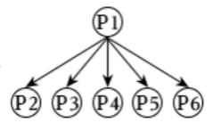 B．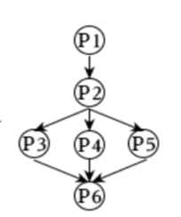 C．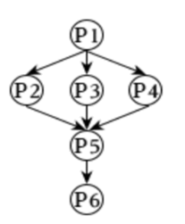 D．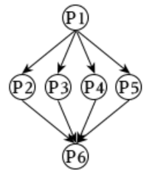
D
“I really want to, but I can’t because...”
It hurts every time I hear someone say it. I see it for what it is—an excuse. Every one of us has hopes, dreams and goals. We talk about how we will achieve them, but when it’s time to do them, we use that sentence. During my teen years, I felt stuck. I wanted to learn so many things and achieve my wildest dreams, yet I couldn’t. Living in an underdeveloped country, we are in great need of water, electricity, and opportunities (机遇).
One day, I had had enough. I decided to use the resources I had to create the future I dreamed of. I made up my mind to get the Japanese Monbusho Scholarship. I found articles and books online to study Japanese. In a few months, I was able to hold a simple conversation in Japanese.
I realized that I would need money. I set out to build a hedgehog (刺猬) care website. Every day, after school, I would research hedgehogs and write detailed articles about them. I studied Japanese and wrote about hedgehogs for three years.
I’m sure you’re expecting a perfect ending where I travel to Japan. That’s not how this story ends. The fact is, I didn’t even get the chance to apply for the scholarship. I failed. Unwilling to accept the facts, I started an online university the next year. And the hedgehog website made me a total of $60.
I can tell you that I tried, but it didn’t work out. It did—just not the way I expected.
I’m not in Japan, but I know how to speak Japanese and have met many interesting people along the way. My hedgehog website didn’t succeed, but I created a new one, that’s even better with the experience I gained.
I didn’t let my difficulties stand in my way, and I created my own opportunities. Anyone can accept the cards they’ve been dealt (发牌) and create their own way to make them into a winning hand.
31．According to Paragraph 2, what does “that sentence” refer to (指的是) ________.
A．Every one of us has hopes, dreams and goals.
B．We will achieve our hopes, dreams and goals.
C．I really want to, but I can’t because...
D．During my teen years, I felt hopeless.
32．According to the passage, which graph can best describe the writer’s attitude(态度) towards life?
A．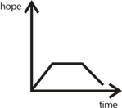 B．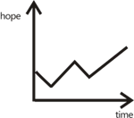 C．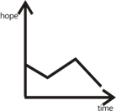 D．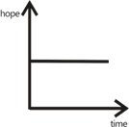
33．Which of the following is the correct order of what happened to the writer?
a. She failed to apply for the Japanese Monbusho Scholarship.
b. She studied Japanese and built a hedgehog care website.
c. She started an online university and created a better website.
d. She wanted to learn so many things but had few chances.
A．b-a-d-c B．d-b-a-c C．d-a-b-c D．b-c-d-a
34．What does the underlined phrase “a winning hand” in the last paragraph mean?
A．一手好牌 B．好手气 C．金手指 D．拿奖的手
35．The writer writes the passage mainly to ________.
A．tell us her terrible experience and hopeless life
B．advise us to get a scholarship and create a website
C．show off that she created two successful websites
D．encourage us to keep trying and realize our dreams
（二）阅读短文，并从下面方框的六个句子中选择五个还原到文中，使原文的意思完整、连贯。
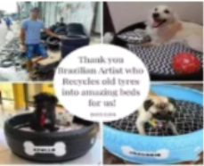
No beauty shines with brighter than that of a good heart. After all, good actions always pay off! 36 He turns old tyres (轮胎) into comfortable and beautiful animal beds.
Everything started several years ago. 37 Then an idea come to his mind: Why not use these tyres to make some comfortable beds for the poor dogs?
From that day on, Amarildo started collecting old tyres. He first cleaned one of them and cut off its top. Next, he covered the holes in its bottom with plywood (胶合板). 38 He even sewed a cushion onto the tyre in order to make the pet bed more comfortable.
After turning one of the tyres into a pet bed successfully, Amarildo made up his mind to make more. He then finished more than 100 colourful beds and gave them to local animal volunteer organizations. 39 He received orders from all over the country. However, most of his pet beds have been given to homeless animals for free.
40 Not only does he recycle harmful materials, but he also helps provide better places to sleep for many animals. “The only way to a great job,” said Amarildo, “is to love what you do.” And by continuing to do this work, he is showing his great love for both the Earth and the animals.
A．The artist then painted the tyre pink.
B．It takes him about forty minutes to make an animal bed.
C．To Amarildo’s surprise, those beds became popular.
D．The Brazilian artist Amarildo Silva is certainly one with a good heart.
E．Amarildo saw a few homeless dogs sleeping in some used tyres on the streets.
F．So far, Amarildo has turned more than 6,000 old and dirty tyres into lovely pet beds.
第Ⅱ卷（非选择题，共55分）
四、词汇运用
（一）（共10小题，每小题1.5分，计15分）
阅读短文，从方框中选择适当的词或短语并用其正确形式填空，使短文通顺、意思完整，每词或短语限用一次。
meaning take hungry a large number of suggest
famous hold get north dress up

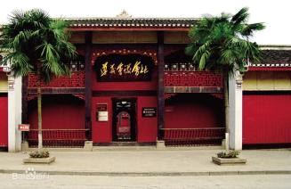I’m from Guiyang, the capital of Guizhou Province. Last National Day, my dad drove my family to Zunyi, a city in the 41 part of Guizhou to have a trip. We set off at 7:00 am. It took us about two hours 42 there.
We first visited the site of Zunyi Conference. There are hundreds of revolution-related (与革命相关的) sites in Zunyi. Among them, the site of Zunyi Conference is 43 . Ms Li, our guide, told us the conference 44 from January 15th to 17th in 1935. It is seen as the turning point in the history of the CPC (中国共产党). We spent two hours there.
Ms Li was very friendly and helpful. She 45 that we should visit a Long March-themed cosplay shop in the city centre. We 46 her advice and went to the city centre. It was lunchtime. We were all very 47 and had some nice food at a restaurant. After lunch, we headed straight for a Long March-themed cosplay shop. There are 48 visitors in the shop. My sister and I 49 as Red Army soldiers, and my parents took lots of photos of us. It was a wonderful experience.
The willows by the hotel look so fresh and green.
Walk out of the tea house, and go to the open-air theatre. The actors with coloured make-ups are performing on the stage in special clothes. It’s a local opera called Huangmei Opera. Also, you can enjoy various (多样的) quyi: crosstalk, kouji and pingshu.
If you want to feel more about the charm of Hongcun, plan a visit to it right now.
The trip was educational and 50 . I hope to visit such places with red culture next time.
（二）（共10小题，每小题1分，计10分）
根据短文内容及首字母提示，填写所缺单词，完成短文。
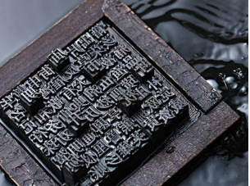
If you are reading this now, it is because these words are printed on this page.
Could this happen 2,000 years ago? Well, you could have read some words, but the words wouldn’t be printed by a m 51 on paper.
Modern printing began in China somewhere b 52 200 BC and 200 AD．A block(块) of wood was carved(刻) so that the w 53 or pictures stood out. Ink(墨) was p 54 on the wood and then cloth was put on top of the wood. Later, during the Han Dynasty in 105 AD, paper-making was invented in China and printing
was done mostly on paper after that.
Much later, a new method c 55 “movable type” was invented. It used small blocks m 56 of metal with characters or letters. The blocks could be moved around e 57 to make a whole page of printed text and it was much faster than carving a block of wood. Methods to do this were invented in China in 1040.
Later this method started to be used in Europe around 1439. Printing became much easier and faster and printing presses became p 58 everywhere.
Now, we s 59 emails, texts and photos to each other. We can download books and click on links(链接) and read on our phones, tablets and laptops. Ideas and knowledge are s 60 faster than at any other time in history.
五、读写综合
（一）阅读并回答问题。（共5小题，每小题2分，计10分）
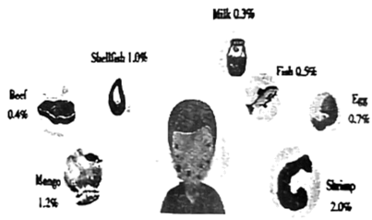
Does your mouth itch （发痒） after eating mangoes? Be carefull! You might be allergic （过敏的） to mangoes. A new study showed that food allergies are increasing among Chinese people!
Why it happens
Allergies happen because the body mistakes the food for something harmful and starts fighting. For some people, an allergic reaction （反应） may not be too serious. It could go away soon. But some people could have serious reactions like finding it hard to breathe or even passing out. These are life-threatening reactions and people need to see a doctor as soon as possible.
What you can do to avoid it
You are more likely to be allergic to certain food if some members of your family are. And if you’re already allergic to one food, it may be more likely that you’ll be allergic lo another, according to the US hospital Mayo Clinic.
There’s still no way to help people avoid food allergies today. The best way to deal with it is to avoid the allergens （过敏原）. Here are two tips for help.
Tip 1 : Know your body
You can have an allergy test to learn whether your body is allergic to something
Tip 2: 3
You should also read the information on food bags carefully to protect yourself from eating the allergens.
The most common food allergens
以上内容仅为本文档的试下载部分，为可阅读页数的一半内容。如要下载或阅读全文，请访问：https://d.book118.com/187136012052006025

