





Survey Method
Online Survey

Regional Coverage
National

Field Timing
October 02 – 12, 2023

Screening Criteria
Self-identifying as Asian,
African American, Hispanic or N.H. White
18+ years

Methodology

TOTAL SAMPLE 1,500

   | 500  Hispanics  250  Asians |     250  African American  500  N.H. Whites

2



Key Findings

Overall, 2 out of 5 consumers say they start their shopping before Black Friday and spread the purchases out over the holiday season. Just under 20% say they are not planning on buying any gifts this season.
About one-quarter of holiday shoppers are planning on spending more on Christmas gifts this year than last year. The same percentage plan to spend less this year.
Holiday shoppers plan to spend an average of $433 this year on gifts. This is significantly less than the amount reported in 2018 ($506).
Consumers are most likely to get ideas for their holiday shopping from family and friends, followed by in-store display promotions.
More than half of consumers plan to do their holiday shopping via online retailers like Amazon, eBay and Temu.
Holiday shoppers are most likely to make online purchases via their smartphone.
Clothing, gift cards and toys/gamestop the list of gifts that shoppers will buy this holiday season.
Over 40% of Hispanics celebrate Three King’s Day. This is most common among foreign-born and Spanish-dominant Hispanics.



3 out of 10 consumers start their shopping on Black Friday/Cyber Monday, with
Asians being the most likely to do so.
Another 3-in-10 shop before Black Friday.
Just under 20% are not planning to shop for the holidays.

When will/did you start shopping for holiday presents?
Base: (1,500)

(n=500) (n=250) (n=250) (n=500)
Total Market Hispanics African- Americans Asians N.H. Whites
(C) (D) (E) (F)

41% CDF
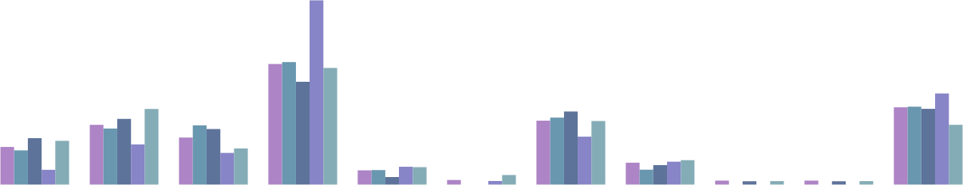
27%
27%
23%
20%

8% E |  | 10% E
10% E
3% 3%
2%
1%
5% 3% 4% 5%5%
16%
15% 14%

13% EF

1% 1%
17% 13%
4% 4%
10%
13%
14%
17%
11%
26%
14%
12%
12%
17%
17%
9%
8%
7%
3%
1%
1%
8%
2%
1%
1%
1%

September | October | November, before | Black Friday / | End of November | First week of | 1-2 weeks before | Shop at the last | The day after | Not sure yet | Not planning on
 |  | Thanksgiving | Cyber Monday deals |  | December | the holidays | minute | Christmas |  | shopping this year

5
Letter indicate significant difference at 95% confidence level.

以上内容仅为本文档的试下载部分，为可阅读页数的一半内容。如要下载或阅读全文，请访问：https://d.book118.com/195023321234011040

