人教版六年级英语下册第一单元测试卷
时间：60分钟 满分：100分
听力部分(40分)
一、听录音，选出与你所听内容相符的图片。听两遍。（10分）
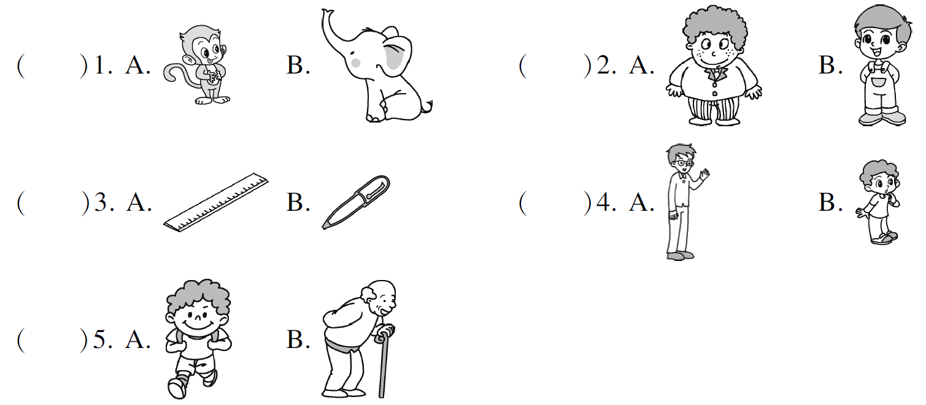二、听录音，选出正确的选项。听两遍。（10分）
（ ）1. The dinosaurs are so big and_______.
A. heavy B. smart C. tall
（ ）2. Zhang Peng’s friend is _______ metres.
A. 1.61 B. 1.63 C. 1.65
（ ）3. You’re older than _______.
A. me B. my C. him
（ ）4. I think you are _______ than Sarah.
A. taller B. thinner C. heavier
（ ）5. Mike’s fish is bigger than _______.
A. Helen’s B. yours C. mine
三、听录音，选出正确的答语。听两遍。（10分）
（ ）1. A. I’m 46 kilograms. B. I’m 1.61 metres.
C. I’m 13 years old.
（ ）2. A. His shoes are size 36. B. I wear size 37.
C. I’m 1.65 metres.
（ ）3. A. Lily is taller than Kate. B. Kate is taller than Lily.
C. Lily is 1.6 metres.
（ ）4. A. Mike. B. Yes, Mike is tall.
C. Wu Yifan is 1.64 m.
（ ）5. A. I’m older than Jim. B. Jim is older than me.
C. I’m 11 years old.
四、听录音，根据所听内容用方框中的单词完成短文。听两遍。（10分）
thinner older heavier shorter younger
Mary, Amy and Sarah are good friends. Mary is 1.______ than Sarah. Sarah is 2. ______ than Amy. Amy is 3. ______ than Mary. How old are they? Mary is 9 years old. She is 4. ______ than Amy. And Sarah is 5. ______ than Amy. They study in the same school.
笔试部分(60分)
五、选出下列每组单词中不同类的一项。（5分）
（ ）1. A. tall B. heavy C. shorter
（ ）2. A. dinosaur B. duck C. smart
（ ）3. A. longer B. strong C. young
（ ）4. A. size B. kilogram C. metre
（ ）5. A. countryside B. become C. shadow
六、选出与所给单词相符的图片。（5分）
（ ）1. taller A. 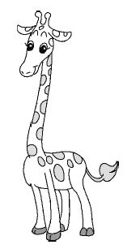 B. 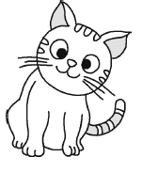
（ ）2. older A. 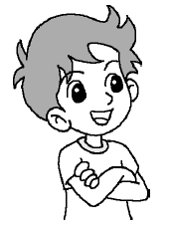 B. 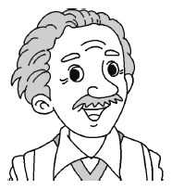
（ ）3. longer A. 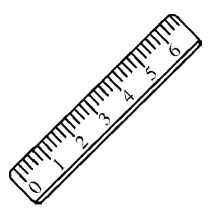 B. 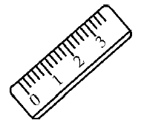
（ ）4. heavier A. 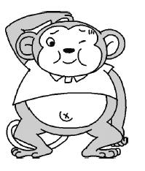 B. 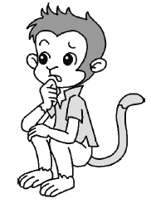
（ ）5. bigger A. 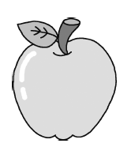 B. 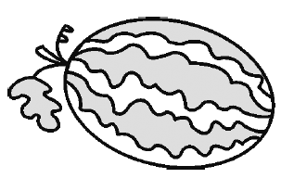
七、单项选择。（10分）
（ ）1. I’m _______ than my mother.
A. older B. stronger C. longer
（ ）2. The river is about 7,500 metres _______.
A. tall B. long C. longer
（ ）3. It is taller than _______ of us together.
A. one B. second C. both
（ ）4. My head is _______ than Fangfang’s, but my hands are than hers.
A. smaller; shorter B. bigger; smaller
C. longer; shorter
（ ）5. — _______is your shirt? —I wear size M.
A. What colour B. What size C. What time
（ ）6. Mike’s cat is bigger than_______.
A. yours B. Chen Jie C. my
（ ）7. His arms are longer than _______.
A. my B. I C. mine
（ ）8. My cat is getting _______.
A. big and big B. stronger and stronger
C. bigger and strong
（ ）9. _______ you taller than your sister?
A. Are B. Is C. Do
（ ）10. My grandma _______ short hair and small eyes.
A. is B. have C. has
八、给下列问句选择正确的答语并连线。（5分）
1. How tall is Mike? A. Mike is younger than Lily.
2. How heavy is your father? B. He is 1.72 metres.
3. Who is younger than Lily? C. Yes, I am.
4. Are you taller than John? D. Yes, I can.
5. Can you answer the question? E. He is 70 kilograms.
九、看图片，根据首字母提示完成句子。（每空一词）（5分）
1. Tim is t______ than Jenny. 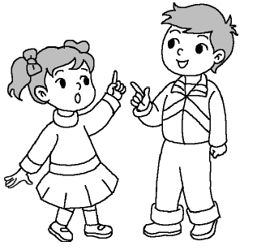
2. Chen Jie’s hair is l______ than Mike’s. 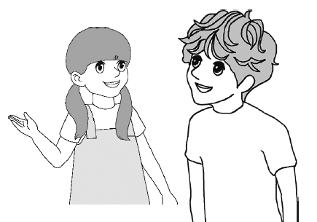
3. The man is y______ than the woman. 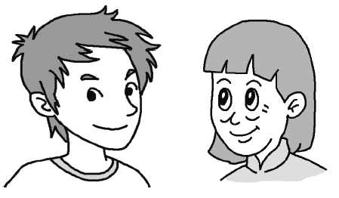
4. I think the monkey is t______ than the bear. 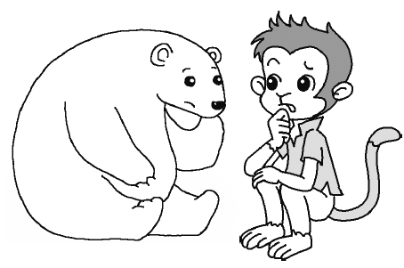
5. The pen is s______ than the ruler. 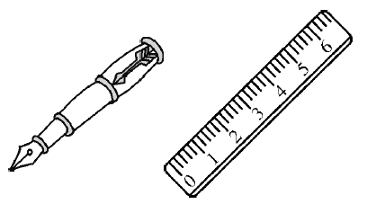
十、从方框中选择适当的选项补全对话。（10分）
Father: Come here, Yuxin. Here are some animals!
Yuxin: Wonderful! 1. ______
Father: No, it’s a tiger. 2. ______
Yuxin: Look! That’s a giraffe. 3. ______
Father: It’s about 7 metres. It’s the tallest animal in the zoo.
Yuxin: Wow! It’s so tall!
Father: 4. ______
Yuxin: Yes, I do. Look at the baby elephant. It’s so cute. Father: The baby elephant is even heavier than the tiger.
Yuxin: 5. ______
Father: Haha!

A. How tall is it? B. Do you like elephants?
C. Is it a big cat? D. It’s much bigger than a cat.
E. The baby elephant is bigger and heavier than me, too.
十一、阅读短文，按要求完成下列任务。（10分）
Hello! I’m Linda. I’m 13 years old. I’m from America. My best friend is Cindy. She’s from the UK. She is one year younger than me. But she is 2 centimetres (厘米) taller than me. I am 1.58 metres tall. I am 46 kilograms. Cindy is heavier than me. She is 50 kilograms. We wear the same size shoes. They’re size 36. We often play and study together. We have a happy time every day.
任务一: Who is Linda? Who is Cindy?
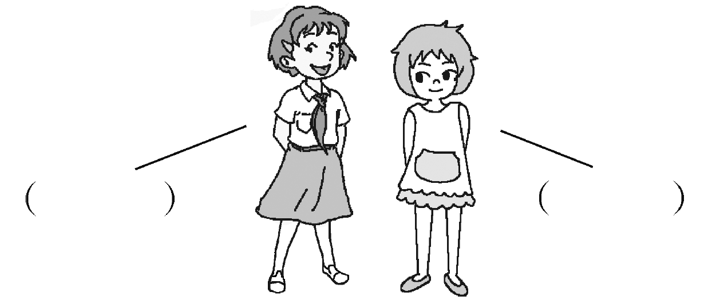
任务二:选择正确的答案。
（ ）1. How tall is Cindy?
A. 1.56 metres. B. 1.58 metres. C. 1.6 metres.
（ ）2. Who is heavier, Linda or Cindy？
A. Linda. B. Cindy. C. We don’t know.
（ ）3. What size are Linda’s shoes?
A. Size 35. B. Size 36. C. Size 37.
十二、书面表达。（10分）
下面是Joe和他妹妹Jane的信息表。请根据表格内容完成一篇英语小短文，可以从年龄、身高、体重等方面进行比较。（不少于40词）
Name | Age | Height | Weight | Size（shoes）
Joe | 9 | 1.48 m | 30 kg | 33
Jane | 5 | 1.2 m | 21 kg | 26
My name’s Joe. I’m a boy. I’m 9 years old. I have ______________
_______________________________________________________________________________________________________________________________________________________________________________________________________________________________________________________________________________________________________
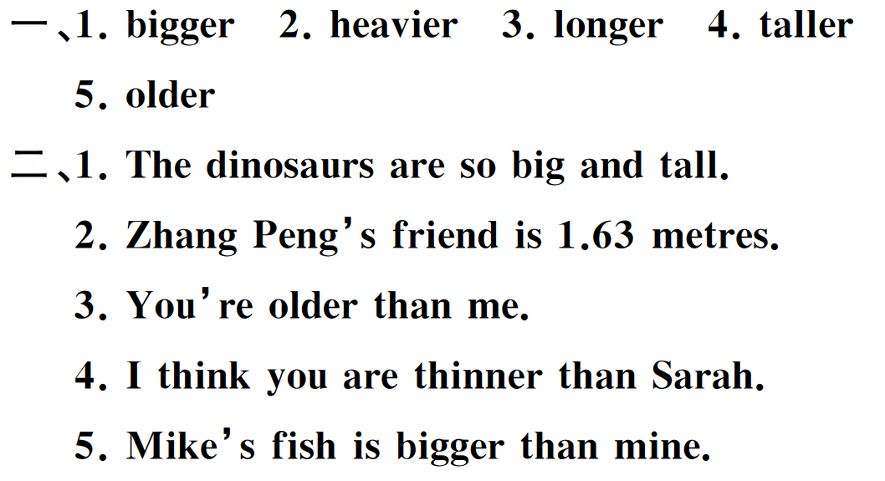
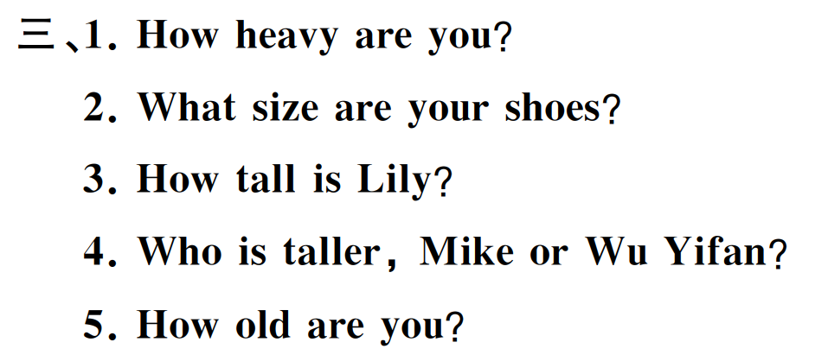
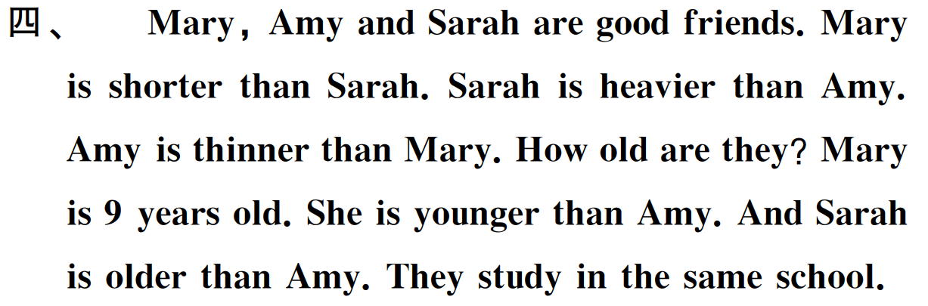
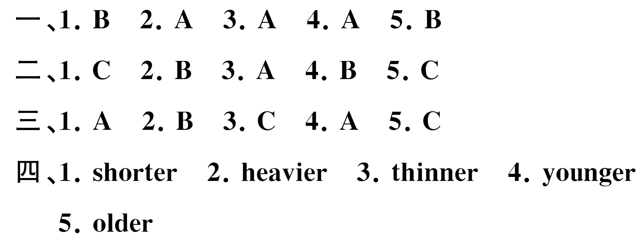
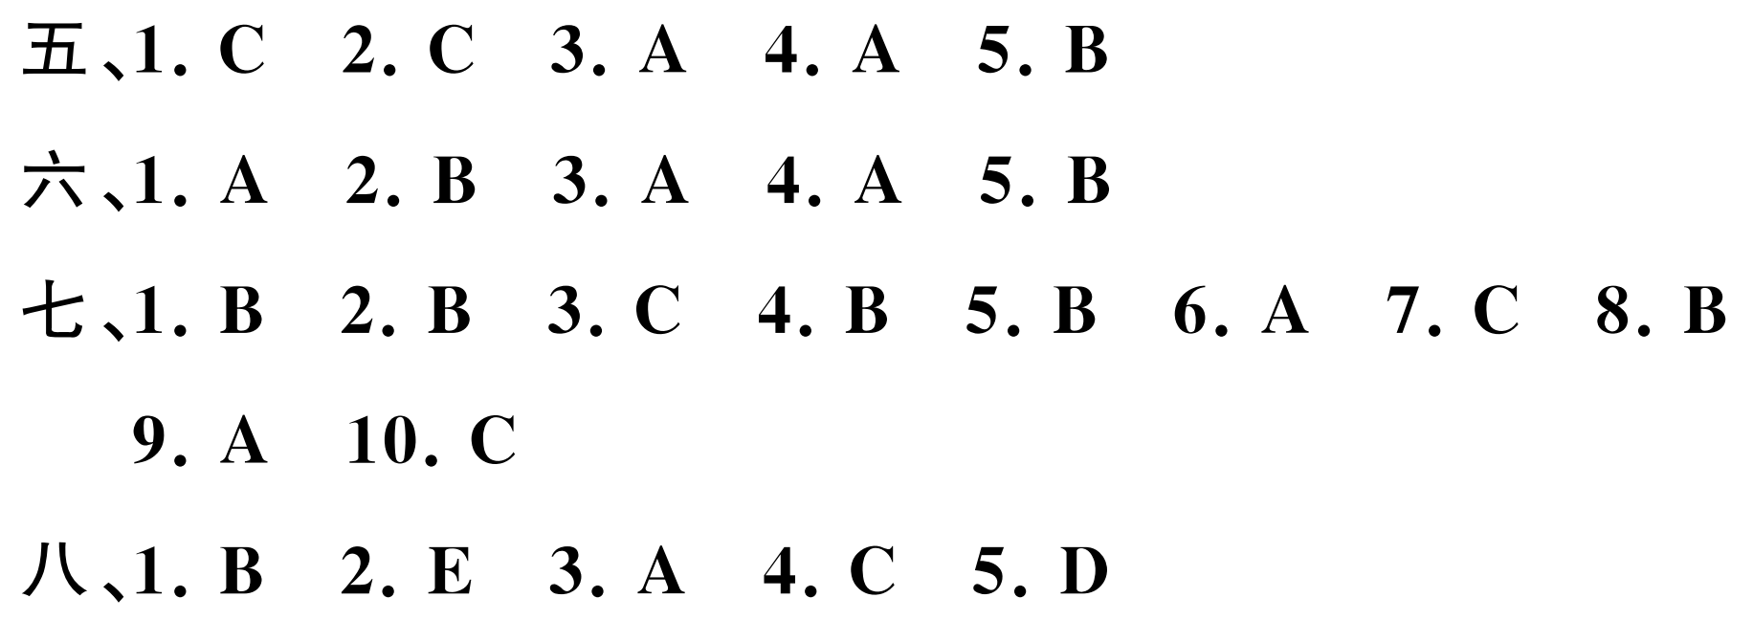
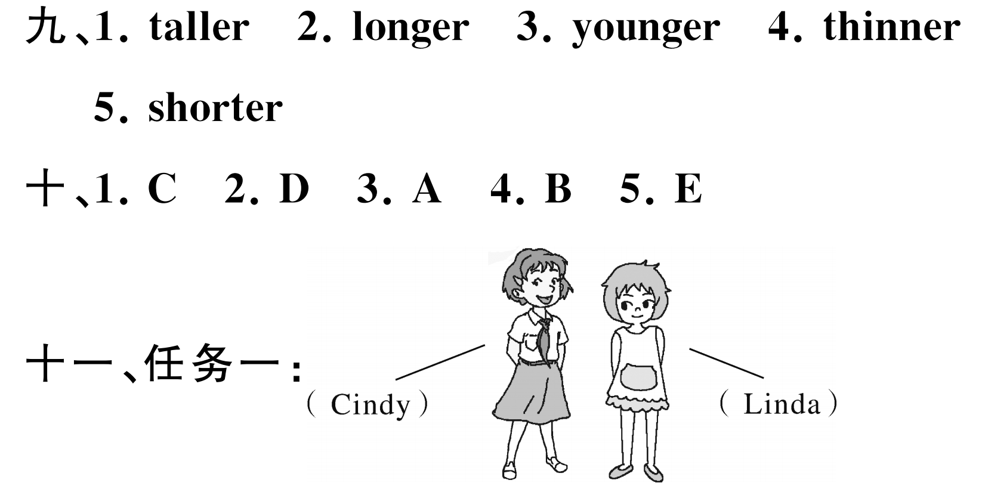
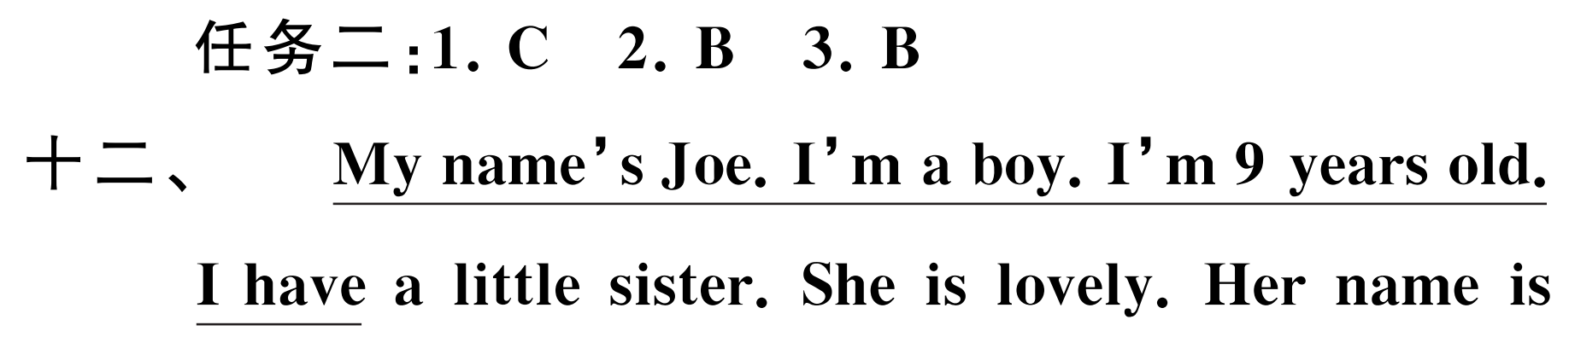
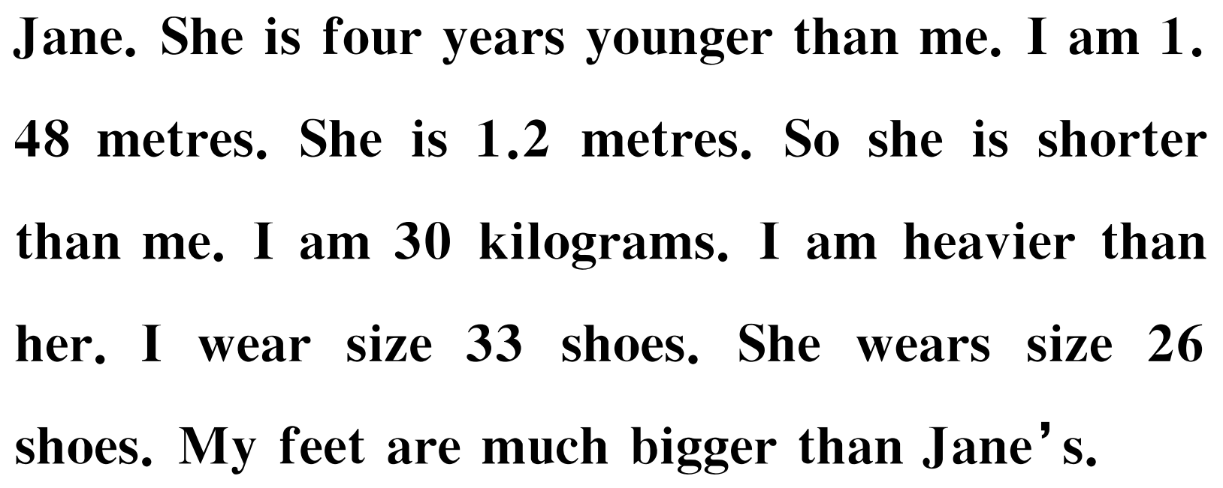

以上内容仅为本文档的试下载部分，为可阅读页数的一半内容。如要下载或阅读全文，请访问：https://d.book118.com/195242010041011121

