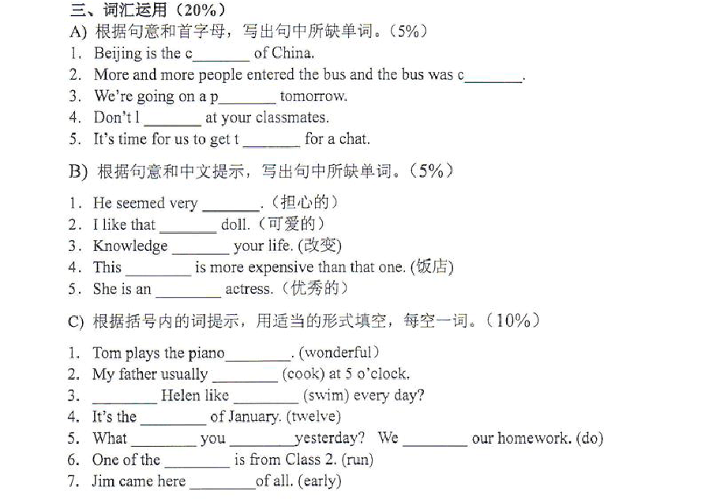
（必读必做）历届小升初首字母填空或单词适当形式填空题2013 大联盟

2013 小联盟
五、词汇知识（每小题 1 分，共 15 分） A）根据句意和首字母提示，将所缺单词补充完整： 1.—What's the m of the word “pudding”
—I don't know. I have to look it up in the dictionary. 's w the football game on TV.
we say weekend, we mean S and Sunday. 4.—Oh, the beautiful vase is broken!
—My uncle careless d it last night help to look a patients in hospital.
Lan has very good s ；she can see things clearly without glasses.

all got i in the book and want to read it after the teacher's task about the writer.
8.—W is your uncle —He is scientist
Lei o worked as a farmer, but now he is a teacher in our school. 10.—Thank you for your great help. —You are w .

B）用所给单词的适当形式填空。
- The children are playing basketball on the playground (happy).
- (Who) handwriting is the best in your class
! They are (run) toward us.
gave Bob a (collect) of stamps as a birthday present.
is my younger brother's (five) birthday. I will Buy a cake for him.

2012 大联盟

三、根据句意和首字母提示，将句子所缺单词补充完整。

- 、The G
- 、 The man is very p
Wall is the longest wall in the world.
,he has no food to eat , no water to drink.

- 、C is a popular festival in western countries.
- 、E are the biggest animals on land
- 、 Plants can't grow well w water and air.
- 、 Please say it again, I can't h you.
- 、 Dr Sun Yatsen was once a d .
- 、I was s when I saw some pretty flowers on my desk.
- 、 Listening a concert is so b ,let 's go to the circus i . 四、 根据括号内的词提示，用适当的形式填空。
1、 Ann often (watch) TV at home, She (watch) again last night 2、 ( not eat ) in the library, Tonny.
3、 your dad often (water) the flowers on weekdays.
4、 My aunt (have) a farm. There are some (deer)in it.
5、 Chongqi is a (large) city, and it is one of the (large）cities in China.
6 、 Be quiet please , the children (have) lesson in the classroom.

2012 小联盟
五、词汇知识。（每小题 1 分，共 15 分）

- 找出不同类的单词，把答案的字母写在相应的方格里。
- A. stool B. shelf C. sofa D. doll
- A. pretty B. garage C. strong D. worried
- A. giraffe B. leopard C. patient D. whale
- A. peach B. onion C. pepper D. broccoli
- A. hospital B. hotel C. kitchen D. museum
- 根据句意和首字母提示，将句子所缺单词补充完整。
- I have been worrying for a long time. I really feel t . I must have a rest first.
- ---Where to ---To the l . I want to borrow some books about Guangzhou.
- If you want to learn English better, you should p it every day.
- We all got e when we knew that we had won the first prize.
- ---What c is your pen ---It’s red. C)用所给单词的适当形式填空。
- Mary is one of the (good) students in our school.
- The bus (stop) suddenly when a child ran onto the road.
- Our teacher always tells us (read) the texts as often as possible.
- The weather report says it will be (sun) tomorrow.
- The cat caught some (mouse) yesterday.

2011 大联盟

三.按句意及首字母提示,将句子所缺单词补充完整。（10％）

- Women’s Day is on the e of M .

- Today I am f . But yesterday I was busy.

- The movies star is very f . Many people know him.

- Christmas is the most important festival in w countries.

- You look pale. You’d better go to see a d .

- We needn’t buy Ricky a bike. He has a new one a .

- Do you usually make a shopping list b you go shopping

- Thursday is the f day of the week in the UK

- The box is h . I can’t carry it. 四.用动词的适当形式填空。（10％）
- My father (like) (play) baseball.

- He (visit) the farm next week.

- Look! The baby panda (get) down from the tree. (be) short in 2002, but now she (look) taller.
- My sister swims very (well). But my brother swims (well) than my sister.

- Miss Chen (start) from Macao two hours ago. All of the students (wait) her here now.

2011 小联盟

五、词汇（每小题 1 分，共 15 分）

- 找出不同类的单词，把答案的字母写在相应的括号内。

( )1. A. pencil B. rubber C. ruler D. hospital ( )2. A. Worker B. farmer C. goat D. inventor
( )3. A. plane B. toilet C. train D. bike ( )4. A. snake B. panda C. kangaroo D. classmate ( )5. A. Canada B. Tokyo C. New York D. London
- 根据句意和首字母提示，将句子所缺单词补充完整

- Canberra is the c of Australia. It's very beautiful.

- ----What s do you like best Summer.

- It is necessary to keep a balanced diet and do more exercises if you want to keep h
- Lu Xun was a great Chinese w . He was born in 1881 and died in 1936.

- Jack wanted to b my bike, but I had lent it to Bill.

- 用所给单词的适当形式填空。

- My father me a toy car as my last birthday present. (buy)

- ----Are there any on the farm ----Yes, there are some. (goose)

- Osaka is the largest city in Japan. (two)

- Guangzhou is much than other cities around it. (noisy)

- Look! The boy is in the river. It's very dangerous! (swim)

2010 大联盟

三、词汇运用（15%）

- 根据句意和首字母，写出句中所缺单词。（4%）

31. We needn’t buy Ricky a bike .

He has a new one a . 32.

Do you usually make a shopping list b
you go shoppin

g ？

- Let’s i
our teachers to our party . They’

ll be very happy to be with us .

- The box is very l . You can carry it easily .

- 根据句意和中文提示，写出句中所缺单词。（4%）

- The girl wants to
(改变) her hair style .

- Annie has a
(圆的) face .

- Hurry up . The
(出租车) is coming .

- It’ s midnight . Dad is
( 仍，还) working .

- 根据句意，用括号中所给词的正确形式填空。（7%）

- The boy never
(lie) . Believe him!

- Now , the students

(collect) stationery for the children from Wenchuan .

- (not stay) out too late, Wendy .

- My uncle plans
(study) in London next year.

- The
(story) are very interesting .

- Kitty is arriving on Sunday , the (five) of January.

- I can spend 20
(many) minutes in bed now .

2010 小联盟五、单词填空
a). 用所给词的适当形式填空。

- Anna (come) back from the football match ten minutes ago.

- ---How is the weather today ---It’s (rain).

- Change your way. Then you can finish it (easy).

- There are many foreigners here. Some of them are (German).

- March 8this the (woman) Day. b). 按句意及首字母提示，将句子所缺单词补充完整。
- I think this book is too b , I am not interested in it.

- Lily lives in Guangzhou, but she was b in Shanghai.

- Which do you p , basketball or football

- Look, the monkey is c the tree.

- Tomatoes is my f food. I like it best.

2009 大联盟

六、用所给词的适当形式填空。（10 分）

(see) his name in the newspaper yesterday.

he (live) ---- He (live) in Nanjing. would like (be ) your penfriend.
father (like) (play) basketball.

(visit) the farm next week.

’s two o’clock in the afternoon. We (have)an English class.

is (nine) month of a year.

2008 大联盟

三、根据上下文意思补全句子中单词所缺的字母。 （8 分） 1．Thursday is the f day of the week in the UK.

2．Our national f is red with five yellow s . 3．Tokyo is noisy. But Wellington is q .
4．Xu beihong was a famous Chinese p . 5．Today I am f . But yesterday I was busy.
- We worked all day yesterday. We were very t . 7．Christmas is the most important f in western countries. 八、用动词的适当形式填空。 （11 分）
1、 Mike (make) a kite yesterday

2、Joan (buy) a bike the day before yesterday.

3、 Joan usually (clean) her teeth before breakfast 4、Look! The baby panda （get）down from the tree.
5、Tom’s mother (have) a nice handbag. 6、Kate likes （dance）.
7、The girl sometimes (have) lunch at home.

8、Joan (not swim) before breakfast every day.

9、She (be) short in 2002, but now she (look) taller.

2012 省实天河

Ⅳ、根据句子意思（或课文）和首字母提示填写单词，使句子的意思完整.(共 20 分)

A 根据句子意思（共 10 分，每小题 2 分）

- Is the monkey more c than the elephant
- S is the first day of a week in western countries.
- Do you think it is good for a to live in the zoo
- I’m just a b because I started to learn the piano one month ago.
- You must be c crossing the road.

B 根据课文（共 10 分，每小题 1 分）

Janet: Mum.
Mrs. Webb: Yes, Janet

Janet: It’s my birthday s 51 .
Mrs. Webb: Yes. It is. W you like to have a party
Janet: Oh yes, please, Mum! A big party! Can we i 53 all my friends And a 54 the people in my class And my teacher too
Mrs. Webb: Well, m 55 . Let’s ask your teacher.
Mrs. Webb: That’s a lot of people! Our house is t 56 small! Janet: Oh p 57 ! I want them all to come!
Mrs. Webb: Well, maybe we could have a picnic o 58 .
Janet: Yes! Yes! A picnic would be g 59 ! Oh please, Dad! Mrs. Webb: Ok then. B 60 you have to help your mother, Janet. Janet: Oh yes, of course!

Ⅴ、补全对话（共 10 分，每句 2 分）

阅读下面对话，根据上下文，从所给的七个句子中选择五个句子，将对话补充完整，并将该选项前面字母的编号写在答卷相应的横线上。

Tom: Hello, this is Tom. Can I speak to Mimi, please
Mimi’s mom: Hello, Tom 61 . Mimi’s doing the dishes in the kitchen. Tom: Ok. Thank you.
Mimi’s mom: Mimi, 62 . Mimi: Thank you, mom.
(Mimi comes and answers the phone) Mimi: Hello, Tom. It’s Mimi.
Tom: Mimi, Let’s go to the library tomorrow.
Mimi: Oh, sorry, Tom. I can’t go with you. I am going to cook dinner tomorrow. Tom: But why
Mimi: 63 .
Tom: Oh, your mom’s birthday! 64 Mimi: I am going to cook some noodles. Tom: 65

以上内容仅为本文档的试下载部分，为可阅读页数的一半内容。如要下载或阅读全文，请访问：https://d.book118.com/205101041022011100

