甘肃省武威市2023年中考英语真题
姓名：__________ 班级：__________考号：__________
题号 | 一 |  | 二 |  | 三 | 四 | 五 | 六 | 七 | 八 | 总分
评分
阅卷人 |  |  |  | 一、语法与情景对话，阅读下列各题，从A、B、C、D四个选项中选择一个最佳答案。（共20小题：每小题1分，满分20分）
得分
1． There are 60 minutes in____ hour.
A．a B．an C．the D．/
2． Put____first and be careful while riding on the road!
A．interest B．money C．knowledge D．safety
3． —What's thirty and ten?
—It's ____.
A．forty B．fifty C．seventy D．eighty
4． That's ____. That's the man I was talking about.
A．me B．her C．him D．it
5． The cat in Picture ____ is on the box.
A．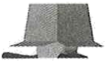 B．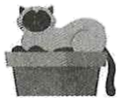
C．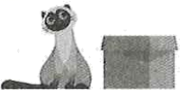 D．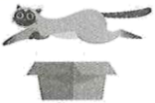
6． Let's wait ____ the rain stops.
A．so B．while C．since D．until
7． There ____a big tree behind the shop. You can see many birds in it.
A．is B．are C．was D．were
8． —____do you exercise?
—Every day.
A．How many B．How old C．How much D．How often
9． I____ at 6 a.m. so I can leave for school at 7 a.m..
A．get up B．put up C．take after D．get on
10． I opened the door and all my friends shouted "Happy Birthday!" I had no idea they were
coming. I was so ____.
A．interested B．surprised C．interesting D．surprising
11． ____trying and do your best.
A．Keep B．Keeping C．To keep D．Kept
12． I haven't got time to wait. If you want to come with me, get dressed ____.
A．carefully B．loudly C．quickly D．heavily
13．—I ____ find my keys.
—Have you checked in your jacket pockets?
A．mustn't B．shouldn't C．can't D．wouldn't
14． —Do you know ____?
—Yes, there's one here. It's in the store.
A．whom he is talking with
B．when I can get to the hotel
C．how to use the machine
D．if there's a restroom around here
15． If you heat ice, it ____into water.
A．turns B．turned C．was turning D．has turned
16． That was the best meal I've ____.
A．ever been to B．ever chatted with
C．ever read D．eaten in a long time
17． Which of the following is TRUE according to the right picture?
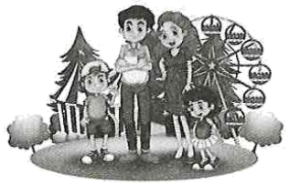
A．They are possibly in the kitchen of their house.
B．It seems that nobody is happy
C．They are probably a family.
D．The girl is taller than the boy.
18．—Home is always the warmest place.
—____ East or west, home is the best.
A．I don't think so. B．I'm afraid not.
C．I couldn't agree more. D．I hope not.
19． Which of the following shows that you can put your waste there?
A． B．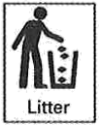 C．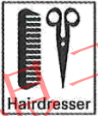 D．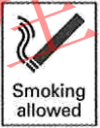
阅卷人 |  | 二、完形填空（共10小题；每小题15分，满分15分）
得分 |  | 二、完形填空（共10小题；每小题15分，满分15分）
阅读下面短文，从短文后各题所给的四个选项中选出能填入空白处的最佳答案。

Emily loved reading. She used to be very shy. She 20． talking to others. So she turned to 21． . In 2019, her dad got sick. It was very serious. Books became an even bigger comfort for 22． .
Emily's dad got better. And she came up with a plan to 23． others.
Emily started a book drive in her hometown. She 24． books. She took them to 25． being cared for in hospitals. 26． , she has collected more than 10,000 books.
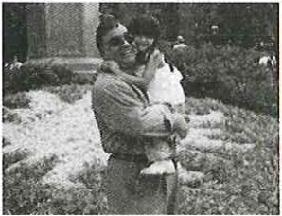
Emily and her father are very close. When her father learned of her plans for the book drive, he wasn't surprised. "She was always interested in books," he says. " 27． she always wanted to do things for the neighborhood." Emily runs the book drive herself, but she gets some help from her 28． . "We do the driving," her dad says.
Emily still runs the book drive. The memory of meeting the children she helps sticks with her. "It was the 29． day of my life," she says. "I realized I wanted to do this type of work forever."
20．A．was afraid of B．was interested in
C．was good at D．was sorry for
21．A．music B．sports C．books D．stamps
22．A．me B．her C．him D．it
23．A．teach B．save C．move D．help
24．A．wrote B．collected C．read D．bought
25．A．kids B．men C．women D．newborns
26．A．In short B．Hardly ever C．So far D．On time
27．A．So B．Or C．But D．And
28．A．parents B．friends C．teachers D．neighbors
29．A．saddest B．best C．shortest D．strangest
阅卷人 |  | 三、阅读理解（共10小题；每小题2分，满分20分）
得分 |  | 三、阅读理解（共10小题；每小题2分，满分20分）
阅读以上天气预报，根据其内容判读下列句子正误。
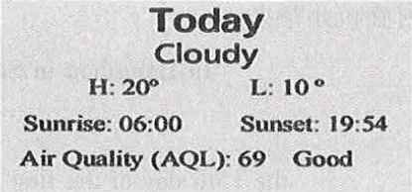
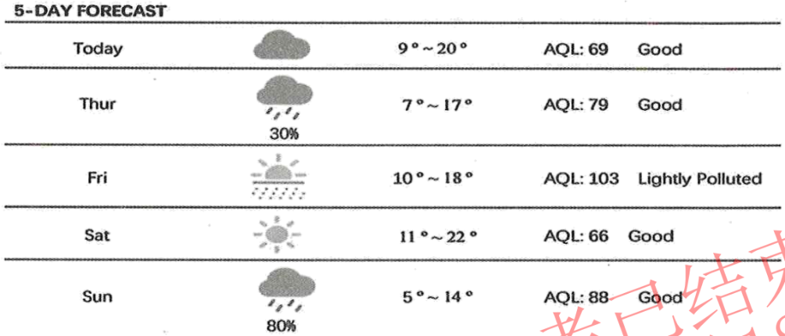
30．The sun rises at 6 o'clock in the morning on Wednesday.
31．It may be rainy on Thursday.
32．Friday would be the best day for an outdoor soccer game.
33．Saturday will be sunny.
34．The night of Sunday will be the warmest.
阅读以下材料，根据其内容回答其后各个小题。
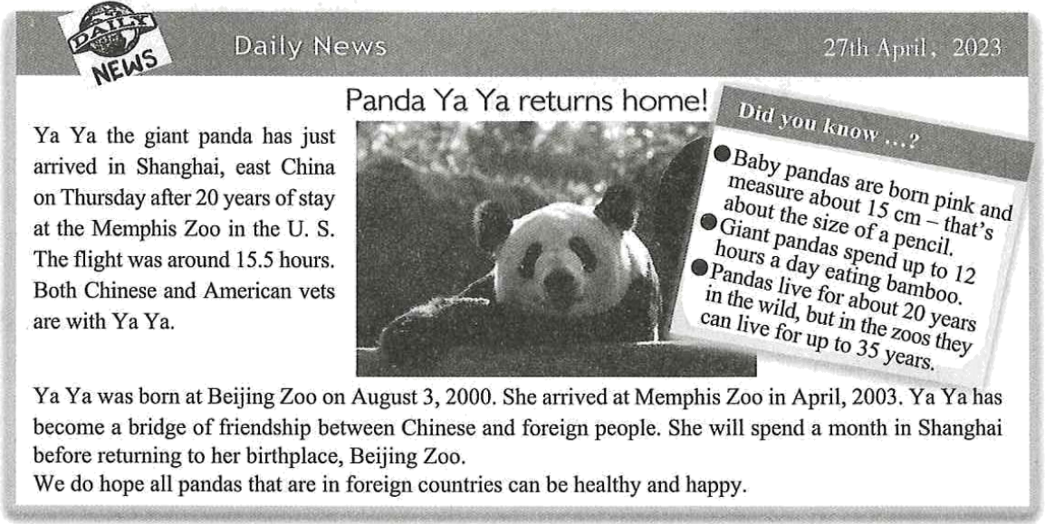
35．Ya Ya had lived in U.S. for ____ years.
A．5 B．10 C．15 D．20
36．Ya Ya was born in ____.
A．Beijing B．Chengdu C．Shanghai D．Guangzhou
37．What color are new-born pandas?
A．Black and white. B．Pink.
C．Yellow. D．Gray.
38．Which of the following is TRUE according to the passage?
A．Ya Ya is still a young panda now.
B．Shanghai Zoo is Ya Ya's final home.
C．Ya Ya had a short flight coming back home.
D．Ya Ya helps foreigners know more about China.
39．This passage is ____.
A．a piece of news B．an ad
C．a diary D．a letter
阅卷人 |  | 四、任务型完形填空（共10空；每空1分，满分10分）
得分 |  | 四、任务型完形填空（共10空；每空1分，满分10分）
用方框中所给单词或短语的适当形式填空，使短文通顺、正确、连贯，每个单词或短语限用一次。
friend, or, silly, look up, you, a little, in, what, sometimes, have
Dear Li Ming,
How are you? My name is Mary. I've been looking forward to 40． a pen

pal for a long time now. I hope we can become great 41． !
Ever since I got your name and address from my teacher, Mrs. Brown, I have been thinking about 42． to write. First, I thought of telling 43． what it's like to go to school here in London. But then, I thought you could 44． London on the internet and read about it yourself. And then I had the idea to tell you about my family, but I realized that the story of my little brother losing a tooth 45． the time we got a new kitten might be kind of boring. After that, I thought about asking you questions about what it's like to live 46． Gansu, but I was afraid you might think my questions were 47． .
I guess I can tell you 48． about myself. In fact, you've probably already learned one thing about me. I 49． have a hard time making up my mind! I hope you will write me back anyway.
Sincerely,
Mary
阅卷人 |  | 五、口语交际（共5小题；每小题1分，满分5分）
得分 |  | 五、口语交际（共5小题；每小题1分，满分5分）
阅读下面的对话，根据上下文，选择恰当的选项补全对话，使句意完整、符合逻辑。（其中有两项为多余选项）
(Li Ming is talking with an exchange student Tom. A is for Li Ming; B is for Tom.)
A: Hello, where are you from?
B: I'm from the United States.
A: Welcome to Gansu! Do you like it here?
B: I like it a lot here. 50． Are you a local here?
A: 51． I'm very proud of my hometown. There are many mountains and rivers in Gansu.
B: Really? I would love to see them. 52．
A: Of course! We have many famous places of interest here, such as the Mogao Grottoes in Dunhuang, the Jiayuguan Great Wall, the Yellow River Stone Forest and so on. You can go there and enjoy the beauty of Gansu.
B: 53． I heard the food here is also very delicious, can you introduce me to some?
A: Of course! We have many local food, such as beef noodles, black bean soup, niangpizi, etc. 54．
B: Thanks a lot.
A: You're welcome. I am happy to share you something about my hometown.
A. Where is Gansu?
B. Yes, I was born and raised here.
C. No, I am from China.
D. Gansu is a very beautiful place.
E. You can go to local restaurants and taste them.
F. Can you tell me some places of interest?
G. Thank you very much for your advice.
阅卷人 |  | 六、词汇考查，根据句意，用括号内所给单词的适当形式填空。（共10小题；每小题1分，满分10分）
得分 |  | 六、词汇考查，根据句意，用括号内所给单词的适当形式填空。（共10小题；每小题1分，满分10分）
55． Frank has more than 500 (stamp).
56．It's not my book. It's (her).
57． Let me (tell) you about my favorite book.
58． Peter is (young) than his sister May.
59． When mom came home, Danny (play) the piano in the living room.
60． My teacher always offers us help (patient).
61． Our home is the (three) from the end on the left.
62．You're expected (shake) hands when meeting people for the first time in China.
63． I (learn) English ever since I was in Grade 3.
64． ChatGPT, an AI chatbot, was (develop) by Open AI and met the public in November, 2022.
阅卷人 |  | 七、根据所给汉语提示完成下列句子（共5小题；每空1分，满分10分）（每空限填一词）
得分 |  | 七、根据所给汉语提示完成下列句子（共5小题；每空1分，满分10分）（每空限填一词）
65． 我们将一起努力实现梦想。
We'll work together to make our dreams .
66． 每日练习对学习英语来说很重要。
It's to English every day.
67．第19届亚运会将于2023年9月在杭州举办。
The 19th Asian Games will in Hangzhou in September, 2023.
68．元宵节在农历正月十五。
The Lantern Festival the 15th day of the first lunar month.
69．"林业英雄"郭万刚在过去的四十年里在腾格里沙漠上建起了一道绿色屏障。
Guo Wangang the forestry hero, a green belt in the Tengger Desert over the past 40 years.
阅卷人 |  | 八、书面表达（满分10分）
得分 |  | 八、书面表达（满分10分）
70．假设你是李辉。你校英语报"Protect the Environment"专栏面向全校学生征集主题海报及宣传稿，需要用英语向大家宣讲环保的意义及作为中学生怎样保护环境。请你根据以下海报提示，以Save the Earth: Let's Do Our Part!为题，用英语给专栏写一篇稿件。
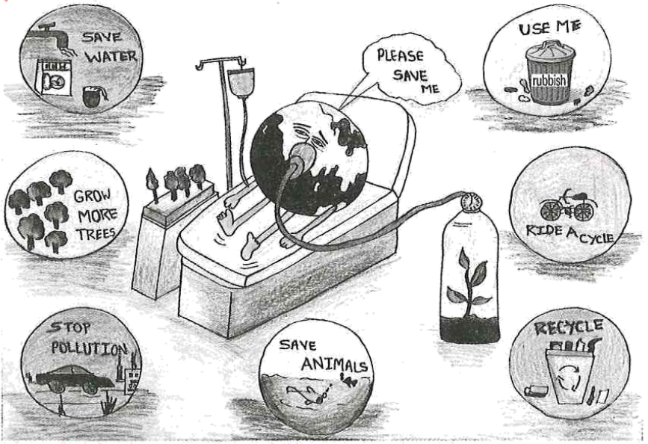
要求：
1. 包括提示中所有的写作要点；
2. 条理清楚，行文连贯，可适当发挥；
3. 稿件中不能出现真实的人名和地名等信息；
4. 词数：80左右。题目和开头已给出，不计入总词数。（不用抄写在答题卡书面表达作答区域。）
Save the Earth: Let's Do Our Part!
The earth is the only home for everyone on it. It's crying for our help now.
答案解析部分
1．【答案】B
【解析】【分析】句意：一个小时有六十分钟。hour是名词单数，第一次提及某物，用不定冠词，是以辅音音素开头的单词，故用不定冠词a表示泛指一个，故选B。
【点评】考查冠词，注意识记an的用法。
2．【答案】D
【解析】【分析】句意：把安全放在第一位，在路上骑车时要小心！A兴趣，B钱，C知识，D安全，根据be careful while riding on the road，可知强调安全，故选D。
【点评】考查名词辨析，注意识记safety的用法。
3．【答案】A
【解析】【分析】句意：——三十加是等于多少？——四十。A四十，B五十，C七十，D八十，根据数学运算可知30+10=40，故选A。
【点评】考查数学运算，注意识记forty的用法。
4．【答案】C
【解析】【分析】句意：就是他，就是我说的那个人。A我，B她，C他，D它，根据man可知指代男生用him，故选C。
【点评】考查代词辨析，注意识记him的用法。
5．【答案】B
【解析】【分析】句意：图片B中的猫在盒子上。A在里面，B在上面，C在旁边，D远离，根据图示猫在盒子上面，故选B。
【点评】考查介词辨析，注意与图片结合。
6．【答案】D
【解析】【分析】句意：我们等雨停了再说。A所以，引导结果状语从句，B而，表示对比，C自从，是现在完成时标志，D直到，引导时间状语从句，搭配持续性动词，根据wait和rain stops，可知是同时存在的动作，故是时间状语从句，可知持续动词搭配until，表示动作一直持续到雨停，故选D。
【点评】考查连词辨析，注意识记until的用法。
7．【答案】A
【解析】【分析】句意：商店后面有一棵大树。你可以在里面看到许多鸟。there be句型表示某地有，描述客观事实用一般现在时，主语是第三人称单数tree，故be用is，故选A。
【点评】考查主谓一致，注意识记there be句型，一般现在时的用法。
8．【答案】D
【解析】【分析】句意：——你多久运动一次？——每天。A多少，修饰名词复数，B几岁，C多少，修饰不可数名词，D多久一次，根据回答every day，可知提问频率用how often，故选D。
【点评】考查疑问词辨析，注意识记how often的用法。
9．【答案】A
【解析】【分析】句意：我早上6点起床，这样我就可以7点去上学了。A起床，B搭建，C与.....像，D上车，根据6 a.m.，可知这是起床的时间，故选A。
【点评】考查短语辨析，注意识记get up的用法。
10．【答案】B
【解析】【分析】句意：我打开门，所有的朋友都喊道:"生日快乐!"我不知道他们要来。我很惊讶。A感兴趣的，B感到惊讶的，C有趣的，D令人惊讶的，根据I had no idea they were coming可知很惊讶，-ed句尾的形容词修饰人，-ing句尾的形容词修饰物，根据I，可知修饰人的心情，故用surprised，故选B。
【点评】考查形容词辨析，注意识记surprised的用法。
11．【答案】A
【解析】【分析】句意：继续努力，尽你最大的努力。A动词原形，B动名词，C不定式，D过去式，根据and do your best，可知and前是祈使句，故用动词原形开头，故选A。
【点评】考查祈使句，注意识记动词原形开头的用法。
12．【答案】C
【解析】【分析】句意：我没时间等了。如果你想和我一起去，快点穿好衣服。A细心地，B大声地，C迅速地，D重地，根据I haven't got time to wait，可知穿衣服的动作要迅速，故选C。
【点评】考查副词辨析，注意识记的quickly用法。
13．【答案】B
【解析】【分析】句意：我应该找不到我的钥匙。您检查过您的夹克口袋了吗？A禁止，B应该不，C不可能，D不会，根据Have you checked in your jacket pockets，可知表示猜测，故用shouldn't，故选B。
【点评】考查动词辨析，注意识记shouldn't的用法。
14．【答案】D
以上内容仅为本文档的试下载部分，为可阅读页数的一半内容。如要下载或阅读全文，请访问：https://d.book118.com/235123122034011042

