

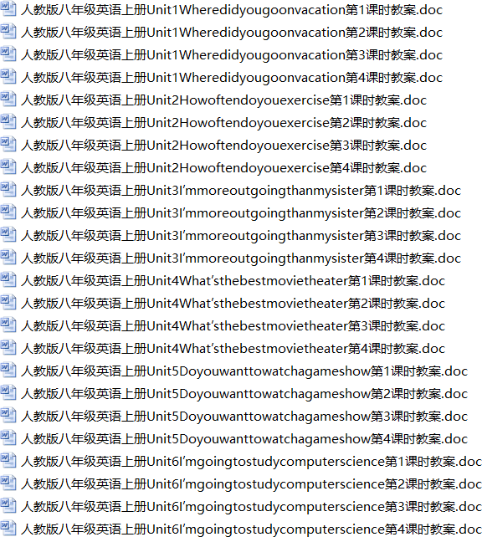
（共 40 套 95 页）人教版八年级英语上册（全册）精品获奖教案汇总

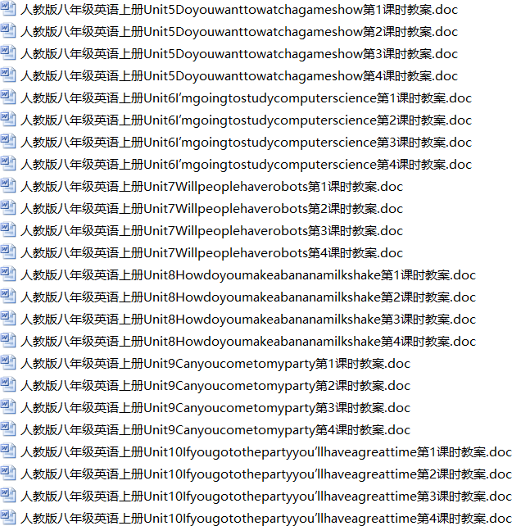

Unit 1 Where did you go on vacation

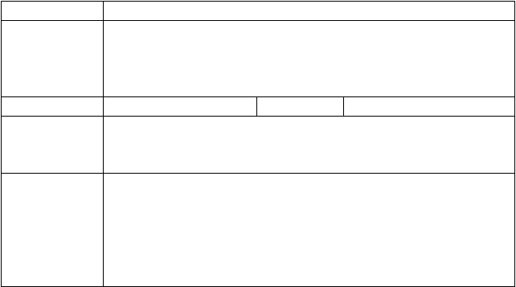
课题名称三维目标

重点目标导入示标

目标三导
Unit 1 Where did you go on vacation? Period 1 (Section A 1a-2d) 1.掌握本课时中与地点名称相关联的名词或短语。
- 能够正确写出并朗读本课时出现的动词的过去式。
- 能够正确运用本课时出现的动词的过去式和地点名词对过去发生的事情进行描述。
难点目标

学做思一：问题 1.你知道怎么用英文表达下列与地点名称相关联的名词或短语吗？
【独立自学 1】
请写出下列地点的英语表达。

  - 家
3. 夏令营
  - 纽约城
- 山，山脉

- 沙滩
7. 中央公园
- 博物馆
- 黄果树瀑布

【思维向导 1】
  - 纽约城、中央公园、黄果树瀑布是专有名词，首字母必须
，并且前面不需要用 。
  - 你知道的表示地点名称相关联的名词还有 。学做思二：问题 2. 你知道怎么用英文表达过去的行为吗？
【独立自学 2】
- 请写出下列动词的过去式。
  - stay→ 2. visit→ 3.
go→

- buy→ swim→
- study→ 6.

  - play→ do→
  - meet→ 9.

10. see→ 11. am, is→ take→
- 请根据句意把所给的汉语词组翻译成英语。
12.

- I didn’t go anywhere last night. I just (呆在家).
- I (去纽约) to (拜访我叔叔).
- — you (去夏令营) ? —No, I didn’t.
- We (去爬山) with teachers last Saturday.
- The students (去沙滩) and played beach volleyball.
- —When they (参观博物馆)？
—Last month.
【思维向导 2】
- 在练习I 中， 1、2、7 是规则动词，其过去式直接在词后加
；5 也是规则动词，但其过去式要先把 变成
，再加 ；其余都是 动词，其过去式形式也是不规则变化，需要特别记忆。
- 动词的过去式用来表达在 发生的行为。学做思三：问题 3.怎样询问他人去过哪里度假？
【独立自学 3】
按要求变化下列句型。
- He went to New York City last Sunday. (变一般疑问句并作肯否定回答)
— he to New York City last Sunday?
—Yes, he ./ No, he .
- She went to the mountains on vacation.(对划线部分提问)
she on vacation?
- They decided to go to Central Park.(对划线部分提问)
they to go?


【思维向导 3】
- 如果句子的谓语是实义动词的一般过去式，其一般疑问句结构是:
+主语+ +…? 肯定回答是：Yes, 主语+
. 肯定回答是：No, 主语+ . 在简略的肯否定回答中, 主语通常用 代词。
- 询问他人去过哪里度假，由 引导特殊疑问句。达标检测 I. 用所给词的适当形式填空。
- Let’s go (camp) this weekend?

- They went to the museum yesterday and
something wonderful.
- He (visit) his uncle last Saturday.
(see)

反思总结

课后练习
- I (stay) at home and (study) for the English test yesterday evening.
- Did you go (somewhere) interesting on vacation?
II. 在空白处填入一个适当的词，使对话完整。
A: Hello, Laura! B: Hello, Kim!
A: Long time no see. 1) did you go on 2) ? B: I 3) to New York City.
A: Did you 4) fun there? B: Yes, I did.
A: 5) was the city? B: It was big and crowded.
A: So 6) you visit Central Park?
B: Yes. And it was 7) beautiful. What 8)
you, Kim?
A: My vacation was awful. It was rainy, so I 9) at home and
10) TV.
- 知识建构

- 能力提高
- 课堂体验单项选择。
( ) 1. —Is there in today’s menu? —Yes. We have Beijing
Duck.
A. anything special B. special anything
C. nothing special D. special nothing
( ) 2. I’m lucky that we took photos there.
A. quite a lot B. quite a few
C. quite a little D. very little

章节： 课时： 备课人： 二次备课人：
Unit 1 Where did you go on vacation

课题名称三维目标

重点目标导入示标

Unit 1 Where did you go on vacation? Period 2 (Grammar focus-3c)
- 掌握复合不定代词做主语时谓语动词的变化。
- 掌握形容词修饰复合不定代词时的位置关系。
难点目标

目标三导

学做思一：问题 1.你知道英文中表示人或物的复合不定代词吗？
【独立自学 1】
- 请写出下列表示人和物的复合不定代词。
1. 某人 /
- 某事
- 任何人 /
- 任何事
- 没有人 /
- 没有东西
7. 每人 /
8. 每一件事
- 观察Grammar focus，试填下列句子。
- There (be) someone lying on the floor.
- (be) everyone here today?
- Something (be) wrong with my eyes.
- Nothing (be) difficult for me.
- Nobody (want) to hear the bad news?
【思维向导 1】
- 复合不定代词是由 个词构成的复合词。
- 复合不定代词作主语时，谓语动词用第 人称
数形式。

学做思二：问题 2. 你知道形容词修饰复合不定代词时的位置关系吗？
【独立自学 2】根据汉语提示完成句子。
- There is (其他人) in the room.
- Did you have ( 特别的事) to tell me today?
- I met (有趣的人) at the party.

- I have
- Put it down, Tom. You mustn’t read 他人的) letter.
【思维向导 2】
(没有重要的事)to do now.
(其

- 形容词修饰复合不定代词时， 形容词必须放在被修饰词的
面。

- 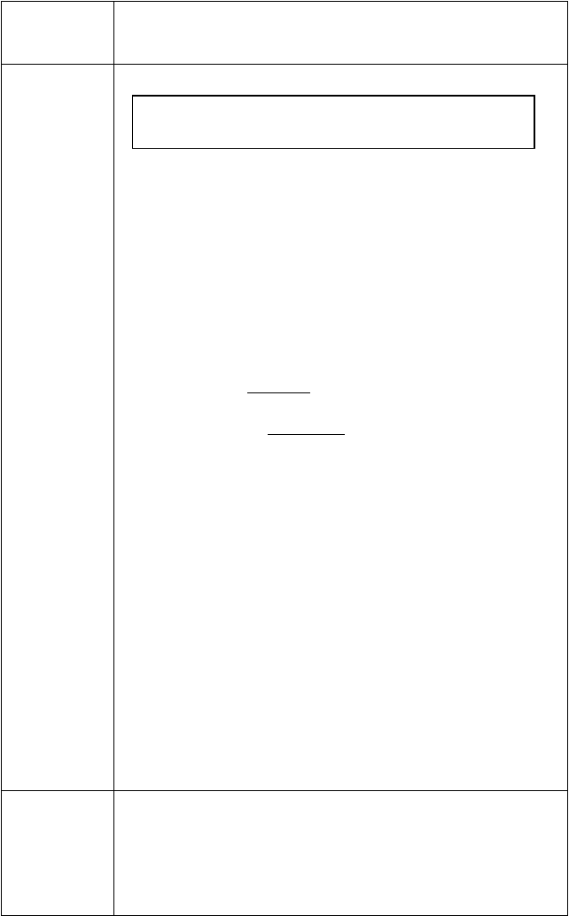表达“其他人的”时， 所有格应放在 后面。如 anybody else’s。

达标检测 I. 根据句意, 选择所给的复合不定代词填空。

反思总结
everyone/everybody, anyone/anybody, no one, someone, something, everything, nothing, anything
- Is in the room? I want some help.
- Is ready for dinner, mum?
- I’d like to be happy in the world.
- I’m sorry I can do with it.
- Is there wrong with your legs?
- —Who finished the work before now? — .
- is knocking at the door? Maybe will happen(发生).
- 按要求变换句型。
  - I bought something for my father.（变一般疑问句）
you for your father?
  - Everything was excellent.(对划线部分提问)
everything?
  - Everyone went to the open air on vacation. (对划线部分提问)
everyone on vacation?
  - I did something interesting.(同义句) I did some .
  - I can see nothing but a bird in the tree. (同义句) I can see a bird in the tree.
- 用复合不定代词填空，一空一词。
Last summer vacation, 1 in my group had fun on the beach. We all did 2 fun there. When we got there, we saw 3 playing beach volleyball. We wanted to join them, but 4 agreed at first. So we said 5 and felt sorry. Just then, we met our classmate Tom. Tom smiled and came to ask us to play together. We were so excited to say that 6 was great. We played about 2 hours. After that, we surfed(冲浪) in the sea, ate some delicious sea food and bought some souvenirs (纪念品) for our other classmates. 7
who got our gifts in our class said “Thanks” to us. We all felt
very happy.
- 知识建构

- 能力提高

- 课堂体验


课后练习
单项选择。
( ) 1. Whatever you do, is difficult if you put your heart into it.
A. nothing
everything
B. anything
C. something
D.
( ) 2. —Who helped you repair(修理) your bike?
— . I repaired it all by myself.
A. Anybody B. Everybody C. Somebody D. Nobody ( ) 3. We’d like to go .
A. somewhere interesting B. interesting somewhere
C. to somewhere interesting D. to interesting somewhere
( ) 4. —Would you like ?—No, thanks. I’m not hungry.
A. anything to eat B. something to eat
C. eat anything D. eat something
章节： 课时： 备课人： 二次备课人：
Unit 1 Where did you go on vacation

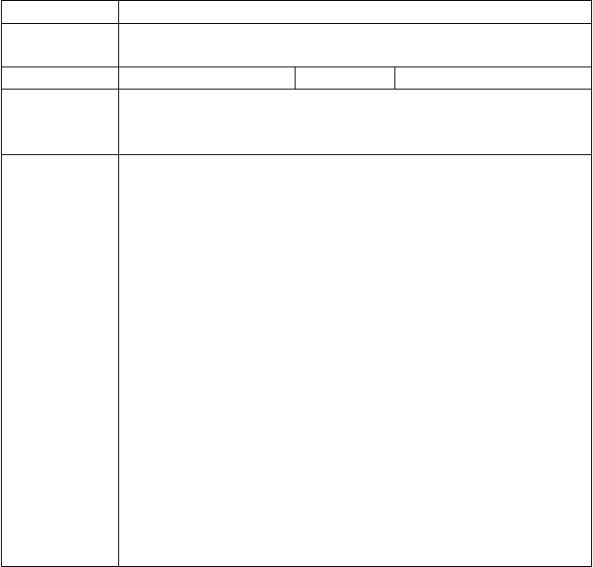
课题名称三维目标

重点目标导入示标

Unit 1 Where did you go on vacation? Period 3 (Section B 1a-1e)
- 学会运用描述性形容词去谈论假期。
- 正确运用不同的特殊疑问句来询问假期情况。
难点目标

目标三导
学做思一：问题 1.你知道谈论假期时常会用到的形容词吗？
【独立自学 1】

I. | 请写出下列形容词的英语。
1. | 味美的 | 2. | 贵的
3. | 令人激动的 | 4. | 便宜的
5. | 糟糕的 | 6. | 枯燥的

  - 不错的
9. 特别的
【思维向导 1】
  - 有趣的

我们发现这几个形容词
是用来描述 的人或事，是褒义词；这几个形容词
是用来描述 的人或事，是贬义词。

学做思二：问题 2. 你知道如何用描述性形容词去谈论假期吗？
【独立自学 2】
    - 独立思考：我们可从哪些方面去谈论假期？
    - 根据句意，用形容词填空。
- The cost(花费) of the trip to the USA is $ 20,000 each one. It’s
too .


- I like an interesting trip, but this is a little
for me. I don’t like it.
- I love the food there because it’s cheap and .
- What weather! We have to stay at home and watch TV.
- The people there are to us. We help each other on the trip.

- When we heard the news, all of us could’n jumping.
t help

- He wanted to meet something on a trip, not so usual.

学做思三：问题 3.你能正确运用不同的疑问句来谈论假期吗？
【独立自学 3】
补全对话， 一空一词。
A: Hi, Lisa. 1) you go on a vacation? B: Yes, I did.
A: 2) did you go? B: I went to Hong Kong. A: 3) did you go with? B: I went there with my family.
A: 4) did you go there? B: On the morning of July 19.
A: 5) did you go there? B: I went there by plane. A: 6) 7) did you stay there?
B: For about 10days.
A: 8) was the weather there? B: It was fine. A: 9) did you do in Hong Kong?
B: I visited many interesting places.
【思维向导 3】
谈论假期时，我们可以从度假的地点、 、
、人物、天气、 等方面进行描述。

达标检测 I. 用所给词的适当形式填空。
- I want to spend a quite (relax) holiday.
- The news was . We were to hear it. (excited)
- He had fun (do) something special on his vacation.
- No one seemed to be (boring).
- The food I ate was (real) terrible.
- Are you in the book? (interest)
- The people there are so (friend) to us.
- Did you buy (something) from the USA?
- Would you like (something) to drink, Jack?
- Everything tastes very (well).
II. 短文填空。
Kim 1) to the Great Wall with his family in the


early morning last Sunday. It 2) snowy and cold. So they 3) great fun playing in the snow. Kim 4)
a snowman with a big red nose and two red eyes. His parents 5)
snow balls with each other. In the afternoon, they 6)
shopping. But the shops 7) crowded. So they 8)
really enjoy it.
反思总结 7. 知识建构

- 能力提高

- 课堂体验

课后练习
单项选择。
( ) 1. —What do you think of the story? — It is very fun. It makes us
A. laugh B. laughing C. to laugh D. to laughing
( ) 2. Mom on my twelfth birthday.
A. bought me a bike B. bought a bike to me

C. bought a bike for me D. Both A and C. ( ) 3. We couldn’t see when it was too dark.
A. everything B. nothing C. anything D. something
( ) 4. Money is important, but it isn’t .
A. A. everything B. nothing C. anything D. something
( ) 5. Listen! is knocking (敲) at the door.
A. Everyone B. No one C. Anyone D. Someone
章节： 课时： 备课人： 二次备课人：
Unit 1 Where did you go on vacation

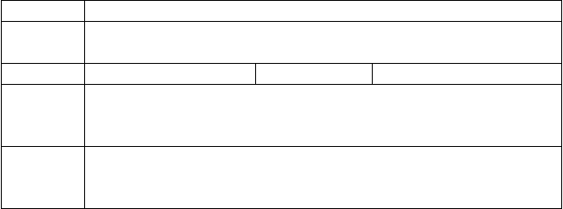
课题名称三维目标

重点目标导入示标

Unit 1 Where did you go on vacation? Period 4 (Section B 2a-2e)
- 理解并学会运用两篇日记中的重点词汇。
- 掌握日记的书写格式及相关要求。
难点目标

目标三导
学做思一：问题 1. 两篇日记中有你不认识的词吗?
【独立自学 1】
请阅读教材第 5 页 2b 中的两篇日记，找出你不认识的词并查词典或生词表弄

清词意。
Diary 1

Diary 2

学做思二：问题 2.你已经掌握本课时所要求的目标词汇了吗？
【独立自学 2】
  - 根据提示，用所给词的正确形式填空。
    - We decided (go) to the beach near our hotel.
    - My sister and I tried (滑翔伞运动).
    - I (感觉像) I was a bird.
    - There are a lot of new (build) now.
    - I really enjoyed (walk) around the town.
    - What a (different) a day makes!
【思维向导 2】
注意decide, try 和enjoy 后动词搭配。在第 1 题中, “决定做某事” 这个短语是 。 第 2 题中, “尽力做某事”这个短语是
，而和 try 有关的另外一个短语“尝试做某事”是 。第 5 题中, “喜欢做某事”这个短语是 。

学做思三：问题 3.你知道写日记应该注意些什么吗?
【独立自学 3】
- 快速阅读 2b, 注意日记要求。
- 日记的格式：时间应放在 , 先写 , 再写
。
- 日记常常是描述过去发生的事情，通常用 时态。
- 细读 2b，找到下列问题的答案。Diary 1:
- When and where did Jane arrive with her family?
- What was the weather like there?
- What did they do on July 15th?
- What did Jane really enjoy doing? Diary 2 :
- How did they get to the top of Penang Hill?
- How was the weather on July 16th?
- Why did they only have one bowl of rice and some fish?
- How do they feel about the food?
【思维向导 3】
- 写一篇英语日记，我们要注意日记的 、 和
。
- 写英语日记时，我们还要记叙清楚过去所发生的事情的 、
、 、 这四大要素。达标检测 I. 单项选择。
( ) 1. —What’s your plan for the summer holiday?
—I’ve no idea, but I’ve decided at home and have a good
rest.


A. stay B. to stay C. stayed D. staying ( ) 2. Please English well, and you will find it very helpful.
A. try learning B. tried learning C. try to learn D. tried to learn
( ) 3. He feels like a diary in his life.
A. keeps B. keep C. to keep D. keeping ( ) 4. She has to buy something .
A. enough money, enough expensive B. enough money, expensive enough
C. money enough, enough expensive D. money enough, enough cheap ( ) 5. We waited the bus stop the bus.
A. at, for B. at, at C. for, for D. for, at
II. 写出下列句子的同义句。
- We decided to go to Penang Hill today.
We a to go to Penang Hill today.
- Because of the bad weather, we couldn’t see anything below.
the weather was bad, we could see below.
- I arrived in Penang in Malaysia this morning with my family. I Penang in Malaysia this morning with my family.
I Penang in Malaysia this morning with my family.
反思总结 10. 知识建构

- 能力提高

- 课堂体验

课后练习
单项选择。
( ) 1. The book is for him to read.
A. easily enough B. easy enough C. enough easy D. enough easily
( ) 2. —What do you think of the cake?
—I like it a lot. It tastes .
A. good B. terrible C. well D. terribly

章节： 课时： 备课人： 二次备课人：
Unit 2 How often do you exercise

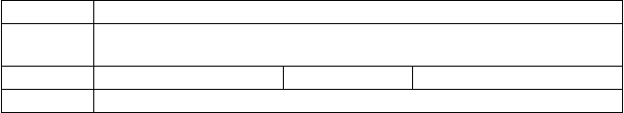
课题名称三维目标

重点目标导入示标

Unit 2 How often do you exercise? Period 1 (Section A 1a-2d)
- 掌握如何恰当地使用频率副词及短语。
- 掌握How often 引导的特殊疑问句。
难点目标

目标三导 学做思一：问题 1. 你知道怎样用英语表达周末的活动吗？
【独立自学 1】请翻译下列词组。
1. | 看电视 | 2. 看英语书
3. | 看电影 | 4. 帮忙做家务
5. | 去购物 | 6. 锻炼
7. | 上网 | 8. 上钢琴课
【思维向导 1】
在 look , see , watch , read 中, 表示看的结果;
表示有意识的看，强调看的动作，后接宾语时要和 连用;
表示所看事物的变化，移动和发展; 强调看书报。学做思二：问题 2. 你知道怎样用英语谈论频率吗？
【独立自学 2】
Ⅰ. 请看一看 2a 里的频率短语，试着找一下规律并写出下列短语.

1. 总是(100%)
- 经常
5. 几乎不
7. 每天
9. 每周两次
11. 每月四次
Ⅱ. 根据要求完成句子。
2. 通常
4. 有时候
6. 从不(0%)
8. 每周一次
10. 每周三次
- 每年五次

  - —你多久上一次网？ —每周两次。
— do you use the Internet? — a week.
  - He goes to the movies twice a week. (对划线部分提问)
he go to the movies?
  - They sometimes watch TV. (对划线部分提问)
do they watch TV?
【思维向导 2】
- 我发现的规律：在次数的表达中，一次是 , 两次是
, 三次或三次以上由 （基数词/序数词）+单词
构成。
- hardly 和 never 表达的是 （肯定/否定）意思，
（能/不能）与not 连用。
- 的意思是“多久一次”，对表示频率的词语提问。

达标检测
- 单项选择。
( ) 1. My sister often goes shopping weekends.
A. in B. on C. to D. for
( ) 2. Li Ming always gets up early and he is late for school.
A. usually B. often C. sometimes D. hardly ever


( ) 3. — do you usually do when you are free?
— I often read something interesting.
A. When B. What C. Why D. Where ( ) 4. — do you use the Internet, Kate?
— Not often, twice a month.
A. How long B. How old C. How often D. How many times
( ) 5. — hours do you sleep every night?
— About nine hours.
A. How long B. How often C. How much D. How many
- 根据汉语意思完成句子。
- The old man (锻炼) every morning.
- I often go to the (电影).
- What do you usually do on (周末)？
- My mother (有时) goes shopping with me.
- Lin Ying (几乎不) watches TV on weekdays.
反思总结 13. 知识建构

- 能力提高

- 课堂体验

课后练习
单项选择
( ) 1. —

do you visit your uncle?

—Once a week, at least.

A. | How | long
B. | How | many | C. | How | often
D. | How | soon
( ) 2. Helen was so excited at the news that she could say a word.
A. ever B. almost C. hardly D. always
( ) 3. —Did you go to the cinema to see 3D Titanic last night?
—No, I go to the cinema. The tickets are too expensive.
A. hardly B. nearly C. still D. only

( ) 4. —
does Mrs. Li wash her car? —Once a week.

A. How long B. How often
C. How many D. How much
章节： 课时： 备课人： 二次备课人：
Unit 2 How often do you exercise

课题名称
三维目标
Unit 2 How often do you exercise ? Period 2 (Grammar focus-3c)
1. 进一步掌握和运用what 和 how often 引导的特殊疑问句。

重点目标导入示标
- 复习并掌握一般现在时态行为动词的一般疑问句。
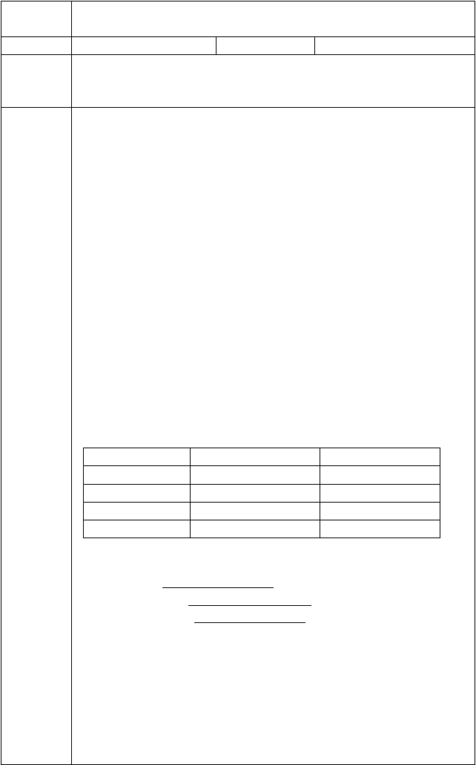
- 熟练运用频度副词。
难点目标

目标三导

学做思一：问题 1. 你能正确使用一般现在时态的助动词do 和 does 吗？
【独立自学 1】
请写出下列句型的一般疑问句形式。
- I stay up every day.
you up every day?
- He often plays tennis after dinner.
he often tennis after dinner?
- They always go to bed early.
they always to bed early?
- We eat apples every morning.
you apples every morning?
【思维向导 1】
一般现在时态的句子中，行为动词作谓语时，其一般疑问句的变化规律： 当主语为第三人称单数，在句首用助动词 ，当主语为第一人称， 第二人称和第三人称复数时，在句首用助动词 。助动词 do/does 后接动词 。

学做思二：问题 2. 你知道怎样用 What 和 How often 引导的特殊疑问句来谈论日常活动吗？
【独立自学 2】

names I
my sisters Jack
...
activities watch TV swim
use the Internet
frequency every Saturday twice a week hardly ever

请根据表格内容填空。
  - I watcth TV .
  - My sisters swim .
  - Jack hardly ever .
【互助共学】
请和小组成员根据图表内容进行问答。
A: What do you do on weekends / weekdays? B: …
A: How often do you…? B: …
【思维向导 2】
- 用所给动词的正确形式填空时，需看主语，当主语为第一人称，第二人称及

所有人称复数，动词用 ，当主语为第三人称单数，动词要
。变化规则为：一般情况下在动词后加 ，以s, x , ch , sh , o 结尾加 ，辅音字母加 结尾的变
为 ，加 。
- 对动词提问用特殊疑问词 ，对频率提问用疑问词
。
学做思三：问题 3. 你知道怎样提高英语吗？
【独立自学 3】请翻译下列短语。
- read English books
- read English newspaper
- watch English movies
- speak English every day
- listen to English songs
【互助共学】
请和小组成员根据上面的短语进行问答。
A: How do you improve your English? B. …
A: How often do you…? B: … 达标检测 I. 单项选择。
( ) 1. My sister often goes shopping weekends.
A. in B. on C. to D. for ( ) 2. — do you usually do on Sunday ? — I often read something interesting.
A. When B. What C. Why D. Where ( ) 3. — do you do your homework? —Every day.
A. When B. How often C. How many times D. What time ( ) 4. She hardly ever sports games TV on Sunday evening.
A. watching; over B. to watch; in C. watch; by D. watches; on
( ) 5. I visit my grandparents a month.
A. two times B. second time C. the second time D. twice
II. 按要求完成下列句子。
- Lin Tao often helps me with my Chinese. （对划线部分提问）
does Lin Tao help you with your Chinese?
- She always does some cooking at the weekend. (变为一般疑问句)
she cooking at the weekend？
- Her favorite program is Animal World . （对划线部分提问）
favorite program?
- They always see a film on Saturdays.（改为同义句）
They always on Saturdays.
- We have an English party once a month.（对划线部分提问）
do you have an English party?


反思总结
16. 知识建构
17. 能力提高
18. 课堂体验
课后练习
单词填空。
- I can (几乎不) see the words on the blackboard.
- Take the medicine (two) a day, and you will be better.
章节： 课时： 备课人： 二次备课人：
Unit 2 How often do you exercise

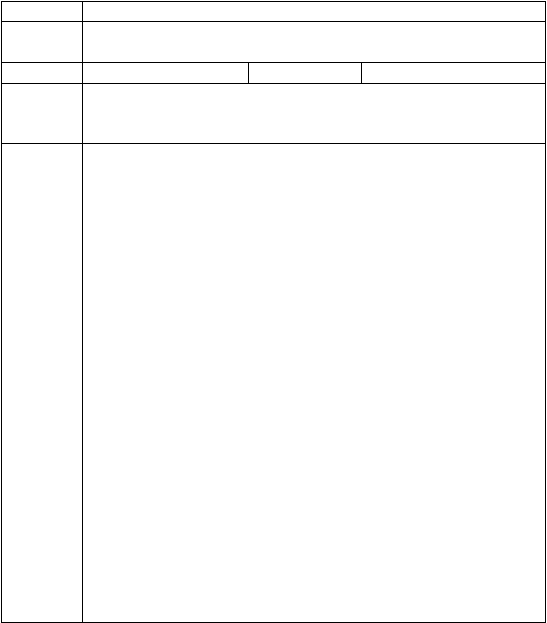
课题名称三维目标

重点目标导入示标

Unit 2 How often do you exercise ? Period 3 (Section B 1a-1e)
- 巩固how many 和 how much 的用法。
- 熟练掌握how often 引导的特殊疑问句。
难点目标

目标三导

学做思一：问题 1. 你知道日常生活中哪些食物是健康的吗？
【独立自学 1】
请将下列词汇归类。
milk apples cola chocolate French fries tea coffee pears oranges tomatoes
健康食物： 不健康食物：

它们中间可数名词是： 不可数名词是：
【互助共学】
请和搭档练习对话。
A: How often do you… B: …
A: Do you like it/ them ? B: Yes, I do . I think it’s good for my
health.

害)my health.
【思维向导 1】
No, I don’t. I think it’s bad for(对…有

  - 不可数名词无 形式，不需要在词尾加 或
。
  - 名词单数或不可数名词用代词宾格 替代，名词复数用代词宾格
替代。

学做思二：问题 2. 你知道how many 和 how much 的用法区别吗?
【独立自学 2】
Ⅰ. 请用how many 和 how much 填空。
- apples did you buy yesterday?

-  water do we need every day?
- milk do they drink every week?
- days are there in a year?
Ⅱ. 对划线部分提问。
- She has a cup of tea every morning.
does she have every morning?
- There were fifteen students in the classroom.
were there in the classroom?
- They bought four bottles of milk last week.
of milk did they buy last
week?
- The cook got a box of chocolate last month.
of chocolate did the cook get
last month?
【思维向导 2】
- 对可数名词的量提问要用 ，后接可数名词的 （单数∕复数）形式。
- 对不可数名词的量提问要用 ，后接不可数名词的原形。达标检测 I. 首字母填空。
- How m hours do you sleep?
- How o do you eat junk food?
- E is good for our health.
- I’m thirsty. I w to drink some water.
- Sleeping late is not good for your h .
II. 在空白处填入一个适当的词，使对话完整。
A: Hello, Tina! B: Hello, Bill!
A: How often do you eat vegetables and 1 ?
B : I eat vegetables every day and I eat fruit every day.
A : All right. So how many 2 do you sleep every night? B: Nine. I need lots of sleep.
A: Same. Nine. I need lots of sleep, too. How often do you 3 milk?
B: Oh, I love milk. I drink it every day.
A: What about junk food? 4 5 do you eat it? B: I love junk food. I eat it three or four times a week.
A: Yeah, I love it, too. I guess I eat it 6 or three times a week. And coffee? How often do you 7 coffee?
B: Oh, I drink coffee four times a day.

A: I 8_
drink coffee. It’s awful. Well, thank you for answering

反思总结
my questions very much. B: You’re welcome.
19. 知识建构


20. 能力提高
21. 课堂体验
课后练习
单项选择。
( )1. — are the Olympic Games held?
—Every four years.
A. When B. How often
( )2. — yogurt do you How often B. How
C. How soon
—Three
C.
D. How long
cups.
A.
need?
long
How
far
D. How much
( )3. Do you know I miss you?
A. how many B. how often C. how much D. how long
章节： 课时： 备课人： 二次备课人：
Unit 2 How often do you exercise

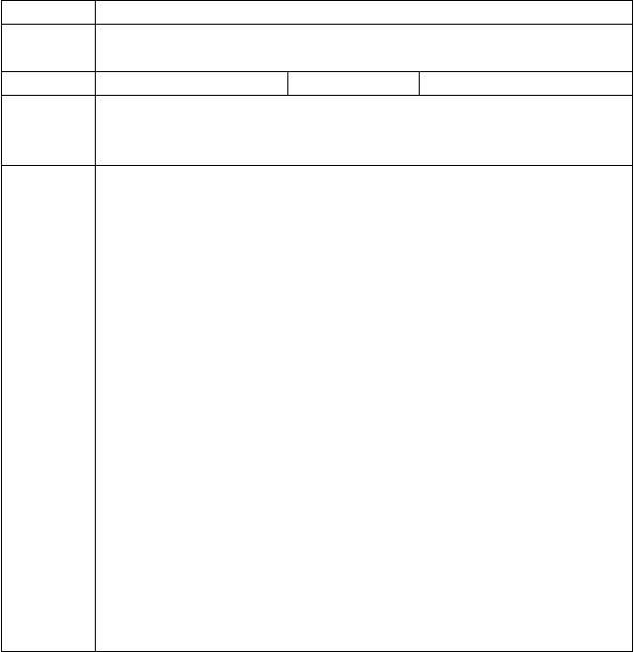
课题名称三维目标

重点目标导入示标

Unit 2 How often do you exercise ? Period 4 (Section B 2a-2e)
- 掌握百分数的英语表达法。
- 学会用 “寻读法”准确了解文章细节。
难点目标

目标三导
学做思一：问题 1. 你知道活动调查的基本要素吗？
【独立自学 1】
- 请快速阅读 13 页 2b，圈出百分数和表频率的短语。百分比：
频率短语：
- 请完成 2b 图表。
【思维向导 1】
- 百分比的英语表达为 数词+percent。当百分比作主语时，谓语动词的单复数由of 后面的 决定。
- 短语 one to six times 中, to 的意思为“到”，短语 one or six times
中, or 的意思为“或者”。
“ 每周 1-3 次” 表达为 ，“ 每周四次或五次” 表达为
。

学做思二：问题 2. 你会用 “寻读法”了解文章细节吗？
【独立自学 2】
- 阅读课文,把下列短语的英文和中文搭配起来并朗读这些短语。
( ) 1. ask students about… A. 开始锻炼
( ) 2. not….at all B. 与某人度过时光
( ) 3. use it for fun C. 通过做某事
( ) 4. be surprised D. 例如，像
( ) 5. the answer to E. 根本不，一点不


( ) 6. at least F. 问学生关于某事
( ) 7. the most popular G.. 做某事最好的方法
( ) 8. by doing sth H. 最受欢迎，最流行
( ) 9. the best way to do sth I . 至少
( ) 10. such as J. ……的答案
( ) 11. spend time with sb K. 对……惊奇
( ) 12. start exercising L. 用它来玩
- 仔细阅读课文，判断下列句子正（T）误（F）。
( ) 1. We can read the article in a magazine.
( ) 2. Twenty percent of the students exercise one time or three times a week.
( ) 3. Many students like to go online. ( ) 4. Most students watch TV every day
【思维向导 2】
判断正误型阅读要用寻读法在 中找出与 相 关 的段落与词句，那些意思基本相符但仍有一点不符的应判定为 。学做思三：问题 3.你知道频率副词相对应的百分比吗？
【独立自学 3】
- 请写出你所知道的频度副词。

- 将频度副词和短语与百分比对应起来。

always | 0％ | every day
usually | 20％ | four to six times
often | 40％ | Three or four times
sometimes | 60％ | one to three times
hardly ever | 80％ | once or twice
never  达标检测 I. 单项选择。 | 100％ | not…at all
( ) 1. Lucy is very fat because she exercises and eats a lot.
A. often B. always C. usually D. never
( ) 2. Forty-five percent of the students from China.
A. is B. are C. am D. be
( ) 3.“60％of the students like reading.” means “ students like reading.”
A. All | B. most | C. Some | D. No.
( ) 4. 400 is  A. one forty | of 1000.  B. forty percent | C. one fortieth | D.
fourth percent II 完成句子。
- 百分之二十根本不锻炼。
percent do not exercise .
- 我们很惊讶百分之九十的学生每天都要使用网络。
We were surprised that of the students use the

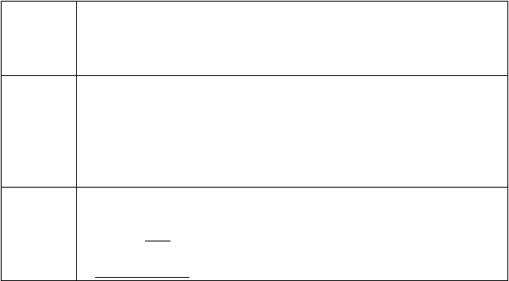
反思总结
Internet every day.
3. 百分之十三的学生每周看电视四到六次。
Thirteen percent watch TV
a week.
22. 知识建构
23. 能力提高
24. 课堂体验
课后练习
句型转换。
- Lucy usually cleans the cage every two days. （对划线部分提问）
does Lucy usually clean the case?
- Bruce has art lessons twice a week. （对划线部分提问）
does Bruce have art lessons?
章节： 课时： 备课人： 二次备课人：

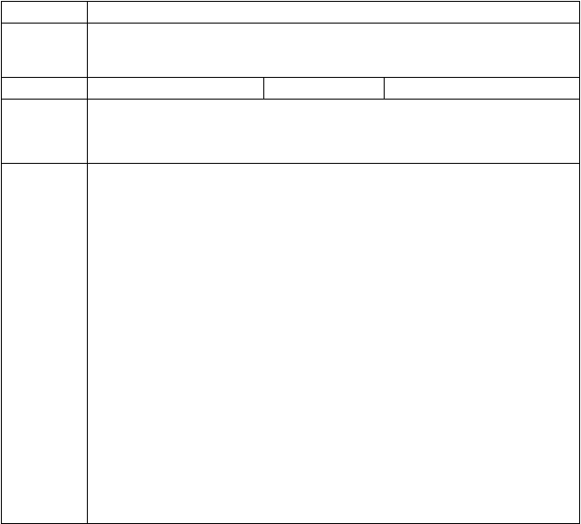Unit 3 I’m more outgoing than my sister
课题名称
三维目标

重点目标导入示标
Unit 3 I’m more outgoing than my sister. Period 1 (Section A 1a-2d)
- 初步认知描述人物特征的词汇并能够分类。
- 初步认识并掌握形容词和副词比较级的规则变化。
- 初步学会运用比较级描述人物特征并对人物进行比较。
难点目标
目标三导
学做思一：问题 1. 你知道从哪些方面描述人物特征吗？
【独立自学 1】
描述外貌特征的词汇：
tall
描述性格特征的词汇：friendly
描述动作特征的词汇：jump high
【思维向导 1】
我认为用英语描述人物可以从 、 和 这三方面进行描述。
学做思二：问题 2.你知道形容词和副词比较级的构成规律吗？

tall | work hard | friendly | short hair | short | smart
lazy
long hair | shy | jump high | thin | run fast | quiet
heavy | funny get | up early

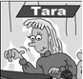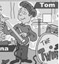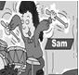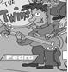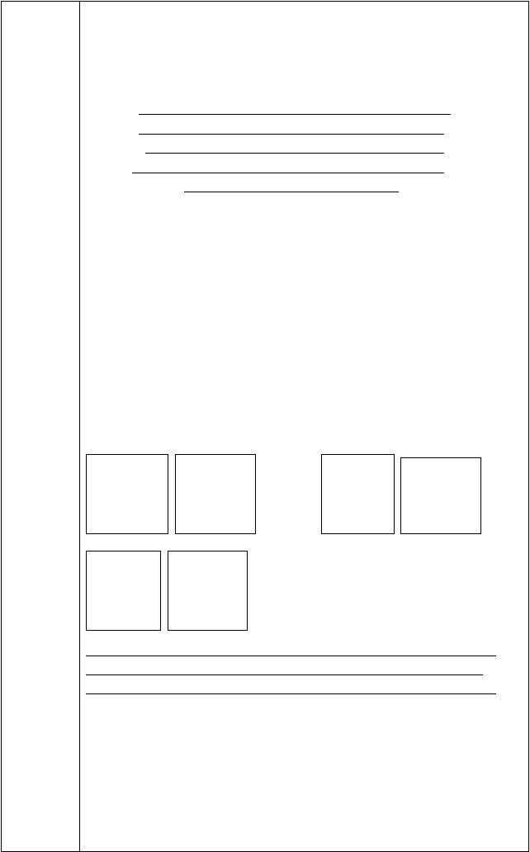【独立自学 2】
仔细看看这些单词的比较级有什么规律，根据这些规律试着帮他们找到自己的家吧！
taller, shorter, heavier, thinner, shier, more outgoing, cuter, more athletic, fatter, longer, nicer, bigger, more beautiful, wiser taller，
cuter， thinner， shier，
more athletic，
【思维向导 2】
根据以上单词比较级变化的规则，我们把形容词和副词比较级的规则变化可总结成口诀：
比较级，要变化，一般词尾加 。 词尾若有哑音e，直接加 就可以。
遇到重读闭音节，辅音字母要 。 辅音字母若加y, 记得把y 变为
。
多音节，词不变，前面加 很关键。

学做思三：问题 3. 你知道如何用比较级描述人物特征并对人物进行比较吗？
【互助共学】
请和搭档一起根据图片内容描述这三对双胞胎，并适当补充拓展。
What are the differences between Tara and Tina/ Tom and Sam/ Pedro and Paul?

【思维向导 3】
通过语言实践发现：
- 描述人物高矮胖瘦，通常用 词；描述人物性格特征，通常用
词；描述人物的动作特征，通常用 词。
- 比较级句子的特点是：句子中通常有表比较的标志词 ，形容词和副词用 （原级/比较级/最高级）。
- 描述两者特征或行为相同时，需用同级比较的句型是：as+形容词或副词原级+as…

例如：Tom 与 Sam 一样高。

Tara 与 Tina 学习一样努力。

达标检测 I. 写出下列形容词和副词的比较级。

- wild
4. healthy
II. 句型转换。
- rude
5. popular
- hot

  - Tara is tall. Tina is short. (合并为一句) Tara is Tina.
  - Peter runs slowly. Paul runs fast. (合并为一句） Paul than Peter.
  - Sam has longer hair than Tom. (同义句)
Sam’s hair is than .
  - I am shy. She is shy, too. (同义句)
I am as she is.
  - Dad works hard. Mum works hard, too. (同义句) Mum as as Dad.

反思总结

课后练习
- 知识建构

- 能力提高
- 课堂体验单项选择
( ) 1. Now telephones are very popular and they are much than
before.
A. cheap B. cheaper C. cheapest D. the cheapest ( ) 2. —Who did English homework better, Leo or Nick?
—Leo was more careful. I think Leo did Nick.
A. as good as B. as well as C. better than D. worse than

章节： 课时： 备课人： 二次备课人：

Unit 3 I’m more outgoing than my sister

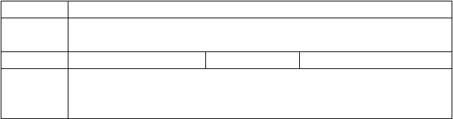
课题名称三维目标

重点目标导入示标

Unit 3 I’m more outgoing than my sister. Period 2 (Grammar Fou-c3sc)
- 进一步掌握含有比较级的一般疑问句和特殊疑问句结构。
- 学会用比较级描述自己过去和现在的变化。
难点目标

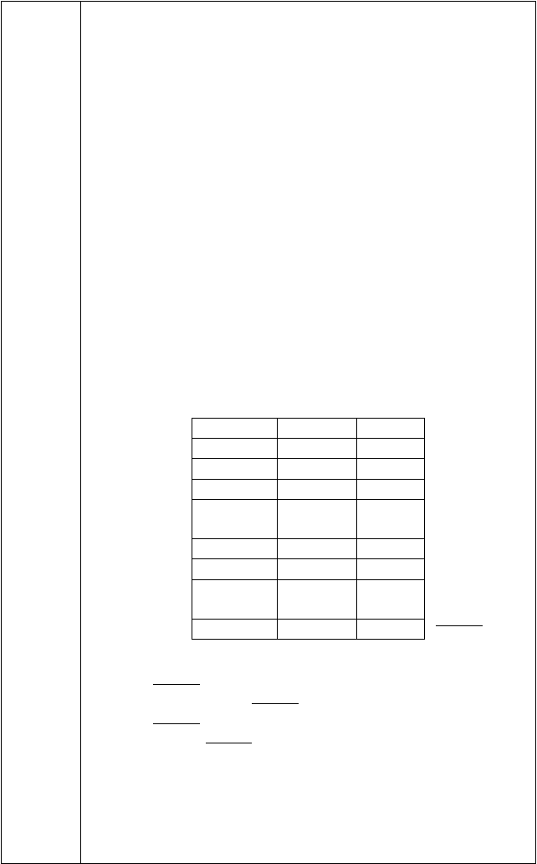
目标三导 学做思一：问题 1. 我们在上一节课中初步认识了形容词和副词的比较级，你知道如何对含有比较级的句子进行提问吗？
【 独 立 自 学 1 】I．请写出下列句型的一般疑问句形式。
  - Tom is smarter than Sam.
Tom than Sam?
  - You are as friendly as your sister.
you as as your sister?
  - Tara works as hard as Tina.
Tara as hard as Tina?
  - Peter got up earlier than Paul yesterday.
Peter up earlier than Paul yesterday?
  - Tom can run faster than Sam.
Tom faster than Sam?
【思维向导 1】
通过以上的语言实践，观察每个问句的第一个词，我们发现：句子中如果有 或 ，就将他们提到句子前面，句子末尾打 号。句子中如果是实意动词，就根据时态在句子前面加 、 或 ， 句子中的动词用 ，句子末尾打 号。
【互助共学】
请和你的搭档根据图表内容及下面的举例进行问答。
可供选择 |  | Sam | Tom
smart |  | ★★★ | ★
tall |  | ★★★ | ★
run fast |  | ★ | ★★★
get  early | up | ★★★ | ★★★
thin |  | ★ | ★★★
funny |  | ★★★ | ★
hard-worki ng |  | ★★★ | ★
friendly |  | ★ | ★★★

A: Is Sam smarter than
Tom?
B: Yes, he is.
B: Is Tom smarter than Sam?
A: No, he isn’t. Sam is smarter than Tom. A: Who is smarter, Sam or Tom?
B: I think Sam is smarter than Tom.

...
学做思二：问题 2. 你知道怎样用比较级描述自己的过去和现在的变化吗？
【独立自学 2】
请用所给词的正确形式填空并完成句子。
- I (be) short two years ago. I (be) tall now.

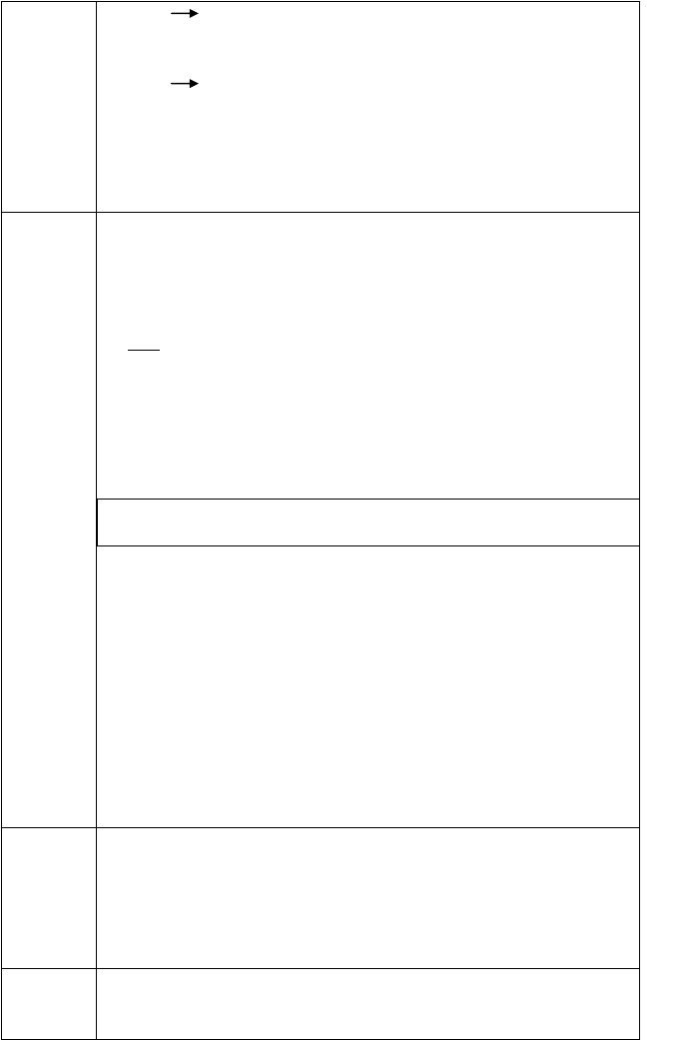I am now than I was two years ago. (tall)
- I (get) up at 7:30am two years ago. I (get) up at 6:30 am now.

【思维向导 2】
I get up than before. (early)

- 当我们描述过去的动作或状态时，要用到 时态。
- 当我们描述现在的状态时，要用到 时态，还可以用
把过去和现在相比较。但当我们不作比较时用形容词和副词的
。达标检测 I．句型转换。
- Sam is smarter than Tom. (改为一般疑问句)
Sam than Tom?
- Sam works harder than Tom. (改为一般疑问句)
Sam harder than Tom?
- Tina runs faster than Tara. (对划线部分提问)
faster than Tara?
- Mom is busier than Dad. (改为选择疑问句）
is busier, Mom Dad?
- Ella’s hair is blacker than mine. (同义句) Ella has hair than . Ⅱ. 选词填空。
am, get, busier, harder, was, got, taller, more, thin, more popular

Two years ago, I was a primary school student. I 1 a short and quiet girl with glasses. I 2 up at 7:30 in the morning. And I did well in Chinese and math. I had much time to play or watch TV with my grandpa at night. Now, I 3 a middle school student. I am as 4 as before. But I am 5 now than I was two years ago. I become an outgoing girl. So I make
6 friends and I’m 7 at school now. As for study, I am 8 than before. I usually 9 up at
6 o’clock in the morning. I have no time to watch TV or chat with my parents. I have too much homework to do at night. I work 10 than before. Life is busy. I am tired but happy.
反思总结 28. 知识建构

- 能力提高

- 课堂体验

课后练习
单项选择
( ) 1. — Which colour do you like , blue or green?— Blue.
A. good B. better C. best D. the best

(
) 2. The more you smile, the you will feel.
A. happy B. happier C. happily D. more happily
章节： 课时： 备课人： 二次备课人：

Unit 3 I’m more outgoing than my sister

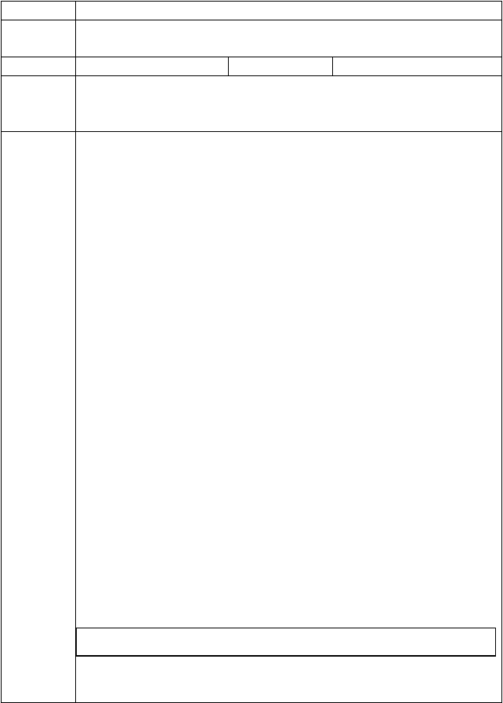
课题名称三维目标

重点目标导入示标

Unit 3 I’m more outgoing than my sister. Period 3 (1a-1e)
- 学会并运用相关语汇表达自己的择友观。
- 学会用both 和比较级描述朋友之间的相似点和不同点。
难点目标

目标三导

学做思一：问题 1. 在选择朋友时，你知道用哪些语汇表达自己的择友观吗？
【独立自学 1】请翻译下列短语。
- 在……方面有天分 talented in…
- 擅长体育 good sports
- 是一个好的听众 a good
- 受人欢迎 popular
- 做同样的事 do thing
- 真正关心我 truly me
- 保守秘密 secrets
- 使我笑 me laugh
【互助共学】
请和你的搭档根据 1a 的短语和 1b 的句型，讨论并分享各自的择友观。A: I think a good friend is…
B: For me, a good friend likes…
【思维向导 1】
在表述自己的择友观时，用到行为动词要注意 和 的变化；用到形容词不要忘记与 连用，构成系表结构。

学做思二：问题 2. 你知道怎样描述朋友之间的相似点和不同点吗？
【独立自学 2】
- 请翻译下列句子，学会描述朋友之间的相似点。
  - 他和我都高。 He tall. I tall, too.
→We both tall. = of us tall.
  - 她和我都爱好运动。 She sports. I sports, .
- We sports.= of us sports.
Ⅱ.请选择方框中的词并用其正确形式填空，学会描述朋友之间的不同点。
fast friendly good long old

- Lily has hair than me.
- My best friend likesrunning. He runs than the others in his

class.
- Linda is ten years old. I am nine years old. So Linda is than me.
- Tony is than before, so he has more friends.
- Sandy is at playing basketball than me.
【思维向导 2】
- 我们可以从 、 和 方面来描述介绍朋友之间的相似点和不同点。
- both 表示 都。
We both have black eyes. We are both Chinese. We can both speak Chinese and English.
观察上面三个句子，both 做副词，用于 动词前， 、 之后。想一想，both 做连词，both…and…连接的主语，谓语动词用单数还是复数呢？

达标检测 I．翻译句子。
- 我们俩都有黑眼睛。
We black eyes.
= have black eyes.
- 我父母都是教师。
My parents teachers.
= my parents are teachers.
= my parents are teachers.
- 莉莉和露西会游泳。
Lily and Lucy swim.
= them can swim.
= Lily Lucy can swim.
- 我比我朋友更擅长英语。
I at English than my friend.
- 我朋友比我更擅长语文。

My friend in Chinese than I.
Ⅱ. 短文填空。
My name is Mary. This is my best friend Tina. She likes to do the
1 things as me. We 2 like swimming. But Tina is 3
at swimming than me, so she always wins.
However, there are some 4 between us. Tina likes reading, and she studies 5 than me. When we study together, she often
6 me with my schoolwork. So I’m 7 better grades than before.
In a word, I’m so lucky to have a good friend 8 Tina.
Ⅲ. 将下列关于择友观的谚语配对。

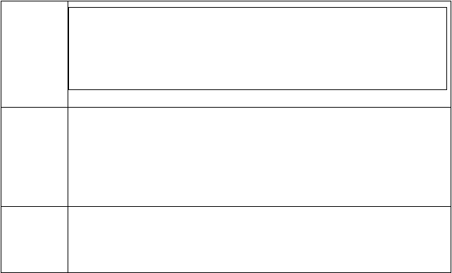
- A friend is easier lost than found.
- Doing is better than saying.
- Two heads are better than one.
- A friend in need is a friend in deed.
- 会说不如会做。
- 两人智慧胜一人。
- 朋友易失不易得。
- 患难朋友才是真正朋友。
反思总结
31. 知识建构
32. 能力提高
33. 课堂体验
课后练习
- Mike is 14 years old. David is 12 years old. (合并为一句)
Mike is 2 years David.
- Peter is 1.9 meters tall. Michael is 1.9 meters tall, too. 同( 上 ) Michael is as Peter.
章节： 课时： 备课人： 二次备课人：

Unit 3 I’m more outgoing than my sister

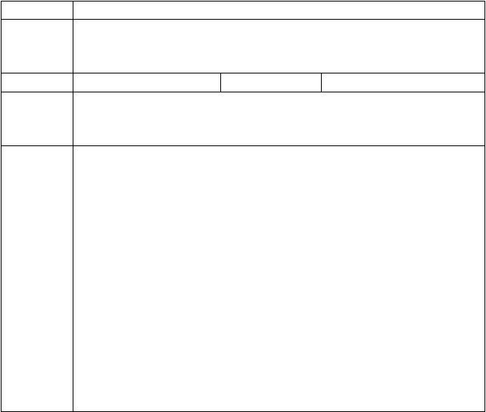课题名称三维目标

重点目标导入示标

目标三导

Unit 3 I’m more outgoing than my sister. Period 4 (Section B2a-2e)
- 熟练掌握如何描述朋友之间的相似点和不同点。
- 通过阅读文章进一步了解不同的交友观，并训练学生略读、扫读和精读的技能。
难点目标

学做思一：问题 1. 你熟练掌握了描述朋友之间的相似点和不同点的短语和句型了吗？
【 独 立 自 学 1 】1．请将下列单词和短语归类。
tall, hard-working, run fast, quiet , serious, jump high, short, smart, funny , like reading, outgoing, heavy, friendly, like sports, thin, popular, be good at tennis, have long curly hair, study hard, shy, cool, sing well, lazy, get up early, have short straight hair, do well in swimming
① What do people look like?

② What are people like?

③ What do people do?

2. 请用以上的单词和短语写出你和好朋友之间的相似点和不同点各两句。注意使用：both, than, as…as, the same as…, be different from…
①

②

③

④

学做思二：问题 2.你了解不同人有各自不同的交友观吗？
【独立自学 2】
- 请略读 2b，将文章中出现的比较级表达划上下划线。
- 请扫读 2b，将三篇短文中出现的关于友谊的谚语摘抄下来。
①

②

③

④

- 请细读 2b，通过精读，翻译下列词组或句子。
①交朋友 friends
②只要…… long ...
③交朋友对我而言不容易 is not easy me make friends.
④没有必要一模一样。It’s not to be .
⑤Larry 与我很不相同。Larry quite different me.
⑥Larry 更不努力。Larry much hard-working.
⑦她比我知道的任何人都要有趣。She is than I know.
⑧我们能够谈论和分享一切。We can and everything.
【思维向导 2】
英语阅读策略有三种阅读技能：略读 (skimming ) 、扫读 (scanning)
和精读(intensive reading)。
“略读”是一种浏览性阅读。要求我们以最快速度浏览阅读材料。通过快速通读全文抓住 ，从而对阅读材料的内容进行总的理解。
“扫读”是一种跳跃阅读。要求我们有目的地查找信息，无需认真阅读全文，只需找到信息所在的段落，了解细节。利用这一技巧进行阅读时，我们要寻找阅读材料的 。


“精读”是一种细嚼慢咽地读。要求我们毫无遗漏地仔细阅读全部语言材料并获得对词汇、句式的学习和运用。我们通过精读，学习 。
达标检测 I．同义句转换。
- I am as old as he.
I have the same he.
- This TV play is more exciting than that one. That TV play is than this one.
- Larry is less hard-working than me. I am than Larry.
- Larry is less hard-working than me.
Larry isn’t hard-working me.
- I am louder than the other kids in my class. I am louder than in my class.
Ⅱ. 阅读理解。
Lily and Lucy are twins. They are in the same school. In some ways, they are the same, and in some otherways, they are different. Lilyis as tall as Lucy, but Lucy has longer hair than Lily. Lucy is friendlier than Lily, so she has more friends than Lily. Both of them enjoy playing tennis, and they practice together every. But Lily plays tennis better than Lucy, so Lily usually wins.
根据短文内容，判断下列句子的正（T）误（F）。
- Lily and Lucy are in different schools. ( )
- Lily isn’t as tall as Lucy. ( )
- Lily has more friends than Lucy. ( )
- Lily and Lucy enjoy playing tennis. ( )
- Lucy usually beats Lily in tennis. ( )

反思总结

课后练习
- 知识建构

- 能力提高
- 课堂体验单项选择
( ) 1. Taking buses in Beijing is than taking a taxi.

A. more cheap B. much cheaper C. a little cheap D. cheapest
( ) 2. — Health is money. — But I think it is money.
A. as important as B. more important than
C. so important than D. the same as
章节： 课时： 备课人： 二次备课人：

Unit 4 What’s the best movie theater

课题名称
Unit 4 What’ s the best movie theater? Period 1 (Section A 1a-2d)

三维目标

重点目标导入示标

目标三导

达标检测
- 掌握形容词和副词最高级的规则和不规则变化形式。
- 学会正确使用最高级谈论喜爱的事物。
难点目标

学做思一：问题 1.你们知道形容词和副词最高级的变化形式吗？
【独立自学 1】
- 请你们将下列形容词和副词的最高级连接起来。
short boring new funny big close popular

newest most popular closest shortest most boring funniest biggest
- 请你们找一找查一查下面这些形容词和副词的最高级。
1. good/well 2. bad/badly/ill
3. many/much 4. far /
5. old / 6. little
Ⅲ. 请你们将下列最高级有着相同变化的形容词和副词分类填入对应横线中。important great tall cold beautifully exciting fine healthy busy large cute friendly hot wet thin
important， busy， large， tall， hot，
【思维向导 1】
1、形容词和副词最高级有 变化和 变化。
2、规则变化：
- 一般情况下，单音节或双音节的形容词（或副词)最高级加 。
- 以e 结尾的词最高级加 。
（ 3 ） 以辅音字母+y 结尾的变 为 再加 。
- 以重读闭音节结尾的形容词和副词， 最后一个辅音字母再加 。
- 多音节和部分双音节的词需要在形容词原级前加 构成最高级。
3、不规则变化：
good/well bad/badly/ill many/much
little far / old /
- 写出下列形容词的比较级和最高级。
  - big
  - cheap
  - popular
  - close

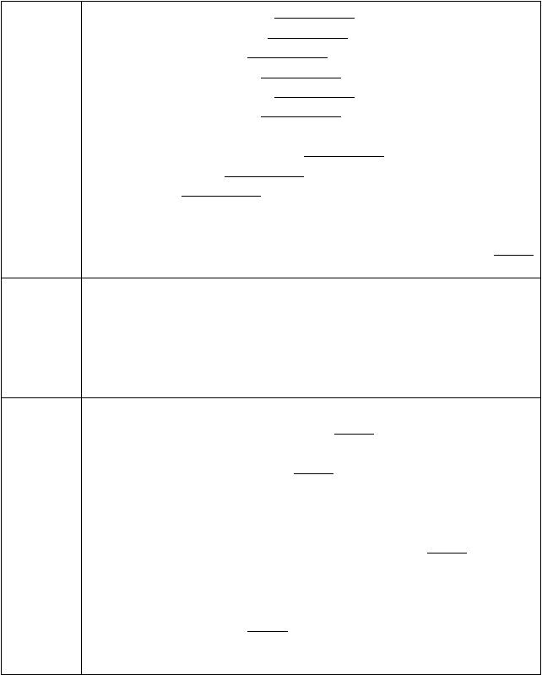
  - friendly
  - expensive
  - good
  - bad
  - boring
  - hot
- 用所给词的正确形式填空。
- The Yellow River is the second （long）river in China．
- I think English is （interesting）of all the subjects.
- Who is the （good）in physics in your class?
- All the movie theaters are good, but the Big Screen Complex has
（comfortable）seats.
- I don’t want to go to Jasper’s clothes store. It has the
（bad）clothes in town.
反思总结 37. 知识建构

- 能力提高

- 课堂体验

课后练习
单项选择。
( ) 1. Which of those radios sounds ? The smallest one.
A. good B. well C. better D. best ( ) 2. —Which student has got score, Frank, Spring or Thomas?
—Thomas, of course, he has got the full marks in the exam.
A. the lowest B. the least
C. the easiest D. the highest
( ) 3. Of all the subjects, chemistry seems to be for me.
A. difficult B. the most difficult
C. more difficult D. too difficult
( ) 4. What do you think of the film you saw yesterday?
—Oh. It’s one of films I’ve ever seen.
A. the most interesting B. more interesting
C. most interesting D. interesting

章节： 课时： 备课人： 二次备课人：

Unit 4 What’s the best movie theater

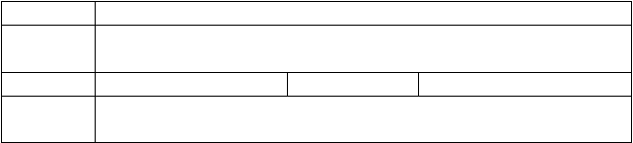
课题名称三维目标

重点目标导入示标

Unit 4 What’ s the best movie theater? Period 2 (Section A 3a-3c)
- 初步掌握形容词和副词最高级的用法。
- 能够正确使用形容词和副词最高级来比较事物并说明原因。
难点目标

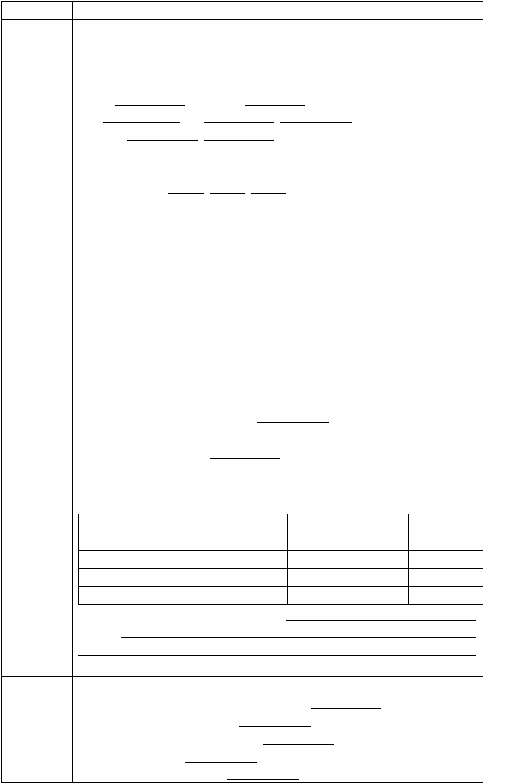
目标三导 学做思一：问题 1.你知道如何正确使用形容词和副词最高级吗？
【独立自学 1】
  - 请写出下列形容词或副词的最高级。
quiet nice
funny expensive
bad far / friendly /
comfortably quickly well
  - 根据汉语意思，完成下列句子。
- My uncle is (最受欢迎的) worker in his factory.
- Town Cinema has (最舒服的) seats.
- Which subject do you (最喜欢), English, Chinese or math?
- Bob is (最高的) boy in his class.
- Which is (最难的) of all the words?
- Bolt runs (最快) of them.
- Amy dances (最好) in our class.
【思维向导 1】
- 形容词最高级的前面一般要加 , 副词最高级前面可以省略
。
- 三者或三者以上之间进行比较时，常用的句型结构是：
“A + 系动词 + the + 形容词的 + 比较范围”，表示“A 在……中最……”。人或物之间的比较范围常用 引导的短语来表示，地点的比较范围常用 引导的短语来表示。

学做思二：问题 2. 你能在我们生活中正确使用最高级吗？
【独立自学 2】
请你结合下面表格，选出你认为最佳的服装店并说明原因。

Clothing  Store | Price | Quality | Service
Lining | ☆ | ☆ ☆ | ☆ ☆
Nike | ☆ ☆ ☆ | ☆ | ☆ ☆
Adidas | ☆ ☆ | ☆ ☆ | ☆ ☆ ☆ ☆
I think the best clothing store is Because

达标检测 | I. | 用所给词的正确形式填空。
 | 1. | Big Screen Complex has (comfortable) | seats of | all.
- Jasper’s has（friendly) service in the neighborhood.
- Funky Fashions has（expensive) jeans of the three stores.
- Jan had (funny) act in the talent show.
- Town Cinema has (loud) music with their movies in the

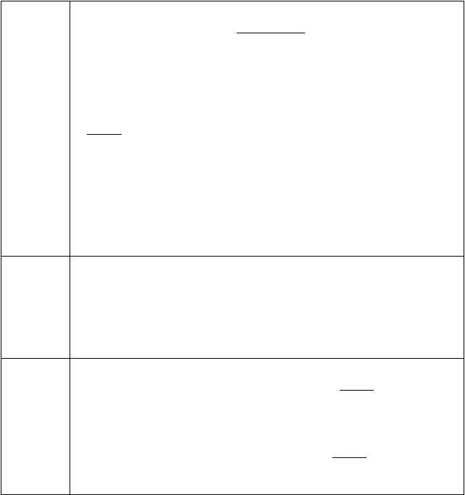town.
- He thinks his ice cream is (delicious) of all the food.
II. 句型转换，每空一词。
- Henry is taller than any other boy in his class. (改为同义句) Henry is boy in his class.
- Nobody is more beautiful than Lucy in our class. (改为同义句) Lucy is beautiful in our class.
- Dennis is the funniest performer. (对划线部分提问)
the funniest performer? 4.Bob is twelve and I am ten. (改为同义句) Bob is years than me.
5.The machine helps them to wash clothes. (改为一般疑问句)
the machine them to wash clothes? 6.太阳电影院有最舒服的座椅。（完成译句）
Sun Cinema has the seats.
反思总结 40. 知识建构

- 能力提高

- 课堂体验

课后练习
单项选择
( ) 1. Pudong International Airport is one of airports in the world.
A. big B. bigger C. biggest D. the biggest ( ) 2. —Did Kate do best in the final exam?
—No, but of all the students she did .
A. the most careful B. more careful
C. most carefully D. more carefully

章节： 课时： 备课人： 二次备课人：

Unit 4 What’s the best movie theater

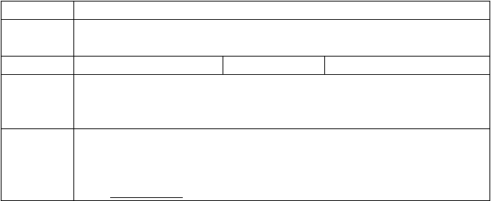
课题名称三维目标

重点目标导入示标

Unit 4 What’ s the best movie theater? Period 3 (Section B 1a-1e)
- 学会使用描述人物性格的形容词的最高级谈论他人。
- 能够正确使用who 引导的特殊疑问句作比较。
难点目标

目标三导
学做思一：问题 1.你知道哪些意义相反的形容词？
【独立自学 1】
- 请你选择出下列词的反义词。
  - loudest a. dullest

  - worst b. most boring
  - most interesting c. funniest
  - most creative d. worse quality
  - most serious e. best
  - better quality f. quietest
Ⅱ. 根据句意，选用方框中形容词的正确形式补全句子。
funny outgoing creative quiet dull

- Julie hardly talks, she is in my class.
- Zhou Xingchi is one of actors in China.
- Vera is person I know, she
won lots of prizes in the painting competition.
- The talent show is too boring and I think it’s
of all.
- One of boys in our school is
Jack.
【思维向导 1】
在表示“其中最……之一”的含义时，常使用“one of + + 形容词的 + 名词的 ”结构。

学做思二：你能正确使用who 的特殊疑问句对他人进行比较吗？
【独立自学 2】
请你们在班上做一个调查，并完成下列表格和对话。

Name
quietest funniest most
creative
most serious
loudest

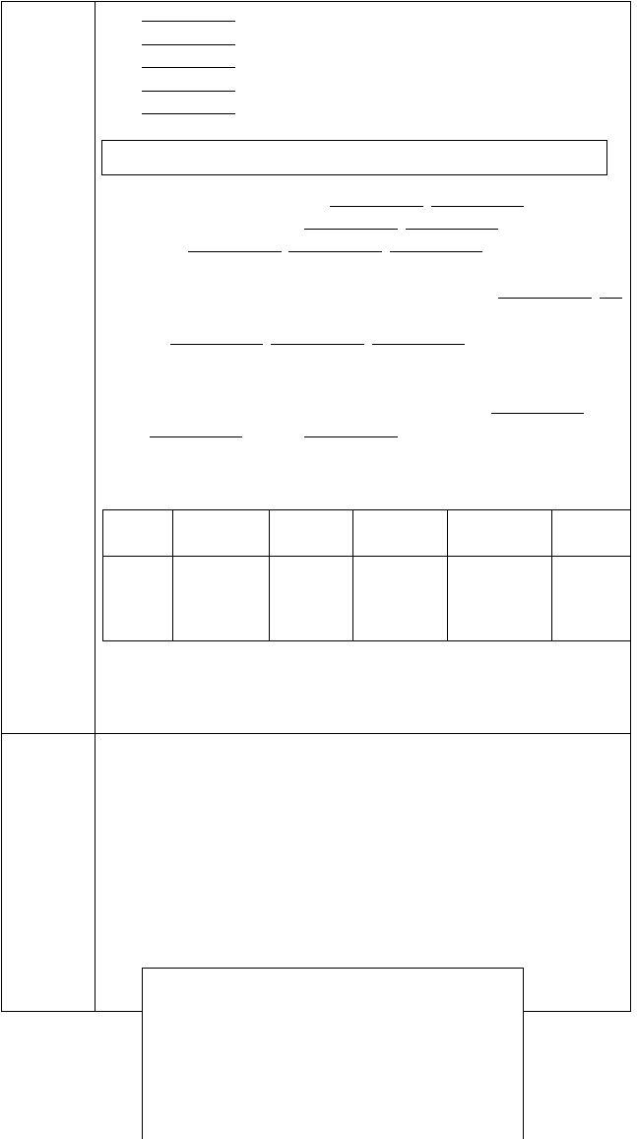

A: Who is the quietest person in your class you know? B: I think ...is the quietest person.
A: Why do you think so? B: Because he/she...
达标检测 I. 请你将下列句子正确连接起来。
- That restaurant has a. funniest performer
- Town Cinema has the cheapest b. movies
- You can buy cheap jeans at c. Dream Clothes
- He is the most popular d. student in our class
- Jim was the e. music
- That is the loudest f. the friendliest service
- 口语应用。
A: He is taller than any other basketball player. B: But I’m not the same as you.
- I like Lin Dan best.
- Which sport do you like best?
- Who is your favorite basketball player?
- I like badminton.
- You’re right.

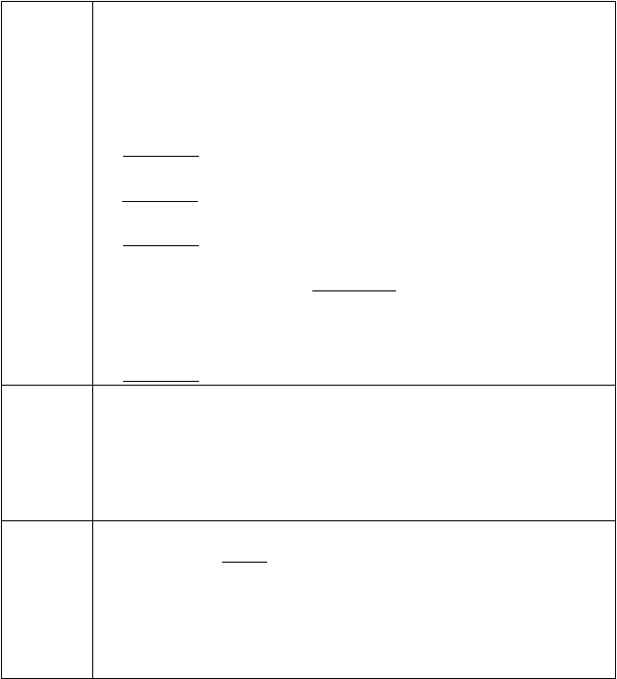
反思总结
A: 1
B: I like soccer best.
A: 2 I think basketball is more popular than the other ball games.
B: 3
A: Yao Ming. Don’t you know him?
B: Yes, I’ve heard of him. 4
A: By the way, what do you think of Chinese Men’s Badminton Team?
B: They are very great.
A: Which player do you like best? B: 5 He plays very well.
43. 知识建构
44. 能力提高
45. 课堂体验
课后练习
单项选择。
( )1. —Who is
running star in your college?
—I think Wu Tao is.
A. famous B. more famous
C. the most famous D. less famous
( )2. My father plays sports every day, so he is in our family.
A. strong B. stronger C. the strongest D. too strong
章节： 课时： 备课人： 二次备课人：

Unit 4 What’s the best movie theater

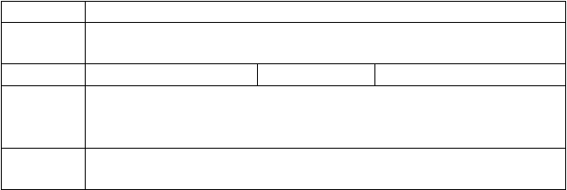
课题名称三维目标

重点目标导入示标

Unit 4 What’s the best movie theater? Period 4 (Section B 2a-2e)
- 通过调查表，熟练掌握形容词和副词的用法。
- 提升阅读能力、掌握抓取细节的技巧。
难点目标

目标三导

学做思一：问题 1. 你能正确运用形容词和副词的最高级吗？
【独立自学 1】

  - 请你完成下列调查表格并做简单报告。

Talents

The best so cer player The most talented dancer
The most interesting writer The fastest runner
The best singer
Classmates’
names

For

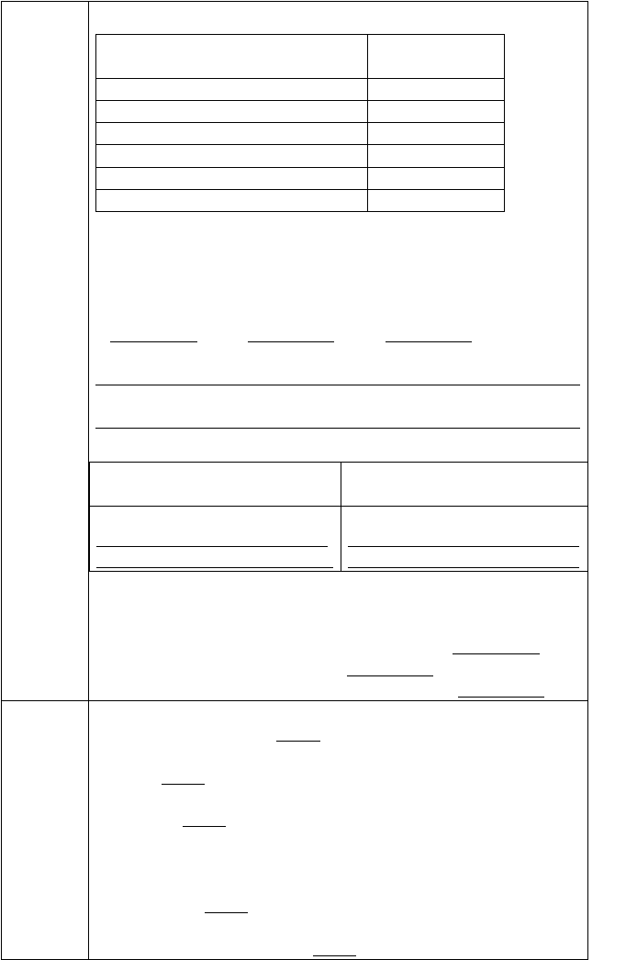
example: Lily is the funniest student in our class.

学做思二：问题 2. 你知道在阅读过程中有哪些技巧吗？
【独立自学 2】
- 请你找出文章第一段中出现的三个才艺节目名称。
1. 2. 3.
- 请你找出文章第二段中所出现的形容词和副词的最高级形式。

Ⅲ. 请你仔细阅读文章完成下列表格。

Why do some people like these Why do some people shows? not like these shows?

【思维向导 2】
我发现的阅读技巧：阅读理解题主要是考查学生通过阅读获取信息、分析信息和处理信息的能力，既要抓住文章的主旨，又要抓住 。细节理解题解题步骤：1. 读懂题干的要求或 ；2. 迅速浏览文章，找到细节出处；3.放慢速度，仔细核对比较内容，直至找到 。
达标检测 I. 单项选择。
( ) 1. Jasper’s is the store in our town.
A. better B. good C. best
( ) 2. radio stations，most people think that one is good.
A. As far B. As for C. As on ( ) 3. The flower store is Mary’s.
A. most popular B. popularest C. more popular
( ) 4. —What do you think of Funky Fashions?
—It has quality than Trendy Teens.
A. good B. better C. the best ( ) 5. —Who do you think is , Jim or John?


—John.
A. funny B. funnier C. the funniest II.阅读理解。
My town is a great place to live in. ’Its the best place to enjoy
your free time. There are three movie theaters in the town. They are all good, but the one nearest my house is the best. Shopping is also easy. There are many shops and most of them are in style. They sell very fashionable clothes. The prices are also cheaper than those in other cities, so students love to shop here. There are also a lot of video and music stores.
These are very popular with students. I go to the music store every week to buy a new CD. The most crowded place for students to hang out is the park. Everyone goes there, so it’s really interesting.
Sometimes there are even street performers. Some students think they’re boring, but I think they’re the most creative people.
( ) 1. The writer’s town is the best place of .
A. food B. having fun C. playing games D. swimming
( ) 2. The cinema nearest the writer’s house is .
A. the best B. the worst C. the most crowded D. the biggest
( ) 3. Most of the shops are .
A. expensive B. interesting C. fashionable D. out of style
( ) 4. For students, the most crowded place to hang out is .
A. the shop B. the music store C. the cinema D. the park
( ) 5. The writer thinks street performers are .
A. boring B. creative C. funny D. fashionable

反思总结 46. 知识建构

- 能力提高

- 课堂体验

课后练习
单项选择。
( ) 1. Which language is to learn, English, French, or Chinese?
A. difficult B. more difficult C. the difficult D. the most difficult
( ) 2. Shu-How Lin is one of basketball players in the NBA.
- popular B. more popular C. the most popular

章节： 课时： 备课人： 二次备课人：
Unit 5 Do you want to watch a game show

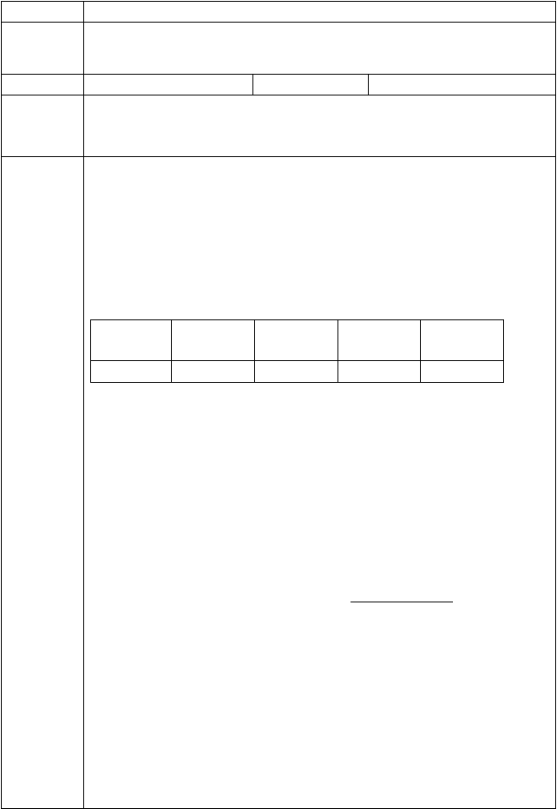课题名称三维目标

重点目标导入示标

目标三导

Unit 5 Do you want to watch a game show? Period 1 (Section A1a-2d)
- 掌握有关电视节目名称的单词及短语。
- 能够正确表达对电视节目的喜好及理由, 并掌握询问事物看法的句型。
- 学会根据自己对电视节目的喜好，拟定计划。
难点目标

学做思一：问题 1.你知道哪些丰富多彩的电视节目呢？
【独立自学 1】
翻译下列电视节目。

  - 脱口秀
3. 运动节目
5. 肥皂剧
  - 情景喜剧
- 游戏节目
- 新闻

学做思二：问题 2.你知道怎样表达对电视节目的喜好吗？
请仔细阅读 1c, 根据自己的喜好，填上相应的面部表情图标。

Talent shows
Sports shows
Game shows Talk shows Soap
operas

【互助共学】
请根据上图表，完成对话。
A: What do you think of talent shows? B: I them.
A: How do you like ? B: I them.
【思维向导 2】
  - 询问电视节目类别时应该用 （单数/复数）形式,回答时代词用 ，news 除外。
  - 询问别人对事物看法的句型有哪两种？
(1)
(2)
  - 回答对电视节目喜好的单词或短语可以有

学做思三：问题 3.你能根据对电视节目的喜好拟定计划吗？
【独立自学 3】
请独立思考下列词组的译文。

- plan to do sth
- like to do sth

- expect to do sth sth
- hope to do

【互助共学】
请和搭档一起完成对话。
A: Do you like to watch soap operas? B: No,they are boring.
A: How about ?
- I love it.
A: So, do you watch news tonight? B: Yes. I watch it every night.
A: Why?
B: Because I find out what’s happening around the world.
【思维向导 3】
通过语言实践发现：
对话中用 表示计划做某事。达标检测 I. 用所给词的正确形式填空。
- I like soap (opera).
- He doesn’t like (sitcom).
- I don’t mind (walk) there.
- How about (make) a meal?
- What do you think of (sport) shows?
II. 完成下列句子。
- She likes game shows. (改为一般疑问句）
she game shows?
- I mind his words. (改为否定句)
I his words.
- What do you think of soup operas? (改为同义句)
do you soup operas?
- I don’t like talk shows because they’re boring. (对划线部分提问)

反思总结

课后练习
you like talk shows?
- 今天晚上我计划看卡通片。我希望放松自己。(完成译句)
I watch cartoons tonight. I
relax myself.
- 知识建构

- 能力提高
- 课堂体验单项选择。
( )1. do you think China’s education?
A. How, like B. What, of C. Where, of D. Who, about
( )2. — they want to go fishing? —Yes.


A. Are
B. Do
C. Does
D. Is
( )3. —You are relaxing yourself here?
—Yes. It feels to walk slowly along the river.
A. fantastic
terrible
B. boring
C. strange
D.

Unit 5 Do you want to watch a game show

课题名称三维目标

重点目标导入示标

Unit 5 Do you want to watch a game show? Period 2 (Grammar Focus-3c)
- 熟练掌握动词不定式作宾语的用法。
- 正确使用动词不定式表达对电视节目的计划和愿望。
难点目标

目标三导
学做思一：问题 1.你知道动词不定式吗？
【独立自学 1】
你能将下列词组翻译成英语吗? 计划做某事 希望做某事 期盼做某事 想要做某事
【思维向导 1】
- 以上词组中都有 的形式，他们都跟在
之后，被称做 。
- 英语中动词不定式是由 + 构成，以上动词不定式充当 成分。
- 及物动词后面直接带不定式作宾语的还有:

学做思二：问题 2.你能正确使用不定式作宾语表达对电视节目的计划和愿望吗？
【互助共学】
与同伴编对话，练习不定式的用法。
A: What do you plan to watch on TV tonight？
B: I hope to , but I also want to .
How about you? Do you a talk show or ?
A: Oh, I want to . B: Why do you want to ?
A: Because I expect
to .
【思维向导 2】


我发现的用法：
在以上练习中，用 拟定观看电视节目的计划和愿望。
达标检测 I.用所给词的正确形式填空。
  - Betty, we need (make) a plan.
  - Please remember (post) the letter for the old man.
  - What bad weather! I hate (go ) out on cloudy days.

  - We planned (make) a school radio programme.
  - I like (follow) the story and (see) what happens next.
- 单选题。
( )1. Remember the letter to me.
A. sending B. sends C. to send
D. send
( )2. English is important to us. We should try it hard.
A. study B. studies C. studied
D. to study
( )3. I would like with you forever.
A. to stay B. stay C. stayed
D. staying
( )4. Daming needs more English in and out of class.
A. speak B. spoken C. to speak D. speaking
( )5 Every student should try the people in trouble.
A. help B. helps C. helped D. to help
Ⅲ. 完成对话。

A: What do you think of soap operas? B: Well, I like sports shows.
- I watched TV.
- He didn’t mind.
- I don’t mind them, but I really like game shows.
- Yes, I do.
- Do you like them?

A: What did you do last Saturday evening, Jack? B: 1
A: Do you often watch TV?
B: 2 I like watching TV very much. A: What shows do you like?
B: 3 But I don’t like talk shows. I think


they are boring. What about you? A: 4
B: Great! 5
A: Soap operas? They are awful! I can’t stand them. B: Me, neither.
Ⅳ.短文填空。
Dear Wang Lin,
It’s very helpful to know something 1 the British meals before traveling. In many houses, peopleeat four 2 a day. They are breakfast, lunch, after tea and 3 .Breakfast 4 at any time from 7:00 to 9:00 in the morning. They usually have eggs ,bread with butter, cheese and so on. English people 5 tea or coffee at breakfast. Lunch comes at one o’clock. It can be a hamburger or a three-course(三道菜) meal. Afternoon tea is 6 4:00 pm and 5:00 pm. Dinner begins at about half past seven. The next is often meat or fish with7 .Then come fruits of different kinds: apples, pears, bananas and so on. But not all English
people eat 8 that . Some of them have their dinner in the 9 of the day. Their meals are breakfast, dinner, tea and supper. And all these meals are 10 simple.
Wish you a good time in England!
反思总结 52. 知识建构

- 能力提高

- 课堂体验

课后练习
单项选择。
( )1. I’d like friends on Sunday .
A .visit B to visit C visiting D visits
( )2. It takes her 2 hours her homework.
A. finish B. finishing C. finished D. to finish
( )3. Ann always helps me my English.
A. with B. do C. to do D. above all

Unit 5 Do you want to watch a game show

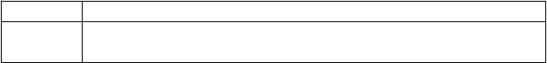
课题名称三维目标

Unit 5 Do you want to watch a game show? Period 3(1a-1d)
- 能够熟练掌握描述电视节目及电影的形容词。
- 学会描述他人对电视节目及电影的喜好及原因。

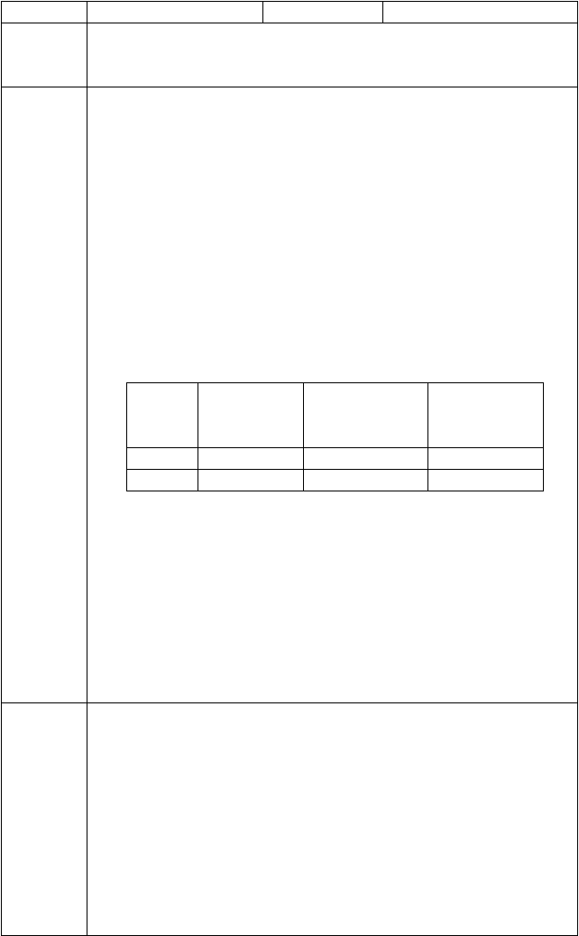重点目标导入示标
难点目标

目标三导 学做思一：问题 1. 你能用哪些形容词来描述电视节目和电影类型呢？
【独立自学 1】
翻译下列词组和句子。
  - 有教育意义的卡通片
  - 轻松的喜剧
  - 无意义的恐怖片
  - 无聊的才艺秀
  - 刺激的动作片
  - 精彩的体育新闻 你还知道哪些呢？

学做思二：问题 2. 你能描述他人对电视节目或电影的喜好和理由吗？
【独立自学 2】
根据表格信息，描述Tom 和 Bob 对电视节目和电影的喜好和理由。

Comedies
Talk shows
Action movies

Tom Bob
exciting interesting
enjoyable meaningless
boring wonderful

Tom and Bob are middle school students. Tom loves comedies very much. He thinks they’re very . He also likes talk shows because they’re kind of . But he can’t stand . He finds them kind of boring. Bob’s favorite is comedies because they are . He likes action movies, too. He thinks the’y re . He doesn’t like talk shows because he thinks they’re so .
【思维向导 2】
描述他人对电视或电影的喜好时，喜欢可用 （褒义/贬义）形容词，如： 等；不喜欢可用 （褒义/贬义）形容词，如： 等。
达标检测 I. 完成下列句子。
- 我认为这部动作片非常令人激动。
I think the action movie really .
- 他一点儿都不喜欢纪录片，他认为很无聊。
He doesn’t like documentaries because he thinks
.
- 我妈妈喜欢看访谈节目，因为很有教育意义。
My mother likes to talk shows, because
.
- 你为什么喜欢看新闻？
do you like ?

以上内容仅为本文档的试下载部分，为可阅读页数的一半内容。如要下载或阅读全文，请访问：https://d.book118.com/255041230134011111

