上海市奉贤区2024届高三一模英语试题（含听力）
学校:___________姓名：___________班级：___________考号：___________

一、听力选择题
1．
A．At an airport.
B．At a hotel.
C．At a cinema.
D．At a station.
2．
A．Husband and wife.
B．Customer and waitress.
C．Guest and hostess.
D．Boss and employee.
3．
A．The man is fond of travelling.
B．The woman is a photographer.
C．The woman took a lot of pictures at the contest.
D．The man admires the woman’s talent in writing.
4．
A．Go home soon.
B．Borrow the typewriter.
C．Visit the woman.
D．Read the woman’s paper.
5．
A．The books there are too expensive.
B．The textbook she needs isn’t in yet.
C．She won’t be able to get the book before class.
D．She prefers to go to the bookstore at 9 o’clock.
6．
A．They won’t celebrate mother’s birthday.
B．They’ve already got plenty of wine.
C．They cannot buy whatever they need.
D．They’ve got enough gifts for the party.
7．
A．The woman will have a test.
B．The man will probably go to the movie.
C．The man will have to sit for an exam.
D．The woman wishes to go to class with the man.
8．
A．The results haven’ t come yet.
B．The results were checked again last night.
C．The woman needs another test tomorrow.
D．The doctor hasn’t come back from the lab.
9．
A．Most neighbors are as noisy as the woman.
B．Dealing with it politely might be a better solution.
C．He can’t understand why the woman is so angry.
D．The woman is too impolite for her neighbors.
10．
A．She always buys new clothes to keep up with the latest fashion trend.
B．She looks down on the fashion victims spending much money on costly clothes.
C．She doesn’t fall into the category of fashion victims.
D．She will buy new clothes next month like those fashion victims.
听下面一段独白，回答以下小题。
11．A．Many people are shy in social life.
B．Most people are shy by nature.
C．Your shyness won’ t hurt others.
D．Shyness is difficult to overcome.
12．A．By prediction.
B．By recording.
C．By observation.
D．By examination.
13．A．The detailed records of people’s actions.
B．Public attitudes towards being shy.
C．People’s real behaviors in social settings.
D．The specific degree of shyness of every interviewee.

听下面一段独白，回答以下小题。
14．A．To recall his own childhood.
B．To show his care for his children.
C．To make up for his own childhood pity.
D．To help his children become more mature.
15．A．They become more mature and responsible.
B．They have less confidence than their peers.
C．They are responsible for building the dream life of their parents.
D．They take possessions and support from their peers for granted.
16．A．To love and support children.
B．To satisfy whatever children wants.
C．To give children too much pressure.
D．To encourage children to meet their goals.

听下面一段较长对话，回答以下小题。
17．A．He wants to change his job assignment.
B．He is unhappy with his department manager.
C．He thinks he deserves extra pay for overtime.
D．He is often singled out for criticism by his boss.
18．A．His workload was much too heavy.
B．His immediate boss did not trust him.
C．His colleagues often refused to cooperate.
D．His salary was too low for his responsibility.
19．A．He never knows how to refuse.
B．He is always ready to help others.
C．His boss has a lot of trust in him.
D．His boss has no sense of fairness.
20．A．Put all his complaints in writing.
B．Wait and see what happens next.
C．Learn to say no when necessary.
D．Talk to his boss in person first.

二、语法填空
Directions: After reading the passage below, fill in the blanks to make the passage coherent and grammatically correct. For the blanks with a given word, fill in each blank with the proper form of the given word; for the other blanks, use one word that best fits each blank.
The First Space Cat
In a few weeks, space scientists will celebrate a remarkable event — the 60th anniversary of the launch of the first cat into space, an astronautical success that has never been repeated.
In the early 60s, dogs and monkeys were the animals usually used by scientists to find out exactly 21 dangerous the conditions were in outer space. And they were also used to assess if humans 22 survive trips beyond the edge of Earth’s atmosphere.
A total of 14 street cats 23 (gather) at France’s space agency for selection as cat astronauts, but the cats were not given names on purpose in order to prevent scientists from becoming too fond of them. The cat selected to travel to space was simply known 24 C341. C341 flew on a French rocket in October 1963, taking it to a place 25 no cat had gone before.
Then, 26 the news of its flight was announced on 18 October 1963, the French press decided this cat had to have its name. They picked “Felix” after a cartoon cat character, only 27 (discover) that C341 was female, so her name was then adjusted to “Felicette” as a result. In putting Felicette in one of its rockets, France added a new species to the list of animals that scientists 28 (send) into space before. Previously, two garden spiders, Anita and Arebella, had been taken to the Skylab 29 (orbit) around the moon.
“In the 60s, 30 (concern) about the possible danger for a human to be in outer space, scientists and engineers primarily undertook animal space flights to see if they suffered or their lives were threatened by the weightlessness or increased radiation or other effects they might experience up there,” said astronomer Jake Foster at the Royal Observatory Greenwich. “The fact that they did not fail paved the way for humans to begin journeys into
space.”

三、选词填空
Directions: Fill in each blank with a proper word chosen from the box. Each word can be used only once. Note that there is one word more than you need.
A．unanticipated B．moments C． evolved D．basically
E. explored F. clearly G. navigate H. rituals
I. integral J. access K. inspiring
Boat of PowerDragon boat racing began in China more than 2,000 years ago as part of a cultural community event to memorize the ancient poet, Qu Yuan. The traditional holiday was a time to perform 31 for good fortune and well-being, and to drive off evil spirits. Over time, dragon boat racing 32 into a global sport.
The Toronto-based Dragons Abreast team stands out at this sport for a few reasons. For one, the79-member team includes people ranging in age from 30 to 93. Prior to joining Dragons Abreast, some members hadn’t been part of a sports team since childhood and wouldn’t have described themselves as particularly athletic ones. And what has brought these women together is something 33 — living with breast cancer.
The breast cancer survivors on this team are in the same boat in every way. For many, being part of a community that knows 34 how life changes after breast cancer is as beneficial as the physical gains. The team offers a supportive space to 35 all the complexities of survivorship.
“I was so surprised at how 36 the racing was for me,” says Liz Johnston Hill, the race coordinator for Dragons Abreast. “It’s almost overwhelming how people encourage, no matter what.”
Being out on the water and connecting to the environment is an important aspect of dragon boating for many of the team members. They talk about how it provides 37 of peace and encourages mindfulness, something we could all use more of in our lives. Outside of dragon boat, the members are a(n) 38 part of each other’s life. “We’ve all been through 39 the same thing in our various ways,” says the race coordinator Liz Johnston Hill. While the number of breast cancer survivor teams grows, barriers to the sport remain
such as cost, time, 40 to water and practice facilities and the lack of cultural and language diversity. But there are ongoing efforts to introduce more people living with breast cancer to dragon boat.

四、完形填空
Like anything built by evolution, the human body has many downsides, teeth without exception. Adult humans only get one set of teeth, which must last about 60 years. However, a(n) 41 of poverty, sugar-rich diets and poor hygiene means 2.5bn people globally suffer from tooth decay, in which acid produced by mouth-living bacteria eats away the hard enamel (牙釉质) that 42 the outside of a tooth, leading to further infection and damage. Once decay has set in, all a dentist can do is to fill the gap with artificial filling.
But in a paper published in Cell, Hannele Ruohola-Baker, a stem-cell biologist at the University of Washington, and her colleagues offer a possible 43 . Stem cells have the 44 to turn themselves into any other type of cell in the body. It may soon be possible, the researchers claim, to use those 45 cells to regrow a tooth’s enamel naturally.
The first step was to work out how enamel is produced. As enamel-making cells, known as ameloblasts, disappear soon after a person’s adult teeth have finished growing, the researchers 46 samples of tissue from human foetuses (胚胎), which contain plenty of functioning ameloblasts. 47 , they checked to see which genes were especially active in the enamel-producing cells. It turned out that genes designed to bind to calcium were particularly busy.
48 that information, Dr Ruohola-Baker and her colleagues next checked to see whether the stem cells could be persuaded to 49 ameloblasts. The team devised various drugs designed to activate the genes expressed in functioning ameloblasts. That worked, with the engineered ameloblasts producing the same proteins as the natural sort.
For now, the work is more concept than a medical treatment. The next step is to boost enamel production further, with a view to 50 beginning clinical trials. The hope is that, one day, medical versions of the team’s findings could be used as biological implants, to 51 a patient’s decayed teeth.
Stem-cell-based therapies are not the only ones heading to clinical trials. Another
treatment, known as biomimetic repair, involves rebuilding the tooth crown using synthetic (人工合成的) proteins, which are similar, but not quite 52 , to human enamel. The proteins could be included in toothpaste and even cough drops. But synthetic formulations can be less 53 than human enamel.
It will take time for either technology to become reality. One question is how durable the enamel made by stem-cell-derived ameloblasts is. Another is how best to deliver the stem cells to a patient’s mouth. But these findings are 54 . As any dentist will tell you, prevention is better than cure. 55 , a better cure would be always welcome. There is no doubt that this research offers a new prospect for future dental care.
41．A．combination B．absence C．application D．coincidence
42．A．contains B．coats C．floats D．fills
43．A．procedure B．alternative C．variation D．recipe
44．A．opportunity B．obligation C．capacity D．intention
45．A．changeable B．noticeable C．complicated D．practical
46．A．appealed to B．objected to C．applied to D．turned to
47．A．Then B．Therefore C．Otherwise D．Still
48．A．Pleased by B．Puzzled by C．Armed with D．Covered with
49．A．transform into B．break down C．speed up D．respond to
50．A．exclusively B．permanently C．inevitably D．eventually
51．A．resemble B．reform C．regenerate D．recycle
52．A．identical B．subject C．relevant D．unique
53．A．accessible B．diverse C．durable D．influential
54．A．fulfilling B．stimulating C．initiating D．promising
55．A．Likewise B．Furthermore C．Nevertheless D．Instead

五、阅读理解
When Steven Spielberg was a kid growing up in the 1950s in Arizona, watching westerns on his family’s 20-inch black-and-white TV, he would climb right up to the screen, as if to surround himself with the image. He also wished he could see these moving pictures in color. So he searched through his family’s collection of slides quickly, having learned that by holding one film or another up to the television screen he could turn grayed-out western
skies blue, or the ground to a realistic-looking green. Sometimes his mom walked in, and she saw him holding these slides up to both of his eyes, right next to the TV set. Often, she would say, “You’re going to burn your eyes out!”
Spielberg’s mom, like all the other 50s moms who said the same thing, was wrong about that. But we all know what she must have been thinking: Who is this child?
If you’ve seen even just one Steven Spielberg movie in the past 50 years or so — Jaws Schindler ‘s Lisl, E.T — you have some sense of who this child grew up to be. And when you see his new film, The Fabelmans, a work of astonishing vividness that’s drawn from his own family’s story, you’ll know even more. Movies have been around for roughly 130 years; Spielberg’s career has covered more than a third of that. Yet The Fabelmans hardly feels like a late-career movie. It’s a jetway for a new beginning.
Not every 75-year-old filmmaker makes a movie like this. Of the ambitious young guys who remade Hollywood in the early 1970s, Spielberg is one of the few still making vital pictures at a consistent clip. Yet his career is extraordinary in any context. He’s made some box-office disappointments, but naming a badly made Spielberg film is hard, probably because there isn’t one. No living filmmaker can match his devotion to craftsmanship, to finding new ways of showing us things we think we’ve seen a million times before.
56．How did Spielberg’s mom feel when she saw her son’s behavior in front of the TV set?
A．Proud but upset. B．Surprised but supportive.
C．Annoyed and desperate. D．Worried and confused.
57．Which of the following is NOT a reason why Spielberg’s career is regarded as extraordinary?
A．He showed great interest in filming at a very young age
B．His career covers more than a third of the movie history.
C．He is committed to filming ordinary things from new perspectives.
D．His films are all well-made despite some box-office disappointments
58．What can be inferred about Spielberg’s new film The Fabelmans?
A．It’s the most outstanding film he has ever made in his career.
B．It has been integrated with part of his growing experience.
C．It represents a totally brand new type of film theme.
D．It established Spielberg as the most influential filmmaker.
59．Which of the following is the best title for the passage?
A．Curiosity makes success. B．Daring to be different.
C．A giant in filmmaking. D．A ground-making new film.

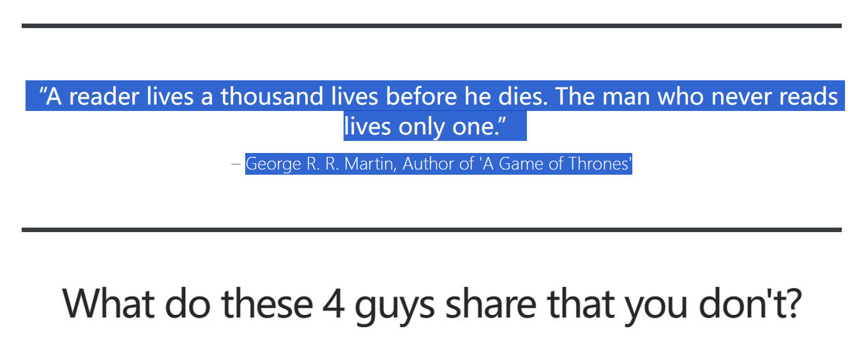

No, it’s not their shoe size.
They read. At least two books a month. They’re also among the top 10 richest people in the world. And they’re not alone in their love for books, with 1, 200 other millionaires, who quote reading as a core part of their self-education.
You knew that reading books makes your life better. It’s not even all about money, fame and success. It’s about becoming a more knowledgeable and valuable person. Additionally, reading helps you prevent stress and keep depression at bay, while enhancing your confidence, improving your decision-making, increasing your empathy and overall satisfaction with life.
You know all the benefits of reading, so what’s stopping you from reading more books?
Time!
“I don’t have time to read.”
Have you said those words before?
You say it because...
you have an incredibly demanding college degree to study for…
your loved ones are sitting at home, counting on you to put food on the table…
you are too occupied with work to open a book…
But let’s imagine another reality for a second. What would your life look like if you read just two books every month?
Would you finally…
have what it takes to start that business?
be a better parent?
feel more fulfilled?
Hold on to that vision for a second. If you want to make it a reality, this email course, Time 2 Read, will be your guide for the next 10 days. It’s free of charge and specifically designed to help you take time back, start building a daily reading habit and turn wanting to read into actual reading.
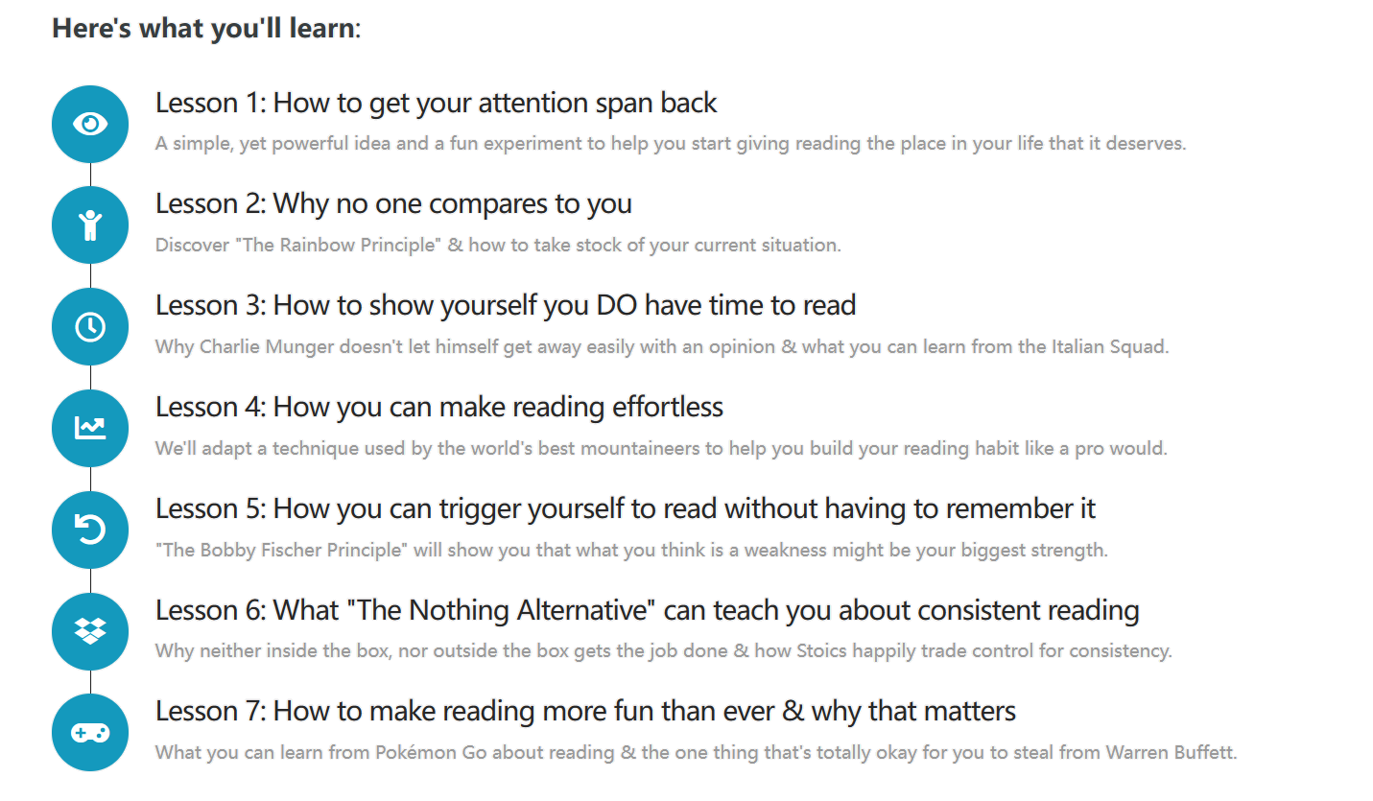
Enter your email below to make time to read, start learning daily and become more valuable to the world.
You’ll be sent 7 lessons via email over the next 10 days, starting right after you sign up here. Each email contains a story, a principle, and an experiment. Get started, and your reading life will never be the same!
60．Where does this passage probably come from?
A．A leaflet publicizing a reading activity.
B．A website promoting a reading course.
C．A TV program advertising reading skills.
D．A handbook providing reading materials.
61．Why does the author mention the four famous people at the beginning?
A．To express his admiration for them.
B．To indicate the importance of reading.
C．To highlight their time management skills.
D．To illustrate the success of the course.
62．Who are most likely to be interested in Time 2 Read?
A．Those who are willing to read more but struggle with time.
B．Those who are sick of making excuses to delay their life plans.
C．Those who are eager to become a millionaire like the four guys.
D．Those who are determined to be more and more self-disciplined.

Scientists know that the internal forces that generate Earth’s magnetic field (磁场) can change and that the strength of the field swings over time. This can lead to gradual shifts in the intensity and location of Earth’s magnetic north and south poles and even reversals where Earth’s magnetic poles trade places.
But are these geomagnetic events responsible for extreme weather, extinction, and even disasters? Claims that Earth’s magnetic field is responsible for climate change are widespread online, but scientists say the theory has no basis. “At this time there aren’t any credible mechanisms that could make it a possibility,” says Gavin Schmidt, a climatologist in New York.” It’s not that we’re ruling out magnetic effects on climate without thinking about it, we collectively have thought about it, and it’s been found devoid.
There are three north poles on Earth: true north, geomagnetic north, and magnetic north. True north is a fixed position on the globe that points directly towards the geographic North Pole. But geomagnetic north, currently located over Canada’s Ellesmere Island, is not a fixed point — it represents the northern axis (轴) of Earth’s magnetosphere and shifts from time to time. Magnetic north corresponds to magnetic field lines and is what your compass locates.
During a pole reversal, Earth’s magnetic north and south poles exchange locations. This
happens on average every 300,000 years or so, but the last reversal occurred around 780.000 years ago. Some scientists have assumed that reversals and the corresponding decrease in strength of the magnetic field could cause a big problem that increased solar radiation was able to enter Earth’s atmosphere, altering ozone levels and driving global climate shifts and extinctions.
Kirk Johnson, a director of the Smithsonian’s National Museum of Natural History, has spent much of his career studying the extinction of dinosaurs. While analyzing fossil records and timelines surrounding his research, Johnson zeroed in on the magnetic reversal that occurred around 66.3million years ago.
Deep ocean samples revealed significant climate change around 66.3 million years ago. But this also coincides with a large volcanic eruption in India called the Deccan volcanism, which produced some of the longest lava (熔岩) flows on Earth. “We’ve always owed that transition to the carbon dioxide released by the Deccan volcanism and the increase of greenhouse gases,” says Johnson. “There are two things happening: The magnetic field is changing, the Deccan volcanism is happening, and there’s climate warming. So that would be an example of coincidental climate change.”
63．The underlined word “devoid” in paragraph 2 probably means .
A．fruitless B．obvious C．reasonable D．misleading
64．Which north pole on earth is involved in the pole reversal?
A．True north. B．Geomagnetic north. C．Magnetic north. D．Geographic north
65．Which of the following is TRUE according to the passage?
A．The geomagnetic events are to blame for the climate change.
B．The decrease in strength of the magnetic field resulted in extinction.
C．The magnetic field is changing all the time with the climate warming.
D．Internal forces which produce Earth’s magnetic field can alter over time
66．Which of the following statements does Kirk Johnson most probably agree with?
A．A magnetic reversal doesn’t necessarily cause climate change.
B．A magnetic reversal is accompanied with significant climate change
C．The extinction of the dinosaurs is due to the magnetic reversal.
D．Climate change is not relevant to the carbon dioxide emission.

Students’ Journey to Empower Rural Heritage
From Aug. 18 to 22 a team of 15 Tsinghua University students, representing diverse backgrounds from China, South Korea, Malaysia, and Indonesia, set foot on an overseas research exploration focusing on rural revitalization(振兴) in Indonesian villages, particularly within Nusa Tenggara Barat(NTB).
With the diverse cultural heritage, Indonesia is home to over 83,000 villages, each radiating its own charm and character. 67
The research mission took the students to Sukarara and Sade villages, two of NTB’s tourist destinations. 68 Sukarara and Sade are a world apart from the busy cities to which most of us are accustomed. The villages are a living test to Indonesia’s rich culture and its devotion to preserving traditions. The Revitalizing these villages goes beyond mere economic development. 69 The weaving skills and architectural techniques of Sukarara and Sade villages are not only beautiful, but they are also an inseparable part to the identity of these communities. It’s essential that they strike a balance between progress and preservation.
As the journey came to an end, the students carry with them not only the memories of their experiences there, but also the responsibility to make a positive impact on these remarkable places. 70 They are optimistic that Indonesian villages can experience meaningful development, ultimately leading to increased opportunities for employment and an improved quality of life.
A．While these villages possess undeniable fascination, many remain underdeveloped.
B．This effort includes the knowledge exchange between the students and local villagers
C．Both were selected for revitalization efforts led by the Village Revitalization Team.
D．In Sukarara, a local tradition requires girls master weaving skills before marriage
E．They decide to be a bridge between tradition and progress, united for their growth
F．It’s about preserving the cultural heritage and ensuring traditions being passed down

六、书面表达
71．Directions: Read the following passage. Summarize the main idea and the main point(s) of the passage in no more than 60 words. Use your own words as far as possible.
How to Be a Better Boss
Workplaces have changed dramatically over the past few years. Teams have become
more isolated owing to remote work. Technology has brought great benefits but also constant interruptions, from endless Zoom calls to message flows on Slack. With each shift, the job of the manager has become harder. Many report feeling burnt-out, overloaded and confused.
Yet in real life everyone suffers when management is bad and benefits when it is good Research based on a long-running survey of management techniques has found that well-managed firms tend to be more productive, export more and spend more on research and development.
So the prize for better management is big. But how to obtain it? Read enough management books and you might conclude that managers need to change their personality thoroughly, becoming either Machiavelli’s prince or a Marvel superhero. However, study successful managers, and more practical lessons can be drawn.
One is to be clear about a firm’s processes. Managers should make clear the purpose of a team, what a meeting should achieve and who will take a decision. Meeting agendas at GSK, a British drugs firm, clearly say whether an item is for awareness, to gather participants’ input or intended to make a decision. Such clarity means that everyone knows what they are doing, and why.
Management isn’t all about piling up tasks, meetings or processes. A second lesson is that managers can add value by deleting. Sparing workers from pointless meetings, emails and projects frees them to concentrate on the work that fattens the bottom line. At the start of the year, Shopify, an e-commerce firm, deleted 12,000 repeated meetings from its employees’ calendars. The useful ones were eventually added back. But the firm says that meetings are down by 14% since the mass deletion while productivity has gone up by a similar amount.
________________________________________________________________________________________________________________________________________________________________________________________________________________________________________________________________________________________________________________________________________________________________________________________________________________________________________________________________

七、翻译
72．穿着睡衣去超市不太合适，不是吗? (It)(汉译英)
73．这副山水画的灵感来源于王维的诗集。(inspire) (汉译英)
以上内容仅为本文档的试下载部分，为可阅读页数的一半内容。如要下载或阅读全文，请访问：https://d.book118.com/256011200141010053

