Unit 2 Good Health to You!
课堂同步练习
Lesson 7: Always Have Breakfast!
姓名： 班级：


( )2.
要点图解秀

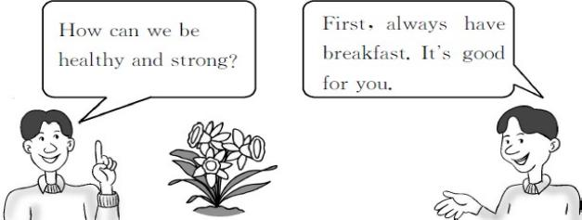
A.This flower is weak.

B.This flower is strong. ( )3.

基础碰碰车

Ⅰ . 请帮它们找到自己的家。
1. es A.br kfast
2. ay B.alw_ s
3. ea C.w k
4. ce D.on
5. ee E.Wedn day

Ⅱ . 单词大变身。
- one( 表倍数或次数的词 )

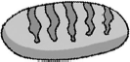
A.Today is Monday. B.Today is Sunday. ( )4.

A.I usually eat bread.
B.I usually eat soup.

Ⅳ . 选出每组中不同类的一项。
( )1.A.once B.twice C.three ( )2.A.usually B.week C.often ( )3.A.Monday B.breakfast C.lunch

- egg( 复数形式 ) 3.health( 形容词 ) 4.have( 过去式 ) 5.eat( 过去式 )
( )4.A.healthy B.flower C.strong

Ⅲ . 根据图片 , 选择答案。
升级跷跷板

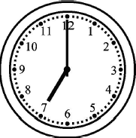
( )1.

A.Danny ate breakfast at seven yesterday.
B.Danny ate breakfast at seven thirty
yesterday.
Ⅴ . 选择难不住我。
( )1.Milk is good you.
A.for B.to C.in D.of ( )2.Everyone wants strong.
A.is B.to is C.be D.to be
( )3.— did you eat breakfast last week?
—Six times.
A.How often B.How much
C.How many D.How

-1-

( )4.What do you usually eat breakfast?
A.on B.with C.of D.for
( )5.We are going to learn what .
A.do B.did C.to do D.does

Ⅵ . 根据汉语提示完成句子。
- 什么是健康强壮 ?
What᾽s and ?
- 她通常在七点十五吃早饭。
She usually at 7:15.
- 金 , 做得好。
,Kim.
- 这盆花是强壮的。
This flower is .
- 她什么时候吃的早饭 ?
did she have breakfast?

Ⅶ . 找朋友。
( )1.Why do you always eat breakfast?
( )2.Do you want to be healthy and strong? ( )3.Is the flower strong?
( )4.What do you usually have for breakfast? ( )5.How often do you watch TV?
Ⅷ . 看表格 , 填空。
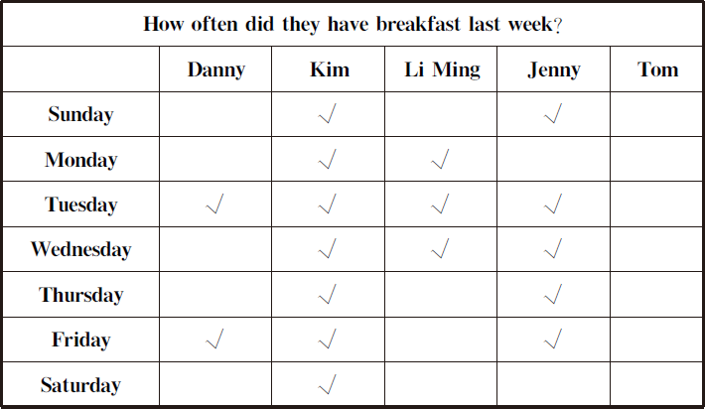

1.Danny has breakfast. 2.Kim has breakfast. 3.Li Ming has breakfast. 4.Jenny has breakfast. 5.Tom has breakfast.

always usually sometimes never

A.Because it is good for me.
B.Yes,it is.
C.Five times a week.
D.Yes,I do.
E.I eat a donut and drink a glass of milk.

-2-

Unit 2 Good Health to You! 课堂同步练习答案
Lesson 7:Always Have Breakfast! 答案 :
Ⅰ .1—5 EBADC
Ⅱ .1.once 2.eggs 3.healthy 4.had 5.ate Ⅲ .1—4 ABBA
Ⅳ .1—4 CBAB
Ⅴ .1—5 ADADC
Ⅵ .1.healthy;strong 2.has breakfast 3.Good work 4.strong 5.When Ⅶ .1—5 ADBEC
Ⅷ .1.sometimes 2.always 3.sometimes 4.usually 5.never

Unit 2 Good Health to You!
课堂同步练习
Lesson 8: Always Brush Your Teeth!
姓名： 班级：

要点图解秀

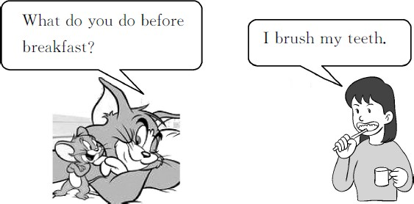

基础碰碰车


Ⅰ . 看图补充单词。

- brush your

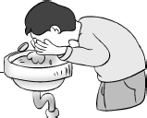
- wash your

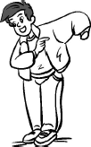
- your clothes

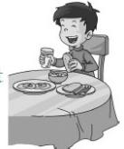
- breakfast


- go to

Ⅱ . 单词大变身。
- wake( 现在分词 )
- brush( 第三人称单数形式 )
Ⅲ . 淘淘猫正在和迷你鼠玩连连看的游戏。你也来连一连吧 !
  - 穿上 A.after supper
2. 吃 早 饭 B.get up
3. 回家 C.work hard
4. 起床 D.put on
5. 努力学习 E.eat breakfast
6. 晚 饭 后 F.go home

Ⅳ . 这儿填什么最恰当 ?
( )1.Jenny,please answer questions.
A.me B.my C.I D.mine
( )2.Jenny to school five times a
week.
A.goes B.go C.went D.going
( )3.Saturday and Sunday different.
A.is B.be C.are D.do ( )4.— do you go to school?
—Five times a week.
A.How B.How many
C.How much D.How often ( )5.— ?
—Because I want to have strong,healthy
teeth.
A.Why B.Where C.What D.Who

升级跷跷板

Ⅴ . 选词填空难不倒我。
on in for at from to

- tooth( 复数形式 ) 4.after( 反义词 )

-1-
- Jenny works hard school.
- She puts her clothes and goes out.

- Jenny goes to school Monday
Friday.
- She gets up at 7:00 the morning. 5.What do you eat breakfast?

Ⅵ . 用所给单词的适当形式填空。
- Jenny is (wash)her hands.
- He brushes his (tooth)after breakfast. 3.Jenny always (do)her homework before
supper.
4.Danny brushes his teeth (two)a day. 5.Look! Jenny is (get)up.

Ⅶ . 根据汉语提示完成句子。
- 李明在早饭前洗手。
Li Ming before
breakfast.
- 詹妮从星期一到星期五上学。
Jenny goes to school
.
- 早饭后你做什么 ?
_do you do ? 4.——你多长时间打一次篮球 ?
——一周三次。
— do you play basketball?
— a week.

Ⅷ . 连词成句。
1.face, she, her, hands, washes, and (.)

2.do, do, breakfast, what, you, before (?)

3.at, Li Ming, eats, in, the, breakfast, 7:00,
morning (.)

- is, bad, teeth, that, for your (.)

- to, go, Jenny, doesn᾽t, on, days, school,
those (.)

Ⅸ . 阅读对话 , 判断正 (T) 误 (F)。
Mr.Wood:Jenny,please answer my questions.What
do you do before supper? Jenny:I do my homework.
Mr.Wood:Why?
Jenny:Because I want to watch TV after supper. Mr.Wood:How often do you watch TV?
Jenny:Once a day.
Mr.Wood:What time do you go to bed? Jenny:At about 9:00.
( )1.Jenny does her homework after supper. ( )2.She watches TV once a day.
( )3.She goes to bed at about 9:00. ( )4.Jenny isn᾽t a good girl.

-2-

Unit 2 Good Health to You! 课堂同步练习答案
Lesson 8:Always Brush Your Teeth! 答案 :
Ⅰ .1.teeth 2.face 3.put on 4.have 5.school Ⅱ .1.waking 2.brushes 3.teeth 4.before
Ⅲ .1—6 DEFBCA
Ⅳ .1—5 BACDA
Ⅴ .1.at 2.on 3.from;to 4.in 5.for
Ⅵ .1.washing 2.teeth 3.does 4.twice 5.getting
Ⅶ .1.washes his hands 2.from Monday to Friday 3.What;after breakfast 4.How often;Three times Ⅷ .1.She washes her hands and face 2.What do you do before breakfast
3.Li Ming eats breakfast at 7:00 in the morning
4.That is bad for your teeth
5.Jenny doesn᾽t go to school on those days Ⅸ .1.F 2.T 3.T 4.F

Unit 2 Good Health to You!
课堂同步练习
Lesson 9: Eat More Vegetables and Fruit!
姓名： 班级：

要点图解秀

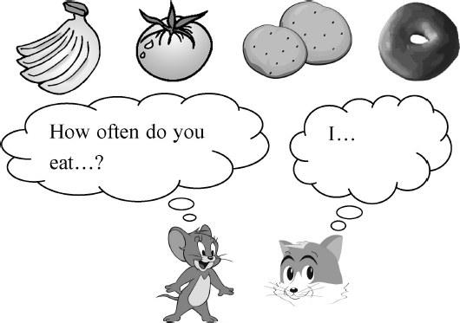

基础碰碰车

Ⅰ . 看图片写单词。

1. 2.


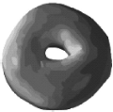3. 4.

- . 淘淘猫 正在和迷你鼠 玩连连看的游戏。你也来连一连吧 !
1.on A.k _p( 使保持在 )
2.ee B.m th( 月 )
3.i C.th k( 感 谢 )
4.o D.tw ce( 两次 )
5.an E.m re( 更多的 )

Ⅲ . 选择正确答案。
( )1.eat vegetables
A. 吃蔬菜 B. 吃水果 C. 吃苹果

-1-
( )2.twice a week
A. 一周两次 B. 一周一次
C. 一周三次( )3.be good for
A. 对……有用 B. 对……有利
C. 对……有害( )4.how often
A. 多 长 B. 经常 C. 多长时间一次( )5.after lunch
A. 午饭前 B. 午饭后 C. 午饭中( )6.play sports
A. 进行体育活动 B. 运动员
C. 运动会

Ⅳ . 这儿填什么最恰当 ?
( )1.— is the cabbage?
—It᾽s green.
A.What B.What colour
C.What sport D.How
( )2.Here᾽s the chart I for Danny.
A.maked B.making
C.makes D.made
( )3.Onions can make you .
A.cry B.to cry
C.crying D.cryed
( )4.I like tomatoes than potatoes.
A.many B.much C.any D.more ( )5.—Do you like noodles?
—
A.Yes,I do. B.Yes,I don᾽t.
C.No,I do. D.No,I am not.

升级跷跷板

Ⅴ . 根据汉语提示完成句子。
- 你需要多吃蔬菜。
You eat more vegetables.
- 你多久吃一次蔬菜 ?
do you eat vegetables?
- 我从来不吃土豆。
I eat .
- 伍德老师一个月吃两次豌豆。
Mr.Wood eats peas
.
- 你最喜欢什么食物 ?
What᾽s your ?

Ⅵ . 调皮的迷你鼠将下面句子中的单词顺序弄乱了 , 快来帮忙排排吧。
1.like /vegetables /I /much /very
. 2.do /like /eat /what /you /to
? 3.body /you /healthy /need /for /to /vegetables
/eat /a
- I usually eat donuts two a day.

- They are good at you.

4 . Y o u can to ask many other questions.
5.Make a chart to one of your friends.

Ⅷ . 根据表格回答问题。
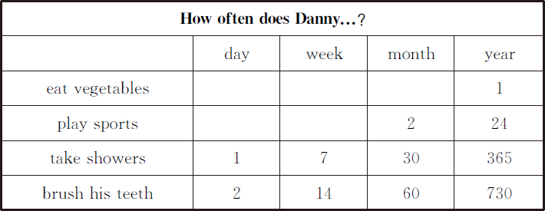
1.How often does Danny eat vegetables a year?

2.How often does Danny take showers a week?

3.Does Danny play sports twice a week?

4.Does Danny brush his teeth twice a day?

. 4.meat /I /like /don᾽t
. 5.often /you /wash /how /face /your /do
5.How often does Danny brush his teeth a year?

?

Ⅶ . 我知道哪儿出错了。
1.Let᾽s see how often Danny eat
vegetables.

-2-

Unit 2 Good Health to You! 课堂同步练习Lesson 9:Eat More Vegetables and Fruit! 答案
Ⅰ .1.potatoes 2.tomato 3.donut 4.apple Ⅱ .1—5 BADEC
Ⅲ .1—6 AABCBA
Ⅳ .1—5 BDADA
Ⅴ .1.need to 2.How often 3.never;potatoes 4.twice a month 5.favourite food Ⅵ .1.I like vegetables very much
2.What do you like to eat
3.You need to eat vegetables for a healthy body
4.I don᾽t like meat
5.How often do you wash your face
Ⅶ .1.C eats 2.C twice 3.C good for 4.A ask 5.B for
Ⅷ .1.Once a year. 2.Seven times a week. 3.No,he doesn't. 4.Yes,he does.
5.Seven hundred and thirty times a year.

Unit 2 Good Health to You!
课堂同步练习
Lesson 10: Exercise
姓名： 班级：

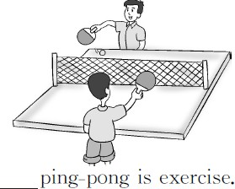
4.
要点图解秀

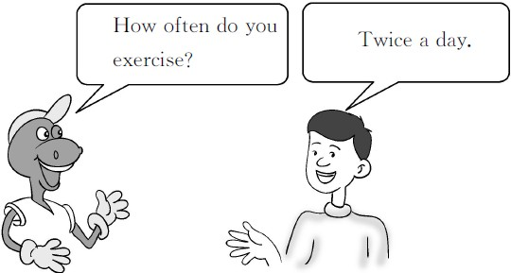
- . 单词大变身。
  - run( 现在分词 ) 2.health( 形容词 ) 3.hour( 同音词 )
基础碰碰车

Ⅰ . 看图片写单词。
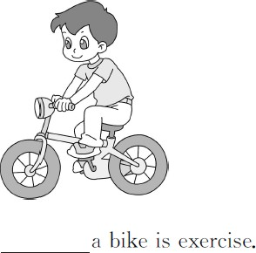
1.

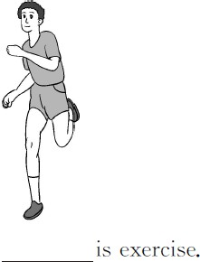
2.

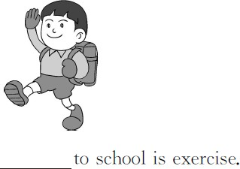
3.
4.minute( 复数形式 ) 5.ride( 现在分词 ) 6.much( 比较级 )

Ⅲ . 淘淘猫 正在和迷你鼠 玩连连看的游戏。你也来连一连吧 !
- walk home A. 骑自行车2.after school B. 六十分钟3.ride a bike C. 必须4.sixty minutes D. 放学后5.have to E. 步 行 回 家6.walk to school F. 步 行 上 学

Ⅳ . 这儿填什么最恰当 ?
( )1.Exercise helps your body healthy
and strong.
A.makes B.make C.making D.made ( )2.How many a day do you clean the
house?
A.minute B.time
C.minutes D.a minute

-1-
( )3.Running exercise.
A.be B.are C.am D.is

以上内容仅为本文档的试下载部分，为可阅读页数的一半内容。如要下载或阅读全文，请访问：https://d.book118.com/257100040054006046

