山东省临沂市河东区2021-2022学年八年级下学期期中考试英语试题（含听力）
一、听力匹配题
1．听句子，选择与句子内容相对应的图片。每个句子读两遍。
A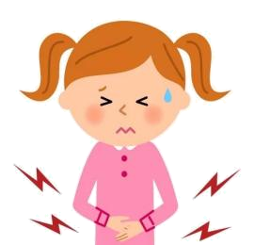 B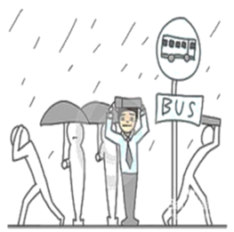 C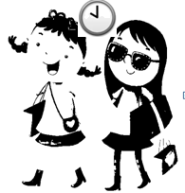
D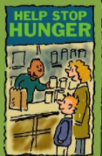 E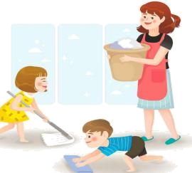 F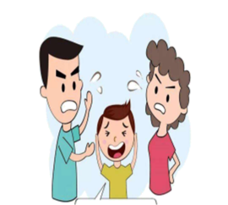
1. ____ 2. ____ 3. ____ 4. ____ 5. ____ .
二、听短对话选答案
2．
A．got hit on the hand. B．got hit on the face. C．got hit on the head.
3．
A．Clean up the streets. B．Hand out notices. C．Put up notices.
4．
A．Call her up. B．Take her to the movies. C．Take her to the concert.
5．
A．Walking home. B．Studying on the computer. C．Taking a walk.
6．
A．Use the computer. B．Watch TV. C．Clean her room.
三、听短文判断
听短文，根据短文内容，判断下列句子正误，正确的用“A”表示，不正确的用“B”表示。短文读两遍。听短文前，你们有20秒钟的时间阅读下列句子。
7．The volunteers will work for the school’s newspaper.
8．If you can take photos, you can take part in this activity.
9．The volunteers don’t need team work.
10．The volunteers do the work in their free time.
11．They should ask their teachers if they want to take part in this activity.
四、听录音补全句子
听写，听对话，根据对话内容，回答问题或完成句子，每空词数不限。对话读三遍。听对话前，你将有20秒钟的时间阅读句子内容。
12．What’s the matter with Charles last night?
He had a ___________.
13．What should Charles do?
He should ___________ and get an X-ray.
14．What was Eric doing at 7:30 this morning when Charles called?
He was ___________ the bus at the bus stop.
15．What’s the movie about?
It’s about the ___________ experience of Aron Rolston.
16．How did Aron save his life?
He used his knife to ___________ half his right arm.
五、短文选词填空
根据短文内容，从方框中选出恰当的单词或短语填空，使语意通顺完整。第一个方框供1—4小题选用，第二个方框供2—8小题选用。每个选项只能使用一次，每框有一项剩余。
A．get on well with B．feeling of satisfaction C．join D．taking risks E. take part in
Gu Ailing, an 18-year-old girl, is known as a genius(天才) for her excellent performances in skiing. As a typical Chinese-American girl, she has quite a few hobbies, such as running, skiing, rock climbing, horse riding, shooting, ballet, piano and so on. As a sports lover, she is used to ___17___. Her mum Gu Yan makes a big difference to her. Gu Yan was once a skiing coach and took her to skiing training all the time. They ___18___ each other and always have proper communication. At the age of three, Gu Ailing first learned to ski and fell in love with this exciting sport. She showed special talent for skiing. As a professional skier, Gu Ailing is successful. She could ski through the forest freely at age 4. She got her first champion(冠军) at age 9. It’s reported that she had already gotten 45 gold medals(金牌) by age 14 before coming to China. In June 2019, she made the decision to ___19___ the 2022 Winter Olympic Games as a Chinese. “I can get a strong ___20___ when skiing. It’s one of the most wonderful experiences for me.” She said she would keep on challenging herself and try her best to let more people love skiing.
A．To everyone’s surprise B．share the housework C．Although D．had a fever E.depend on parents
To compete and win in competitions, Gu Ailing needs to spend so much time skiing that she has little time to study. However, she keeps a good balance of training and schoolwork. She usually finishes her homework on her way from and to training. ___21___ she works hard, she has to take some after-school classes to get into her dream school—Stanford University, one of the top universities in the world.She’s always thinking about challenging herself in the face of difficulties. One night she ___22___ of nearly 40°C．Her throat hurt so much that she just cried. She was taken to the hospital and stayed there until late at night. ___23___, she woke up early the next morning and got home with another gold medal.
Gu Ailing hates housework, like making her bed, folding the clothes and cleaning the bedroom. “For me, doing chores is a waste of time. This makes my mum angry.” Her mum thinks family members should ___24___ to keep it clean and comfortable.
六、阅读单选
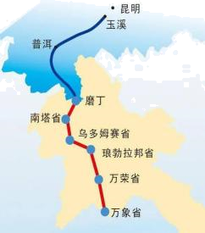
The China-Laos Railway began to have transport service on December 3, 2021. The line connecting southwest China’s Kunming, capital of Yunnan Province, with the Lao capital of Vientiane is a key project of the Belt and Road Initiative (一带一路). It is 1,035 kilometers long with 422 kilometers passing through Laos. The train, running at a speed of 160 km/h, cuts the travel time between the two cities to about 10 hours.
On the train, a lot of thoughts have gone into how to better serve passengers. Chinese knots (中国结) in different colors are used to represent (代表) different passenger groups with special needs, with blue standing for the old, yellow for children, green for the sick, purple for the disabled and red for the pregnant. Attendants (乘务员) can provide services for those in need quickly according to the color of the Chinese knots. Passengers on the train can also enjoy multilingual (多语的) service, such as Chinese, Lao and even English. And there is quite a lot of good and special food offered on the train, including Yunnan food like rice noodles and Western food like pizza and coffee.
The railway passes through well-known natural and cultural sites in both countries, such as Xishuangbanna. You can learn all kinds of plants you’ve never heard of, and even meet wild elephants as Xishuangbanna is home to the largest natural habitat (栖息地) for wild Asian elephants in China.
Jaruwan Udomsab from Thailand took the ride on the first train of the railway. “I think more fruit from Thailand will enter the Chinese market more easily, as the transportation costs will be greatly reduced. The Chinese people will enjoy them at much lower prices,” she said. “The railway makes it easier for people from my county to come to China to study or travel. I’ll bring my family here by train.” Soukdawane Rattanabandith, a Lao student from a university in Yunnan
said.
根据短文内容，选择最佳答案。
25．How long is the railway passing through China?
A．422 km. B．613 km. C．1035 km.
26．Who will have a purple Chinese knot on the train?
A．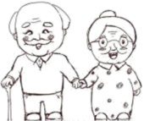 B．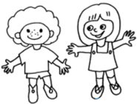 C．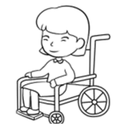
27．Which of the following sentences can be put in ___________?
A．It’s quite difficult to build the railway.
B．The railway is important for business people.
C．There are many places worth visiting along the way.
28．Where can we see the passage?
A．In a newspaper. B．In a student’s diary. C．In a science book.
Helping others is a great thing to do. You can learn new things and have fun. There are many ways of helping others in your community. You can help people, animals or the environment. It can make you feel good too! How can you help?
Charities (慈善机构) are organizations that help others like UNICEF or the World Wildlife Fund. You can help charities by giving your time, giving money or giving things that you own. You can also help people or places you know.
Volunteering
Volunteering is when you give your time to help others. It’s something that you do not have to do or for which you will not be paid. Some ways of volunteering are:
·visiting old people to talk to them or help them
·walking dogs at an animal shelter (避难所)
·cleaning up a park
Fundraising
Fundraising is when you collect money to help others. Some ways of fundraising are:
·making cakes or biscuits to sell
·doing a sponsored (赞助) activity. For example, family and friends give you money if you finish a long walk.
Donating
Donating is when you give your things or money to help others. Some ways of donating are:
·giving your old toys or clothes to a charity that helps sick children or poor people
·giving your old books to a library
·giving your money to a charity
So, what can you do to help others?
根据短文内容，选择最佳答案。
29．You’ll ___________ when you help other people.
A．feel uncomfortable B．have a great job C．feel good
30．How many ways of volunteering are mentioned in the article?
A．Two. B．Three. C．Four.
31．Which of the following is a way of donating?
A．Cleaning up a park.
B．Giving your old computer to a charity.
C．Taking care of sick people in hospital.
32．What is the best title for the passage?
A．Helping Others B．Ways of Volunteering C．A Great Thing to Do
七、阅读还原5选4
Average humans can consume（消费）15 or more drinks in plastic bottles a month. If you were born after 1978, and live until 80 years old, you will leave behind at least 14,400 plastic
bottles on this planet. ____33____ Humans may end up living along with plastic（塑料的）waste in the future. Most of the waste is consumed by fish and birds, which will shorten or even end their lifetime.
The Plastic Bottle Village is just a great idea that might finally save us from being buried in plastics. ____34____ The design process begins with building steel frames（钢筋框架）, which are then filled with these bottles. Once this step is complete, and electrical and plumbing（管道装置）lines are put inside. The plastic walls are covered with concrete（混凝土）—both inside and outside. ____35____ This will keep the house 17°C cooler than the outside.
Robert Bezeau came up with the idea of setting up several environmental projects. He started a recycling program four years ago. He collected thousands of plastic bottles. He wondered how to put these plastic bottles to good use. ____36____
The project hopes to make people realize the waste that these bottles create so that they can do more to protect the environment.
根据短文内容，选出四个选项填入文中空缺处，使短文内容通顺完整。有一项剩余。
A．It’s a neighborhood made of used bottles in Panama.
B．People can easily tell that the walls are made of plastic.
C．These bottles take hundreds of years to break down into tiny pieces of plastic, and will never disappear.
D．Soon enough, an idea hit him and he decided to use them to build houses.
E．So no one will actually be able to tell that the walls are made of plastic.
八、语法填空
阅读下面短文，在空白处填入一个适当的单词或括号内单词的适当形式，必要时可加助动词或情态动词。
Should teenagers help parents with the housework? Different people have different opinions. Some people think teenagers have enough ___37___ (press) from school. It’s the parents’ job ___38___ (provide) a clean and comfortable home for the children so that children can spend their
time ___39___ schoolwork to get good grades and then a good university.
In my opinion, it’s important for children’s ___40___ (develop) to help with the housework. It’s ___41___ (fair) for parents to do all the chores. Doing chores ___42___ (teach) kids how to look after ___43___ (they). It also helps develop their independence. The ___44___ (early) kids learn to be independent, the better it is for their future.
阅读下面短文，在空白处填入一个适当的单词或括号内单词的适当形式，必要时可加助动词或情态动词。
People often remember what they were doing when something important happened. The crash of MU5735 from China Eastern Airlines was such ___45___ event. The passenger plane took off from Kunming, the capital of southern Yunan Province and was due(预期) to land in Guangzhou, one of the ___46___ (lively) cities in China. Unluckily, it plunged more than 20,000 feet in just over a minute ___47___ crashed in Teng County, causing 132 deaths. Mr. Wang is a truck driver. There was something wrong ___48___ his truck that day. He was repairing it when he ___49___ (hear) the large boom. My elder brother ___50___ (eat) lunch at that time. We saw black smoke rising in the forest and bushes and were ___51___ (complete) shocked. We rode our motorbikes to the mountains to check if there were survivors(幸存者).
九、阅读回答问题
根据短文内容，回答下列问题。
How would you feel if you received a large amount of money all at once? That’s exactly what happened to Nkosikho Mbele, a worker at a gas station in South Africa. His sudden luck was brought about by an act of kindness he did for a young woman—Monet, a company manager.
One day, Monet stopped at the gas station to refuel（加油）. But when Nkosikho was about to serve her, she realized she didn’t have any money or cards on her. She immediately tried to stop him. Knowing about her trouble, Nkosikho decided to pay her gas bill of about R100 （＄ 7）to make sure that she could travel across the highway with enough gas.
“Madam, I’ll pay for you so that you won’t run out of gas on the road. Whenever you are near here again, you can just give me back the money,” Nkosikho said. As for him, the R100 was
almost all he made in a day. He had to support a big family. He needed the money very much. He wasn’t even sure if Monet would come back to return his money, but he still volunteered to help her.
Several days later, Monet came back with his money and a box of chocolate. She was so thankful that she also posted their story on the Internet. Great changes took place. Nkosikho became famous in his town. Many people were moved by his act and offered to raise money for him. Nkosikho received around ＄ 24,000 as much as about his salary（薪水）of eight years. His boss also heard of his kind act and decided to give him a rise in salary.
“I feel like I’m dreaming. My life has been turned—upside down,” Nkosikho said thankfully. As normal people, we can bring a great change to life by doing a small good thing.
52．Where does Nkosikho work?
___________________________________________________________________________
53．What was the matter with Monet when she went to refuel one day?
___________________________________________________________________________
54．Was Nkosikho sure that Monet would come back to return his money?
___________________________________________________________________________
55．Why did Monet post their story on the Internet?
___________________________________________________________________________
56．What can we learn from the story?
___________________________________________________________________________
十、填写适当的句子补全对话
根据对话内容，在空白处填入一个适当的句子，使对话完整，合乎情景。
Mrs. Brown is talking about the Volunteer Day with her students in class.
Mrs. Brown: Boys and girls, Volunteer Day is only one week from now. We need to come up with the jobs we can help.
Girl 1: Yes, Mrs Brown. We can’t put off doing that. I’m good at drawing. I could make some posters and notices. I’ll hand them out after school to call more students to help.
Mrs. Brown: Good girl! What about you, Linda? __________57__________
Girl 2: I can visit the sick kids in the hospital to cheer them up.
Mrs. Brown: That’s so nice of you. Maybe we could also see Jimmy in the hospital.
Boy 1: __________58__________
Mrs. Brown: He hurt his leg carrying bikes when the rainstorm came yesterday. __________59__________
Boy 2: I was taking my dog for a walk at the time of the rainstorm. I hurried home but still got wet.
Mrs. Brown: I’m sorry to hear that. Remember to take an umbrella with you next time. It’s time to finish our class. Our classroom is in a mess. Tom is on duty today. Tom, __________60__________
Boy 3: Yes, sure. I’ll take out the rubbish as soon as I finish sweeping the floor.
Mrs. Brown: Thank you so much,Tom.
Boy3: It’s my pleasure, Mrs. Brown.
十一、书信作文
61．Linda向你求助，她最近很苦恼，怎样才能让网课学习更加高效呢？假设你的名字是Mary Brown，请结合自己的实际经验，根据提示用英语写一封信向Linda介绍一下自己的建议。
提示：上课认真听讲；做笔记（take notes）；按时完成作业；有问题向老师或家长求助；规律作息；勤运动；……
要求：1. 要用上以上要点，还可适当发挥，注意语句通顺，语法正确，书写规范。
2. 80词以上，开头已给出，不计入总词数。
3. 短文中不得出现任何人名、校名及其它相关信息，否则不予评分。
Dear Linda,
I’m sorry to hear that you have problems studying on the computer. At first I had some problems, too. But I’m used to it and I’m getting better grades. Here are some suggestions for you.

____________________________________________________________________________________________________________________________________________________________________________________________________________________________________________________________________________________________________________________________________________________________________________________________________________________________________________________________________________________________________________________
Yours,
Mary Brown

参考答案：
1． F B A C D
【原文】
1. When my parents fight, it’s like a big, black cloud hanging over our home.
2. I was waiting for the bus when it began to rain heavily.
3. I was invited to Linda’s birthday party last night. I ate too much junk food so I got a stomachache.
4. Mum, could I hang out with my friends until ten o’clock tonight? Tomorrow is Saturday.
5. I’d like to give out food at the food bank to help the homeless people.
2．C
【原文】
W: You have blood on your face. What’s the trouble?
M: I got hit on the head when playing basketball.
W: It seems to be a little serious. You need to get an X-ray first.
Question: What’s the matter with the man?
3．A
【原文】
W: Clean-up Day is coming. What volunteer job can you do?
Girl: I can clean up the streets.
以上内容仅为本文档的试下载部分，为可阅读页数的一半内容。如要下载或阅读全文，请访问：https://d.book118.com/258116063043006040

