2021学年上海市长宁区第一学期初三英语教学质量监测试卷

Part 1 Listening (第一局部听力)

1.Listening Comprehension(听力理解)(共25分)Listen and choose the right
picture(根据你听到的内容，选出相应的图片)(5分)
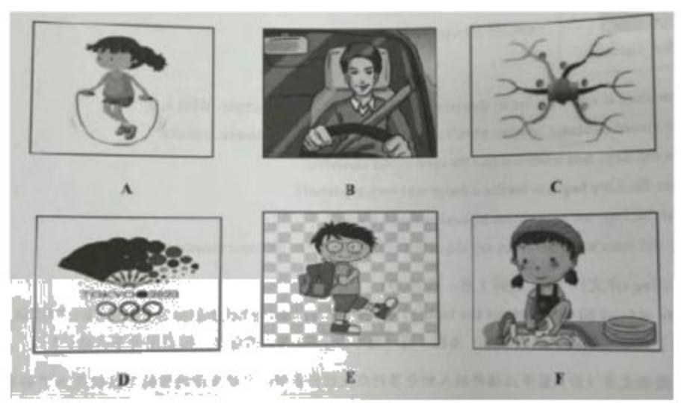
1.2.3.4.5.
A.Listen to the dialogue and choose the best answer to the question you hear(根据 你听到的对话和问题，选择最恰当的答案)(5分)

6 .A)Sunny.B)Windy.
7 .A)Go to the cinema.
C)Watch a basketball match.
8.A)At a fruit market.

C)In a computer factory.
9.A)Boss and Worker.
C)Manager and secretary.
10.A)The exam had only one page,
problems.
C)The exam was too difficult for the

girlSnowy.D)Rainy.
8)Play with her sister.
C)Buy two tickets.
B)In a phone store.
D)At the booking office.
B)Librarian and student.
D)Shop assistant and customer.
B)The girl worked out the last twoD)The girl finished the exam in an hour.

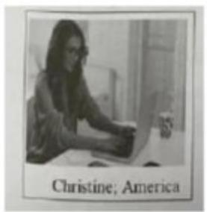
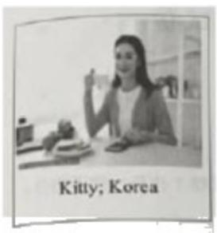

their thoughts are shared below.

I hated typing at school about 20 years ago.Only
secretaries typed in those days;no one had computers at home or at work.What's more,I was no good at all.I was as bad at typing
as I was at tennis I made so many mistakes.But today I'm the
fastest typist at the keyboard.

I get the job done faster and more easily than my colleagues in the office.That one year of typing class has made my whole life easier.
We had a class called Guidance to learn about making
good decision in life.I found it pretty boring and didn't pay much attention.One day the teacher made us guess which appliance we should buy first once we had our own homes.The answer was a
fridge

Without a fridge,you cannot keep your food fresh
and will waste a great deal of money with food going off.I learnt that it was true once I had
my own place.The first day I bought some chicken meat.By dinner time it smelled and I
couldn't even eat it!My housemate and I started saving to buy a fridge immediately even though we were university students
without much money.

When I used to ask my teacher how to spell something,
she often said,I don't know.Then she would take out the
dictionary and took it up.She always dared to admit that she did
John;Canada
not know the answer.I learnt two things.You don't have to know everything:and if you
don't know how to spell something,just get the dictionary out.Both are very useful
lessons!

78.Sometimes at school,it seems that you are only learning for one purpose.What is it?
79.As a school student,Christine wasn't as good at typing or playing tennis,was she?
80.How did Kitty feel when she had the class called Guidance?
81.When did Kitty begin to realize a fridge was very important?
82.What did John use to do when he couldn't spell a word?

83.Why did John's teacher often say she didn't know?(Give two different reasons.)VD. Writing

84.Write at least 60 words about the topic Tve learned something helpful fbr my future life”(请以“我学到了对未来生活有用的东西”为题，写一篇不少于60个词的短 文，标点符号不占格。)阅读文章(D)篇中三位年轻人提供的在校经历说明：学校 生活的目的不仅仅是为了升学，更重要的是学习对未来生活中有用的一种能力本 领、 一种精神品质、或者是获取一个经验教训。请你以一个具体的事例谈谈你学
校生活中这方面的一点收获。

、心："山 
听力音频自取
参考答案1-5BFDCE

6-10DABDC11-15TTFTF
16 the third 17 free time 18 raised money 19 build safe 20 through diet21-25:BDCDA26-
30:CDABC31-35:BDCAB
36-39:CAEB41-43:BAEDIV44-
51:opinions,second,himself,traditional,recently,operate,length,dislike V52-57: didn't have; How often; where to; broke down/went wrong; are added;
if/whether…had58:Taking notes is a useful tool to improve your memory.
VIA:CBDAACB:BDABCD
C:hard,recognize,Although,move,less,whether,stepD:78:To get into the right
university.
79:No,She wasn't.

80:She felt bored.
81:When she had her own place./After he bought some chicken meat in her own place.
82:He used to ask his teacher how to spell it.
83:Because she dared to admit she didn't know the answer and she could get help from
the dictionary. (主观题，意思答对即可。) vn.作文略听力文本

A.Listen and choose the right picture (根据你听到的内容，选出相应的图片)l.One A driver must wear a safety belt while driving.
2.Doing housework can develop a child's sense of responsibility.
3 .Tokyo hosted the 2020 Summer Olympic Games this year.
4.A good way of improving our thinking ability is to use a mind map.
5 .Jack often walks to school every day because it's not far from his home.
B.Listen to the dialogue and choose the best answer to the question you hear (根据 你听到的对话和问题，选择最恰当的答案) (5分)

6.Bob,did you have a good time and the Disney park last Sunday?
No,I didn't go to the Disney Park because of the heavy rain.
Question What was the weather like last Sunday?
7.Hi,Cathy.Fve got two tickets for the basketball match at Shanghai Stadium tomorrow
evening.Will you go with me?
Thank you,James,but I'd rather go to the cinema with my sister.Well see a Chinese film.
Fve heard it is a hit in Shanghai now.
Question What is Cathy going to do tomorrow evening?
8.This is a new kind of mobile phone.We've sold a lot today.

Really?It looks very different from the others in your shop.This is the latest model from
Apple Company.
Question Where does the dialogue most probably take place?
9.Can I help you?I bought this t shirt as a gift last week,but have found it is the wrong
size,so I want to return it.
If you have your receipt,there will be no problem.Thank you very much.
Question What is the probable relationship between the two speakers?
10.What did you think of the math exam last week?It wasn't as easy as I expected.At the end of the 1st hour,I was still on the 1st page,I hardly had any time to work out the last
two problems.
What a pity question.

What can we know from the dialogue?

C.Listen to the passage and tell whether the following statements are true or false.
(判断以下句子是否符合你听到的短文内容，符合的用表示，不符合的用表示)
(5分)John and Mary are talking about a job interview.

W:Good moning,John.How was the job interview you had yesterday?
M:It didn't go well.I didn't get there on time because I didn*t find parking close to the
office.I parked five blocks away.
W:How late were you?
M:Only 15 min I ran to the office.
W:That*s too late for an interview.Next time,go to the place the day before the
interview,you can check travel time and parking,then.
M:I didn't like the interview.Mary.It took an hour.There were two people behind a desk.
They asked me a lot of questions,which made me feel nervous.
W:What was some of the questions?

M:Well,one question was,why do you want this job?I told them the truth.My last job
was difficult.I worked a lot of hours.I didn't make enough money.
W:You shouldn't complain about your past jobs.Instead,say positive things about this

new company.
M:I told them good things.I said their company was easy to get to.I didn*t complain about
the parking.
W:But you didn*t say anything about the company.Find out some information on the company's website.What does the company do?What do you like about it?It's important
to know something about the company.
M:I made a lot of mistakes in this interview.I said the wrong things.
W:Don't worry.It was good practice.It is going to be easy next time.You*re going to be
more prepared.

D.Listen to the passage and fill in the blanks (听空，完成以下句子。每限填一
词) (10分)

Ann is a great tennis player from Australia.She grew up in a small town.She came from a large family and was the 3rd of eight children.Anne was only five years old when she was seen looking through the fence at the tennis court.She was watching people play
tennis and was invited to play.She spent all her free time playing tennis from that time on,

以上内容仅为本文档的试下载部分，为可阅读页数的一半内容。如要下载或阅读全文，请访问：https://d.book118.com/265231034014011101

