Unit 4 Li Ming Comes Home
课堂同步练习
Lesson 19: Buying Gifts
姓名： 班级：


要点图解秀

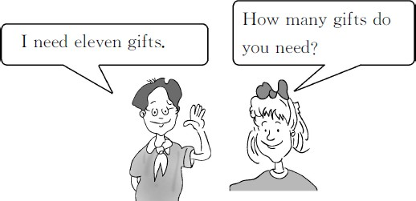

基础碰碰车

Ⅰ . 把单词补充完整。
( )1.C n da( 加拿大 )
A.a;e B.e;a C.a;a ( )2.s rpr se( 惊喜 )
A.u;i B.u;r C.e;i
( )3.T-sh t( 体 恤 衫 )
A.ri B.ir C.ar
( )4.f m ly( 家庭 )
A.a;i B.i;a C.e;i
( )5.c sin( 堂 兄 妹 )
A.oa B.ou C.uo

- . 根据图片的内容完成句子。

  - This is China᾽s national .

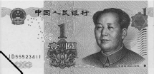
  - It is one yuan.It᾽s .


  - I need eleven .

  - Jenny went to the store by .
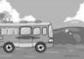

-1-
Ⅲ . 给下列句子选择正确的译文 , 你选对了吗 ?
( )1.I want gifts from Canada.
A. 我想要礼物从加拿大。
B. 我想要来自于加拿大的礼物。
C. 我买了加拿大的礼物。
( )2.I know a good store for souvenirs of
Canada.
A. 我知道一个好的纪念品的商店。
B. 我知道加拿大的一个纪念品商店。
C. 我知道一个卖加拿大纪念品的好商店。
( )3.I need a gift for everyone in my family.
A. 我需要给我家里的每个人买一件礼物。
B. 在我家里需要一件礼物。
C. 我需要一件礼物为我的家人。( )4.What about these flags?
A. 关于这些旗。
B.( 买 ) 这些旗子怎么样 ?
C. 这些旗子关于什么 ? ( )5.What are the gifts?
A. 礼物在哪里 ?
B. 这是什么 ?
C. 礼物是什么 ?

Ⅳ . 单词大变身。
1.store( 同义词 )
2.here( 对应词 )
3.look( 现在分词 )
4.happy( 副词 )
5.gift( 复数形式 )

升级跷跷板

Ⅴ . 连词成句。
1.do,want,buy,your,friends,for,to,you,what(?)

2.ride,they,bikes,will,their(?)

3.need,how,gifts,many,do,you(?)

4.flags,finds,Jenny,some(.)

5.will,it,I,now,buy(.)

Ⅶ . 改正句子中的错误。
1.“They cost ten dollars!”says Danny happy.

2.I need things that are about ten dollar.

3.I would like to got the flags.

4.I will fly China next week.

Ⅷ . 看一看 , 想一想 , 根据图片内容补全对话。
1.—What are these?
—These are .

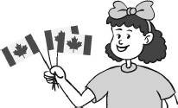
— are these flags?

Ⅵ . 找出正确的选项。
( )1.Here some books about Canada. A.are B.is C.be
( )2.— are these flags?

—One dollar.

—Thirty dollars.
2.—
gifts?

A.How far B.How many C.How much —Five gifts.

( )3.What about ?
—
are they?

A.watch TV B.watching TV
C.to watch TV
( )4.I want to buy a surprise Jenny.
A.in B.on C.for
( )5.These are good gifts China.
A.e from B.from C.to

—Fifty dollars.
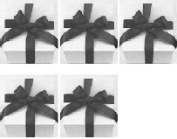
—That᾽s expensive.

3.— are these?

( )6.— will they go to the store?
—By bus.
A.How far B.How C.How much

-2-
—These are .
— books do you need?


—Eight books.

Unit 4 Li Ming Comes Home 课堂同步练习答案
Lesson 19: Buying Gifts 答案 :
Ⅰ .1—5 CABAB
Ⅱ .1.flag 2.cheap 3.gifts 4.bus Ⅲ .1—5 BCABC
Ⅳ .1.shop 2.there 3.looking 4.happily 5.gifts
Ⅴ .1.What do you want to buy for your friends? 2.Will they ride their bikes?
3.How many gifts do you need? 4.Jenny finds some flags.
5.I will buy it now. Ⅵ .1—6 ACBCBB
Ⅶ .1.C happily 2.C ten dollars 3.B to get 4.C to China Ⅷ .1.flags;How much 2.How many;How much 3.What;books;How many

Unit 4 Li Ming Comes Home
课堂同步练习
Lesson 20: Looking at Photos

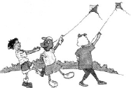
1.—What are they doing?
要点图解秀
—They are kites.
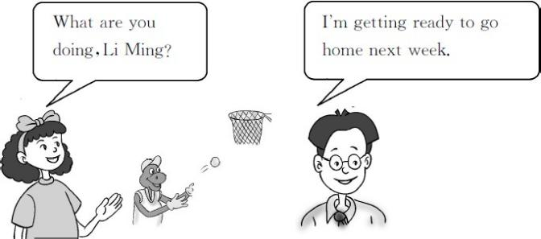


2.—What is he doing?
—He is a book.


3.—What is Sam doing?
—He is .

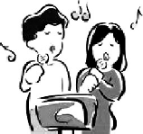
4.—What are they doing?
基础碰碰车
—They are .

Ⅰ . 词语对对碰。
( )1.remember( 反义词 ) A.dry
( )2.wrong( 反 义 词 ) B.quickly ( )3.wet( 反义词 ) C.learn
( )4.slowly( 反 义 词 ) D.right ( )5.teach( 反义词 ) E.forget

Ⅱ . 把下面的动词变成过去式。
1.buy— 2.are—
3.hit— 4.find—
5.teach—

Ⅲ . 读一读 , 想一想 , 你能帮淘淘猫把其中不同类的项选出来吗 ?
( )1.A.heavy B.picture C.photo
( )2.A.found B.wanted C.getting ( )3.A.picture B.find C.teach
( )4.A.basketball B.ping-pong C.play ( )5.A.me B.we C.them

Ⅳ . 看一看, 读一读, 想一想, 他们在干什么呢? 完成句子, 每空一词。

升级跷跷板

- . 这儿填什么最恰当 ?
( )1.I᾽m ready to go home next week.
A.get B.getting C.will get ( )2.I have many things .
A.to do B.do C.doing ( )3.It rainy yesterday.
A.is B.are C.was ( )4.Danny wanted ping-pong.
A.plays B.playing C.to play
( )5.Jenny wanted to walk .She likes
the rain.
A.slowly B.slow C.slowy

Ⅵ . 读一读 , 想一想 , 根据汉语提示完成句子。
  - ——李明 , 你在干什么 ?
——我在看照片。
—What you ,Li Ming?
—I᾽m

-1-

  - 我教丹尼打乒乓球 , 但是他打到了自己的手。 Ⅷ . 选出正确答案补全对话。

I taught Danny
pong,but he his . 3.——我可以看这些照片吗 ?
——当然可以 !
— I the pictures?
— !
- 这是你的一张照片。
ping-

going,great,ready,sure,may
A:What are you doing?
B:I᾽m getting 1 to go on a trip. A:Where are you 2 ?
B:I will go to Beijing.

a photo of you.
- 你正在干什么 ?
What you ?

Ⅶ . 回忆课文内容 , 理清句子顺序 .
( )Oh! Poor Danny.
( )I᾽m getting ready to go home next week.I᾽m
packing things.
( )What are you doing,Li Ming?
( )Yes.Danny wanted to play ping-pong,but he
hit his hand. ( )May I see it?
( )Look! I found a picture. ( )It᾽s a picture of Danny.
A: 3 I go with you? B: 4 .
A:That᾽s 5 . B:Let᾽s go.

1. 2. 3. 4.
5.

Unit 4 Li Ming Comes Home 课堂同步练习答案
Lesson 20: Looking at Photos 答案 :
Ⅰ .1—5 EDABC
Ⅱ .1.bought 2.were 3.hit 4.found 5.taught Ⅲ .1—5 ACACB
Ⅳ .1.flying 2.reading 3.playing basketball 4.singing Ⅴ .1—5 BACCA
Ⅵ .1.are;doing;looking at pictures 2.to play;hit;hand
3.May;see;Sure 4.Here is
5.are;doing Ⅶ .7216435
Ⅷ .1.ready 2.going 3.May 4.Sure 5.great

Unit 4 Li Ming Comes Home
课堂同步练习
Lesson 21: A Party for Li Ming
姓名： 班级：

要点图解秀
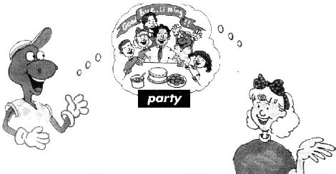
Danny:This is a surprise party for Li Ming. Jenny:I will invite some friends.

基础碰碰车

Ⅰ . 连一连。
1.ou A.p ty
2.ar B.s prise
3.ear C.l ve
4.ur D. ly
5.ea E.ab t

Ⅱ . 把不同类的项选出来。
( )1.A.cake B.cookies C.water
( )2.A.tea B.bread C.milk
( )3.A.noodles B.dumplings C.eat
( )4.A.go B.late C.early
( )5.A.sister B.dad C.nine

Ⅲ . 连连看。
1. 圣 诞 礼 物 A.talk to sb
2. 与 某 人 交 谈 B.have fun
3. 坐 下 C.sit down
4. 明 天 见 。 D.Christmas gifts
5. 玩 得 高 兴 E.See you tomorrow.

Ⅳ . 这儿填什么最恰当 ?
( )1.Let᾽s tell Li Ming.
A.isn᾽t B.don᾽t C.not
( )2.Let᾽s have a party for him good-
bye.
A.to say B.say C.say to
( )3.—How many people are to the
party,Jenny?
—Nine.
A.e B.eing C.ing
( )4.Jenny calls Steven on the phone.Steven
the phone.
A.answers B.answer C.answered ( )5.—Will we Li Ming about the
party?
—No.
A.say B.tell C.speak

升级跷跷板

- . 组词成句。
1.to,a,party,for,e,Would,you,Li Ming
? 2.the,time,begin,What,does,party
? 3.before,I,e,4:00,will
. 4.Li Ming,We,to,surprise,want
.
5.soon,Li Ming,is,leaving
.

Ⅵ . 读一读 , 想一想 , 用所给单词的适当形式填空。
  - Li Ming is (leave)soon. 2.We want (surprise)Li Ming.
- I will invite some friends (e)to
the party tomorrow.
- What time (do)it begin?

Ⅶ . 我知道哪儿出错了。
- Don᾽t is late.

- It᾽s Jenny call.

- It᾽s a surprised for Li Ming.

- Please doesn᾽t tell him.
B:In my house.
A: 4
B:At 5:00.Don᾽t e after 5:00.Don᾽t be late.
A:OK.I will e before 5:00.
B : G r e at! 5
A:See you!
A.Would you like to e? B.See you tomorrow!
C.Where is the party?
D.When does the party begin?
E.Is that Mini?

1. 2. 3. 4.
5.

Ⅷ . 选出正确答案补充对话
(Taotao is calling Mini on the phone.)
A:Hello?
B:Hello,this is Taotao. 1
A:Yes,this is Mini speaking.
B:Mini,tomorrow is my birthday.I᾽ll have a
party. 2
A:Sure. 3

Unit 4 Li Ming Comes Home 课堂同步练习Lesson 21:A Party for Li Ming
答案
Ⅰ .1—5 EADBC
Ⅱ .1—5 CBCAC
Ⅲ .1—5 DACEB
Ⅳ .1—5 CACAB
Ⅴ .1.Would you e to a party for Li Ming 2.What time does the party begin
3.I will e before 4:00 4.We want to surprise Li Ming
5.Li Ming is leaving soon
Ⅵ .1.leaving 2.to surprise 3.to e 4.does
Ⅶ .1.B be 2.C calling 3.B surprise 4.A don᾽t Ⅷ .1—5 EACDB

Unit 4 Li Ming Comes Home
课堂同步练习
Lesson 22: Surprise!
要点图解秀

Danny and Jenny are making a cake and cookies for the party

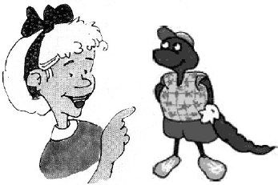

基础碰碰车

Ⅰ . 看图片 , 写出相应的单词。
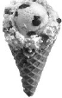 1.
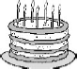 2.

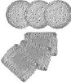
3.


4.

Ⅱ . 单词变身。
1.flour( 同音词 )
2.close( 反义词 )
3.make( 现在分词 )
4.my( 名词性物主代词 )
5.cookie( 复数形式 )
以上内容仅为本文档的试下载部分，为可阅读页数的一半内容。如要下载或阅读全文，请访问：https://d.book118.com/278061044047006042

