上海市 2014 年中考英语真题试题（解析版）

(满分 150 分，考试时间 100 分钟)

考生注意：本卷有 7 大题，共 94 小题。试题均采用连续编号，所有答案务必按照规定在答题纸上完成， 做在试卷上不给分。
Part 1 Listening (第一部分听力）

- Listening Comprehension.(听 力 理 解 ) ( 共 30 分)

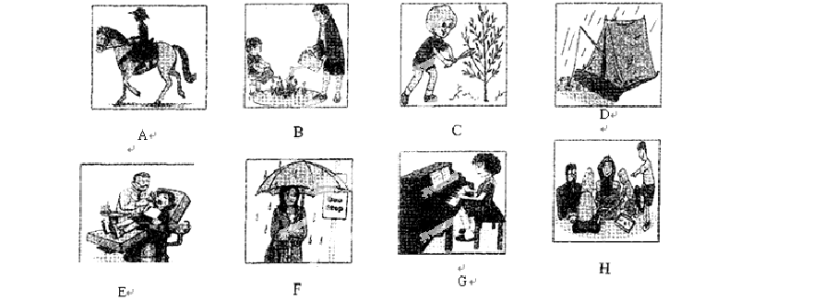
- Listen and choose the right picture（根据你听到的内容，选出相应的图片）（6 分）

1、＿＿＿ 2、＿＿＿ 3、＿＿＿ 4、＿＿＿ 5、＿＿＿ 6、＿＿＿

- E A. Chemistry. B. History. C. English. D) Maths.

- A. A hamburger.
- A. Tired.

- A fruit salad. C. A hot-dog.

B. Surprised. C. Excited.
D) A sandwich.
D) Frightened.

- A. Watch TV.
B. Play football. C. Go to the cinema. D. Read a book.

- A. Fifteen minutes’walk.
C) Fifty minutes’ walk.
B. Fifteen minutes’ bus ride.

D. Fiftyminutes’ bus ride.

- A. Thursday.
- A. Trips.
B. Friday.

B. Computers.
C. Saturday.

C. Parents.
D. Sunday.

D. Jobs.

- A. At the beach.
D. In the hotel.
B. At the airport.
C. In the theatre.

C. Listento thepassage and tell whether the following statements are true or false ( 判 断 下列 句 子 是 否 符 合 你 听 到 的 短 文 内 容 ，符 合 的 用 “ T ” 表 示 ， 不 符 合 的 用 “ F ” 表

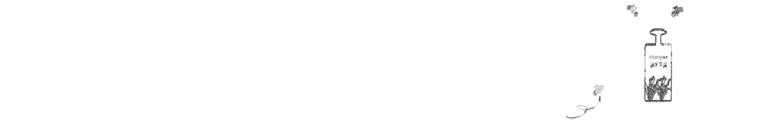示 ) （ 6 分 ）
- My aunt and uncle sent me a bottle of honey as a birthday present

last year.

- The smell of my hair attracted lots of bees when I went outside.
- I jumped into my neighbour’s swimming pool to stay away from the bees.

  - When I climbed out of the po ol, the bees were still flying around.

  - My aunt and uncle wrote me a letter and apologized to me.

  - This is a story about my unforgettable birthday present.

D. Listen to the passage and complete the following sentences（听短文，完成下列内容。每空格限填一词）（10 分）
  - Dan Carter lives in London and works as there.
  - Dan and I stay in touch and sometimes we call each other.
  - When I or when I need to talk to somebody, I can always call Dan.
  - Dan is always everything and he never says sorry.
  - One day, we arranged to meet to play football, but Dan didn’t come on time.
Part 2 Phonetics, Grammarand Vocabulary

（第二部分语音、语法和词汇）

- Choose the best answer（选择最恰当的答案）（共 20 分）

for the underlined word?
26.Garden Sch ool is very famous and it’s Mary’s first choice. Which of the following is correct

A./f st/ B. /fi:st / C. /fri:st / D. /frist /

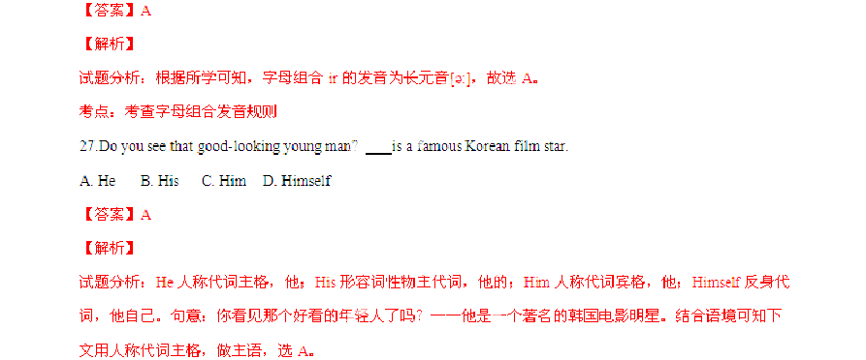
考点：考查代词。

- More and more people in Shanghai choose to go to work underground.
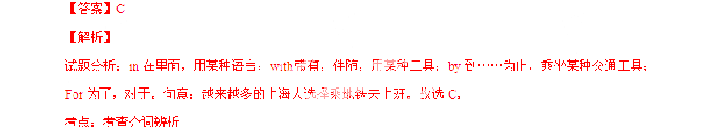
  - in B. with C. by D. for

- Students are encouraged to share their learning experience their classmates.
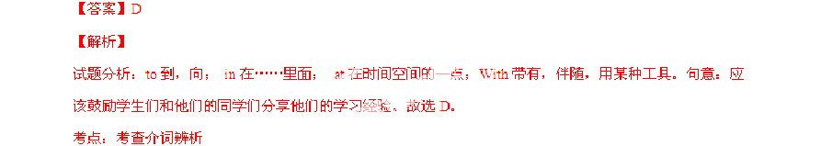
  - to B. in C. at D. with

- The traffic is moving very slowly as so many cars on their way back to Shanghai.
  - am B. is C. are D. be

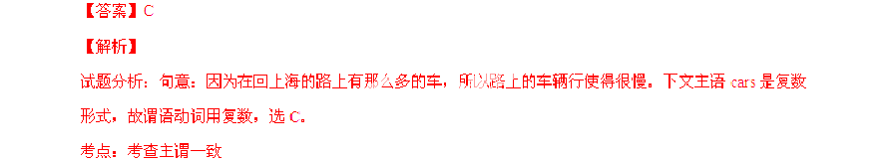
- — can you finish the report on food safety?

- In two days.

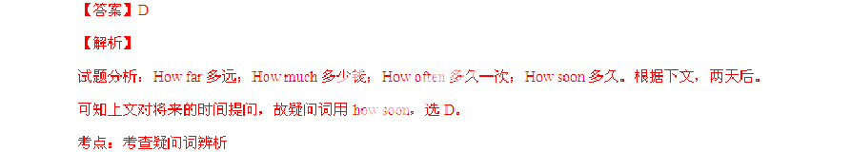
  - How far B. How much C. How often D. How soon

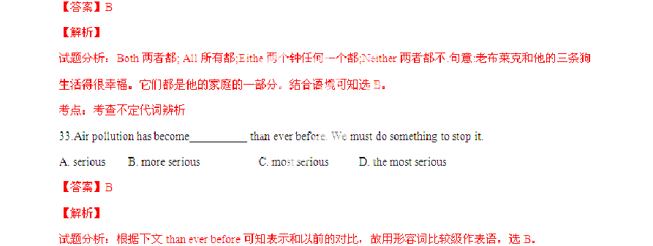
A. Both B. All C. None D. Neither
32.Old Mr. Black lives happily with his three dogs. of them are part of his family.

考点：考查比较级

- carefully, Michael! There’s a school ahead.
A. Drive B. To drive C. Drove D. Driving

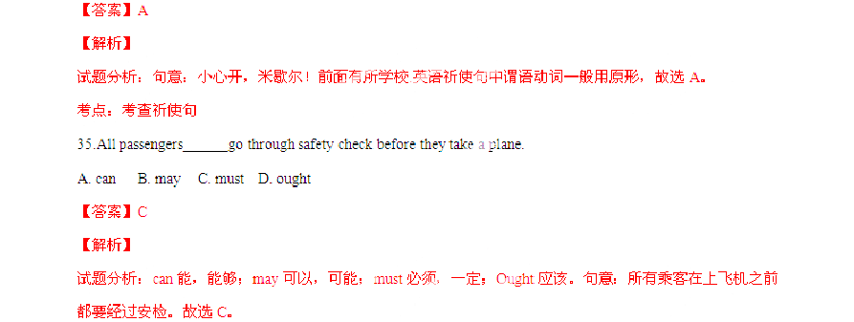
考点：考查情态动词

- — Would you like to go to the cartoon show with me?

- It sounds like fun, I’m too busy.
  - so B. for C. or D. but

【答案】D

【解析】

试题分析：so 因此；for 因为；or 或者，否则；But 但是，可是。句意：你愿意和我一起去参加卡通节目吗？——听起来很有趣，但是我太忙了。结合语境可知选D。
考点：考查连词辨析

- John didn’t give up looking for a job he got an offer from a German company.
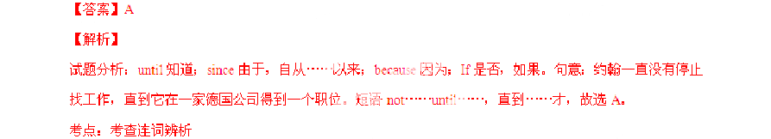
  - until B. since C. because D. if

- Aunt Lucy will tell us something about her trip to Australia when she back.
  - came B. comes C. would come D. will come

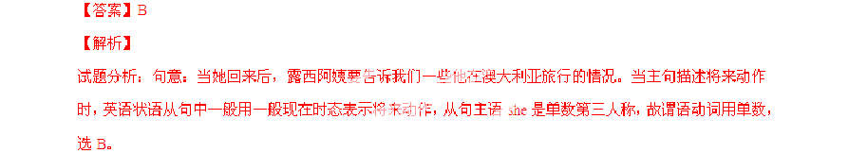
考点：考查动词时态

- The robot can help me sweep the floor.

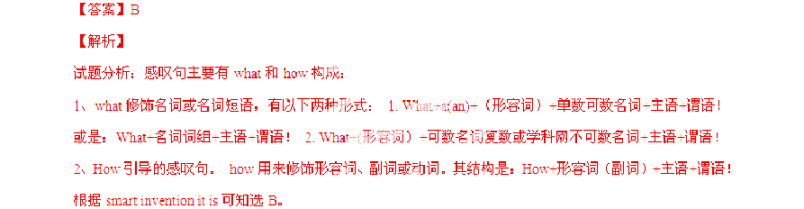
  - What B. What a C. What an D. How
smart invention it is!

考点：考查感叹句

- Susan and Lily tomatoes a nd other vegetables on the farm this time yesterday.
  - pick B. are pickingC. will pick D. were picking

【答案】D

【解析】

试题分析：根据时间状语this time yesterday 可知本句描述的是过去某时正在进行的动作，故用过去进行时态，选D。
考点：考查动词时态。

- By the end of last week, she in the west of China for two months helping the homeless children.
  - will stay B. has stayedC. would sta y D.had stayed

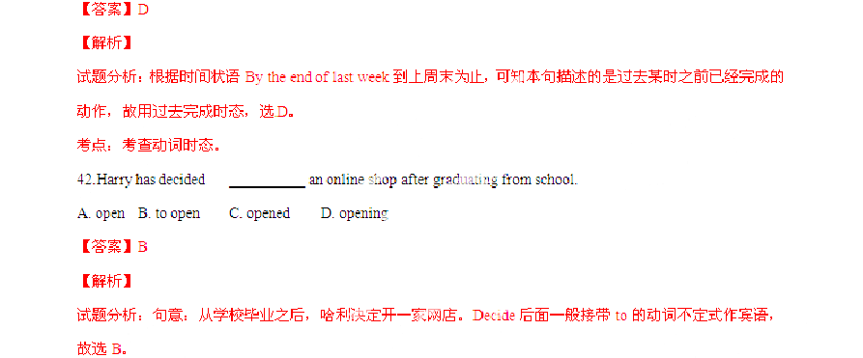
考点：考查非谓语动词

43.I wouldn’t mind a roommate. We can help each other and save money as well.
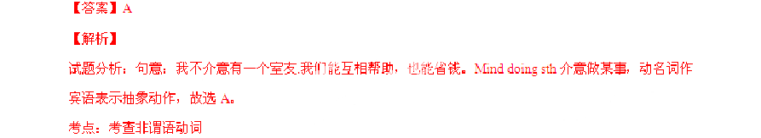
A. having B. to have C. have D. had

- — Remember to print on both sides of the paper.

— .
  - Me, too. B. Well done.C. Sure. I will. D. That's all right.

【答案】C

【解析】

试题分析：Me, too.我也是；Well done.做的不错；Sure. I will.当然了，我会的；That's all right. 那好吧。根据上文，记得在纸的两面都打印上。可知选C 最符合语境。
考点：考查交际用语

- — I was just in time to get there for the meeting. Thank you for lending me the bike.

— .
  - That’s right. B. Of course not.

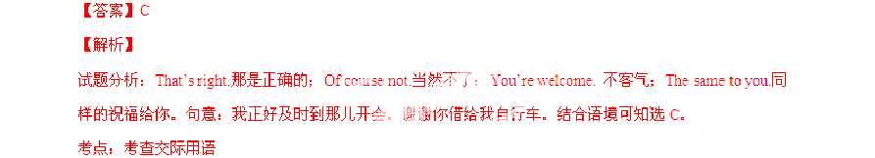
C. You’re welcome. D. The same to you.

- Complete the following passage with the words or phrase in the box. Each can only be used once（将下列单词或词组填入空格。每空格限填一词，每词只能填一次）（共8 分）

My relationship with my mother changed after I went to college. When I was at home, we【小题 1】about many things, for example, wearing makeup( 化 妆 ) and talking on the phone. One time, before a big party, she
A) behavious
B. mad
C. refused
D. argued
E) modern
【小题 2】to let me leave the house. She thought my makeup was too heavy. I had to wash my face before I went to the party. I was the only girl without makeup, and I was 【so小题 3】. And when
I talked to my friends on the phone, my mum always shouted to tell me to hang up, and the person I was talking to could hear her. Her【小题 4】always made me upset.

But
A.closer to
B. completely
C. tradition
D. together
E) advice

after a few months at college, I changed mysel【f 小题 1】. I met new people. I started learning

about history, politics, and the world. I didn’t have the time or patience for long phone conversations. I stopped caring so much about things like makeup. I once went to a party with no makeup on, but I felt fine. I just laughed about it. My new way of thinking brought me【小题 2】my mother. Now, I talk to my mother almost every day. We get along quite well. We go to movies
【小题 3】and read the same books. I tell her about my problems and she gives me go【od小题 4】. Last month, my mother helped me through a bad time. She is an amazing person. I know that now.
【答案】

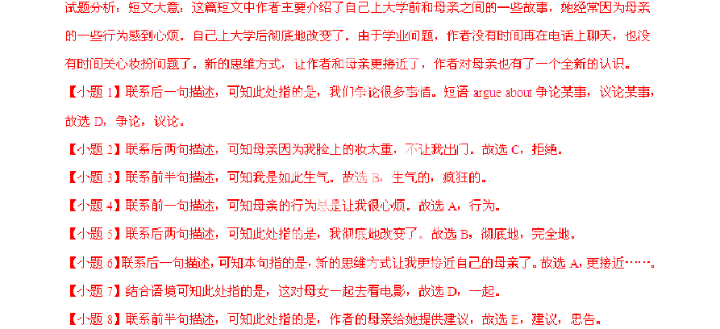
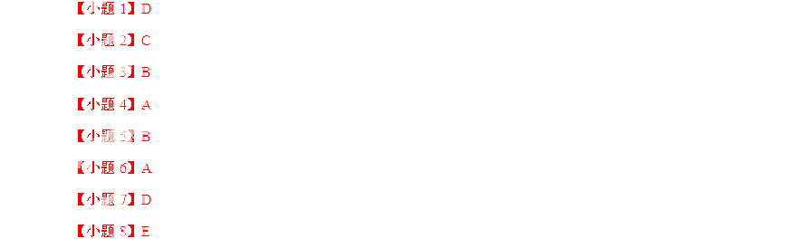
【解析】

考点：考查选词填空
- Complete the sentences with the given words intheir proper forms（用括号中所给单词的恰当形式完成下列句子。每空格限填一词）（共8 分）
【小题 1】Don’t be afraid of making . They help you learn. (mistake)
【小题 2】The medicine should be taken a day after meals, George. (two)
【小题 3】I plan to enter for a summer camp with a friend of . (me)
【小题 4】I am not satisfied with the service here. I want to speak to the . (manage)

【小题 5】The boy moved
into the hall as the concert had already begun. (quiet)

【小题 6】The soldier saved the boy from the flood with a piece of . (wooden)

以上内容仅为本文档的试下载部分，为可阅读页数的一半内容。如要下载或阅读全文，请访问：https://d.book118.com/295213040223011040

