Unit 4 Food and Restaurants
课堂同步练习
Lesson 19 I Like Fruit!
姓名： 班级：


要点图解秀
升级跷跷板

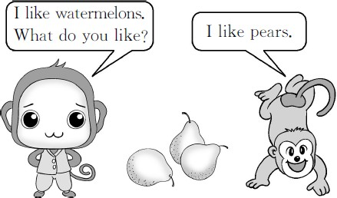

基础碰碰车

Ⅰ . 请将单词和相应的数字连线。
- 15 A. eleven
- 12 B. fourteen
- 11 C. thirteen
- 13 D. twelve
- 14 E. fifteen

Ⅱ . 小法官 , 巧判断。判断图片与句子是否相符 , 正确的打√ , 错误的打 ×。
( )1.I like apples  .

( )2.I like pears .

( )3.It᾽s an orange  .


( )4.This is a watermelon .

Ⅲ . 数一数 , 算一算 , 选择正确的数量单词。

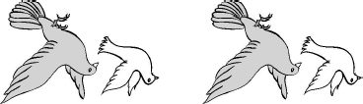
( )1. ×3=

A.eleven B.twelve


( )2. ×7=

A.fifteen B.fourteen

( )3. ×5=
A.fifteen B.ten

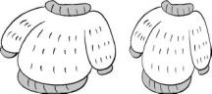
( )4. ×9=

A.seventeen B.eighteen


( )5. ×2=

A.twelve B.fifteen

Ⅳ . 根据图片 , 在横线上填上正确的单词。


1. I like .

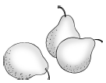
2.  I like .

3. I like .

4. 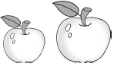 I like .

Unit 4 Food and Restaurants 课堂同步练习答案
Lesson 19 I Like Fruit! 答案 :
Ⅰ .1.E 2.D 3.A 4.C 5.B
Ⅱ .1.× 2.× 3. √ 4. √
Ⅲ .1.B 2.B 3.A 4.B 5.A
Ⅳ .1.oranges 2.watermelons 3.pears 4.apples

Unit 4 Food and Restaurants
课堂同步练习
Lesson 20 Hamburgers and Hot Dogs
姓名： 班级：

Ⅲ . 选择方框里的单词填空。
some a an
要点图解秀

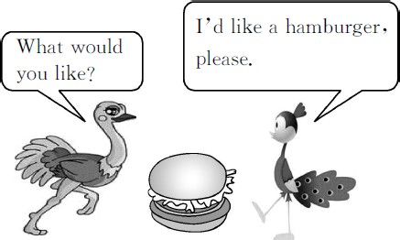
- I᾽d like bread,please.
- I᾽d like egg,please.
- I᾽d like hamburger,please.
- I᾽d like donut,please.
- I᾽d like apple,please.
- I᾽d like ice cream,please.

基础碰碰车
升级跷跷板

Ⅰ . 将图片和对应的单词连线。

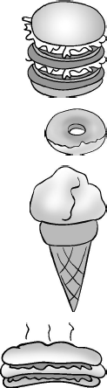
1. A.hot dog 2. B.hamburger
3. C.donut

4.
D.ice cream

Ⅱ . 小老鼠正在做算术。你来当老师, 给它判断“√”或“×”。

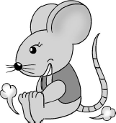
( )1.45-32=thirteen ( )2.28-12=fifteen ( )3.45-34=eleven
( )4.3+9=twelve
( )5.8+7=fourteen ( )6.5+6=ten

-1-
Ⅳ . 读句子 , 选出正确的图片。
( )1.I᾽d like a donut, please.
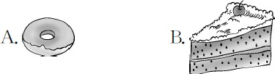

( )2.—Would you like a hot dog?
—Yes, please.

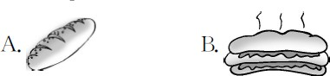

( )3.—May I have some pears?
—Sure.

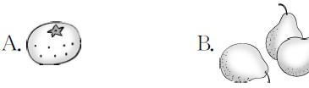

( )4.Look! This is my ice cream.

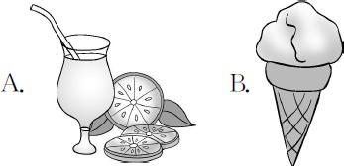

Ⅴ . 读问句 , 选择对应的答句。
( )1.What᾽s this?
A.It᾽s a donut. B.Seventeen. ( )2.What would you like?
A.I᾽d like an ice cream.
B.That᾽s what I like.
( )3.How many pears are there?
A.It᾽s seven. B.There are seven. ( )4.May I have a hot dog?
A.Sure. B.Thanks.

-2-

Unit 4 Food and Restaurants 课堂同步练习答案
Lesson 20 Hamburgers and Hot Dogs 答案 :
Ⅰ .1.B 2.C 3.D 4.A
Ⅱ .1. √ 2.× 3. √ 4. √ 5.× 6.×
Ⅲ .1.some 2.an 3.a 4.a 5.an 6.an Ⅳ .1.A 2.B 3.B 4.B
Ⅴ .1.A 2.A 3.B 4.A

Unit 4 Food and Restaurants
课堂同步练习
Lesson 21 In the Restaurant
姓名： 班级：

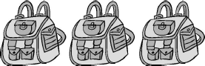
( )4. ×4=
要点图解秀
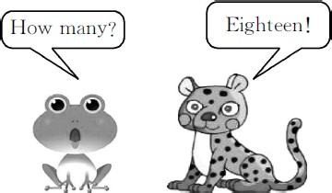

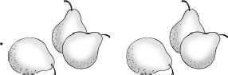
A.twelve B.thirteen ( )5. ×2=

A.fourteen B.twelve

升级跷跷板

Ⅰ . 将单词和相应的数字连线。1.sixteen A.19 2.twenty B.17 3.nineteen C.18 4.seventeen D.20 5.eighteen E.16

- . 数一数 , 选择正确的数量单词。

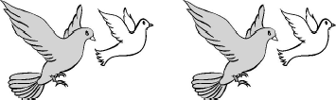
( )1. ×5=

A.eighteen B.twenty


( )2. ×8=

A.sixteen B.seventeen
Ⅲ . 算一算 , 将相应的单词序号填入星星中。

基础碰碰车
A.eighteen B.nineteen C.twenty
D.sixteen E.seventeen F.thirteen


  - four+thirteen=

2.twenty-one=

3.six+twelve=

4.ten+six=

5.three+five+eight+four=

( )3.  ×6=

A.nineteen B.eighteen

-1-

6.twenty-seven=

Ⅳ . 读句子 , 写出下列物品的数量。
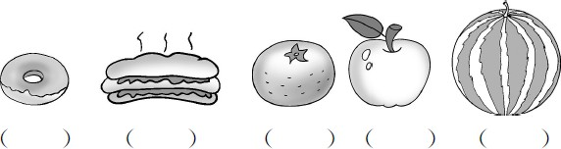

1.—How many apples are there?
—There are thirteen. 2.—How many donuts are there?
—There are nineteen.
3.—How many watermelons are there?
—There are fifteen.
4.—How many hot dogs are there?
—There are twenty.
5.—How many oranges are there?
—There are seventeen.

-2-

Unit 4 Food and Restaurants 课堂同步练习Lesson 21 In the Restaurant
答案
Ⅰ .1.E | 2.D | 3.A | 4.B | 5.C
Ⅱ .1.B | 2.A | 3.B | 4.A | 5.B
Ⅲ .1.E | 2.B | 3.A | 4.D | 5.C 6.F
Ⅳ .19, 20, 17, 13, 15

Unit 4 Food and Restaurants
课堂同步练习
Lesson 22 How Much Is It?
姓名： 班级：
要点图解秀
升级跷跷板

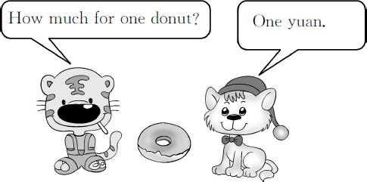

基础碰碰车

Ⅰ . 根据中文释义 , 选择对应的选项。
( )1. 热狗多少钱一个 ?
A.How much is this hamburger?
B.How much for one hot dog? ( )2. 我要 13 个面包圈。
A.I᾽ll take fifteen hot dogs.
B.I᾽ll take thirteen donuts. ( )3. 我的朋友喜欢汉堡包。
A.My friends like hamburgers.
B.My friends like ice cream. ( )4. 你想要什么 ?
A.What would you like?
B.How much is it?

Ⅱ . 单项选择。
( )1. donuts do you want?
A.How many B.How much ( )2. for one donut?
A.How many B.How much ( )3.My sister hot dogs.
A.like B.likes
( )4.I᾽ll six hamburgers.
A.take B.want

Ⅲ . 读问句 , 选择对应的答句。
( )1.How much for one hamburger?
A.Five yuan. B.Thanks. ( )2.How many donuts are there?
A.One yuan. B.Nineteen. ( )3.What would you like?
A.I like it. B.I᾽d like an egg. ( )4.Do you know the donut man?
A.No,it᾽s me. B.Yes,he᾽s there. ( )5.Do you like an ice cream?
A.Yes,I do. B.Yes,I am.

Ⅳ . 根据给出的情景 , 选择正确的句子。
( )1. 你想知道一个热狗多少钱 , 你这样问 :
A.How much for one hot dog?
B.How much is that hamburger?
( )2. 你告诉同学一个面包圈是一元 , 你这样说 :
A.Five yuan for one hamburger.
B.One yuan for one donut.
( )3. 你问妹妹想吃什么 , 你这样问 :
A.What colour do you like?
B.What would you like?
( )4. 你告诉营业员你想买十五个汉堡包 , 你这样
说 :
A.I᾽ll take fifteen hamburgers,please.
B.I᾽ll take fourteen donuts,please.
( )5. 你告诉妈妈你喜欢吃冰淇淋 , 你这样说 :
A.I like hot dogs,Mum.
B.I like ice cream,Mum.

Unit 4 Food and Restaurants 课堂同步练习答案
Lesson 22 How Much Is It?

答案 :
Ⅰ .1.B | 2.B | 3.A | 4.A
Ⅱ .1.A | 2.B | 3.B | 4.A
Ⅲ .1.A | 2.B | 3.B | 4.B 5.A
Ⅳ .1.A | 2.B | 3.B | 4.A 5.B

以上内容仅为本文档的试下载部分，为可阅读页数的一半内容。如要下载或阅读全文，请访问：https://d.book118.com/315144221124011114

