Chapter 5

Discussion Questions
5-1. Discuss the various uses for break-even analysis.

Such analysis allows the firm to determine at what level of operations it will break even and to explore the relationship between volume, costs, and profits.

5-2.

5-3.

5-4.

5-5.
What factors would cause a difference in the use of financial leverage for a utility company and an automobile company?

A utility is in a stable, predictable industry and therefore can afford to use more financial leverage than an automobile company, which is generally subject to the influences of the business cycle. An automobile manufacturer may not be able to service a large amount of debt when there is a downturn in the economy.

Explain how the break-even point and operating leverage are affected by the choice of manufacturing facilities (labor intensive versus capital intensive).

A labor-intensive company will have low fixed costs and a correspondingly low break-even point. However, the impact of operating leverage on the firm is small and there will be little magnification of profits as volume increases. A capital-intensive firm, on the other hand, will have a higher break-even point and enjoy the positive influences of operating leverage as volume increases.

What role does depreciation play in break-even analysis based on accounting flows? Based on cash flows? Which perspective is longer term in nature?

For break-even analysis based on accounting flows, depreciation is considered part of fixed costs. For cash flow purposes, it is eliminated from fixed costs.

The accounting flows perspective is longer-term in nature because we must consider the problems of equipment replacement.

What does risk taking have to do with the use of operating and financial leverage?

Both operating and financial leverage imply that the firm will employ a heavy component of fixed cost resources. This is inherently risky because the obligation to make payments remains regardless of the condition of the company or the economy.

5-6.

5-7.

5-8.

5-9.

5-10.
Discuss the limitations of financial leverage.

Debt can only be used up to a point. Beyond that, financial leverage tends to increase the overall costs of financing to the firm as well as encourage creditors to place restrictions on the firm. The limitations of using financial leverage tend to be greatest in industries that are highly cyclical in nature.

How does the interest rate on new debt influence the use of financial leverage?

The higher the interest rate on new debt, the less attractive financial leverage is to the firm.

Explain how combined leverage brings together operating income and earnings per share.

Operating leverage primarily affects the operating income of the firm. At this point, financial leverage takes over and determines the overall impact on earnings per share. A delineation of the combined effect of operating and financial leverage is presented in Table 5-6 and Figure 5-5.

Explain why operating leverage decreases as a company increases sales and shifts away from the break-even point.

At progressively higher levels of operations than the break-even point, the percentage change in operating income as a result of a percentage change in unit volume diminishes. The reason is primarily mathematical — as we move to increasingly higher levels of operating income, the percentage change from the higher base is likely to be less.

When you are considering two different financing plans, does being at the level where earnings per share are equal between the two plans always mean you are indifferent as to which plan is selected?

The point of equality only measures indifference based on earnings per share. Since our ultimate goal is market value maximization, we must also be concerned with how these earnings are valued. Two plans that have the same earnings per share may call for different price-earnings ratios, particularly when there is a differential risk component involved because of debt.

Problems
5-1. Gateway Appliance toasters sell for $20 per unit, and the variable cost to produce them is $15. Gateway estimates that the fixed costs are $80,000.

- Compute the break-even point in units.
- Fill in the table below (in dollars) to illustrate that the break-even point has been achieved.

Solution:

a. BE =
Sales
–Fixed costs
–total variable costs
Net profit (loss)

Gateway Appliance

Fixed costs
Price - variable cost per unit

= $80,000 = $80,000

= 16,000 units

$20 − $15 $5

b. | Sales | $320,000 (16,000 units x $20)
 | –Fixed costs | 80,000
 | –Total variable costs | 240,000 (16,000 units x $15)
 | Net profit (loss) | $ 0

5-2. Hazardous Toys Company produces boomerangs that sell for $8 each and have a variable cost of $7.50. Fixed costs are $15,000.

Solution:
- Compute the break-even point in units.
- Find the sales (in units) needed to earn a profit of $25,000.

The Hazardous Toys Company

- BE =
$15,000
$8.00 − $7.50
= 30,000 units

- Q =
Profit + FC = $25,000 + $15,000

(P − VC) $8.00 − $7.50

= $40,000 = 80,000 units
$.50

5-3. Ensco Lighting Company has fixed costs of $100,000, sells its units for $28 and has variable costs of $15.50 per unit.

Solution:
- Compute the breakeven point.
- Ms. Watts comes up with a new plan to cut fixed costs to $75,000. However, more labor will now be required, which will increase variable costs per unit to $17. The sales price will remain at $28. What is the new breakeven point?
- Under the new plan, what is likely to happen to profitability at very high volume levels (compared to the old plan)?

a.
BE =

Ensco Lighting Company

Fixed costs
Price − variable cost per unit

= $100,000 = $100,000

= 8,000 units

$28 − $15.50 $12.50

b.
BE =

Fixed costs
Price − variable cost per unit

= $75,000
= $75,000
= 6,818 units

$28 − $17 $11

The breakeven level decreases.

c. With less operating leverage and a smaller contribution margin, profitability is likely to be less at very high volume levels.

5-4. Air Filter, Inc. sells its products for $6 per unit. It has the following costs:

Rent $100,000
Factory labor $1.20 per unit Executive salaries $89,000
Raw material $ .60 per unit

Solution:
Separate the expenses between fixed and variable cost per unit. Using this information and the sales price per unit of $6, compute the break-even point.

Air Filter, Inc.

 |  |  |  | Fixed Costs | Variable Costs (per  unit)
Rent |  |  |  | $100,000
Factory labor Executive salaries  Raw materials |  |  |  | $89,000 | $1.20  .60
 |  |  |  | $189,000 | $1.80
BE = | FC  P − VC | = | $189,000  $6.00 − $1.80 | = $189,000 = 45,000 units  $4.20

5-5. Shawn Penn & Pencil Sets, Inc. has fixed costs of $80,000. Its product currently sells for $5 per unit and has variable costs of $2.50 per unit. Mr. Bic, the head of manufacturing, proposes to buy new equipment that will cost $400,000 and drive up fixed costs to $120,000. Although the price will remain at $5 per unit, the increased automation will reduce variable costs per unit to $2.00.

Solution:
As a result of Bic's suggestion, will the break-even point go up or down? Compute the necessary numbers.

Shawn Penn & Pencil Sets, Inc.

BE (before) =
$80,000 = $80,000
= 32,000 units

$5.00 − $2.50 $2.50

BE (after) =
$120,000
= $120,000
= 40,000 units

$5.00 − $2.00 $3.00

The break-even point will go up.

5-6. Gibson & Sons, an appliance manufacturer, computes its break-even point strictly on the basis of cash expenditures related to fixed costs. Its total fixed costs are $1,200,000, but 25 percent of this value is represented by depreciation. Its contribution margin (price minus variable cost) for each unit is $2.40. How many units does the firm need to sell to reach the cash break-even point?

Solution:
Gibson & Sons

Cash related fixed costs = Total Fixed Costs – Depreciation
= $1,200,000 – 25% ($1,200,000)
= $1,200,000 – $300,000
= $900,000

BE =
$900,000
$2.40
= 375,000 units

5-7. Draw two break-even graphs—one for a conservative firm using labor-intensive production and another for a capital-intensive firm. Assuming these companies compete within the same industry and have identical sales, explain the impact of changes in sales volume on both firms' profits.

Solution:

Labor-Intensive and capital-intensive break-even graphs

Labor-Intensive

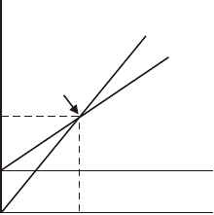Revenue and costs
Total revenue
Profits
Total costs
BE
Variable cost
Capital-Intensive

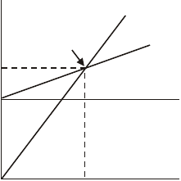Revenue and costs
Total revenue
BE
Profits
Total costs
Variable cost

Fixed costs

Units produced and sold Units produced and sold

The company having the high fixed costs will have lower variable costs than its competitor since it has substituted capital for labor. With a lower variable cost, the high fixed cost company will have a larger contribution margin. Therefore, when sales rise, its profits will increase faster than the low fixed cost firm and when the sales decline, the reverse will be true.

5-8. The Sosa Company produces baseball gloves. The company’s income statement
for 2004 is as follows:

Sosa Company Income Statement
For the Year Ended December 31, 2004

 | Sales (20,000 gloves at $60 each) ...................... | $1,200,000
 | Less: Variable costs (20,000 gloves at  $20) ....................................................................  Fixed costs...................................................... | 400,000  600,000
 | Earnings before interest and taxes (EBIT) ......... | 200,000
 | Interest expense.................................................. | 80,000
 | Earnings before taxes (EBT).............................. | 120,000
 | Income tax expense (30%) ................................. | 36,000
 | Earnings after taxes (EAT)................................. | $ 84,000
 | Given this income statement, compute the following:
- Degree of operating leverage.
- Degree of financial leverage.
- Degree of combined leverage.
Solution: | Sosa Company

Q = 20,000, P = $60, VC = $20, FC = $600,000, I = $80,000
Q (P − VC)
- DOL = Q (P − VC)− FC

20,000 ($60 − $20)
=
20,000 ($60 − $20)− $600,000
20,000 ($40)
=
20,000 ($40)− $600,000

5-8. Continued

=

$800,000

= $800,000

= 4.00x

$800,000 − $600,000 $200,000

- DFL =
EBIT = $200,000

EBIT − I $200,000 − $80,000

= $200,000
$120,000
= 1.67x

Q (P − VC)
- DCL = Q (P − VC)− FC − I

= ( 20,000 ($60 − $20)
20,000 $60 − $20)− $600,000 − $80,000

$200,000($40)
= $20,000($40)− $680,000

= $800,000 = 6.67x
$120,000

5-9. The Harmon Company manufactures skates. The company's income statement for 2004 is as follows:

Harmon Company Income Statement
For the Year Ended December 31, 2004

 | Sales (30,000 skates @ $25 each)........................... | $750,000
 | Less: Variable costs (30,000 skates at $7) ............ | 210,000
 | Fixed costs .......................................................... | 270,000
 | Earnings before interest and taxes (EBIT).............. | 270,000
 | Interest expense....................................................... | 170,000
 | Earnings before taxes (EBT)................................... | 100,000
 | Income tax expense (35%)...................................... | 35,000
 | Earnings after taxes (EAT) ..................................... | $65,000
 | Given this income statement, compute the following:
- Degree of operating leverage.
- Degree of financial leverage.
- Degree of combined leverage.
- Break-even point in units.
Solution: | Harmon Company

Q = 30,000, P = $25, VC = $7, FC = $270,000, I = $170,000
Q (P − VC)
- DOL = Q (P − VC)− FC

30,000 ($25 − $7)
=
30,000 ($25 − $7)− $270,000
30,000 ($18)
=
30,000 ($18)− $270,000

5-9. Continued

=

$540,000

= $540,000

= 2x

$540,000 − $270,000 $270,000

- DFL =
EBIT = $270,000

EBIT − I $270,000 − $170,000

= $270,000
$100,000
= 2.7x

Q (P − VC)
- DCL = Q (P − VC)− FC − I

= ( 30,000 ($25 − $7)
30,000 $25 − $7)− $270,000 − $170,000

30,000 ($18) $540,000

= 30,000 ($18)− $440,000 = $100,000
= 5.4x

- BE =
$270,000
$25 − $7
= 15,000 units

5-10. University Catering sells 50-pound bags of popcorn to university dormitories for
$10 a bag. The fixed costs of this operation are $80,000, while the variable costs of the popcorn are $.10 per pound.

Solution:
- What is the break-even point in bags?
- Calculate the profit or loss on 12,000 bags and 25,000 bags.
- What is the degree of operating leverage at 20,000 bags and 25,000 bags? Why does the degree of operating leverage change as the quantity sold increases?
- If University Catering has an annual interest payment of $10,000, calculate the degree of financial leverage at both 20,000 and 25,000 bags.
- What is the degree of combined leverage at both sales levels?

University Catering

  - BE =
$80,000 = $80,000
= 16,000 bags

$10 − ($.10 × 50) $5

b. |  | 12,000 bags | 25,000 bags
 | Sales @ $10 per bag | $120,000 | $250,000
 | Less: Variables Costs ($5) | (60,000) | (125,000)
 | Fixed Costs | (80,000) | (80,000)
 | Profit or Loss | ($ 20,000) | $ 45,000

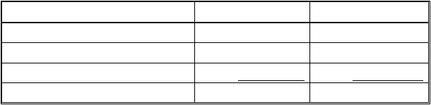
Q (P − VC)
- DOL = Q (P − VC)− FC
20,000 ($10 − $5) DOL at 20,000 = 20,000 ($10 - $5)− $80,000

= $100,000 = 5.00x
$20,000

5-10. Continued

25,000 ($10 − $5)

DOL at 25,000 = 25,000 ($10 - $5)− $80,000

= $125,000 = 2.78x
$45,000

Leverage goes down because we are further away from the break-even point, thus the firm is operating on a larger profit base and leverage is reduced.

- DFL =
EBIT EBIT − I

First determine the profit or loss (EBIT) at 20,000 bags. As indicated in part b, the profit (EBIT) at 25,000 bags is $45,000:

Sales @ $10 per bag | $200,000
Less: Variable Costs ($5) | 100,000
Fixed Costs | 80,000
Profit or Loss | $ 20,000

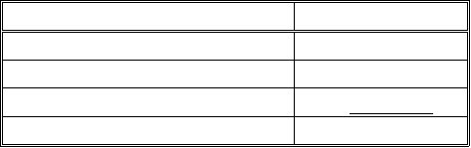DFL at 20,000 = $20,000
20,000 bags
$20,000 − $10,000

= 2.0x

5-10. Continued

DFL at 25,000 =

$45,000
$45,000 − $10,000

= 1.29x
Q (P − VC)
- DCL = Q (P − VC)− FC − I

20,000 ($10 − $5)

DCL at 20,000 = 20,000 ($10 - $5)− $80,000 − $10,000

= $100,000
$10,000
= 10.0x

25,000 ($10 − $5)

DCL at 25,000 = 25,000 ($10 − $5)− $80,000 − $10,000

= $125,000
$35,000
= 3.57x

5-11. Leno’s Drug Stores and Hall’s Pharmaceuticals are competitors in the discount
drug chain store business. The separate capital structures for Leno and Hall are presented below.

Leno Hall
Debt @ 10% ....................... $100,000 Debt @ 10% $200,000
Common stock, $10 par ..... 200,000 Common stock, $10 par 100,000
Total ................................. $300,000 Total $300,000
Shares ................................. 20,000 Common shares 10,000

5-11. Continued

Solution:
- Compute earnings per share if earnings before interest and taxes are $20,000,
$30,000, and $120,000 (assume a 30 percent tax rate).
- Explain the relationship between earnings per share and the level of EBIT.
- If the cost of debt went up to 12 percent and all other factors remained equal, what would be the break-even level for EBIT?

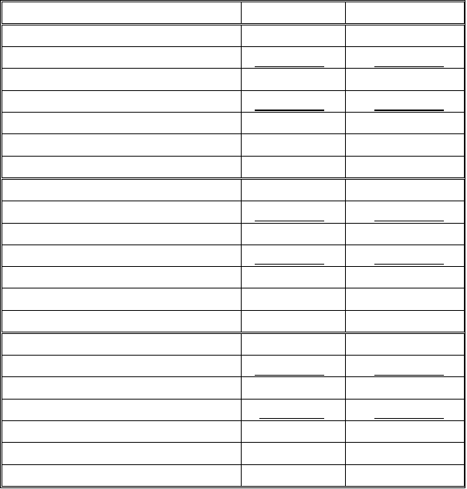
Leno Drug Stores and Hall Pharmaceuticals

a. |  | Leno | Hall
 | EBIT | $ 20,000 | $ 20,000
 | Less: Interest | 10,000 | 20,000
 | EBT | 10,000 | 0
 | Less: Taxes @ 30% | 3,000 | 0
 | EAT | 7,000 | 0
 | Shares | 20,000 | 10,000
 | EPS | $.35 | 0
 | EBIT | $ 30,000 | $ 30,000
 | Less: Interest | 10,000 | 20,000
 | EBT | 20,000 | 10,000
 | Less: Taxes @ 30% | 6,000 | 3,000
 | EAT | 14,000 | 7,000
 | Shares | 20,000 | 10,000
 | EPS | $.70 | $.70
 | EBIT | $120,000 | $120,000
 | Less: Interest | 10000 | 20,000
 | EBT | 110,000 | 100,000
 | Less: Taxes @ 30% | 33,000 | 30,000
 | EAT | 77,000 | 70,000
 | Shares | 20,000 | 10,000
 | EPS | $3.85 | $7.00

5-11. Continued

b. Before-tax return on assets = 6.67%, 10% and 40% at the respective levels of EBIT. When the before-tax return on assets (EBIT/Total Assets) is less than the cost of debt (10%), Leno does better with less debt than Hall. When before-tax return on assets is equal to the cost of debt, both firms have equal EPS. This would be where the method of financing has a neutral effect on EPS. As return on assets becomes greater than the interest rate, financial leverage becomes more favorable for Hall.

c. 12% x $300,000 = $36,000 break-even level for EBIT.

5-12. In Problem 11, compute the stock price for Hall Pharmaceuticals if it sells at 13 times earnings per share and EBIT is $80,000.

Solution:

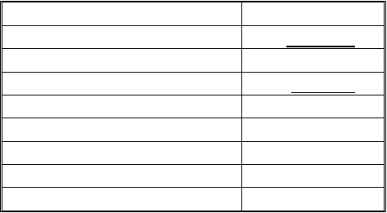
Hall Pharmaceuticals (Continued)

EBIT | $80,000
Less: Interest | 20,000
EBT | $60,000
Less: Taxes @ 30% | 18,000
EAT | $42,000
Shares | 10,000
EPS | $ 4.20
P/E | 13x
Stock Price | $ 54.60

5-13. Pulp Paper Company and Holt Paper Company are able to generate earnings before interest and taxes of $150,000.

The separate capital structures for Pulp and Holt are shown below:

Pulp |  | Holt
Debt @ 10% $ | 800,000 | Debt @ 10%.................. | $ 400,000
Common stock, $5 par .... | 700,000 | Common stock, $5 par .. | 1,100,000
Total $1,500,000 |  | Total ............................ | $1,500,000
Common shares............... 140,000 |  | Common shares............. | 220,000

  - Compute earnings per share for both firms. Assume a 40 percent tax rate.
  - In part a, you should have gotten the same answer for both companies' earnings per share. Assume a P/E ratio of 20 for each company, what would its stock price be?
  - Now as part of your analysis, assume the P/E ratio would be 15 for the riskier company in terms of heavy debt utilization in the capital structure and 26 for the less risky company. What would the stock prices for the two firms be under these assumptions? (Note: Although interest rates also would likely be different based on risk, we hold them constant for ease of analysis).
  - Based on the evidence in part c, should management only be concerned about the impact of financing plans on earnings per share or should stockholders' wealth maximization (stock price) be considered as well?

Copyright © 2005 by The McGraw-Hill Companies, Inc.S-176

Solution:

Pulp Paper Company and Holt Paper Company
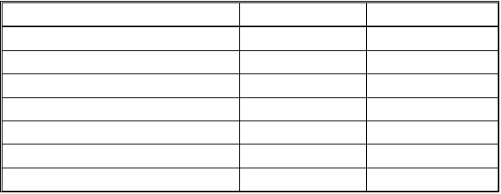a.
Pulp
Holt

EBIT | $150,000 | $150,000
Less: Interest | 80,000 | 40,000
EBT | 70,000 | 110,000
Less: Taxes @ 40% | 28,000 | 44,000
EAT | 42,000 | 66,000
Shares | 140,000 | 220,000
EPS | $.30 | $.30

- Stock price = P/E x EPS
20 x $.30 = $6.00

- Pulp
15 x $.30 = $4.50
Holt
26 x $.30 = $7.80

- Clearly, the ultimate objective should be to maximize the stock price. While management would be indifferent between the two plans based on earnings per share, Holt Paper, with the less risky plan, has a higher stock price.

5-14. Firms in Japan often employ both high operating and financial leverage because of the use of modern technology and close borrower-lender relationships.
Assume the Susaki Company has a sales volume of 100,000 units at a price of
$25 per unit; variable costs are $5 per unit and fixed costs are $1,500,000. Interest expense is $250,000. What is the degree of combined leverage for this Japanese firm?

Solution:

DCL =

Susaki Company
Q (P − VC)
Q (P − VC)− FC − I

= ( 100,000 ($25 − $5)
100,000 $25 − $5)− $1,500,000 − $250,000

100,000 ($20)
=
100,000 ($20)− $1,750,000

= $2,000,000 = $2,000,000

= 8x

$2,000,000 − $1,750,000 250,000

Copyright 2005 by The McGraw-Hill Companies, SI-n1c7.8

5-15. Glynn Enterprises and Monroe, Inc., both produce fluid control products. Their financial information is as follows:

Capital Structure

Glynn Monroe
Debt @ 10% .................................................. | $1,500,000 | 0
Common stock, $10 per share....................... | 500,000 | $2,000,000
 | $2,000,000 | $2,000,000
Common shares............................................. | 50,000 | 200,000

Operating Plan

Sales (200,000 units at $5 each).................... | $1,000,000 | $1,000,000
Less: Variable costs..................................... | 600,000 | 200,000
 | ($3 per unit) | ($1 per unit)
Fixed costs................................................. | 0 | 400,000
Earnings before interest and taxes (EBIT).... | $ 400,000 | $ 400,000

  - If you combine Glynn’s capital structure with Monroe’s operating plan, what
is the degree of combined leverage?
  - If you combine Monroe’s capital structure with Glynn’s operating plan, what
is the degree of combined leverage?
  - Explain why you got the results you did in part b.
  - In part b, if sales double, by what percent will EPS increase?

5-15. Continued

Solution:

Glynn Enterprises and Monroe, Inc.
Q (P − VC)

- DCL = Q (P − VC)− FC − I

= ( 200,000 ($5 − $1)
200,000 $5 − $1)− $400,000 − $150,000

200,000($4)
= $200,000($4)− $550,000

= $800,000
$250,000
= 3.20x

Q (P − VC)
- DCL = Q (P − VC)− FC − I
200,000 ($5 − $3)
=
200,000 ($5 − $3)− 0 − 0
200,000 ($2)
= 200,000 ($2)

= $400,000
$400,000
= 1x

Copyright 2005 by The McGraw-Hill Companies, SI-n1c8.0

5-15. Continued
- The combined leverage is fairly high in part a because you are combining firms that both use operating and financial leverage. However, the leverage factor is only one in part b because Monroe has no financial leverage and Glynn has no operating leverage.

d.

5-16.
EPS will increase by 100 percent. However, there is no leverage involved. EPS merely grows at the same rate as sales.

DeSoto Tools, Inc., is planning to expand production. The expansion will cost
$300,000, which can be financed either by bonds at an interest rate of 14 percent or by selling 10,000 shares of common stock at $30 per share. The current income statement before expansion is as follows:

DeSoto Tools, Inc. Income Statement 199X

Sales .............................................................. |  | $1,500,000
Less: Variable costs..................................... | $ 450,000
Fixed costs................................................. | 550,000 | 1,000,000
Earnings before interest and taxes................. |  | 500,000
Less: Interest expense ................................. |  | 100,000
Earnings before taxes .................................... |  | 400,000
Less: Taxes @ 34%..................................... |  | 136,000
Earnings after taxes ....................................... |  | $ 264,000
Shares ............................................................ |  | 100,000
Earnings per share ......................................... |  | $2.64

After the expansion, sales are expected to increase by $1,000,000. Variable costs will remain 30 percent of sales, and fixed costs will increase to $800,000. The tax rate is 34 percent.

  - Calculate the degree of operating leverage, the degree of financial leverage, and the degree of combined leverage before expansion. (For the degree of operating leverage, use the formula developed in footnote 2; for the degree of combined leverage, use the formula developed in footnote 3. These instructions apply throughout this problem.)

以上内容仅为本文档的试下载部分，为可阅读页数的一半内容。如要下载或阅读全文，请访问：https://d.book118.com/315214202013011034

