Unit 1 Hello Again!
课堂同步练习
Lesson 1 How Are You?
姓名： 班级：


要点图解秀

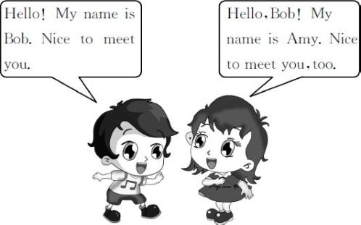

基础碰碰车

Ⅰ . 选出正确的字母或字母组合 , 将下列单词补充完整。
( )1.n me
A.a B.e C.o ( )2.m t
A.aa B.ae C.ee ( )3.f ne
A.e B.i C.u ( )4.t cher
A.ee B.ea C.ae ( )5.y
A.uor B.our C.rou ( )6.h llo
A.e B.o C.u ( )7.fr nd
A.ei B.ie C.ae ( )8.n ce
A.o B.i C.a
Ⅱ . 根据中文释义 , 选择对应的选项。
( )1. 欢迎回到学校 !
A.Wele to my home!
B.Wele back to school! ( )2. 你可以叫我吉姆。
A.You can call me Jim.
B.My name is Jim. ( )3. 很高兴见到你。
A.How are you?
B.Nice to meet you. ( )4. 他是一名新学生。
A.He is a new pupil.
B.He is a new teacher. ( )5. 这些是我的朋友。
A.These are my books.
B.These are my friends.

升级跷跷板

Ⅲ . 我会选择正确答案 , 并将序号填在题前的括号里。
( )1.—Hello,Jim!
— ,Li Lei.
A.Good morning B.Hello C.Goodbye ( )2.I your new teacher. My name
James Wood.
A.am;is B.are;is C.am;are ( )3.—Hi,Kate.How are you?
—
A.How are you,Jack?
B.Hi,I᾽m Jack.
C.Fine,thank you.

-1-

( )4.You can me Mr.Wood.
A.thank B.call C.take ( )5.—Nice to meet you.
— .
A.My name is Kim
B.Nice to meet you,too
C.Thank you
( )6.This is my friend. name is
Jenny.
A.Your B.His C.Her
Ⅳ . 补全对话 , 每空一词。Li Hua: 1 ! Tom. Tom:Hello! Li Hua.
Li Hua:Tom,this 2 Wang Lin.Wang Lin, 3 is
Tom Green.
Tom:Hello! Wang Lin! Nice to 4 you. Wang Lin:Hello! Tom! Nice 5 meet you,
6 .How 7 you? Tom: 8 ,thanks. 9 you?
Wang Lin:I᾽m very 10 ,thank you.
1. 2. 3. 4.
5. 6. 7. 8.
9. 10.

-2-

Unit 1 Hello Again! 课堂同步练习答案
Lesson 1 How Are You?

答案 :
Ⅰ .1.A | 2.C | 3.B | 4.B | 5.B 6.A 7.B 8.B
Ⅱ .1.B | 2.A | 3.B | 4.A | 5.B
Ⅲ .1.B | 2.A | 3.C | 4.B | 5.B 6.C
Ⅳ .1.Hello 2.is 3.this 4.meet 5.to 6.too 7.are 8.Fine 9.And 10.well

Unit 1 Hello Again!
课堂同步练习
Lesson 2 Is This Your Pencil?
姓名： 班级：

( )5.Is this your apple?
要点图解秀
( )6.What᾽s in your pencil box?
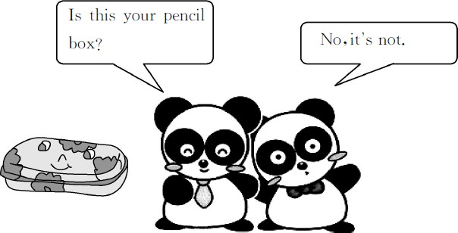
A.Fine,thank you.And you?
B.No,it isn᾽t. C.Hello,Li Lei!
D.A ruler and five pencils. E.Nice to meet you,too.
F.It᾽s Kate᾽s.

基础碰碰车
升级跷跷板

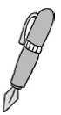Ⅰ . 看图片 , 写单词。
2.


1.


3. 4.

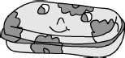
5.

- . 从方框中找出下列各句的最佳答语。
( )1.Hello,Jim!
( )2.How are you,Bill?
( )3.Whose book is this? ( )4.Nice to meet you.
Ⅲ . 我会选择正确答案 , 并将序号填在题前的括号里。
( )1.—Is this English book?
—Yes, is.
A.you;this B.your;this C.your;it ( )2.— pencil box is this?
—It᾽s Danny᾽s.
A.Where B.Whose C.What ( )3.—Is this Steven᾽s ruler?
—No.It isn᾽t ruler.
A.your B.her C.his

Ⅳ . 模仿例句用 Yes 或 No 回答以下问题。
Example:
Is this your book? √ Yes,it is.It᾽s my book. Is this Mike᾽s car?× No,it isn᾽t.It isn᾽t his
car.
  - Is this Danny᾽s ruler? √ 2.Is it Jenny᾽s dog?× 3.Is this your school? √
4.Is it Steven᾽s pencil box?× 5.Is it Kim᾽s pencil? √

Unit 1 Hello Again! 课堂同步练习答案
Lesson 2 Is This Your Pencil? 答案 :
Ⅰ .1.pencil 2.pen 3.ruler 4.crayons 5.pencil box Ⅱ .1.C 2.A 3.F 4.E 5.B 6.D
Ⅲ .1.C 2.B 3.C
Ⅳ .1.Yes,it is.It᾽s his ruler. 2.No,it isn᾽t.It isn᾽t her dog.
3.Yes,it is.It᾽s my school. 4.No,it isn᾽t.It isn᾽t his pencil box.
5.Yes,it is.It᾽s her pencil.

Unit 1 Hello Again!
课堂同步练习
Lesson 3 Where Are They?
姓名： 班级：

( )3.The panda is the ball.
要点图解秀

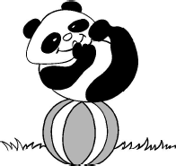
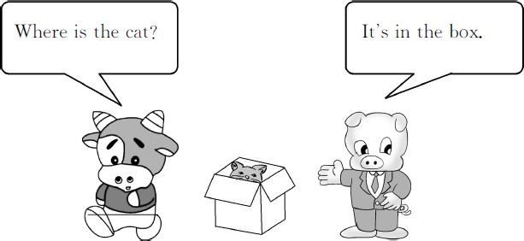
A.on B.under

( )4.Jenny is Li Ming and Mr.Wood.
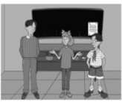
A.beside B.between

基础碰碰车
升级跷跷板

Ⅰ . 读单词 , 选择对应的图片。

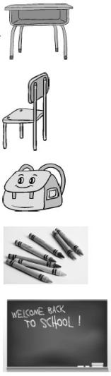
( )1. blackboard A. ( )2. crayons B.
( )3. desk C.

( )4. schoolbag D.

( )5. chair E.

Ⅱ . 看图 , 选择正确的方位词填空。
( )1.The pencils are the pencil box.

A.on B.in 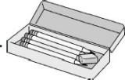
( )2.The cat is the chair.

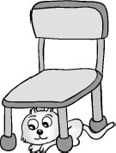
A.under B.beside

-1-
Ⅲ . 根据中文释义 , 选择对应的选项。
( )1. 在书桌上面
A.on the desk B.in the desk ( )2. 在盒子下面
A.under the box B.beside the box ( )3. 在书包里面
A.on the blackboard
B.in the schoolbag ( )4. 在课桌和椅子之间
A.between the desk and the chair
B.beside the desk and the chair

Ⅳ . 你来当导演 , 选择正确的对话给下面的图片配音。

A.—Where is the pencil?
—It᾽s in the box.

B.—Where is Amy?
—She᾽s under the desk.

C.—Where is the schoolbag?
—It᾽s beside the chair.

D.—Where is the apple?
—It᾽s on the books.

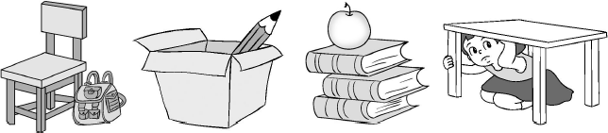
1.( ) 2.( ) 3.( ) 4.( )

-2-

Unit 1 Hello Again! 课堂同步练习Lesson 3 Where Are They?
答案
Ⅰ .1.E | 2.D | 3.A | 4.C 5.B
Ⅱ .1.B | 2.A | 3.A | 4.B
Ⅲ .1.A | 2.A | 3.B | 4.A
Ⅳ .1.C | 2.A | 3.D | 4.B

Unit 1 Hello Again!
课堂同步练习
Lesson 4 How Many Books Are There?
姓名： 班级：

( )4.eleven crayons
要点图解秀

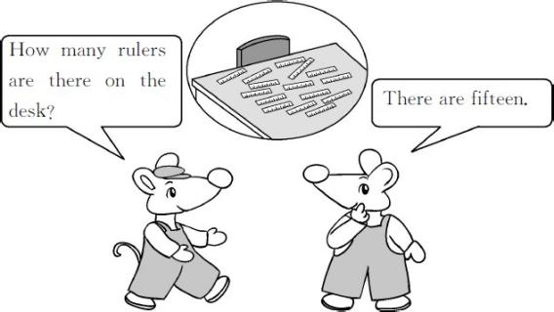
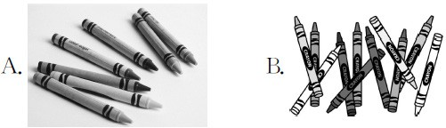
升级跷跷板

Ⅲ . 算一算 , 将相应的单词序号填入星星中。
A.thirty B.sixty-eight C.twelve D.seventy-one
基础碰碰车

Ⅰ . 将单词和相应的数字连线。

sixteen 50
twenty-nine 47
forty-seven 100 fifty 16
one hundred 29

Ⅱ . 数一数 , 选择正确的图片。
( )1.four birds
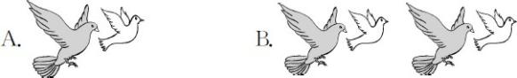

( )2.twelve books

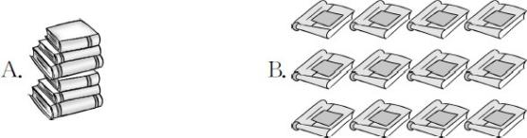

( )3.seven pupils

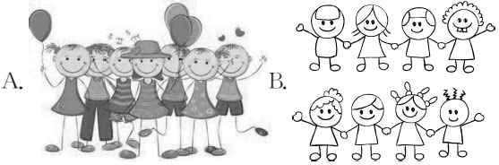

-1-
E.forty-nine F.thirteen


1.three+nine=

2.forty-five-thirty-two= 3.seventeen+thirteen=

4.one hundred-twenty-nine=

5.eleven+fifty-seven=

6.sixty-four-fifteen=

Ⅳ . 看图 , 数一数再回答问题。

( )1. 

—How many pencils do you have?
— .
A.Sixteen B.Fourteen

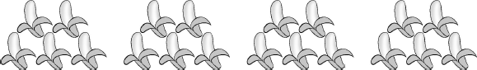
( )2.

—How many bananas can you see?
— .
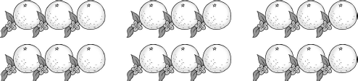
A.Twenty-five B.Twenty ( )3.

—How many oranges are there?
— .
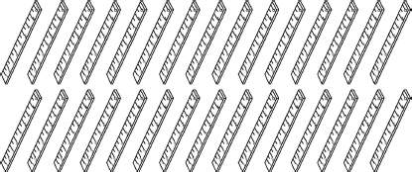
A.Eighteen B.Nineteen ( )4.

—How many rulers are there?
— .
A.Thirty B.Forty
Ⅴ . 阅读对话 , 完成后面的判断题。正确的打“√”, 错误的打“×”。
Lily:Look! I have some new pencils and new
crayons.
M i k e :Oh,how many new pencils do you have?
Lily:I have fifteen new pencils and twenty new
crayons.
Mike:But I can see twelve new crayons only.
Lily:The others( 其他的 )are in my schoolbag,under
the chair.
Mike:Oh,I see.
( )1.Lily has twelve new crayons.
( )2.The twelve new crayons are under the
chair.
( )3.Lily has fifteen new pencils.
( )4.Mike can see twenty new crayons.

-2-

以上内容仅为本文档的试下载部分，为可阅读页数的一半内容。如要下载或阅读全文，请访问：https://d.book118.com/325144240124011114

