

IDENTITY THEFT
R E S O U R C E C E N T E R

OCTOBER 2023

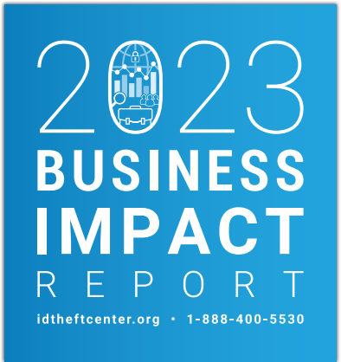

Table of Contents
1

Letter from the CEO 02 Consumer & Business Resources 12

Methodology 04 Appendix 13
2023 Business Impact Survey 14

Key Takeaways 05

Summary of Key Findings 6
Summary and Analysis of 2023
Key Findings 7
First-Time Questions 10

A Word About Supply Chain Data
Breaches 11

© IDENTITY THEFT RESOURCE CENTER 2023 | IDTHEFTCENTER. ORG

2
CEO Letter

Once upon a time, it was true that small businesses and
solopreneurs were not a favorite target for cybercriminals.
Attackers tended togo for
larger, data-rich organizations with lots of cash and thousands of employees, where the law of averages meant it was easier to find someone to fall for a
phishing attack.

That hasn’t been true since at least 2020, and the past year has seen a big jumpin the number of attacks targeting small businesses. In our
third annual ITRC Business Impact Report,
73 percent (73%) of owners or leaders of SMBs shared they had experienced a data breach, a
cyberattack, or both in the previous 12 months. That follows a year when there was aslight dip in attacks against smaller businesses.
Figure 1

Figure 1 | Data Breaches, Cyberattacks, or Both, Reported by SMBs
2021
58%
2022
43%
2023
73%

These trends follow the same patterns the ITRC
has seen in consumer impacts and data
breaches: a peak year of attacks in 2021 with a small reduction in 2022 due to a variety of
factors, including the Russian invasion of
Ukraine and disruption in the cryptocurrency markets. Since then, much like the legitimate stock market, the identity crime markets have
adjusted to conditions that resulted in fewer attacks in 2022 and rebounded with a
vengeance in 2023.

As you will see in the pages that follow, the
number of first-time attacks against small
businesses jumped 18 percentage points
compared to 2022. At the sametime, more SMB
leaders believe they are ready to take on cyber attackers. In 2022, 70 percent (70%) of SMBs believed they were ready to defend against a cyberattack or data breach. This year, the
number was 85 percent (85%).

One new area we probed in 2023 was the
concept of new or emerging data security tools. As you’ll notice, the uptake of new solutions
such as Multi-Factor Authentication (MFA) and practices like data minimization were slow to
gain acceptance. Utilization ranged from 34
percent (34%) for MFA to 20 percent (20%) for newer tools such as passkeys that were known to be effective protections.

Likewise, privacy protections were yet to break fully into the mainstream. The ability to opt-out
of data collection or to have information
deleted about you remained far less than
40 percent (40%), even as more states moved toward adopting their own comprehensive
privacy laws.

© IDENTITY THEFT RESOURCE CENTER 2023 | IDTHEFTCENTER. ORG

以上内容仅为本文档的试下载部分，为可阅读页数的一半内容。如要下载或阅读全文，请访问：https://d.book118.com/337161152001006026

