Leadership
Vision for 2024
Top 3 Strategic Priorities for Heads of ERM

© 2023 Gartner, Inc. and/or its affiliates. All rights reserved. This presentation, including all supporting materials, is proprietary to Gartner, Inc. and/or its affiliates and is for the sole
internal use of the intended recipients. Because this presentation may contain information that is confidential, proprietary or otherwise legally protected, it may not be further copied,
distributed or publicly displayed without the express written permission of Gartner, Inc. or its affiliates.

Leadership Vision for Heads of Enterprise Risk Management (ERM) in 2024

New technologies and the rise of AI, privacy concerns,

Key questions addressed:
② What are the major trends affecting heads of ERM?
What challenges are heads of ERM facing in the year ahead?
② What actions should heads of ERM and their teams take to succeed?
regulatory requirements, environmental risks, and
geopolitical, economic and social change are shaping how
the best organizations will manage enterprise risk in 2024.
In this context, the top priorities for heads of ERM in 2024
should be:
• How can ERM increase confidence in enterprise risk assessments?
• How can ERM enhance its value to corporate strategy?
• How can ERM help the organization respond to the risks of generative AI?

Heads of ERM can use this research to stay ahead of
major trends and lead their teams toward a successful
future.

2

RESTRICTED DISTRIBUTION
© 2023 Gartner, Inc. and/or its affiliates. All rights reserved.




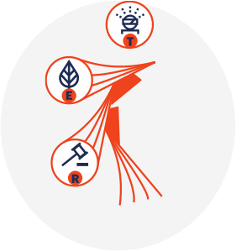

2024 Potential Enterprise Risk Trends
Framework From Gartner Future Lab’s TPESTRE Project and Associated, Potential Risks
 | Technological | • • • | Generative AI disruptions and impacts  Data model degradation  State-sponsored malware
 | Political | • • • | Renationalization of international trade  Geopolitical conflict  Political fractionalization and government dysfunction
 | Economic | • • • | Interest rate uncertainty  Persistence of inflationary and labor market challenges  Price bubbles
 | Social/Cultural | • • • | Social polarization  Retirement wave  Declining productivity
 | Trust/Ethics | • • • | Expectations for action on controversial issues  AI privacy concerns  AI-driven misinformation
 | Regulatory/  Legal | • • • | Anti-trust targeting technology providers  Fragmentation of data governance regulations  Cybersecurity disclosure and governance requirements

 | Environmental | • Environmental, social and governance (ESG) risks  • Extreme weather events  • Degraded water supplies, soil, air and other natural resources
Source: Gartner
RESTRICTED DISTRIBUTION
© 2023 Gartner, Inc. and/or its affiliates. All rights reserved.
3

以上内容仅为本文档的试下载部分，为可阅读页数的一半内容。如要下载或阅读全文，请访问：https://d.book118.com/345033231112011042

