Unit 3 All about Me
课堂同步练习
Lesson 13 How Old Are You?
姓名： 班级：

要点图解秀
升级跷跷板

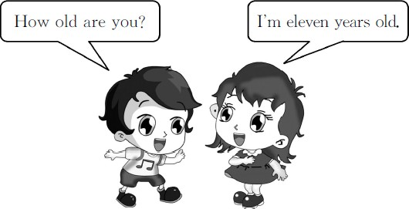

基础碰碰车

Ⅰ . 将年龄与对应的蛋糕连线。
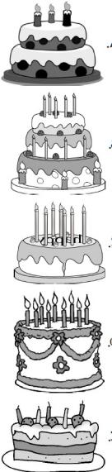
( )1.seven years old A.

( )2.three years old B.

( )3.nine years old C.

( )4.five years old D.

( )5.twelve years old E.

Ⅱ . 我会选择正确答案 , 并将序号填在题前的括号里。
( )1.How old you? A.is B.are
( )2.I᾽m eleven old.
A.year B.years
( )3.— is your birthday?
—January 22.
A.When B.Where
( )4.Steven is ten. birthday is
December 17.
A.Her B.His

Ⅲ . 读句子 , 将人物、年龄以及生日进行匹配 , 并用线连接起来。


My name is Lily.I᾽m 12 years old.My
birthday is November 25.


I᾽m Ms.White.I᾽m 32 years old.My
birthday is May 16.


My name is Sam Green.I᾽m 11 years
old.My birthday is June 28.



I᾽m Miss Cat.I᾽m 24 years old.My
birthday is March 10.

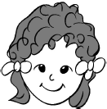

My name is Liu Hong.I᾽m 8 years
old.My birthday is February 14.



I᾽m Mr.Monkey.I᾽m 40 years old.My
birthday is September 3.

Name Age Birthday
Lily eight Feb.14
Ms.White twenty-four Mar.10
Sam Green twelve Sept.3
Miss Cat forty Nov.25

-1-

Liu Hong eleven Jun.28 Mr.Monkey thirty-two May 16
A.You are a little girl. B.When is your birthday,Mary? C.How old is your father?
D . W h a t about you?
E.November the ninth.

Ⅳ . 从方框中选择适当的句子补全对话。
Mary: 1
Tom:He is thirty-two years old.How old are you? Mary:I᾽m thirty-two years old,too.
Tom:No,you aren᾽t. 2
Mary:I᾽m sorry.I᾽m twelve years old. 3 Tom:I᾽m thirteen years old. 4
Mary:My birthday is August the eleventh.When is your birthday?
Tom: 5 Mary:I see.

1. 2. 3. 4.
5.

-2-

Unit 3 All about Me 课堂同步练习答案
Lesson 13 How Old Are You?
答案 :
Ⅰ .1.C 2.A | 3.D | 4.E 5.B
Ⅱ .1.B 2.B | 3.A | 4.B
Ⅲ .(略)
Ⅳ .1.C 2.A | 3.D | 4.B 5.E

Unit 3 All about Me
课堂同步练习
Lesson 14 Are You Short or Tall?
姓名： 班级：

要点图解秀

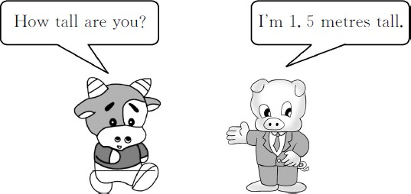

基础碰碰车

Ⅰ . 为下列英文句子选择正确的中文释义 , 并将其序号填在题前的括号里。
( )1.Let᾽s get to work,class! ( )2.I don᾽t know.
( )3.Stand on your feet,please. ( )4.Kim,you᾽re the first!
( )5.How tall am I?
( )6.Are you short or tall?

- 金姆 , 你是第一个 !
- 你是高还是矮 ?
- 我不知道。
- 我有多高 ?
- 请站在地上。
- 我们开始工作吧 , 同学们 !

Ⅱ . 读句子 , 在图片旁边标上对应句子的序号。
1.( ) 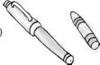 ( )
A.The crayon is short. B.The pen is long.
2.( ) ( )


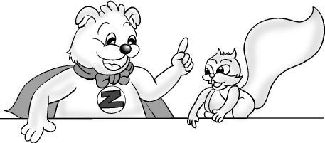
A.Seven is short. B.One is tall.

3.( ) ( )


A.Zoom is tall. B.Zip is short. 4.( ) ( )

A.Pan Changjiang is short.
B.Yao Ming is tall.

升级跷跷板

Ⅲ . 你来当导演。选择正确的对话给下面的图片配音。
A.—How tall is Winnie?
—It is 0.83 metre tall. B.—How tall is Meimei?
—She is 1.25 metres tall. C.—How tall is your brother?
—He is 1.65 metres tall. D.—How tall is Amy?
—She is 1 metre tall.
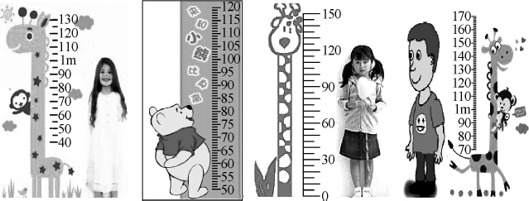

1.( ) 2.( ) 3.( ) 4.( )

-1-

Ⅳ . 看图片 , 编对话询问下面这些明星的身高和年龄。

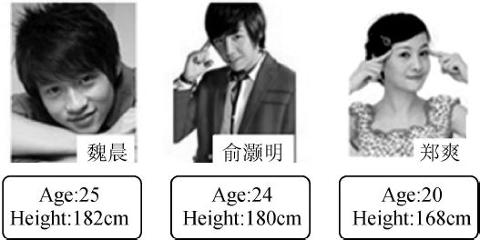

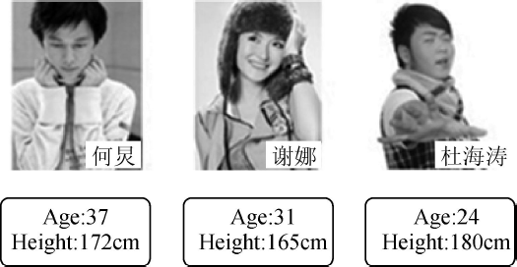

-2-

Unit 3 All about Me 课堂同步练习答案
Lesson 14 Are You Short or Tall? 答案 :
Ⅰ .1.F 2.C 3.E 4.A 5.D 6.B Ⅱ .1.BA 2.BA 3.AB 4.BA
Ⅲ .1.D 2.A 3.B 4.C
Ⅳ .(略)

Unit 3 All about Me
课堂同步练习
Lesson 15 Where Do You Live?
姓名： 班级：

要点图解秀
升级跷跷板

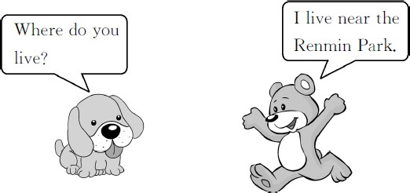

基础碰碰车

Ⅰ . 淘淘猫正在和迷你鼠玩连连看的游戏。你也来连一连吧 !
( )1. park A. 超市
( )2. restaurant B. 电影院( )3. library C. 学 校
( )4. supermarket D. 公园
( )5. cinema E. 图书馆
( )6. school F. 餐馆

Ⅱ . 我会选择正确答案 , 并将序号填在题前的括号里。
( )1.I live a house beside the park.
A.on B.in C.at
( )2.Where you live?
A.are B.is C.do
( )3. is your address?
A.Where B.What C.How
( )4.The cinema is far our school.
A.to B.for C.from

Ⅲ . 看图片 , 判断句子的正 ( √ ) 误 (×)。
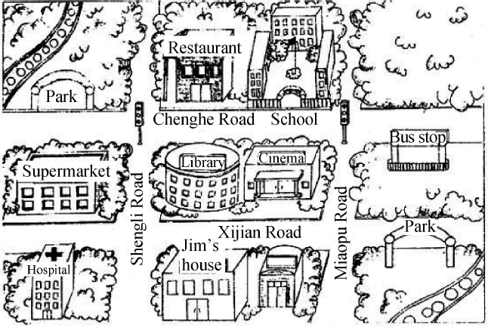
( )1.Jim lives beside the school.
( )2.The school is on Chenghe Road.
( )3.The restaurant is far from the school. ( )4.Jim᾽s house is near the library.

Ⅳ . 给下列打乱顺序的句子排排队。
( ) Me,too! What᾽s your address?
( ) My address is 135 Heping Road. ( ) Where do you live,Steven?
( ) Yes! I live beside it!
( ) Is that near the People᾽s Cinema? ( ) I live in a house on Heping Road.

Unit 3 All about Me 课堂同步练习Lesson 15 Where Do You Live?
答案
Ⅰ .1.D 2.F 3.E 4.A 5.B 6.C
Ⅱ .1.B 2.C 3.B 4.C
Ⅲ .1.× 2. √ 3.× 4. √
Ⅳ .3 4 1 6 5 2

Unit 3 All about Me
课堂同步练习
Lesson 16 How Do You Go to School?
姓名： 班级：

( )3.The old man goes to the park
要点图解秀
every morning.
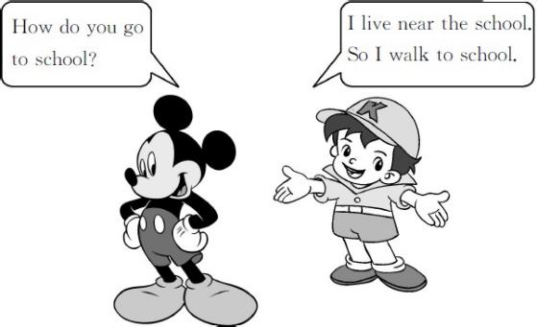
A.by foot B.by feet
C.on foot D.on feet
( )4.—Is your school near your home?
—No,it᾽s my home.I go to school
by bus every day.
A.beside B.far from
C.under D.in front of
基础碰碰车

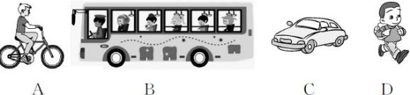
Ⅰ . 看一看 , 读一读 , 选一选。
升级跷跷板

( )1.—How does Mr.Black go to work?
—By car.
( )2.—Do you walk to school?
—No.I ride my bike.
( )3.—How does Jim go to school?
—On foot.
( )4.—Do you go to school by bus?
—Yes,we do.

- . 我会选择正确答案 , 并将序号填在题前的括号里。
( )1.I often go to work . A.ride my bike B.by bike
C.by a bike D.on bike
( )2.— do you e to school in the
morning?
—By bus.
A.What B.Where
C.When D.How

-1-
Ⅲ . 句型转换 , 每空一词。
  - I go to work by bike.It᾽s good for me.( 写出同
义句 )
I to work.It᾽s good
for me.
  - My father drives to work every day.( 同上 )
My father goes to work every
day.
3.My school is near my home.So I walk to
school.( 同上 )
My school is near my home.So I
.
4.I go to the library by bus.( 对画线部分提问 )
you go to the library? 5.Larry᾽s grandfather is eighty-six.( 同上 )
is Larry᾽s grandfather?
6.I live in a house beside the library.( 同上 )
you live?

以上内容仅为本文档的试下载部分，为可阅读页数的一半内容。如要下载或阅读全文，请访问：https://d.book118.com/346121210103010054

