专题01名词、代词、介词、冠词


名词主要包括普通名词和专有名词两种。注意掌握名词变复数的变化规则，掌握不可数名词向可数名词转化的规律，名词所有格的用法，名词的句法功能等，并做到灵活运用，以便提高综合运用能力。中考对于名词的考查，主要以词义理解、名词所有格及词形转换居多。
冠词是说明名词所表示的人或事物的一种虚词，置于名词之前，它不能离开名词而单独存在。冠词的分类:不定冠词、定冠词、零冠词。中考冠词重点考查定冠词和不定冠词的基本用法。
介词常考的主要是表示时间、地点、方位的介词用法，以及一些同义近义词用法的辨析。突破介词考点，需要熟记一些常用的介词及其短语的意义和名词的搭配、动词的搭配及大量的固定结构。
代词是中考必考的知识点之一。重点考查人称代词、物主代词、不定代词、指示代词、反身代词及易混代词的区别；命题方式通过设置语境，把对代词的考查放在具体的语境中。



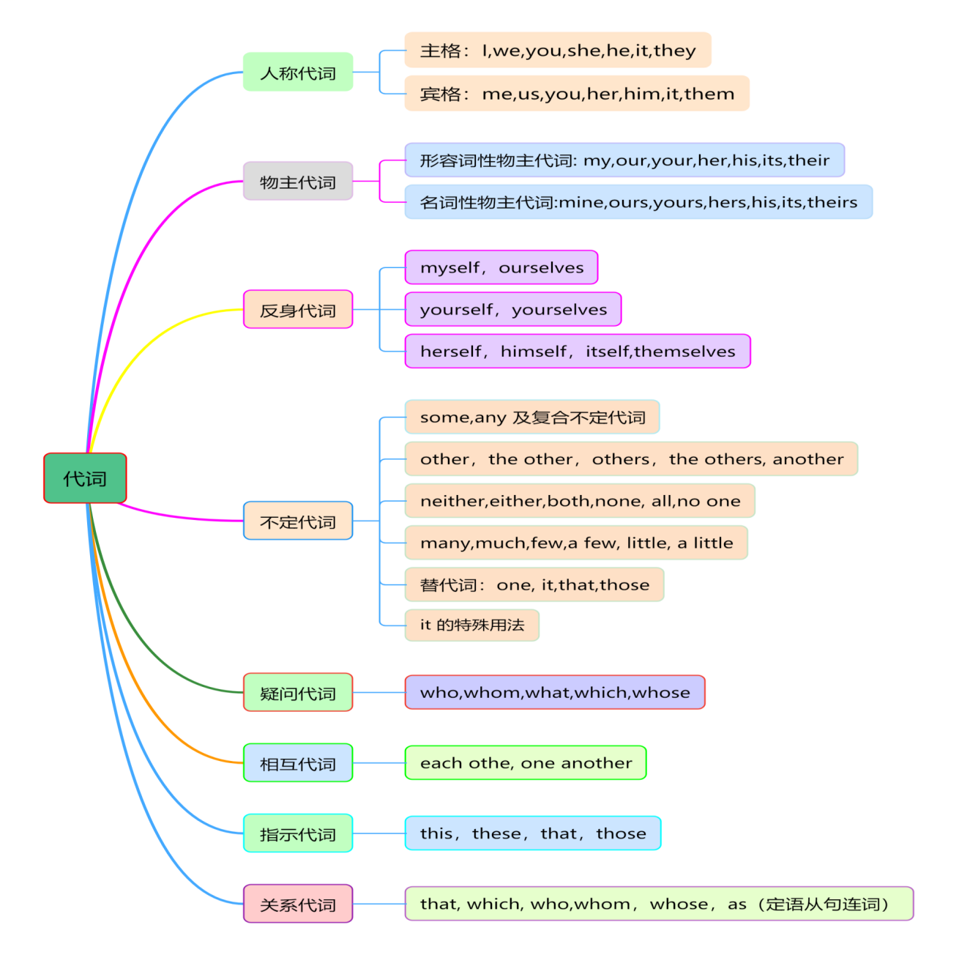

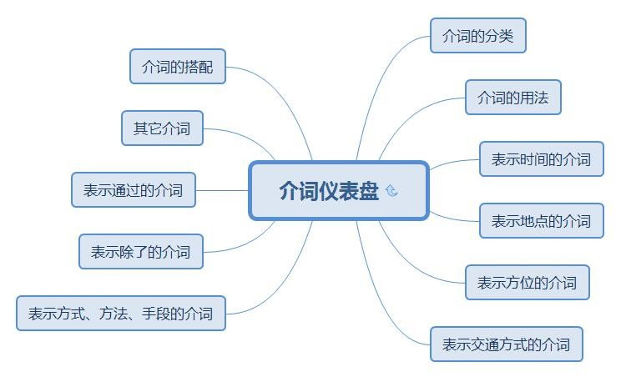
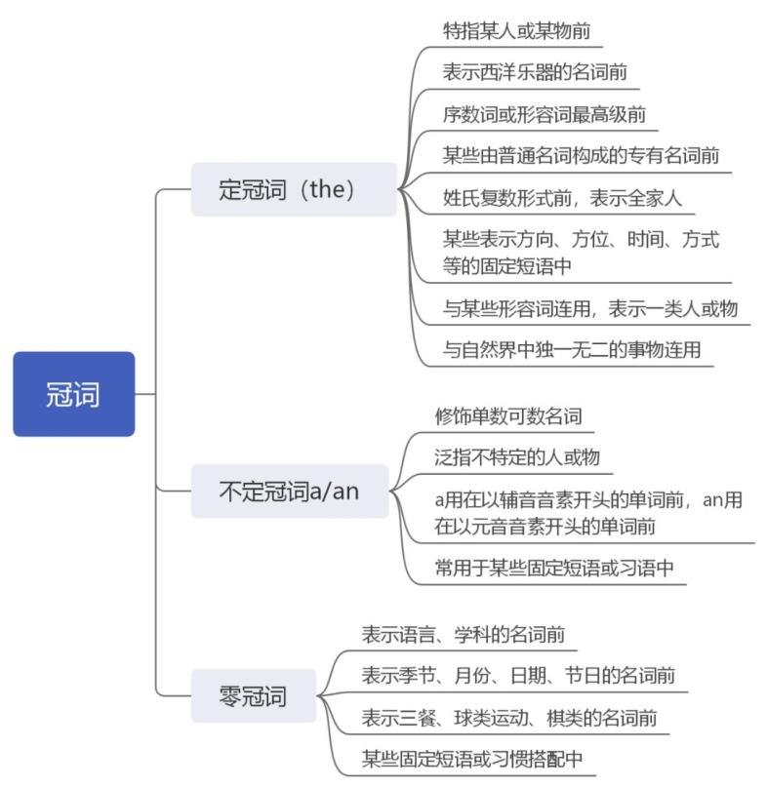

一、名词
1．（2022·浙江温州·统考中考真题）—Jack, I have no idea for the report.
—Me neither. Why don’t we ask the teacher for ________?
A．help B．jokes C．food D．tickets
2．（2021·浙江温州·统考中考真题）Mike, a 7-year-old boy, has a great talent for ________. He can draw nice pictures though he has never learned it.
A．art B．sport C．music D．science
3．（2020·浙江温州·统考中考真题）Lucy’s father works in No. 1 Hospital. He is a________.
A．teacher B．doctor C．postman D．policeman
4．（2019·浙江温州·中考真题）- Sir, did you enjoy your stay in our________________?
- Yes, I slept well and I like the breakfast.
A．hotel B．school C．factory D．company
5．（2011·浙江宁波·中考真题）— You look so healthy!
— Yeah, I like eating apples. An apple a day keeps the _________ away.
A．teacher B．worker C．farmer D．doctor
6．（2011·浙江温州·中考真题）I am tired after the long walk. I want to have a _________.
A．talk B．look C．party D．rest
7．（2011·浙江绍兴·中考真题）—Excuse me, may I know your _______?
— Sure. It’s No. 3 Bridge Street.
A．house B．address C．way D．place
8．（2015·浙江温州·中考真题）Annie has a ___________,and she is going to see her dentist today.
A．cold B．fever C．cough D．toothache
9．（2011·浙江丽水·中考真题）My father will have a holiday next month. He’ll take me to Qingdao.
A．ten days B．ten day’s C．ten-days D．ten days’
10．（2011·浙江丽水·中考真题）— Would you like some .
— Oh, yes, just a little.
A．milk B．apple C．pears D．oranges
11．（2011·浙江杭州·中考真题）For breakfast, I usually have ______ and two pieces of bread.
A．a cup of mild half B．half a cup of milk
C．a half milk cup D．half a milk cup
12．（2011·浙江嘉兴·中考真题）--- How far is your family from here?
--- It’s about ten _____ walk.
A．minute’s B．minute C．minutes’ D．minutes
13．（2018·浙江温州·中考真题）---What was the _______ of the football match last night?
--- AC Milan won the game.
A．value B．Result C．choice D．decision
14．（2017·浙江温州·统考中考真题）I have the ________ of reading before sleeping. It has been part of my life.
A．courage B．chance C．spirit D．habit
15．（2013·浙江丽水·中考真题）—Tommy, you can never let others know what I have told you today.
—Don’t worry. I will keep the ______.
A．secret B．money C．address D．grade

二、代词
1．（2017·浙江温州·统考中考真题）—Did anyone call me when I was out ?
—Yes. A man who called _______ Tom .
A．myself B．himself C．herself D．yourself
2．（2011·浙江衢州·中考真题）________ is difficult if you put your heart into it.
A．Something B．Everything C．Anything D．Nothing
3．（2013·浙江杭州·中考真题）There has never been such a beautiful village _________ in the world.
A．anywhere B．everywhere C．somewhere D．nowhere
4．（2010·浙江金华·中考真题）—How many students are there in the classroom?
—__________. They are all in the lab.
A．Some B．None C．All D．Neither
5．（2011·浙江宁波·中考真题）—Who helped Jessie with her English?
—______, she taught herself.
A．Anybody B．Somebody
C．Nobody D．Everybody
6．（2020·浙江温州·统考中考真题）—Can you play volleyball or basketball?
—________ of them. I'm good at ball games.
A．Both B．Either C．Neither D．None
7．（2019·浙江温州·中考真题）Sam finds sweeping robots useful, and he plans to buy ___________ for his grandma.
A．it B．one C．this D．that
8．（2013·浙江杭州·中考真题）They are able to talk openly to one another whenever _________ of them feels hurt.
A．either B．both C．some D．all
9．（2014·浙江湖州·中考真题）—Excuse me， I’m looking for my umbrella.
—Oh， sorry. I took by mistake.
A．hers B．mine C．yours D．his
10．（2015·浙江温州·中考真题）---Mom, what would you like, coffee or tea?
---_________. Just water,please.
A．Either B．Both C．Neither D．None
11．（2014·浙江温州·中考真题）—Look, _______ is dancing under the tree.
—Oh, that’s my cousin, Anna.
A．everybody B．anybody
C．nobody D．somebody
12．（2023·湖南湘西·统考中考真题）________ is necessary to wear a helmet (头盔) when we are riding a bicycle to ensure our safety.
A．It B．This C．That
13．（2023·湖南湘西·统考中考真题）—Is the green sweater yours?
—Yes, it is. It’s ________ sweater.
A．my B．mine C．hers
14．（2023·辽宁鞍山·统考中考真题）—Did you see ________ at the Hangzhou National Tea Museum?
—Yes. I saw many beautiful tea sets and all kinds of tea there.
A．something interesting B．everything interesting
C．anything interesting D．nothing interesting
15．（2023·西藏·统考中考真题）—What would you like for dinner, rice or dumplings?
—________. I’d like some Tibetan noodles.
A．Either B．Neither C．Both D．All
16．（2023·四川甘孜·统考中考真题）There are many trees on ________ sides of the street.
A．both B．all C．each D．either
17．（2023·湖北襄阳·统考中考真题）—Cindy! Can you help me pass the level 2 of the game “Word Puzzle(字谜)”？
—Oh, dear. There’s ________ I can do to help you. I can’t pass it, either.
A．something B．anything C．everything D．nothing
18．（2023·辽宁盘锦·统考中考真题）The class was over, but I still had ________ questions to ask.
A．a little B．little C．a few D．few
19．（2023·辽宁盘锦·统考中考真题）When our bread maker broke, the Taylors lent us ________.
A．they B．them C．their D．theirs
20．（2023·江苏常州·统考中考真题）I’ve visited New York and Los Angeles, but I don’t like ________ of them
very much.
A．either B．any C．neither D．none

三、介词
1．（2023·江苏南通·统考中考真题）Shenzhou 16 was sent up into space ________ the morning of May 30, 2023.
A．in B．on C．at D．from
2．（2023·江苏镇江·统考中考真题）Dance is not just a form of art, but also a language which tells stories ________ body.
A．towards B．over C．past D．through
3．（2023·湖北十堰·统考中考真题）—________ my surprise, the restaurant is actually very nice.
—The service is also great.
A．In B．At C．On D．To
4．（2023·辽宁抚顺·统考中考真题）The girl takes her dog for a walk ________ the river every evening.
A．in B．along C．over D．under
5．（2023·江苏无锡·统考中考真题）A new bridge was built ________ the Yellow River last year.
A．around B．across C．against D．along
6．（2023·四川遂宁·中考真题）Look! The traffic light is green. We can go ________ the road now.
A．across B．above C．below D．against
7．（2023·辽宁营口·中考真题）The newly-built teaching building provides the students ________ a comfortable learning environment.
A．for B．to C．with D．in
8．（2023·湖北武汉·统考中考真题）Please bring Ms. Steen to the welcome party ________ telling her so that she can be surprised.
A．about B．from C．without D．for
9．（2023·安徽·统考中考真题）Do whatever you can for the community, ________ looking after the old or teaching kids art.
A．with B．under C．like D．over
10．（2023·江苏连云港·统考中考真题）The instrument EyeHarp is specially designed ________ disabled people
to play music with eyes.
A．in B．as C．for D．over
11．（2023·辽宁丹东·统考中考真题）________ the teacher’s help, I have made much progress.
A．Thanks to B．As for C．Such as D．Up to
12．（2023·江苏扬州·统考中考真题）We need to tell people to just do one small thing well ________ 100 things poorly.
A．as well as B．instead of C．according to D．because of

四、冠词
1．（2022·浙江温州·统考中考真题）Ben watched Tom and Jerry yesterday. ________ cartoon made him laugh.
A．A B．An C．The D．/
2．（2021·浙江温州·统考中考真题）Tony is a kind boy and I’m very lucky to have ________ friend like him.
A．a B．an C．the D．/
3．（2020·浙江温州·统考中考真题）I have________ dog. His name is Floppy.
A．a B．an C．the D．/
4．（2019·浙江温州·中考真题）- Peter, shall we go for a picnic this Sunday?
- OK. Let's add it to _____________ weekend plan.
A．a B．an C．the D．／
5．（2011·浙江嘉兴·中考真题）— Who’s that lovely girl?
— You mean ______ girl with long hair? That’s Kate.
A．a B．an C．the D．不填
6．（2011·浙江温州·中考真题）Lucy is ____ good girl. She often helps others.
A．a B．an C．the D．/
7．（2014·浙江湖州·中考真题）Who is young lady with curly blonde hair?
A．a B．an C．the D．/
8．（2017·浙江温州·统考中考真题）— This photo makes me think of ________ trip to the Great Wall last year.
— Yeah, we had a great time there.
A．a B．an C．the D．/
9．（2014·浙江丽水·中考真题）Mr.Smith has 8-year-old daughter who has won two national painting prizes.
A．a B．an C．the D．不填
10．（2013·浙江丽水·中考真题）It is a good habit to go to ______ bed early and get up early.
A．a B．an C．the D．不填

一、名词
考点一 名词词义辨析
词汇辨析是中考最大考向之一，考查范围是中考必备词汇，是同学们很容易混淆的知识点，也是中考难度较大的一个考题，词汇辨异在中考中主要考查单词意义的辨识，用法上的辨异，语境应用。偏重实词的辨异（名词，动词，形容词，副词）。考题以单项选择和完形填空的形式出现，以下归纳一些高频常考的高频名词（形近词）
1.activity 活动 address 地点 advertisement广告 advantage 优点 attention注意力
action 行为，行动 ability 能力
2.challenge 挑战 chance 机会 choice 选择 change改变 collection 收集物
competition 竞赛 composition 作文，文章 cause 原因 communication 沟通，交流
comment 评论 community社区 condition条件 confidence自信心 conversation 谈话，会话
courage勇气 crowd群，人群 culture文化 champion战役
3. distance距离 disease 疾病 difference 差异，不同 decision决定 difficulty 困难 direction方向，指示 director导演，负责人 development 发展 discussion讨论
4. experiment 实验 event 事件，活动 explanation解释 energy 能源，能量 expression 表情，短语。 Education教育 exchange交换 effect 效果，影响 environment 环境 excuse借口 experience经验，经历
5. fact事实 feeling感觉，情感 form 格式，表格 fear害怕 furniture 家具 fashion时尚
6. guide指南;导游;向导 government政府;治理， gift礼物;天赋 guard保护;警卫 guest客人
7. habit习惯 hobby爱好 health健康 harm伤害 heat 加热 honour荣誉;尊敬; hug 拥抱
8. impression印象 influence影响，效果 interest 爱好，利益，兴趣 information信息
Industry工业 instruction 指令，说明 interview采访;面试 introduction介绍 invention发明
instrument仪器，乐器;
9. language 语言 law法律 level 水平 lamp灯 lantern 灯笼，提灯 literature文学
10. meaning 意义 memory记忆 message口信，信息 method 方法 mistake错误 manner方式;举止;礼貌;
master大师，师傅 material 材料
11. passenger 旅客 patient 病人 population 人口 present礼物， 现在 practice 实践，业务活动，惯例;训练; president总统;院长，主席; pressure压力programme 方案，程序。节目 progress 进步
purpose 目的 position地点，职位，位置。
12. reason理由 record记录 relationship 关系 relative亲戚 research调查 result结果
13. safety安全 score得分，分数 secret 秘密 service服务 shame 羞耻 sign符号，标记
silence安静 situation情况;状况;形势society社会 solution解决方案 speech演讲 spirit 精神
standard 标准，水准 success成功 suggestion 建议 survey调查 symbol 象征
14. task 任务 taste品味，味道 technology 技术 test测试 trade贸易 traffic交通
treasure 珠宝 trouble麻烦事，困境 truth 真相 talent才能;天赋
- university 大学 universe宇宙 wave波 wealth 财富 weight重量 wonder 疑惑 wound伤

考点二 名词的数
1）可数名词复数的规则变化
规则变化 | 示 例
- 大多数名词在词尾加-s | letter→ letters, cat→ cats, boy→ boys, desk→ desks
② 以s, x, ch, sh结尾的名词，在词尾加-es | class→ classes, box→ boxes, watch→ watches, brush→ brushes
③ 以“辅音字母+y”结尾的名词，变y为i，再加-es | hobby→ hobbies, city→ cities, country→ countries
④ 以o结尾的名词，大多数加-s，少数加-es | 加-s: radio→ radios, zoo→ zoos, photo→ photos, piano→ pianos  加-es: hero→ heroes, tomato→ tomatoes, potato→ potatoes
⑤ 部分以f或fe结尾的名词，变f或fe为v，再加-es | knife→ knives, half→ halves  用顺口溜记住常见的把f或fe改为v加-es的单词：  树叶 半 数自己黄，妻子拿刀去割粮，  架后窜出一只狼，就像盗贼逃命忙。  leaf树叶 half一半 self 自己 wife妻子 knife 小刀  Shelf 架子 wolf 狼 thief 贼 life 生命

注意：可数名词可与不定冠词a/an连用，有复数形式。普通名词中个体名词和集体名词一般是可数名词。
2）可数名词复数的不规则变化
不规则变化 | 示 例
① 变化元音字母构成复数 | foot→ feet, goose→ geese, tooth→ teeth, man→ men,  woman→ women
② 单复数形式相同 | sheep, deer, fish （注意：fish指鱼的数量时单复数同形；指鱼的种类时复数是fishes）
③ 特殊变化 | child→ children, mouse→ mice, ox→ oxen

3）不可数名词
不可数名词没有复数形式，不能与不定冠词a/an连用。抽象名词和物质名词一般是不可数名词。
（1）常见的不可数名词
物质类：air, beef, beer, bread, candy, cheese, chicken, chocolate, coffee, cotton, coal, electricity, fire, fish, food, fruit, furniture, glass, grass, gold, hair, ice, ink, juice, land, light, meat, medicine, milk, oil, paper, pork, rain, rice, salt, snow, soup, sugar, tea, water, wind, wine, wood
抽象类：advice, age, beauty, danger, death, energy, fear, fun, failure, happiness, health, help, homework, housework, information, joy, love, luck, knowledge, money, music, nature, news, pleasure, progress, safety, sleep, success, surprise, time, trouble, truth, weather, work
（2）不可数名词的数
① 不可数名词常借助于量词表示一定的数量。常见的量词有a piece of, a bottle of, a cup of等。如：
a piece of furniture一件家具 some pieces of paper几张纸
two bags of rice两袋米
② 有些名词表示物质或抽象概念是不可数的，而在表示个体或种类时是可数的，如：
Two beers, please. 请来两杯啤酒。
It was a special tea. 它是一种特殊的茶。
As a teacher, she is a success, but as a mother, she is a failure because she spends little time looking after her child. 作为一名教师她是一个成功的人，但是作为一位母亲，她是一个失败者，因为她几乎没有时间照顾自己的孩子。

考点三 名词所有格
名词所有格表示所有关系，修饰另一名词，作定语。它有三种形式：­'s所有格、of所有格和双重所有格。
No 1．'s所有格的构词规则
表示人或其他有生命的东西的名词常在词尾加's或'，表示所有关系。
构成规则 | 示例
单数名词词尾通常加­'s；复数名词词尾没有­s时，也要加­'s | my sister’s telephone number我姐姐的电话号码；the children's toys那些孩子的玩具  the women’s changing room女更衣室
以­s结尾的复数名词后直接加“'” | teachers' office 教师们的办公室
以­s结尾的单数名词或专有名词之后加“'”或­'s均可 | my boss's/boss' plan我老板的计划；Engles’/Engles’s works恩格斯的著作
合成词一般是在最后一个词的后面加­'s | her son­in­law's car她女婿的车
表示时间、距离、重量、地方等无生命的事物的名词也可以借助­'s表示所有关系 | a week's holiday 一周的假；thirty minutes' ride三十分钟的车程
作为一个整体的词组一般在最后一个词的词尾加­'s | an hour and a half's walk步行一个半小时的路程
不定代词后接else时，­'s加在else之后 | somebody else's bag别人的包

易错点：
- 表示两者或多者各自的所有关系时，分别在每个名词的词尾加's或'；表示两者或多者共有时，在最后一个名词词尾加's或'。
Tom's and Jim's fathers 汤姆的父亲和吉姆的父亲
Tom and Jim's father 汤姆和吉姆的父亲
- 表示店铺、办公室或某人的家时，名词所有格后被修饰的名词一般省略。
at the barber's 在理发店
at my uncle's 在我叔叔家
No 2．of所有格
表示无生命的事物的名词通常用of所有格表示所有关系；名词短语或有定语修饰的有生命的名词也常用of所有格。the door of the room房间的门
以上内容仅为本文档的试下载部分，为可阅读页数的一半内容。如要下载或阅读全文，请访问：https://d.book118.com/348034133026006047

