Unit 4 My Favourites
课堂同步练习
Lesson 19 My Favourite Colours
姓名： 班级：

-  (We/Our)clean (we/our)classroom
要点图解秀
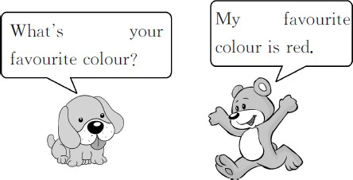
every day.
- My sister is in (she/her)room.
- —You are a pupil.Is (you/your)brother a
pupil,too?
—Yes, (he/his)is.
- (We/Our)have a good teacher.
(She/Her)son is (we/our)friend.
基础碰碰车

Ⅰ . 选出正确的字母组合 , 将下列单词补充完整。
( )1.br n( 棕 色 )
A.oa B.ow ( )2.gr n( 绿 色 )
A.ea B.ee
( )3.yell ( 黄 色 )
A.ou B.ow
( )4.bl ( 蓝 色 )
A.ue B.eu
( )5.col ( 颜色 )
A.oar B.our
( )6.fav rite( 最喜欢的 )
A.ou B.oe

Ⅱ . 选词填空。
- (I/My)like (I/my)orange hat.
升级跷跷板

Ⅲ . 从方框中选择适当的句子补全对话。
L:Hello! What᾽s your name? T: 1
L:My name is Lily. 2 T:Nice to meet you,too. 3
L:My favourite toy is a kite.What about you?
T:My favourite toy is an electric dog( 电 子 狗 ). 4 L:My favourite colour is blue.
T: 5
A.Blue is my favourite,too. B.What᾽s your favourite toy? C.My name is Tom.And you?
D.Nice to meet you.
E.What᾽s your favourite colour?

- This is Lily. (She/Her)favourite
colour is red. 3.—Where is Jim᾽s pen?
— (He/His)pen is on the desk. 4.Mr.White has two daughters. (They/
Their)names are Jane and Jenny. (They/
Their)are students.
1.
2.
3.
4.
5.

-1-

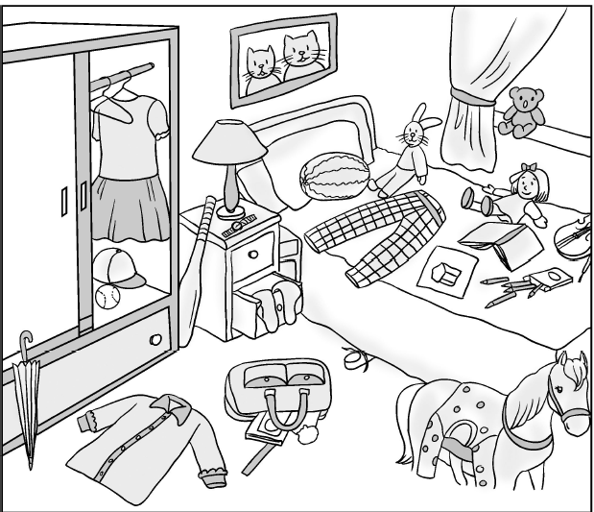
Ⅳ . 读句子 , 按要求给图片涂色。1.Colour the horse brown. 2.Colour the umbrella orange. 3.Colour the shirt green.
4.Colour the dress red.

5.Colour the trousers on the bed blue.

-2-

Unit 4 My Favourites 课堂同步练习答案
Lesson 19 My Favourite Colours 答案 :
Ⅰ .1.B 2.B 3.B 4.A 5.B 6.A
Ⅱ .1.I;my 2.Her 3.His 4.Their;They 5.We;our 6.her 7.your;he 8.We;Her;our Ⅲ .1.C 2.D 3.B 4.E 5.A
Ⅳ .(略)

Unit 4 My Favourites
课堂同步练习
Lesson 20 My Favourite Clothes
姓名： 班级：

要点图解秀

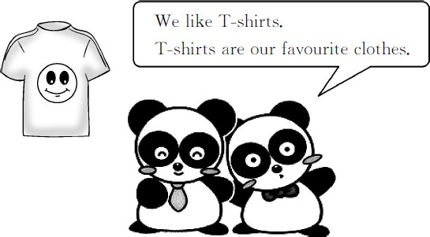

基础碰碰车

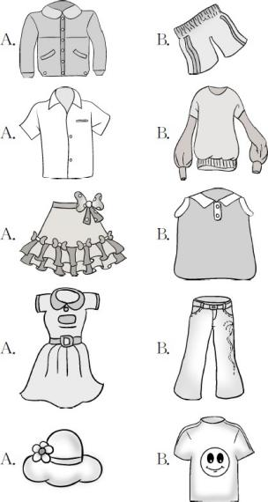
Ⅰ . 读单词 , 选择对应的图片。

( )1.shorts

( )2.shirt

( )3.skirt

( )4.trousers

( )5.hat

- . 根据中文释义 , 选择对应的选项。
( )1. 我的绿色毛衣
A.my green sweater B.my blue jacket ( )2. 你的黄色短裙
A.your green dress B.your yellow skirt ( )3. 她的蓝色连衣裙
A.her blue dress B.his brown shirt
( )4. 他的黑色 T 恤衫
( )5. 我们的白色短裤
A.our white shorts
B.your white trousers ( )6. 他们的棕色鞋子
A.their brown shoes
B.they purple shoes

升级跷跷板

Ⅲ . 读句子 , 给下列衣物涂上它的主人最喜欢的颜色。
1.Look!This is my shirt.My favourite colour is
white.
  - The dress is my sister᾽s.Her favourite colour
is purple.
  - The T-shirt is my brother᾽s.His favourite
colour is yellow.
  - The skirt is my mother᾽s.Her favourite colour
is red.
  - The sweater is my grandpa᾽s.His favourite
colour is blue.
  - The jacket is my father᾽s.His favourite colour
is brown.

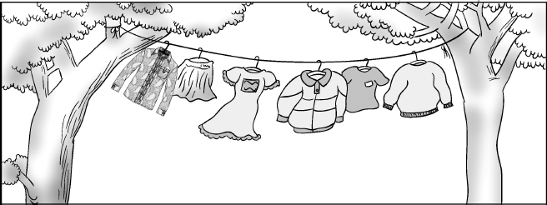

Ⅳ . 连词成句难不住我。
1.favourite are clothes shorts their (.)

A.her black shirt B.his black T-shirt

-1-

2. shoes like blue we our (.)

4. favourite is green colour my

3. your colour is what favourite (?)

-2-

Unit 4 My Favourites 课堂同步练习答案
Lesson 20 My Favourite Clothes 答案 :
Ⅰ .1.B 2.A 3.A 4.B 5.A
Ⅱ .1.A 2.B 3.A 4.B 5.A 6.A
Ⅲ .(略)
Ⅳ .1.Their favourite clothes are shorts./Shorts are their favourite clothes.
2.We like our blue shoes.
3.What is your favourite colour?
4.Green is my favourite colour./My favourite colour is green.

Unit 4 My Favourites
课堂同步练习
Lesson 21 My Favourite Food
姓名： 班级：

要点图解秀

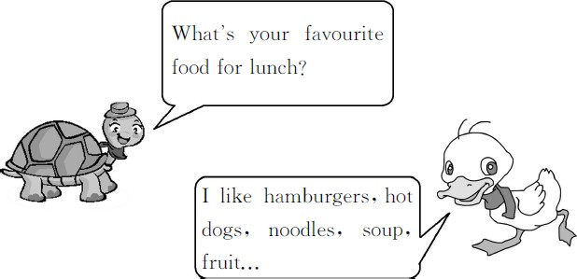

基础碰碰车

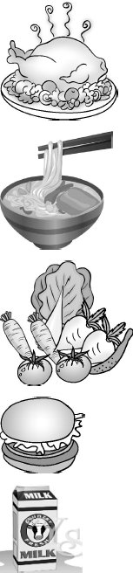
Ⅰ . 看一看 , 读一读 , 选一选。

( )1.
A.fish B.chicken

( )2. A.dumplings B.noodles

( )3. A.vegetables B.fruit

( )4. A.hamburger B.hot dog

( )5. A.soup B.milk

- . 根据中文释义 , 选择对应的选项。
( )1. 我饿了。
A.I᾽m thirsty. B.I᾽m hungry. ( )2. 你午餐最喜欢吃什么食物 ?
A.What᾽s your favourite food for
dinner?
B.What᾽s your favourite food for
lunch?
( )3. 我晚上七点吃晚饭。
A.I have dinner at 7:00 in the evening.
B.I have breakfast at 7:00 in the
morning.

-1-
( )4. 她们喜欢她们的紫色连衣裙。
A.They like their pink skirts.
B.They like their purple dresses.

升级跷跷板

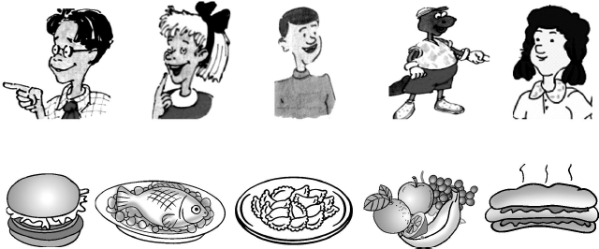
Ⅲ . 老师正在调查同学们最喜欢的食物是什么。请读对话 , 连线。

( )1.—What᾽s your favourite food,Li Ming?
—My favourite food is dumplings. ( )2.—What᾽s your favourite food,Jenny?
—Hamburgers are my favourite.
( )3.—What᾽s your favourite food,Steven?
—I like fish.
( )4.—What᾽s your favourite food,Danny?
—Hot dogs are my favourite.
( )5.—What᾽s your favourite food,Kim?
—I like fruit.

Ⅳ . 看图 , 补全句子。
  - I have at 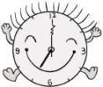o᾽clock in
the morning.I like , and

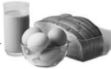
.

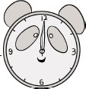
  - I have at o᾽clock.

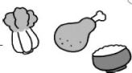
I like , and

.

-2-

  - I have at in the

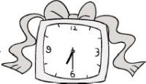
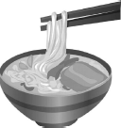
evening. I like

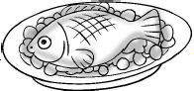

and

Unit 4 My Favourites 课堂同步练习Lesson 21 My Favourite Food
答案
Ⅰ .1.B 2.B 3.A 4.A 5.B
Ⅱ .1.B 2.B 3.A 4.B
Ⅲ .(略)
Ⅳ .1.breakfast;7:00;bread;milk;eggs 2.lunch;12:00;vegetables;chicken;rice
3.dinner;6:30;noodles;fish

以上内容仅为本文档的试下载部分，为可阅读页数的一半内容。如要下载或阅读全文，请访问：https://d.book118.com/348061121047006042

