考生注意：

普通高等学校招生全国统一考试上海 英语试卷
（2017 年 1 月）

- 本场考试时间 120 分钟。试卷共 12 页，满分 140 分，答题纸共 2 页。
- 作答前，在答题纸正面填写姓名、准考证号，反面填写姓名。将核对后的条形码贴在答题纸指定位置。
- 所有作答务必填涂或书写在答题纸上与试卷题号对应的区域，不得错位。在试卷上作答一律不得分。
- 用 2B 铅笔作答选择题，用黑色字迹钢笔、水笔或圆珠笔作答选择题。

Listening Comprehension Section A
Directions: In Section A, you will hear ten short conversations between two speakers. At the end of each conversation, a question will be asked about what was said. The conversations and the questions will be spoken only once. After you hear a conversation and a question about it, read the four possible answers on your paper, and decide which one is the best answer to the question you have heard.

  - A. Pie cake.
B. Ice cream. C. Chocolate cake. D. Cheese

  - A. The museum opens at 8 every day. clearly.
- She can’t see the sign

- The glass museum closes too early. sign.
- She can ’t understand the

  - A. Delighted. Respectful.
B. Doubtful.
C. Relieved. D.

  - A. She works as a librarian.
- She does a lot of reading at home.
- She spends much time reading in the library.
- She wants to borrow some books from the library.
  - A. He isn’t sure if the weather will be good. B. He probably won ’t go skiing.
C. The weather won’t be as bad as forecast D. The weather forecast isn’t reliable.

  - A. His brother ate up the food. the fridge.
C. His brother lost his appetite. dine with him.
B. His brother helped him clean

D. His brother went out to

  - A. Keep some small change. B. Buy another T-shirt.

C. Invite someone else to the concert. D. Dress himself properly.

  - A. See a doctor.
C. Go to school.
B. Repair his car.
D. Give the woman a ride.

  - A. She has no interest in the man’s words. understand the man.
- She doesn’t

- She doesn’t want to follow the man. pictures by kids.
- She hates to study

  - A. She missed the beginning of the program. awakened during the quiz.
C. She fell asleep before the program ended. had gone to sleep earlier.

Section B
B. She was

D. She wishes she

Directions: In Section B, you will hear two passengers and one longer conversation. After each passage or conversation, you will be asked several questions. The passengers and the conversation will be read twice, but the questions will be spoken only once. When you hear a question, read the four possible answers on your paper, and decide which one is the best answer to the question you have heard.
Questions 11 through 13 are based on the following announcement.

  - A. dangerous room.
C. A suspect handbag.
B. An explosive device.
D. A fire extinguisher.

  - A. Hand in valuable items to the police.
- Help elderly and disabled people.
- Let children and women go first.
- Leave by the nearest exit.

  - A. At a theatre.
C. At an airport.
B. At a police station.
D. At a department store.

Questions 14 through 16 are based on the following talk.
  - A. An ad-blocking device. B. A parented screen.

C. A telephone answering machine. D. A sound controller.

  - A. She spent twenty years on the new invention.
- She designed the new invention for the deaf.
- She invested four thousand pounds in the new invention.
- She worked with her husband on the new invention.
  - A. It is similar to her previous invention.
- It can be used just to control the TV set.
- It must be kept at a particular angle.
- It is too big to hold.
Questions 17 through 20 are based on the following conversation.
  - A. How to organize thoughts for a speech. B. How to get an expected grade.

C. How to give a speaking assignment. speech.
D. How to prepare a

  - A. Bearing listeners in mind.
C. Adding a sense of humour.
  - A. The purpose of the speech.
C. The instructor’s advice.
  - A. List interesting examples.
C. Put down all the related ideas.
B. Developing ideas soundly.
D. Being informative.
B. The speaker’s influence.
D. The structure of the speech.
B. Read a model speech.
D. Start to write the whole

speech.

Grammar and Vocabulary Section A
Directions: After reading the passage below, fill in the blanks to make the passage coherent and grammatically correct. For the blanks with a given word, fill in each blank with the proper form of the given word; for the other blanks, use one word that best fits each blank.
“Zootopia” Broke Disney Records
Last weekend, the latest Disney movie, “Zootopia,” broke records. The movie had the largest opening weekend for a Disney animation（ 动画 片 ）. People across the United States bought more then $75 million worth of tickets.
“Zootopia” is a city of animals. The movie stars a rabbit police officer and a fox criminal
(21) team up to find a missing otter（ 水 獭 ）. He is among several animals that have suddenly disappeared from the city.
“Zootopia” (22) (praise) for its sharp humor and strong message since its release. The film explores racism and other issues in its description of relations (23) two kinds of animals in the city.
Jared Bush and Phil Johnston wrote “Zootopia.” They told reporters that it started out as a spy movie (24) (set) in several different contexts. But they changed the story (25) they found the animal

world especially interesting. They said to (26) something like this.
“What’s this world like? What’s the history of this world?” And then,
Bush said, they went to the experts. Not only
(27) the writers speak with people who study couture and group behavior, but also they talked with animal experts like zookeepers.
The creators have noted that the variety of animals was not easy (28) (produce) in drawings. In the movie, 64 species live in multiple neighborhoods (29) (represent) different animals’ living environments. Disney says “Zootopia” is its (30) (complex) animation yet. The extra effort is certainly paying off at the box office.

Section B
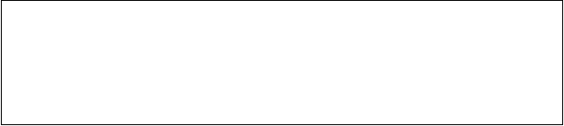Directions: After reading the passage below, fill in each blank with a proper word given in the box. Each word can be used only once. Note that there is one more word than you need.
A. acknowledgement
B. actually C. commonly
D. confirm
E. conscious
F. crackG. eliminate
H. independent
I. log
J. shortcut K. unimaginative

Why your Password May Not Be As Safe As It Seems
Does “qaz2ws” strike you as a nice safe password? What about “adgjmptw”? An analysis has found them to be among the passwords that are most 31 used, which of course means they are not secure at all.

When ten million passwords were leaked on to the internet, they appeared to 32 that attempts by internet security experts to make us improve our password strength had been successful, even if, in the
specific case of the leaked passwords, they are also completely pointless. While many of the passwords were still single words, such as “password”, there was also a clear attempt by many to make them
harder to 33 . The problem was that people seemed to do so in the
same way.
“Users are becoming slightly more 34 of what makes a password strong,” explained WP Engine, an internet company that performed the analysis. “For instance, adding a number or two at the end of a text phrase. That makes it better, right?”
But 35 no. They found that almost half a million passwords did this---and in 20 per cent of those all people did was put the number “1” at the end.
Perhaps this is why some companies are now trying to move gradually beyond passwords. Yahoo! is giving users the option to associate their mobile phone with an account, had have a single use passwords texted to it each time they want to 36 on.
Although the services is voluntary, Dylan Casey an executive at Yahoo!, said that it was “the first step to 37 passwords ”. He said it was a(n) 38 that it was increasingly hard for people to remember all

the passwords they had. “I don ’t think we, as an industry, have done a good enough job of putting ourselves in the shoes of the people using our products,” he said.
It would certainly be a more sensible strategy than same people’s improving upon “password” by using “wasspord” or, tran5p053d numb3r5 f0r 13tt3r5.
“We are, for the most part, predictably 39 when it comes to choosing passwords, despite a decade of warnings from password strength checkers during sign-ups,” said WP Engine. “We love taking a(n) 40 , and so do password crackers.

Reading Comprehension Section A
Directions: For each blank in the following passage there are four words or phrases marked A, B, C and D. Fill in each blank with the word or phrase that best fits the context.
Ever been just about to call someone when the phone rings and the person in question is on the other end? Or have you experienced a sudden feeling of unease or danger even though you’re in a(n) 41 situation? If you don ’t believe in it, you ’ll put it down to 42 and on overactive imagination. But some people believe it is 43 that there is a sixth sense beyond smell, taste, touch, hearing and sight. Now, scientists are carrying out experiments not only to prove that it exists,

but also to find out how you can 44 it to your advantage.
Dean Radin, a researcher in California, has set up the Boundary Institute in Los Altos and is currently using its website to recruit （招募） 4,000 people in 57 countries to find out if there are any 45 instances of sixth sense or, as he calls it, “precognition”—the ability to predict outcomes. The results so far are 46 . In a card test, where you have to
- which of the five cards on a computer screen will be turned over to reveal a picture, the top scorers hit the right card 48% of the time —the
- of this happening are 2,669 to 1.
- , Radin’s most famous study involves participants looking at a variety of images that are designed to stimulate a specific responses. In the experiment, participants sit alone in a room in front of a computer, with devices attached to their bodies to measure changes in skin resistance and blood flow, which are measures of emotional arousal. Radin has found that one in six people has a rise in arouse before they see the road accident-type pictures, while remaining 50 before the tree-type pictures.
But even if you do accept that a sixth sense exists, the question is, does it actually 51 ? Radin says it does. “the future of our civilisation depends on 52 that are being made now, whether it ’s about how we farm our food, how we get rid of our waste or whether we allow chemicals to be included in everyday products. We don ’t have answers

to these important questions, yet what we decide on will 53 our lives for decades or longer. Anything we can do to improve our ability to predict future events is well worth the 54 , ” he says. “If it turns out that some people can genuinely forecast the future some of the time, as I believe the data shows, then 55 this ability is as important as cutting-edge science.
- A. unfamiliar B. tough C. harmless D. ridiculous

- A. coincidence
- A. mystery
- A. alter
B. resistance
B. evidence
B. define C. find
C. innovation
C. falsehood
D. use
D. distraction
D. innocence

- A. historical B. strange C. mistaken D. true

- A. extraordinary disappointing
B. inevitable C. alarming D.

- A. ask B. guess C. recall D. learn

- A. figures
- A. However Consequently
- A. active
B. methods C. scores
B. Otherwise C. Meanwhile

B. calm C. silent D. alert
D. chance D.

- A. serve any purpose
C. make any progress
B. take any advantage
D. win any support

- A. inquiries comparisons
B. decisions
C. donations D.

- A. ruin B. improve C. affect D. wait

- A. expense
- risk
- effort
- wait

- A. proving

Section B
B. challenging C. limiting
D. understanding

Directions: Read the following three passages. Each passage is followed by several questions or unfinished statements. For each of them there are four choices marked A, B, C and d. Choose the one that fits best according to the information given in the passage you have read.
(A)
What happens in a particular class on a particular day depends on the interactions that occur between the teacher, the students,, and the material being studied. The classroom context, generally speaking, includes all those factors that influence what happens during teaching and learning. These factors operate on different levels.
The physical context, for example, influences what happens in the classroom. Space may restrict participation, depending on how a teacher interprets the situation. Some teachers use their surroundings to promote learning. Notice boards reflect themes or topics being studied; a display area presents students’written work for others to read. Of course, some teachers remain unaware of the physical environment that they and their students inhabit together. A room, after all, is just a room. Yet the physical environment of the classroom affects

the nature and types of interactions that will occur. Straight rows of tables, for example, are favourable to classroom lectures and turn- taking routines in which students one by one, recite answers to a teacher’s questions.
A room isn’t just a room for teachers who seek to make the physical environment suitable for interactive learning. Interactive learning invites thinking, reading, writing, speaking, listening, and sharing. Such classrooms are arranged for individuals rather than for the “class” as a whole; they welcome students as active participants. Various physical arrangements encourage interactive learning, but they depend on the size of the room and the furniture that is available.
A class can be organized for individual, group, or whole-class activities. Students are initially assigned seats at a combination of small and large tables. However, when the students work individually or in groups, they are free to abandon the assigned seating. The chalkboard occupies a central position in the room to accommodate whole-class study.
- According to the passage, “the physical context ” (paragraph 2) may include .
  - teachers’ roles
  - themes being studied
  - a display area

  - 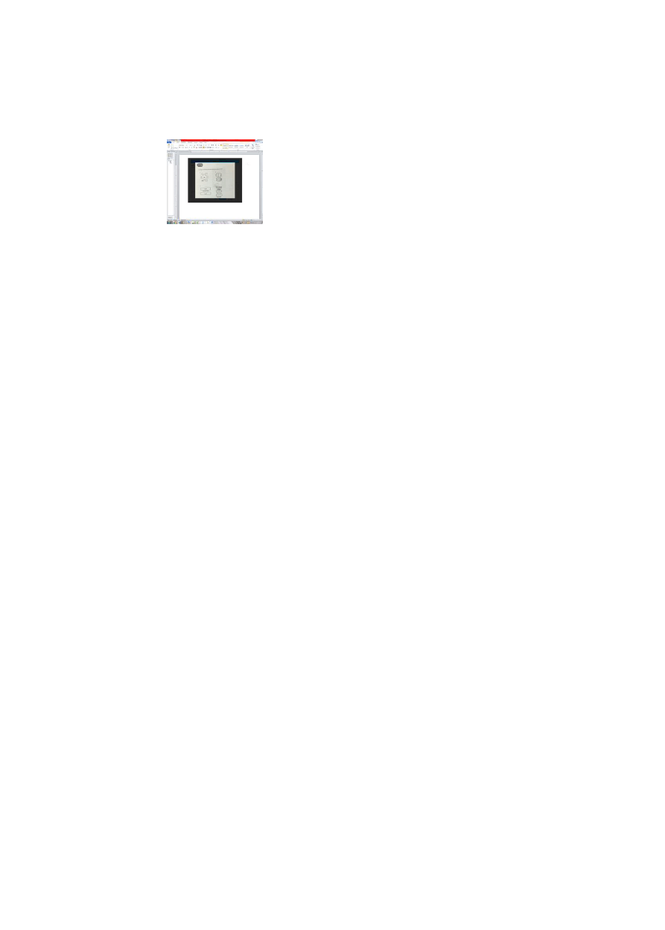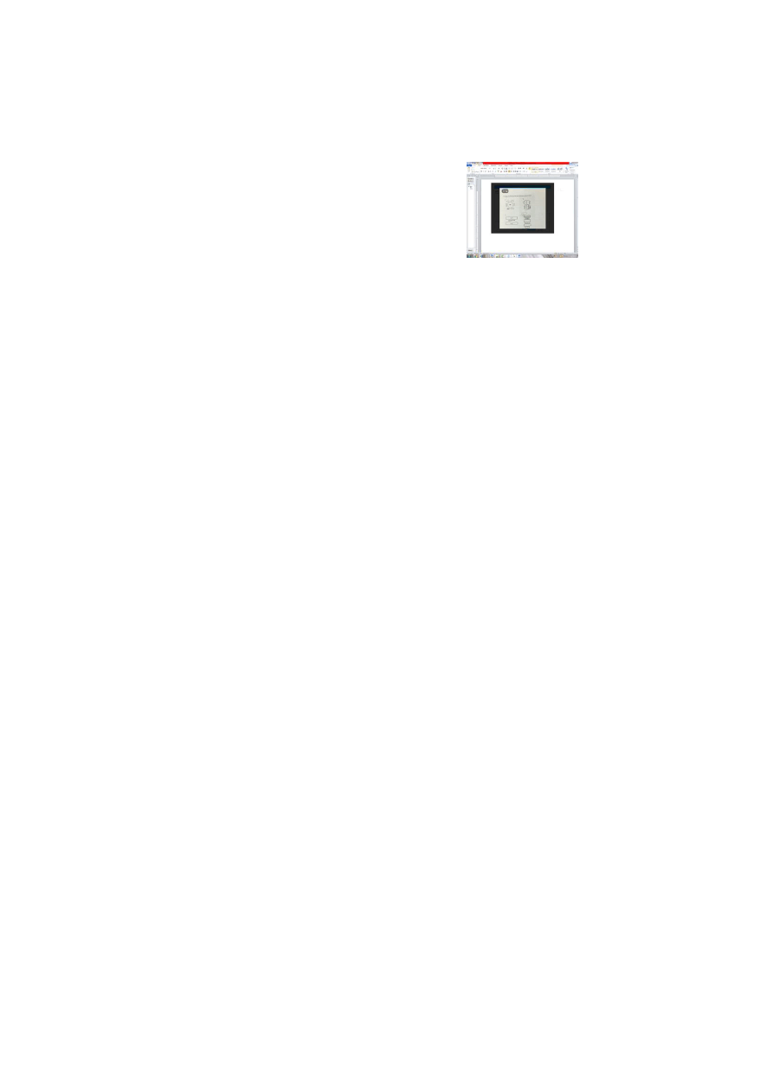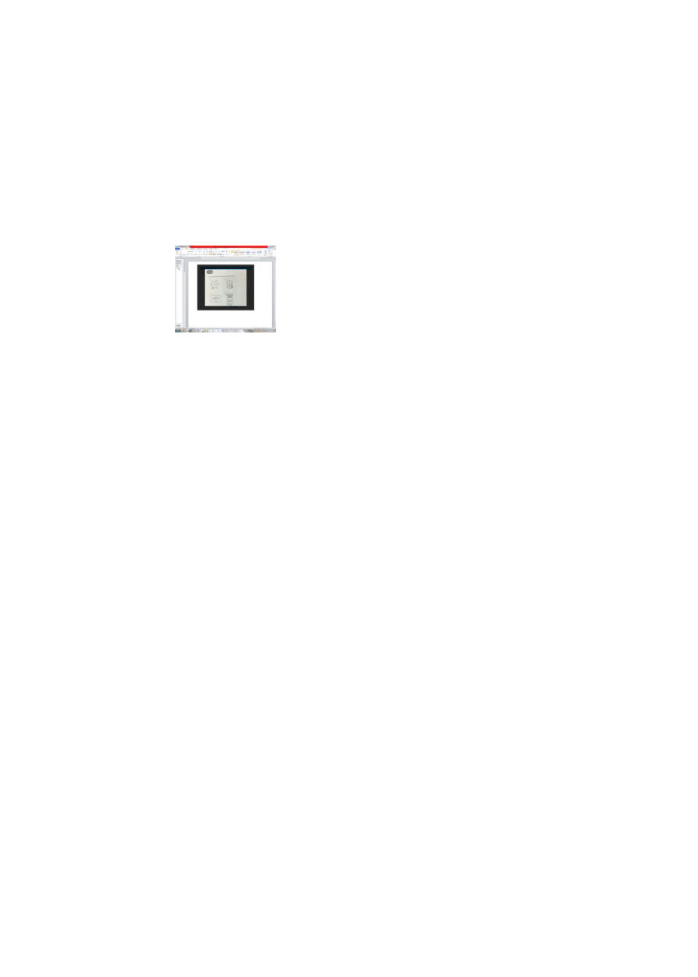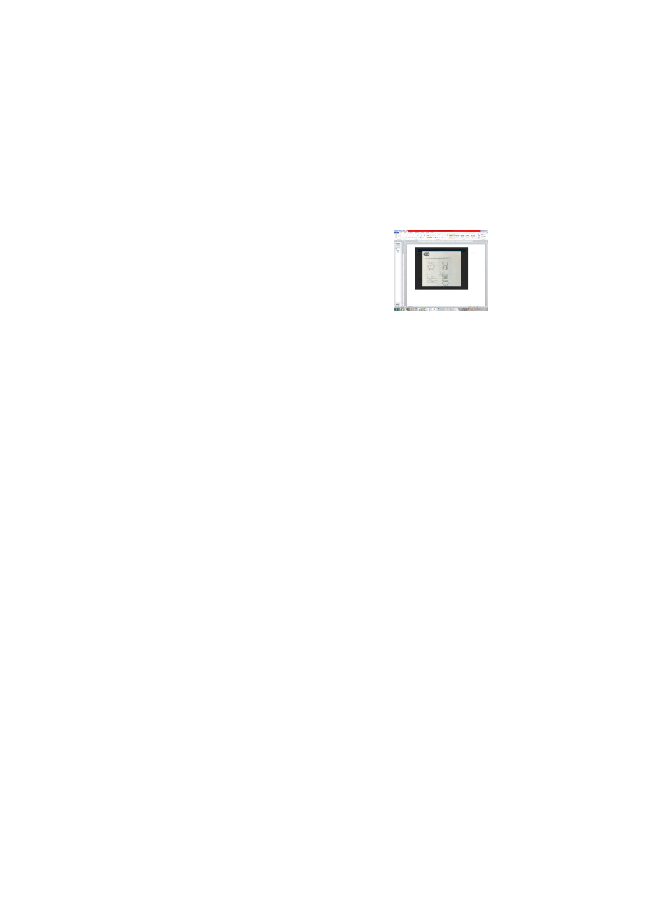students’participation
- Which of the following is the most suitable for a classroom lecture?

A B
. .

C D
. .

- From the last paragraph, we can learn that .
  - classrooms should be arranged for the class as a whole
  - the chalkboard should be abandoned during group work
  - seating can be changed for different classroom activities
  - interaction can be encouraged by combining small and large tables
- What is the passage mainly about?
  - The physical classroom environment varies with different types of interaction.
  - The physical environment is a deciding factor for a successful lesson.
  - Interactive learning depends on individuals’ active involvement.
  - Group work has become a trend in classroom teaching.
(B)

    - $15.00USD-8.5x11 Paper
    - $24.00USD-11x17 Paper
    - $30.00USD-13x19 Paper
    - $45.00USD-17x22 Paper
    - $95.00USD-24x30 Paper
    - $185.00USD-34x47 Paper
    - $70.00USD-17x22 Exhibition Canvas（帆布）
    - $140.00USD-24x30 Exhibition Canvas
    - $275.00USD-36x50 Exhibition Canvas
    - $350.00USD-44x61 Exhibition Canvas

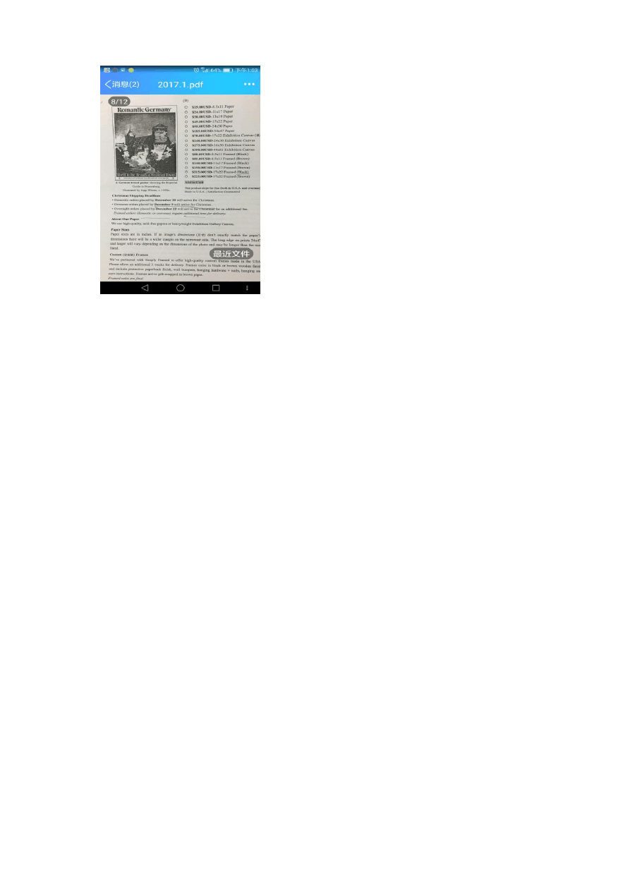

A German travel poster
showing the Imperial
- $80.00USD-8.5x11 Framed (Black)
- $85.00USD-8.5x11 Framed (Brown)
- $140.00USD-11x17 Framed (Black)
- $150.00USD-11x17 Framed (Brown)
- $215.00USD-17x22 Framed (Black)
- $225.00USD-17x22 Framed (Brown)

Add to Cart
This product ships for free (both in U.S.A.


Castle in Nuremberg.
and overseas)
Illustrated by Jupp Wiertz, Made in U.S.A. / Satisfaction Guaranteed
c. 1930s.

Christmas Shipping Deadlines
- Domestic orders placed by December 20 will arrive for Christmas.
- Overseas orders placed by December 9 will arrive for Christmas.
- Overnight orders placed by December 22 will arrive for Christmas for an additional fee.
Framed orders (domestic or overseas) require additional time for delivery.

About Our Paper
We use high-quality, acid-free papers or heavyweight Exhibition Gallery Canvas.

Paper Sizes
Paper sizes are in inches. If an image’s dimensions（ 尺寸） don’t exactly match the paper ’s dimensions there will be a wider margin on the narrowest side. The long edge on prints 34x47 and larger will vary depending on the dimensions of the photo and may be longer than the size listed.
Custom（定制的）Frames
We’ve partnered with Simply Framed to offer high-quality custom frames made in the USA Please allow an additional 3 weeks for delivery.

Frames come in black or brown wooden finish and include protective paperback finish, wall bumpers, hanging hardware + nails, hanging and care instructions. Frames arrive gift-wrapped in brown paper.
Framed sales are final.
- If you want to order a 17x22 print on canvas with a black frame, how much are you expected to pay?

A. $45.00USD. C. $215.00USD.
B. $70.00USD. D. $225.00SD.

- If you hope your framed order will reach your friend in Germany for Christmas, you’d better place your order by .

  - December 20
19

December 9C. November 30 D. November

以上内容仅为本文档的试下载部分，为可阅读页数的一半内容。如要下载或阅读全文，请访问：https://d.book118.com/355131341303011033

