Unit 2 In Beijing 第 1 课时 课堂同步练习
姓名： 班级：


要点图解秀

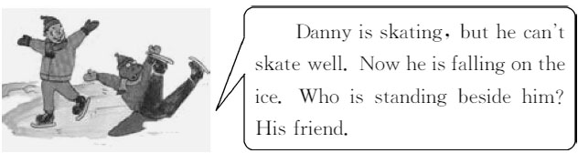

基础碰碰车

Ⅰ . 请将下面的单词补充完整。
( )1.m y
A.en B.an C.in
( )2.p ple
A.oe B.ea C.eo
( )3.g l
A.ir B.ur C.ar
( )4.w man
A.a B.e C.o
( )5.ch d
A.ll B.il C.li

- . 写出下列动词的现在分词。
  - fly
  - sing
  - dance 4.run 5.play
Ⅲ . 按要求进行句式转换 , 每空一词。
- Jill is trying to find the library.( 对画线部
分提问 )
Jill trying to do?
- There are some people in the park.( 改为一般疑
问句 )
people in the park? 3.His mother wants to buy him a puter.( 改为
同义句 )
His mother wants to buy a
puter
4.That policeman is working hard.( 改为复数形式)
are working hard. 5.Stand over there,Danny!( 改为否定句 )
over there,Danny!

Ⅳ . 根据上下句意 , 用适当的疑问词填空。
- — do you feel after running?
—I feel too tired.
- — is that girl looking for?
—She is looking for her sister. 3.— can I put my suitcase?
—On the table,of course.
- — are the children doing over there?
—They are playing puter games.
- — people are there in the park?
—There are too many.

-1-

升级跷跷板

Ⅴ . 按要求进行句式转换 , 每空一词。
- They are buying new books.( 改为一般疑问句 )
new books?
- They are sitting beside the window.( 对画线部
分提问 )
they sitting? 3.Brian,you can᾽t play here.( 改为祈使句 )
Brian, here.
- Danny is writing some letters on the paper.( 改
为否定句 )
Danny letters on the
paper.
- The boys are playing games over there.( 对画线
部分提问 )
are the boys over there?

Ⅵ . 下列每句话中有一处错误 , 请找出来并加以改正。
1.That girl is looking at her mother. Maybe she
is lost.

2.I see Li Ming on my way of the hotel.

3.Let her es with us now.

4.What are your sister Linda doing now?

5.There are much students in our school.

Ⅶ . 根据所给的图示用恰当的词语填空。
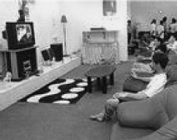
- The man TV at home now.

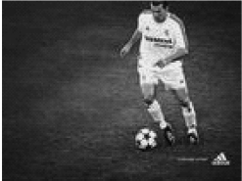

- The man is

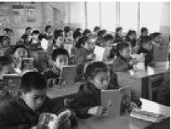

- The students are in the
classroom.
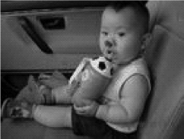
- The little boy water now.
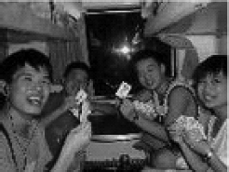

- Look! They are on the train.

-2-

Unit 2 In Beijing 第 1 课时 课堂同步练习答案
答案 :
Ⅰ .1-5 BCACB
Ⅱ .1.flying 2.singing 3.dancing 4.running 5.playing
Ⅲ .1.What is 2.Are there any 3.for him 4.Those policemen 5.Don᾽t stand Ⅳ .1.How 2.Who 3.Where 4.What 5.How many
Ⅴ .1.Are they buying 2.Where are 3.don᾽t play 4.isn᾽t writing any 5.What,doing Ⅵ .1.at 改为 for 2.of 改为 to 3.es 改为 e 4.are 改为 is 5.much 改为 many
Ⅶ .1.is watching 2.playing football 3.reading books 4.is drinking 5.playing cards

Unit 2 In Beijing 第 2 课时 课堂同步练习
姓名： 班级：

要点图解秀
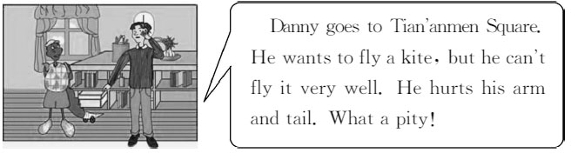

基础碰碰车

Ⅰ . 请将下面的单词翻译成汉语。
( )1.worry
A. 唱歌 B. 担心 C. 写字( )2.help
A. 帮助 B. 教学 C. 学习( )3.sad
A. 恶劣的 B. 快乐的 C. 悲伤的( )4.say
A. 讲述 B. 说 C. 告 诉( )5.difficult
A. 困难的 B. 不同的 C. 新鲜的

- . 用适当的介词填空。
  - Don᾽t worry your lessons. 2.Can you help me my English?
3.There are many people the square. 4.You can take pictures my camera. 5.The kite is flying the sky!

Ⅲ . 写出下列动词的现在分词形式。

help
- sit
- say

Ⅳ . 根据所给汉语完成句子 , 每空一词。
- 他正在看电视。
He TV now.
- 街道上有一些公共汽车吗 ?
buses in the
street?
- 听 ! 他们正在大声说话。
Listen! They are
- 孩子们正在睡觉。
The children
- 不要担心。我会帮助你的。
Don᾽t I can you.

升级跷跷板

Ⅴ . 按要求进行句式转换 , 每空一词。
1.There are some apples in the box.( 改为否定句)
There apples in the box. 2.The sheep are eating grass.( 对画线部分提问 )
are the sheep ?
- She can see the houses in the village.( 改为一
般疑问句 )
the houses in the
village?
- Danny points to something far away.( 改为否定
句 )
Danny far

- take
- ask

-1-
away.

5.This house has seven rooms.( 改为同义句 )
seven rooms in this house.

Ⅵ . 根据上下句意 , 用适当的疑问词填空。
- — are they doing?
—They are playing puter games.
- — it is for one pair of socks?
—Five yuan.
- — do you feel after running?
—I feel too tired.
- — are they arriving?
—They are arriving in Beijing.
- — is your brother looking for?
—He is looking for his friend,Lisa.

Ⅶ . 从所给的七个句子中选出五句将对话补充完整。
A: 1 B:By bike. A: 2
B:I usually go to school on foot.
A: 3
B:I᾽m mending my mother᾽s bike.
A: 4 B:It᾽s broken. A: 5 B:Thank you.
A:You᾽re wele.
Ⅷ . 阅读理解。
Today our class go on a trip to Nanjing by train.We arrive there at about ten.First,we go to Bailuzhou Park.The park is small,but it is nice.The grass is green and the flowers are colourful.In the park you can see a lake,a bridge,some chairs and some tables.We walk around the park.Then we leave the park for downtown( 商 业 区 ).There are a lot of people in the street.We do some shopping.I buy some pictures.At half past eleven,we go back to the park.We have lunch there.We eat bread,meat,eggs and some fruit.At five in the afternoon we e back home.We are very tired,but we are all happy.

根据短文内容判断正误 , 正确的填 T, 错误的填 F。( )1.I go to Nanjing with my family today.
( )2.We drive to Nanjing and arrive there in
the afternoon.
( )3.There are some flowers in Bailuzhou
Park.
( )4.We have lunch in the park at about
twelve.
( )5.All my classmates have a good trip to
Nanjing.

A.What᾽s the matter with it? B.Do you live near school? C.Where are you going?
D.What about you?
E.Let me help you mend it.
F.How does your mother usually go to work? G.What are you doing now?

-2-

Unit 2 In Beijing 第 2 课时 课堂同步练习答案
答案 :
Ⅰ .1-5 BACBA
Ⅱ .1.about 2.with 3.on 4.with 5.in
Ⅲ .1.taking 2.asking 3.helping 4.sitting 5.saying
Ⅳ .1.is watching 2.Are there any 3.talking loudly 4.are sleeping 5.worry,help
Ⅴ .1.aren᾽t any 2.What,doing 3.Can she see 4.doesn᾽t point to anything 5.There are Ⅵ .1.What 2.How much 3.How 4.Where 5.Who
Ⅶ .1-5 FDGAE
Ⅷ .1-5 FFTTT

Unit 2 In Beijing 第 3 课时 课堂同步练习
姓名： 班级：

要点图解秀

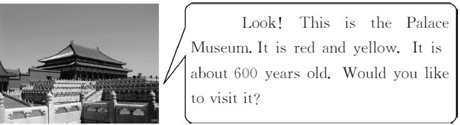

基础碰碰车

Ⅰ . 请将下面的单词补充完整。
( )1.pict
A.are B.ire C.ure ( )2.besi
A.da B.de C.be
( )3.caref
A.al B.ll C.ul
( )4.f l
A.al B.il C.el
( )5.h t
A.ir B.ur C.ar

- . 选择正确的答案填空。
( )1. ! They are the radio
now.
A.Listen,listening
B.Listen to,listening to
C.Listen,listening to
D.Listen to,listening
( )2.There are two workers in this
factory.
A.thousand B.thousands
C.thousands of D.thousand of ( )3.—Don᾽t look out of the window in
class, Danny!
— .
A.Yes, I will
B.Yes, that᾽s all right
C.You᾽re wele
D.Sorry, I won᾽t
( )4.—What do you think of this trip to
Qinhuangdao?
— .
A.It᾽s nice and interesting
B.That᾽s all right
C.It᾽s my second time to Beijing
D.Beijing is our capital
( )5.—Have a nice trip to Beijing!
— .
A.I like doing that
B.I᾽ll go there,too
C.It᾽s far from here
D.Thank you very much

Ⅲ . 写出下列动词的第三人称单数形式。
  - cry
  - dance
  - read
  - put 5.talk

Ⅳ . 根据句子意思用适当的介词填空。
- What do you usually do Saturdays and
Sundays?
- Don᾽t worry your lessons.I can help
you.

- Danny falls down the tree and breaks his
legs.
- Thanks a lot taking pictures for me. 5.Why does this kind of matter happen her
every day?

升级跷跷板

Ⅴ . 根据所给的汉语完成下面的句子 , 每空一词。
  - 李明 , 请当心 !
Ⅶ . 将所给单词连成完整正确的句子。( 单词不得重复使用, 标点已给出 )

1.find, is, a, to, she, hotel, trying
.
2.playing, are, game, a, they, word
? 3.the, to, Danny, washroom, wants, use
. 4.do, buy, how, tickets, you, many, to, want
?

Li Ming, please
  - 张红正站在她妹妹旁边。
Zhang Hong is
  - 墙上有很多画吗 ?
!

her sister.
5.her, day, takes, every, she, of, mother, care
.

Ⅷ . 阅读理解。

many pictures on the wall?
One day Mr.and Mrs.White go shopping by car.

  - 箱子里一个苹果也没有。
They stop their car near a shop. They buy a

apples in the box.
lot of things from the shop and the things are

  - 我想要他给我照张相。
heavy. They want to put the things in their

I want

car. But Mr.White can᾽t open the door of the

a picture for me.

Ⅵ . 根据所给的答语用适当的疑问词填空。
1.— are they going?
—They are going to the Palace Museum.
car.“Let᾽s ask a policeman for help,” says Mrs.White. They ask a policeman to help them. The policeman is very friendly to help them open the door of the car. At that time a man es up and shouts,“What are you doing with

2.—
—It᾽s blue.
is the sky?
my car?” Mr.and Mrs.White look at the number of the car. Then they say sorry to the man.

- — are they doing now?
—They are drawing pictures.
- — will they go to the zoo?
—This Sunday.

根据短文内容选择正确答案。
( )1.How do Mr.and Mrs.White go shopping one
day?

5.—
is this museum?
A.By bike. B.By car.

—One hundred years old.
C.With a policeman
D.With their son.

( )2.They want to after shopping.
A.put the heavy things into their car
B.carry the heavy things home
C.ask a policeman to carry the things for
them
D.buy a car
( )3.Mr.White can᾽t open the door of the
car .
A.but Mrs.White can
B.but the policeman can
C.but they open it at first
D.and they open the car all day
( )4.Who helps them open the door of the car?
A.An old man. B.A woman.
C.A policeman. D.No one.
( )5.How do they know they are wrong?
A.They see the man angry.
B.The angry man tells them.
C.The policeman lets them know.
D.They look at the number of the car and
finds out it is not their car.

-3-

以上内容仅为本文档的试下载部分，为可阅读页数的一半内容。如要下载或阅读全文，请访问：https://d.book118.com/367100160054006046

