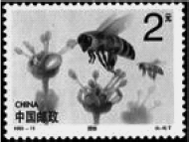
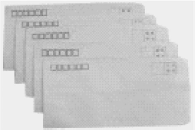

Unit 3 Writing Home 第 1 课时 课堂同步练习
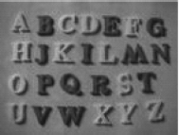
姓名： 班级：

要点图解秀  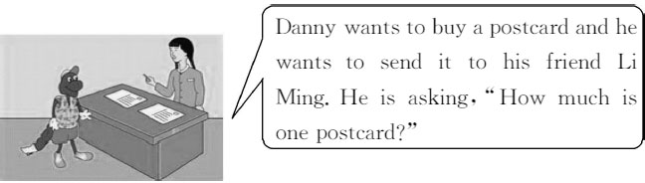  基础碰碰车  Ⅰ . 请将下面的单词补充完整。  ( )1.m ch  A.e B.u C.i ( )2.le er  A.tt B.ss C.nn ( )3.postc d  A.ir B.ur C.ar ( )4.pict  A.air B.ear C.ure ( )5.put  A.ar B.er C.or |  |  |  | Ⅲ . 根据所给的图示用适当的单词填空。  1.There are twenty-six in English.  - This is an old . Do you like it?  - Can you see the on the table?  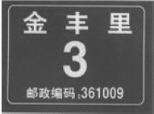  - Her new is Jinfengli No.3.  - Here are some . Whose are they?
Ⅱ . 写出下列动词的第三人称单数形式。 |  |  |  | Ⅳ . 根据句子意思用适当的介词填空。
1.fly 2.sing 3.dance 4.have 5.play |  |  |  | - Two yuan is a pencil.It᾽s too  expensive.  - Emily often sends her friends messages  email.  - They are leaving for Beijing February  10.
 |  |  |  | 4.Look! Danny is writing two pens at the

same time.
5.Her parents want to buy a new puter her.
A: 5

升级跷跷板

Ⅴ . 按要求进行句式转换 , 每空一词。
- Wang Hong, put the letters on the table.( 改为
否定句 )
Wang Hong, the letters on
the table.
- There aren᾽t any puters in this hotel.( 改
为同义句 )
This hotel any puters. 3.She needs five envelopes to send letters.( 改
为一般疑问句 )

five envelopes to send letters?
4.How is the weather in Canada now?( 改为同义句)
the weather in Canada now? 5.They are going back to Canada next week.( 对画
线部分提问 )
they going back to Canada?

Ⅵ . 请从所给的七个句子中选出五句将对话补充完整。
(A)
A: 1
B:I᾽m reading today᾽s newspaper. What᾽s up,
Jack?
A: 2
B:For how long?
A: 3
B:OK. No problem. A:Thanks. 4
B:Yes,they are over there. Help yourself.

Ⅶ . 完形填空。
A.It᾽s very kind of you. B.Till the end of this week. C.Where are you going?
D.What are you doing now?
E.By the way, have you got any CDs? F.How much is your DVD machine?
G.May I use your DVD machine?
Jack is from London.His father 1 a shop there and his mother works on a farm. He is a 2 of Grade Seven. His father drives him to 3 every day. So he is 4 late and his teachers like him very much.
It᾽s Tuesday today. Miss Read 5 them to count from one to ten. Jack is working hard in class. Soon he can 6 to ten. Miss Read is very glad and 7 him,“How many people are there in your family, Jack?”
Jack 8 and says,“Two,Miss Read.”
“Who are they?”
“My father and mother.”
“Oh?” Miss Read is surprised and says,“
9 three people in your family.”
“But now I᾽m not at home. I᾽m 10 ,you know!”

( )1.A.makes B.does C.has D.takes ( )2.A.teacher B.student
C.doctor D.worker ( )3.A.school B.farm
C.factory D.library ( )4.A.often B.always
C.sometimes D.never

same time.
( )5.A.taught B.teaches
C.will teach D.is teaching
( )6.A.make B.count C.draw D.write ( )7.A.asks B.shows C.laughs D.tells ( )8.A.sits down B.listens to
C.looks at D.stands up ( )9.A.They have B.It is
C.There are D.They are ( )10.A.on the way B.at school
C.far from them D.lonely

Ⅷ . 阅读理解。
Tom and Jenny are good friends.But they live far from each other.Tom lives in Canada and Jenny lives in the United States.They write to each other very often.He writes her letters about the life in Canada and she writes him letters about the life in the U.S..They never forget each other᾽s birthday.This year he sends her a silver bracelet( 手镯 )and she sends him a silk necktie( 领带 ).
Tom and Jenny help each other very often. He es to see her when she is in the hospital and she gives advice( 建 议 )when something is wrong with him. They like each other very much.
根据短文内容选择正确答案。
( )1.The two friends live in .
A.the U.S. B.Canada
C.the same country
D.different countries
( )2.Tom and Jenny often each other.
A.see B.write to C.call D.visit ( )3.Jenny gives Tom for his birthday.
A.a bracelet B.silk
C.silver D.a necktie ( )4.Tom goes to see Jenny when she
is .
A.ill B.out C.a doctor D.at home ( )5.Jenny when something is wrong
with Tom.
A.goes to see him
B.calls him
C.gives him advice
D.gives him presents

-3-

Unit 3 Writing Home 第 1 课时 课堂同步练习答案
答案 :
Ⅰ .1-5 BACCB
Ⅱ .1.flies 2.sings 3.dances 4.has 5.plays
Ⅲ .1.letters 2.stamp 3.postcards 4.address 5.letters Ⅳ .1.for 2.by 3.on 4.with 5.for
Ⅴ .1.don᾽t put 2.doesn᾽t have 3.Does she need 4.What᾽s,like 5.When are Ⅵ .1-5 DGBEA
Ⅶ .1-5 CBADD 6-10 BADCB
Ⅷ .1-5 DBDAC

Unit 3 Writing Home 第 2 课时 课堂同步练习
姓名： 班级：

要点图解秀

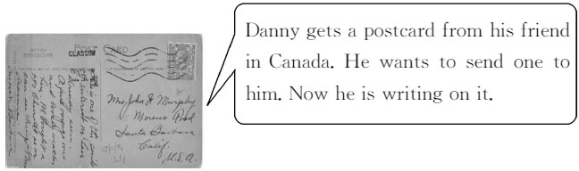

基础碰碰车

Ⅰ . 请将下面的单词翻译成汉语。
( )1.dear
A. 和平的 B. 附近的 C. 亲爱的( )2.fine
A. 帮 助 的 B. 好的 C. 美丽的( )3.right
A. 右边的 B. 快乐的 C. 左边的( )4.write
A. 讲述 B. 说 C. 写( )5.left
A. 困难的 B. 左边的 C. 新鲜的

- . 根据所给的汉语用适当的词语填空。
  - How many ( 电子邮件 )did you write this
morning?
  - Can you ( 寄 )a postcard to me on my
birthday?
  - He is ( 来到家中 )this afternoon.
Let᾽s meet him at the station. 4.Can you ( 给我看看 )your new
dress, Jenny?
5.This hotel ( 有 )a lot of puters.

-1-
Ⅲ . 选择正确的答案填空。
( )1.Please pass some paper.
A.Tony and I B.I and Tony
C.Tony and me D.me and Tony ( )2.—What᾽s the date today?
—It᾽s .
A.Friday B.cloudy
C.seven thirty D.March 10
( )3.— do you e to school every
day?
—By bike.
A.Why B.When C.How D.Where ( )4.— are your new dress?
—It᾽s 500 yuan.
A.How much B.How many
C.How long D.How
( )5.The hotel isn᾽t here.You can walk
there.
A.near B.far from
C.next to D.beside here

Ⅳ . 下列每句话中有一处错误 , 请找出来并加以改正。
1.It is sun today. Let᾽s go out to play.
2.I want to write a email to my friend.

3.Where are they going to?

4.Please put the stamp in the right.

- Let᾽s see if the hotel have a puter.

升级跷跷板

Ⅴ . 从所给的七个句子中选出五句将对话补充完整。
A: What can I do for you? B: I᾽d like some envelopes.
A: Do you want the large size or small size? B: 1 Do you have any writing paper?
A: 2 We have large ones. 3
B: Yes, please.And I want some markers. A: Here you are. 4
B: That᾽s all. 5 A: Ten yuan.
B: Here᾽s the money. Bye! A: Bye!
A.Do you have dresses?
B.The large size,please.
C.Would you like some? D.Yes,we do.
E.How much are they?
F.Is that all?
G.No,thanks.

Ⅵ . 按要求进行句式转换 , 每空一词。
Ⅶ . 阅读理解。
A father asks his son,“Tony!How many letters are there in the alphabet( 字母表)?” “I don᾽t know.” The father is very angry( 生气).He says angrily,“You are in school for one year. You don᾽t know how many letters in the alphabet. How do you work?”
Tony says,“Dad!You work in the post office. How many letters are there in the post office,do you know?”
根据短文内容判断正误 , 正确的填 T, 错误的填 F。( )1.Tony is a student.
( )2.Tony᾽s father is an English teacher.
( )3.The father doesn᾽t think his son studies
well at school.
( )4.The word “letter” has two different
meanings.
( )5.Tony᾽s father knows how many letters
there are in the post office.

Ⅷ . 短文填词。
根据短文意思用适当的词语填空。
Dear Tony,

  - We have fun in Beijing.( 改为同义句 ) How are you?We go to school five days a

We

1 .I have a lot of friends in my school.

in Beijing.
  - The palace is red and yellow.( 对画线部分提问)
is the palace?
  - She wants to take a picture here.( 改为同义句)
to take a picture here. 4.We can help them to do that.( 改为一般疑问句 )
help them to do that? 5.Jenny puts the postcard on the table.( 对画线
部分提问 )

the postcard?
And one of 2 is from Canada.His name is Billy.I am learning English.And I learn to 3 English from him after school.He is glad to help me.He wants to learn Chinese.So I help him 4 his Chinese.Sometimes we go out 5 Sundays.
Please write to me soon. Love from
Mike
1. 2. 3.
4. 5.

-2-

Unit 3 Writing Home 第 2 课时 课堂同步练习答案
答案 :
Ⅰ .1-5 CBACB
Ⅱ .1.emails 2.send 3.ing home 4.show me 5.has Ⅲ .1-5 CDCAB
Ⅳ .1.sun 改为 sunny 2.a 改为 an 3. 去掉 to 4.in 改为 on 5.have 改为 has Ⅴ .1-5 BDCFE
Ⅵ .1.have a good time 2.What colour 3.She᾽d like 4.Can you 5.Where does Jenny put Ⅶ .1-5 TFTTF
Ⅷ .1.week 2.them 3.speak 4.with 5.on

Unit 3 Writing Home 第 3 课时 课堂同步练习
姓名： 班级：

要点图解秀
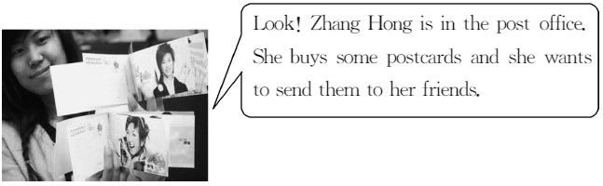

基础碰碰车

Ⅰ . 请将下面的单词补充完整。
( )1.t n
A.ar B.ir C.ur ( )2.wr ng
A.a B.e C.o ( )3.o ice
A.ll B.ff C.tt ( )4.s nd
A.e B.i C.o ( )5.n d
A.aa B.ee C.oo

Ⅱ . 根据句子意思和所给的首字母用适当的词语填空。1.The store is near here.You can w there. 2.She often buys presents f her family. 3.There is something wrong with my left arm.It
h badly.
4.She is w two postcards to her mother. 5.Please t right at the traffic lights.

Ⅲ . 用括号中所给动词的适当形式填空。
- They want (send)some postcards to

their teachers.
- Is it time (have)lunch now? 3.Linda (write) the postcard now.
- your brother (work)in this pany?
- Can she (play)basketball?

Ⅳ . 下面每句话中有一处错误 , 请找出来并加以改正。
1.Jack is having a new sweater now.
2.Daddy, please pass me and Petesome
chopsticks.

3.What do you want him does?

4.Danny, you speak Chinese very good.

5.Let Tony goes home with us today.

升级跷跷板

Ⅴ . 根据句子意思用适当的词语填空。
1.—Thank you very much.
—You᾽re .
2.Danny is going to Beijing January 5. 3.Five yuan for a pen not expensive. 4. your brother often use puters? 5.Thank you very much your help.

Ⅵ . 按要求进行句型转换 , 每空一词。

-1-

1.I am trying to find a hotel.( 对画线部分提问 )
are you trying ? 2.Can᾽t you see us standing there?( 进行肯定回答)
,I .
- Do you know anything else?( 改为同义句 )
do you know?
- I think it᾽s a flag of a school.( 改为否定句 )
I a flag of a
school.
- Look at your ticket,Danny.( 改为否定句 )
Danny, at your ticket.

Ⅶ . 阅读理解。
Mr.Smith looks at his watch. It is half past seven. He gets out of bed quickly.Then he puts on his clothes. He is often late, so he doesn᾽t have time for breakfast. He runs all the way to the station and he gets there just in time for the bus. Mr.Smith never eats anything in the morning. He always says to his friends at the office,“It᾽s good to have breakfast in the morning, but it is better to be in bed.”
根据短文内容判断正误 , 正确的填 T, 错误的填 F。 ( )1.Mr.Smith does not eat breakfast every
morning.
( )2.He has a clock to wake him up every
day.
( )3.He never gets up late in the morning. ( )4.He works in an office.
( )5.He often runs all the way to work.

-2-

Unit 3 Writing Home 第 3 课时 课堂同步练习答案
答案 :
Ⅰ .1-5 CCBAB
Ⅱ .1.walk 2.for 3.hurts 4.writing 5.turn
Ⅲ .1.to send 2.to have 3.is writing 4.Does,work 5.play
Ⅳ .1.is having 改为 has 2.me and Pete 改为 Pete and me 3.does 改为 to do 4.good 改为 well 5.goes 改为 go Ⅴ .1.wele 2.on 3.is 4.Does 5.for
Ⅵ .1.What,to do 2.Yes,can 3.What else 4.don᾽t think it᾽s 5.don᾽t look Ⅶ .1-5 TFFTF

以上内容仅为本文档的试下载部分，为可阅读页数的一半内容。如要下载或阅读全文，请访问：https://d.book118.com/376121240103010054

