
Retail Media Buyer’s Guide
iab
JULY 2023

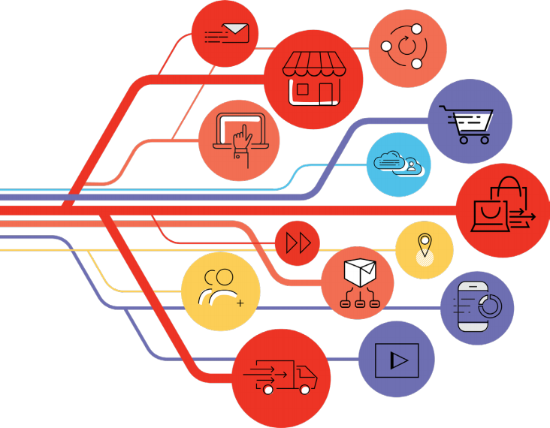



Table of Contents
1. What Is Retail Media? 2
1.1 Benefits of Retail Media 2
1.2 Challenges of Retail Media 4
1.3 The Privacy Landscape 5
2. Introduction To Planning for Retail Media 6
2.1 Understanding Partner Properties 6
2.2 Retail Media Makes Everything Performance Media 7
2.3 Closed-Loop Measurement 9
2.4 Onsite 10
2.5 Offsite 12
2.6 In-Store 13
2.7 The Endemic and Non-Endemic Spectrum 15
2.8 Unifying the Online and Offline Experience With Retail Media 16
3. Fostering Collaboration 17
3.1 Understanding Partner Properties 17
3.2 Joint Business Plan Negotiations 18
3.3 Changing Dynamics and Collaboration Across Retailers, Brands, and Agencies 19
3.4 Retail Media Briefing Process 21
4. Developing Your Audience Strategy 22
4.1 Identifying the Objective 22
4.2 How To Develop an Audience Strategy 22
4.3 First-Party Data Opportunity 24
4.4 Balancing Scale and Efficiency 26
4.5 Understanding Product Distribution 28
4.6 What Are the Audience Capabilities 28
4.7 Activating Your Audience 30
4.8 In-Store Audience Strategy 31
5. Retail Media Buying and Creative Strategy 35
5.1 Onsite Media Buying 35
5.2 Offsite Media Buying 36
5.3 In-Store Media Buying 37
5.4 Creative Planning and Strategy 38
5.5 Tailor Call-To-Action to the Funnel-Stage 39
5.6 Creative Planning Best Practices 40
Acknowledgments 41
About IAB 45
Contact Information 47

RETAIL MEDIA BUYER ’ S GUIDE 1

2


1. WhaT Is ReTaIl MedIa?

1. What Is Retail Media?

1.1 Benefits of Retail Media
Retail media is a form of digital advertising that allows brands to promote their products or services within a retailer’s e-commerce platform or physical store. It involves the use of targeted advertisements and
sponsored content that is displayed to shoppers while they browse and make purchases. Retail media is a relatively new concept, but it is quickly gaining popularity due to its ability to provide brands with highly targeted advertising opportunities and retailers with a new revenue stream.
One of the main benefits of retail media is its ability to provide highly targeted advertising opportunities. By leveraging customer data and analytics, retailers can deliver ads and promotions to customers who are most likely to be interested in their products. This means that brands can reach customers who are already in a shopping mindset, increasing propensity to purchase/convert. In addition, retail media allows brands to measure the effectiveness of their advertising campaigns in real-time, allowing them to optimize their strategies for better results.
For retailers, retail media represents a new revenue stream that can help offset the costs of running an e-commerce platform or physical store. Retail media also allows retailers to provide a better shopping experience for their customers by displaying targeted ads and sponsored content that is relevant to their interests.

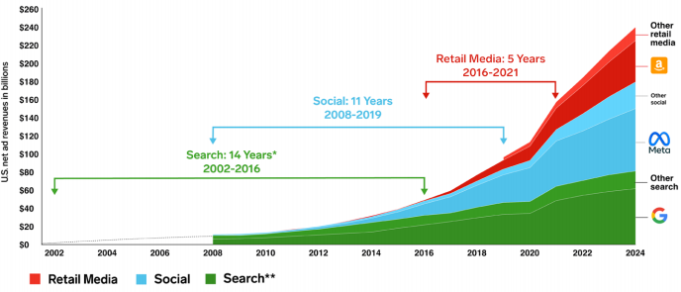
Note: *Using the IAB estimate of $900 million in search advertising revenues in 2002. **Excludes search ad revenues from retail media advertising
Methodology: Estimåates are based on the analysis of various elements related to the ad spending market, including macro-level economic conditions; historical trends of the advertising market; historical trends of each medium in relation to other media; reported revenues from major ad publishers; estimates from other
research firms; data from benchmark sources, consumer media consumption trends; consumer device usage trends, and eMarketer interviews with executives at ad agencies, brands, media publishers, and other industry leaders.
Source: eMarketer, Oct 2022

RETAIL MEDIA BUY ER ’ S GUIDE

3

1. WhaT Is ReTaIl MedIa?

Retail media is considered the third wave of digital advertising because it combines the targeting and
measurement capabilities of digital advertising with the scale and reach of traditional advertising. The first
wave of digital advertising was search advertising, which involved placing ads on search engines like Google. The second wave was social advertising, which involved placing ads on social media platforms like Facebook.
The opportunity for retail media is vast and encompasses various areas, including onsite, offsite display, social commerce, CTV, and in-store digital advertising.
• Onsite retail media involves displaying ads within a retailer’s e-commerce platform, such as search
result pages, product pages, and category pages. These ads can be highly targeted based on the
customer’s search history and purchase behavior, making them more likely to convert.

• Offsite display retail media involves displaying ads on third-party websites and apps, (i.e. Criteo,
Google Display Network, or TTD), which can help increase brand awareness and drive traffic to a
retailer’s website.
• Social commerce retail media involves using social media platforms like Instagram, Facebook, and
Pinterest to promote products and drive sales. Retailers can create shoppable posts and ads that allow
customers to purchase products directly from the platform.

• CTV Retail Media involves displaying ads on streaming TV services like Hulu, Roku, and Amazon Fire
TV. CTV offers retailers the opportunity to reach customers who are increasingly shifting away from
traditional cable TV and towards streaming services.

• In-store retail media involves displaying ads and promotional content within a physical store, such as
audio, digital signage, product displays, location-based, notifications, and interactive kiosks. In-store
retail media can help increase product awareness, promote new products, and drive sales.

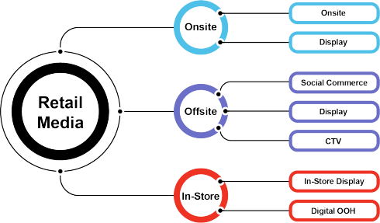

Source: IAB Intro to Retail Media Course, 2023

RETAIL MEDIA BUY ER ’ S GUIDE

in planning and executing across an RMN ecosystem. This requires acquiring the right experienced
talent, building the right models, and workflows. Also, there is significant competition for Retail Media
talent, and there is often a significant gap in RMN knowledge across different agencies. Agencies are
increasingly tasked with helping clients ensure optimal media spending without duplication.
• Consumers are promised a more relevant shopping experience through better-targeted ads with RMNs.
However, there is a potential risk of a degraded consumer experience via ad overload if monetization
pressures aren’t calibrated against what consumers will find useful. Therefore, it is vital to maintain
consumer trust in what they are seeing via search and display by displaying the best options rather than
only showing solutions that have paid to play.
4

1. WhaT Is ReTaIl MedIa?

1.2 Challenges of Retail Media

Retailers Are Becoming Media Companies

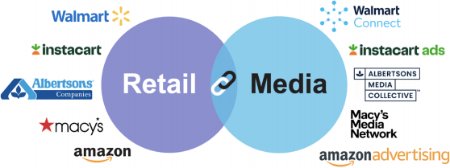

Source: IAB Intro to Retail Media Course, 2023
The rise of retail media networks (RMNs) offers both retailers and brands a host of exciting possibilities.
However, despite the many proposed benefits, there are still several obstacles standing in the way of realizing RMN’s full potential. To overcome these challenges, it is critical to identify and address them head-on.
• Retailers face the challenge of launching a successful RMN that requires competencies in customer
data management, media, and ad tech. These competencies are not typically found in the core business
of retailing, which means retailers must create standalone functions to handle RMN. In addition,
consistent and granular closed-loop measurement on spend within retail media networks increases the
likelihood of unlocking investment.

• Brands have an abundance of choices in terms of where to invest in RMNs. It is therefore essential for a
retailer’s RMN to have a clear and distinct value proposition to attract incremental investment/revenue.
RMNs provide for both “upper-funnel” brand building and “lower-funnel” performance marketing, which blurs
the traditional roles between commercial and marketing functions. The impact of brands looking to increase
the money spent within their RMNs can mean retailers are willing to accept more new SKUs than before to
create greater auction density on more keywords. This creates more competition online and in-store.
• Agencies face the challenge of building full-capability teams that can guide clients strategically and

RETAIL MEDIA BUY ER ’ S GUIDE

5

1. WhaT Is ReTaIl MedIa?

Overall, because RMNs represent one of the biggest shifts in advertising in decades, significant challenges and obstacles are to be expected. Overcoming them requires collaboration across stakeholders within
companies, between brands and retailers, and across the industry. By identifying and addressing these challenges, RMNs can continue to grow and thrive, providing benefits for all stakeholders involved.

1.3 The Privacy Landscape
The changes in data privacy regulations, such as the EU’s General Data Protection Regulation (GDPR) and the California Privacy Rights Act (CPRA), along with platform changes like Apple’s identifier for advertisers (IDFA), have made it more difficult for brands to access and use customer data for targeted advertising.
This has resulted in the need for new solutions, such as retail media, that allow brands to leverage first-
party data and reach customers in a closed-loop environment. Retail media provides a way for brands to target customers based on their shopping behavior and preferences, with the added benefit of closed-loop measurement to track the effectiveness of campaigns. This has highlighted the value of retail media as a reliable and effective advertising channel, particularly in a landscape where data privacy and measurement are becoming increasingly challenging.
However, it is important to note that this increased reliance on first-party data comes with a responsibility to adhere to consumer privacy. Brands and retailers must ensure that the data they collect is used ethically and transparently, and that consumers have control over their data and how it is used. Failure to do so can result in loss of consumer trust, legal repercussions, and damage to brand reputation. Adhering to consumer privacy not only protects the consumer, but also supports the long-term success and growth of retail media.

RETAIL MEDIA BUY ER ’ S GUIDE

6

2. InTRoduCTIon To PlannIng foR ReTaIl MedIa

2. Introduction To Planning for Retail Media

2.1 Understanding Partner Properties

Planning and executing a media investment strategy in the age of commerce media requires close

collaboration between retailers and brands to ensure alignment between business goals and target audiences. At the executive level, business goals such as sales growth, profitability, market share, in- store visibility, and successful velocity on new product launches will dictate the competitive strategy. Consequently, these business goals directly impact media strategy and planning.
Developing a media investment strategy that aligns with enterprise-level and brand-level goals requires a clear understanding of the target audience, how that audience consumes media, and eventually, how they consume your product. It is also essential to consider how various media channel options will
impact behavior at different points in the customer lifecycle and how the consumer will reach to different messaging, offers or personalization efforts.
Moreover, as more retail platforms transform their ability to capture and activate shopper data, marketers are getting better equipped to manage personalization strategies and benefit from a more direct line to full-funnel performance measurement and validation. As a result, the planning process now requires a comprehensive understanding of the advertiser’s total relationship with each retail partner and commerce media’s influence on the media landscape, although many fundamentals of the process remain the same.

The integration of retail media into a holistic brand plan is important as activations span both tactical operations and marketing touchpoints such as driving traffic
across tactics. The goal is to transition from “info sharing” between teams to executing across full-funnel planning.

RETAIL MEDIA BUY ER ’ S GUIDE

7

2. InTRoduCTIon To PlannIng foR ReTaIl MedIa

2.2 Retail Media Makes Everything Performance Media

Retail media networks have evolved to offer a range of solutions that can be utilized to optimize performance and achieve business objectives. To effectively leverage these solutions, it is important to take a top-down approach and prioritize retailers and budgets based on the desired business outcome. This will enable

brands to allocate their resources in a way that drives the greatest impact and results.
One of the key advantages of advanced retail media networks is the ability to create custom audiences using first-party data. This enables brands to target the right message to the right audience at the right touchpoint, thereby improving the effectiveness of their campaigns. By accessing a retailer’s first-party data, brands
can also gain valuable insights into shopper behavior and preferences, which can inform their targeting and messaging strategies.
It is important to overcome the perception that retail media networks are only conversion focused. Brands
should recognize the value of these networks in building stronger partnerships with retailers, enabling sales and customer development support, and accessing first-party data for programmatic targeting. Additionally, insights and shopper teams can benefit from the ability to better understand the shopper by retailer, while measurement and finance teams can appreciate the closed-loop reporting capabilities that many retail media networks offer.
To optimize performance and achieve business objectives, it is important to have fluidity in budget allocation both within and across accounts. Brands should be willing to allocate their resources where they have the
best chance of performing based on the criteria. In addition, a second layer mapping to the various parts of the shopper journey with corresponding digital media KPIs can be considered, including brand awareness, performance, and brand loyalty.

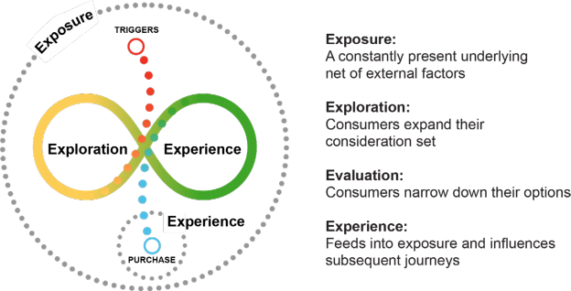

Source: Google

RETAIL MEDIA BUY ER ’ S GUIDE

以上内容仅为本文档的试下载部分，为可阅读页数的一半内容。如要下载或阅读全文，请访问：https://d.book118.com/387036053105006043

