人教PEP六年级英语下册Unit 3 Where did you go
大单元整体教学任务单
课程基本信息
教材版本 | 人教PEP版 | 学科 | 英语 | 年级 | 六年级 | 册别 | 下册
课题 | Unit 3 Where did you go?  Part A Let’s learn & Listen, answer and write
学生信息
姓名 | 学校 |  |  | 班级 |  |  | 学号
学习目标
目标：
1.学生能听、说、读写过去式单词went,rode,hurt和词组went camping,went fishing。
2.学生能够在情境中运用型Where did you go? What did you do?并正确回答。
3.学生能够正确运用本课时五个动词短语谈论周末活动。
4.培养学生热爱运用，合理安排生活的习惯。
课前学习任务
预习：
1.跟读Unit 3单词音频，预习第一单元单词；
2. 预习A部分 Let’s learn内容，跟读短语和句子。
旧知链接
（非必选）
预习A部分 Let’s learn内容，完成下面的小练习。
1.翻译下列动词短语。
rode a horse________ rode a bike________ went camping________ hurt my foot________ went fishing________
2.翻译下面的句子。
Where did you go last Saturday?____________________________________
I went to a forest park._____________________________________
What did you do there?_____________________________________
I rode a bike._____________________________________
课上学习任务

【学习任务一】
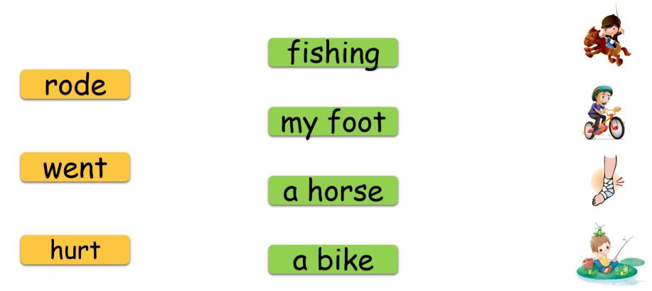
Ⅰ.Read and match

【学习任务二】
Ⅱ.Listen and order
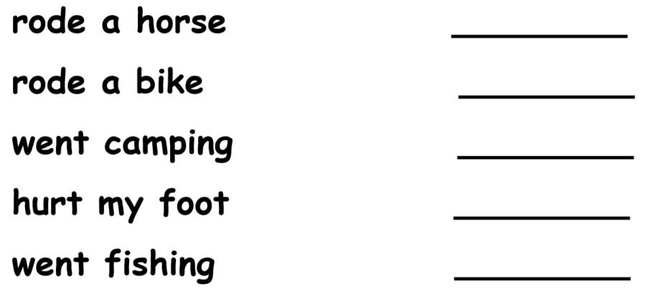

Ⅲ.Watch and answer
1. Where did John go last Saturday?

He went to a __________.

2. What did he do there?

He __________.

Ⅳ.Listen, answer and write
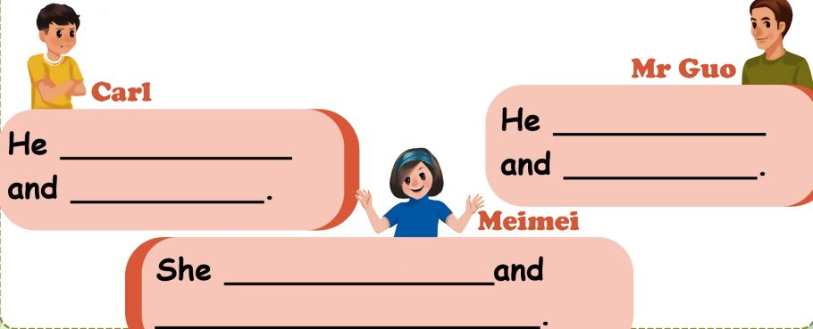

【学习任务三】

Ⅴ. Listen and choose
1. A.I read books. B.He read books.
2. A.We went fishing. B.We went to the library.
3. A.In the city. B.With my father.
4. A.Yes, she did. B.Yes, she was.
5. A.On Sunday. B.By subway.
Ⅵ.二、按要求完成句子。
1. Sarah rode a bike there.（就画线部分提问。）
______ ______ Sarah _______ ______?
2. Mike went to a forest park yesterday.（就画线部分提问。）
______ ______ Mike ______ yesterday?
3. I hurt my leg last Saturday.（用Amy改写。）
______ ______ ______ leg last Saturday.

参考答案

旧知链接:
1.翻译下列动词短语。
骑马 骑单车 去野营 伤到脚 去钓鱼
2.翻译下面的句子。
上周六你去哪里了？
我去了森林公园。
你在那里做了什么？
骑单车。
【学习任务一】
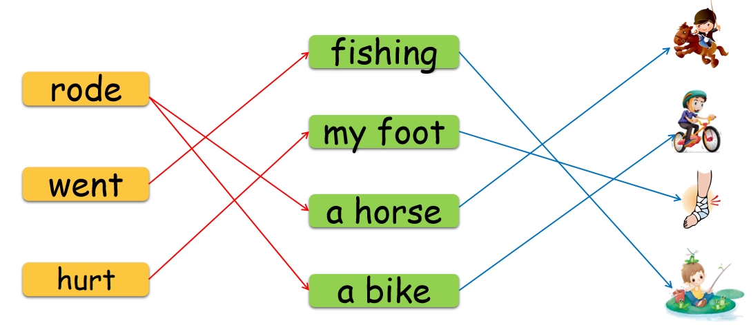

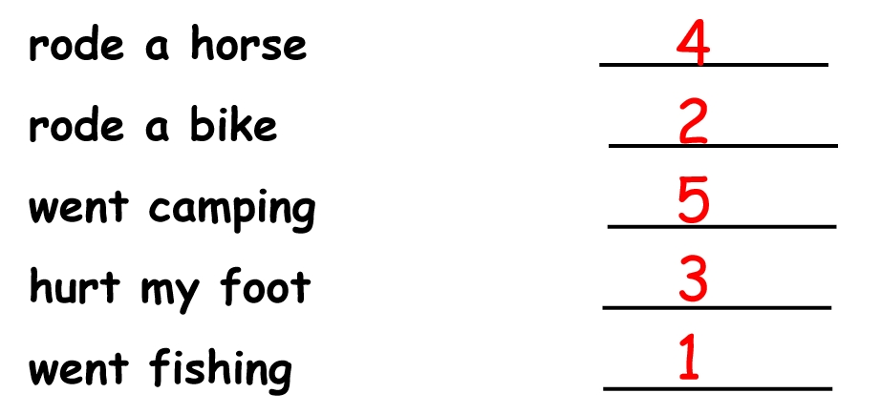
【学习任务二】

forest park rode a bike
went camping；hurt his foot went fishing；rode a horse
got a new bike；rode it for the whole day
【学习任务三】
A B A A B
- What did do there
- Where did go
- Amy hurt her

学习任务单
课程基本信息
教材版本 | 人教PEP版 | 学科 | 英语 | 年级 | 六年级 | 册别 | 下册
课题 | Unit 3 Where did you go?  Part A Let’s try & Let’s talk
学生信息
姓名 | 学校 |  |  | 班级 |  |  | 学号
学习目标
目标：
1.1.学生能够听、说、认读单词：fell off, look like, Turpan, mule, could, till;能够听、说、认读句型：What happened? Are you all right? It looks like a mule.
2.学生能够在情境中运用型Where did you go? What did you do?并正确回答。
3.学生能够在情景中恰当的运用由Where和What引导的一般过去时特殊疑问句。
4.能够通过对话学习了解新疆的风土人情。
课前学习任务
预习：
1.跟读Unit 3单词音频，预习第一单元单词；
2. 预习A部分 Let’s talk内容，跟读对话。
旧知链接
（非必选）
预习A部分 Let’s talk内容，完成下面的小练习。
1.写出下列动词过去式的原型。
happened________ fell________ hurt________ did________ rode________ saw________ could ________
2.翻译下面的句子。
What happened?____________________________________
That’s too bad._____________________________________
Are you all right now?_____________________________________
Come and look at my photos from the Labour Day holiday.___________________________________
It looks like a mule._____________________________________
We saw lots of grapes there._____________________________________

They won’t be ready till August._____________________________________
课上学习任务
【学习任务一】
Ⅰ.Listen and choose
1. John is _______now.
A. At home. B. At hospital.
2. Amy is ______ now.
A. At home. B. At hospital.
3. Who didn’t e to school today?
A. Amy. B. John.
【学习任务二】
Ⅱ.Listen, tick or cross
( )The second class is beginning.
( )John is at home.
( )John hurt his foot.
Ⅲ.Watch and answer
1. What happened to John?
2. Where did he go?
3. What did he do in Xinjiang?
A. He went fishing.
B. He rode a horse.
C. He rode a bike.
D. He saw lots of grapes.
Ⅳ.Listen and order
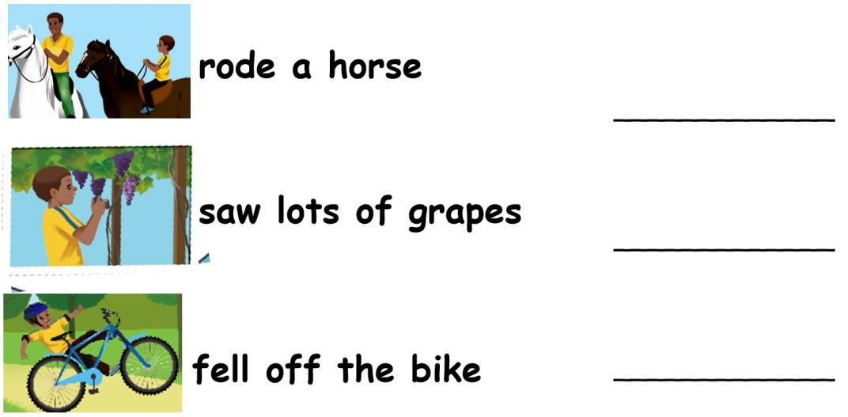

【学习任务三】
Ⅴ. Fill in the blanks
John _______ his bike last Saturday and _____ his foot. Now he is ___. He went to ___________, Xinjiang over his _________ holiday. He ____ a horse. It's very _____ and it _____ like a _____. He also went to _______. He saw lots of _____ there, but he couldn't _____ them because they won't be _____ till ______.
【学习任务四】

Ⅵ.Read and choose
1.发生什么事了？
A. What happened? B. What did you do?
2.你做了什么？
A. What happened? B. What did you do?
3.你去了哪里？
A. Where are you going? B. Where did you go?
4.那真是太糟糕了。
A. That’s too bad. B. That’s great.
Ⅶ.Read and choose
1.Did you ride a horse?
A. Yes, I did. B. Yes, I didn’t.
2.I had a bad cold and slept at home.
A. That’s too bad. B. Thank you.
3.What did you do?
A. I rode a horse. B. I went to Mt Tianshan.
4.What happened?
A. I’m OK now. B. I hurt my hand.
【学习任务五】
Ⅷ.Read and choose
1. I ___ off my bike last Saturday.
A. fall B. falled C. fell
2. Where ___ you go last weekend?
A. do B. did C. does
3. It ___ like a mule.
A. looks B. looked C. look
Ⅸ.单项选择。
( )1. —Did you go to Turpan, Mike?
—_________
A. Yes, we do. B. Yes, he did. C. No, we didn’t.
( )2. —_________ did you go on your holiday?
—I went to Shanghai.
A. What B. Where C. Who
( )3. It _________ like a horse.
A. look B. looks C. looking
Ⅹ.情景交际。
( )1. 你想要知道对方的身体状况，可以说：___________

A. Are you all right? B. Don’t worry.
( )2. 你想知道对方发生了什么事情，可以说：_________
A. What happened? B. What did you do?

参考答案

旧知链接:
1.写出下列动词过去式的原型。
happen fall hurt do ride see can
2.翻译下面的句子。
发生什么事了？
那真是太糟糕了。
你现在好了吗？
来看看我在劳动节拍的照片。
它看上去像头骡子。
我们在那里看到了许多葡萄。
到八月份它们才成熟。
【学习任务一】
Ⅰ.Listen and choose
B A B
【学习任务二】
Ⅱ.Listen, tick or cross
× × √
Ⅲ.Watch and answer
He fell off his bike last Saturday and hurt his foot.
He went to Xinjiang.
B D
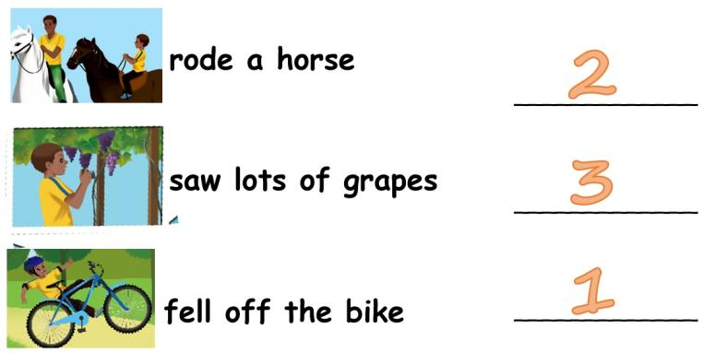
Ⅳ.Listen and order

【学习任务三】
Ⅴ. Fill in the blanks
fell off hurt OK Mt.Tianshan Labour Day rode small looks mule Turpan grapes eat ready August
【学习任务四】
Ⅵ.Read and choose
A B B A
Ⅶ.Read and choose
A A A B
【学习任务五】
Ⅷ.Read and choose
C B A
Ⅸ.单项选择。
C B B
Ⅹ.情景交际。
A A

学习任务单

课程基本信息
教材版本 | 人教PEP版 | 学科 | 英语 | 年级 | 六年级 | 册别 | 下册
课题 | Unit 3 Where did you go?  Part B Let’s learn & Look and say
学生信息
姓名 | 学校 |  |  | 班级 |  |  | 学号
学习目标
目标：
1.学生能够听、说、读、写单词和词组：ate fresh food, went swimming, took pictures, bought gifts.
2.学生能够运用句型How was your summer holiday?询问别人的假期情况。
3.学生能够正确使用上述单词和词组描述自己的假期生活。
4.引导学生关注自己身边的人，激发学生学习英语的热情，培养学生学习英语的兴趣，树立学好英语的信心。
课前学习任务
预习：
1.跟读Unit 2单词音频，预习第二单元单词；
2. 观看Let’s learn课文视频，跟读课文，完成下列学习单。
旧知链接
（非必选）
- 预习Let’s learn &Look and say，完成下面的小练习。
1.写出下列动词过去式的原型。
ate___________ went___________ took_________
bought__________ was___________ hurt__________
fell__________ came__________ did__________
2.翻译下列短语和句子。
ate fresh food _____________________________________
went swimming_____________________________________
took pictures_____________________________________
bought gifts_____________________________________
暑假你过得怎么样？_____________________________________

以上内容仅为本文档的试下载部分，为可阅读页数的一半内容。如要下载或阅读全文，请访问：https://d.book118.com/387121112142006042

