9.1.2 一元线性回归方程的建立
数据：9.1工龄与年薪.sav
问题：MBA研究生毕业后工作的第一年年薪为应变量Y,读MBA之前工龄为自变量X,在X与Y之间建立线性回归方程。
解答：
第一步：明确X与丫，绘制散点图，目测线性关系的存在性。
总体回归模型，理论回归方程：
- = P +P X +8
简单回归方程，一元线性回归方程：
- = p +pX
样本回归模型
- = P +B X + e
0 1
Y=P +BX
01
估计的回归方程（直线），经验回归方程

Y=P +Bx
01
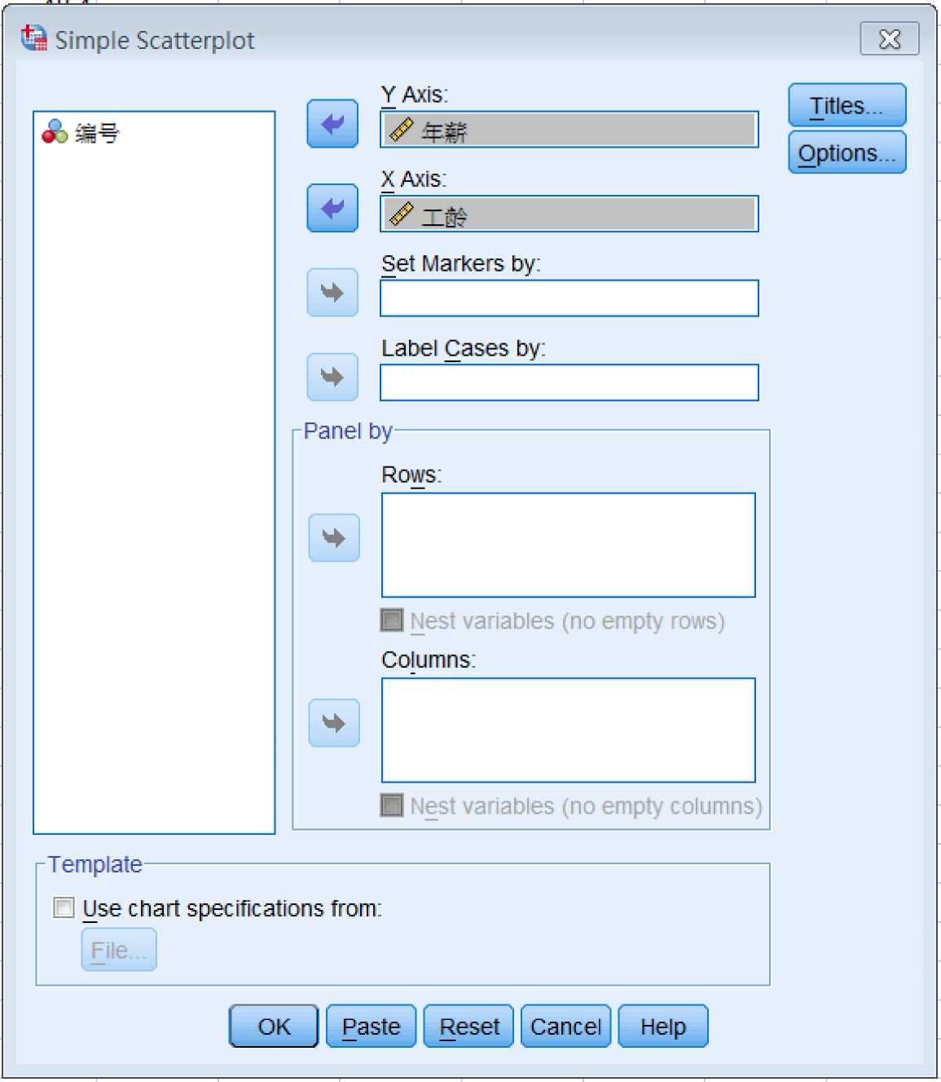

70.0-
60.0-
年 薪 ⁵⁰ ⁰⁻
40.0-
30.0-
0
0
.0
10.0
工龄
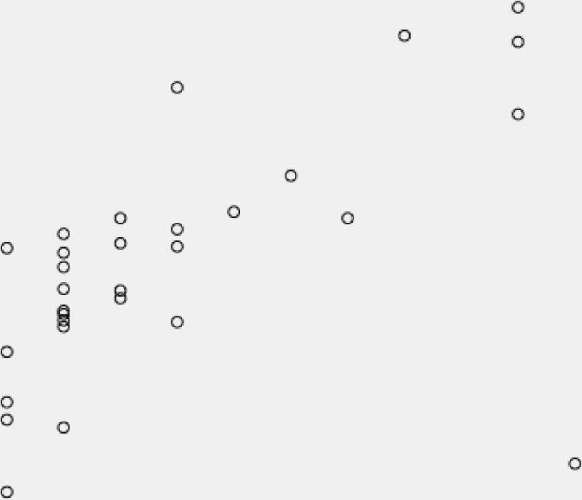
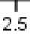
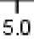
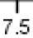
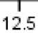

第二步：拟合最有代表性的方程（直线）

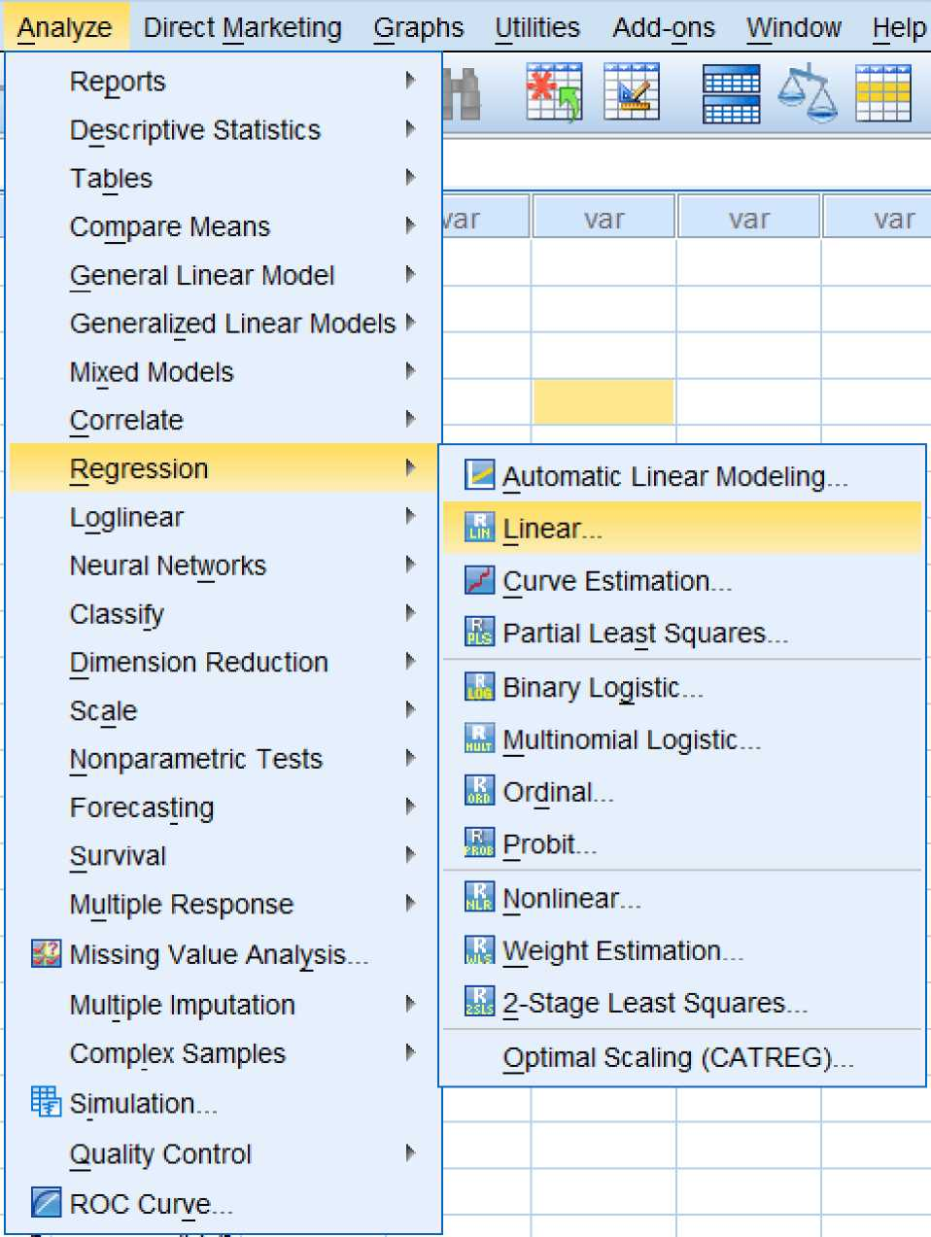

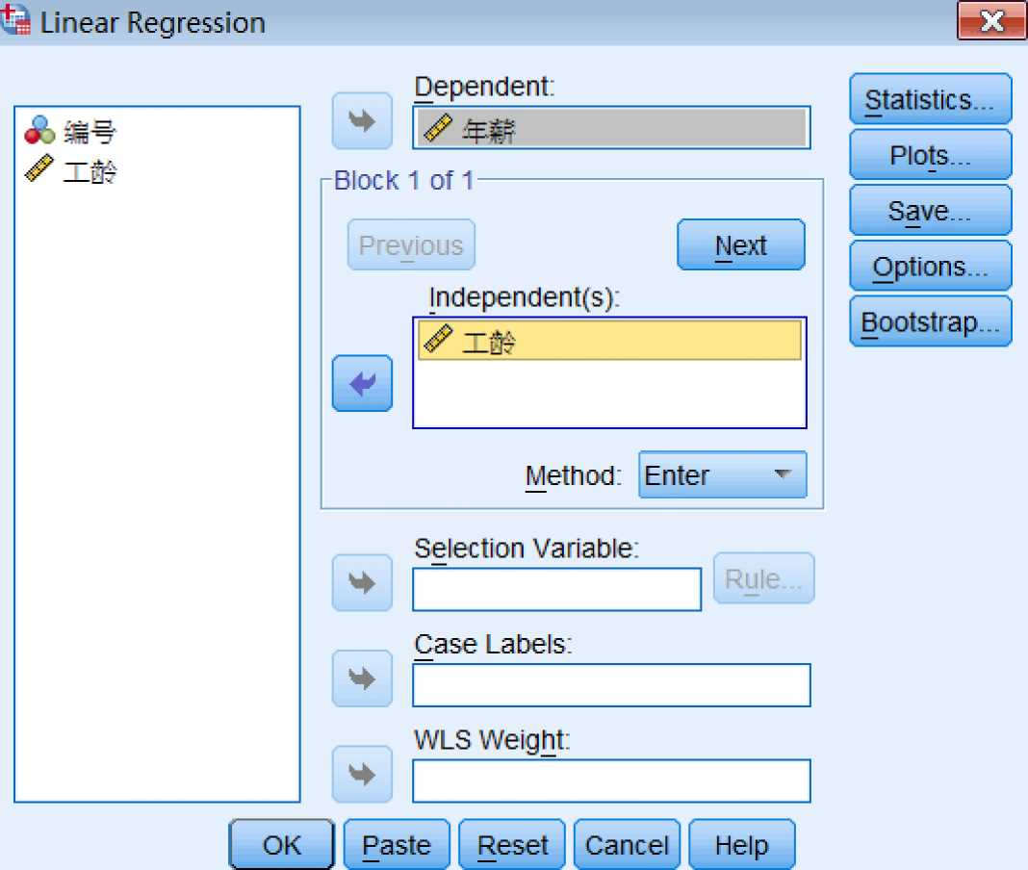

Model |  | Coefficientsa  Unstandardized Coefficients |  | Standardized | t | Sig.
 |  | B |  | Couiiiciunts | t | Sig.
4 | (Constant) | 40.507 | 1.257 |  | 32.219 | .000
1 | 工龄 | 1.470 | .213 | .703 | 6.916 | .000
a. Dependent Variable:年薪

人 一 _ _ 一 _
- = 40.507 +1.470X
工龄增加1单位，年薪平均增加1.47个单位。
人 _ _
- = .703X
第三步：回归方程的检验
- 理论检验：参数估计值的符号和取值范围是否与其相对应的理论或经验一致。
- 统计学检验：运用统计学的抽样理论对样本回归方程的可靠性进行检验。包括：经验回归方程的显著性检验、回归系数的显著性检验、拟合 优度检验、对方程的适宜性做出评价。
 |  |  | ~~ANOVAa__  df |  | F | Sic
1 | Regression  Residual  Total | 1395.959  1429.868  2825.827 | 49  50 | 1395.959  29.181 | 47.838 | .000^{b}

- Dependent Variable:年薪
- Predictors: (Constant),工龄
Model Summary
Model | R | R Square | Adjusted R Square | Std. Error of the
 | ^0^ | 494 | 48^ | 5.4019
a. Predictors: (Constant),工龄

- 经济计量学检验：对回归模型中的随机误差项的假设条件是否能得到满足进行检验P590。
- 残差均值为0的判断：
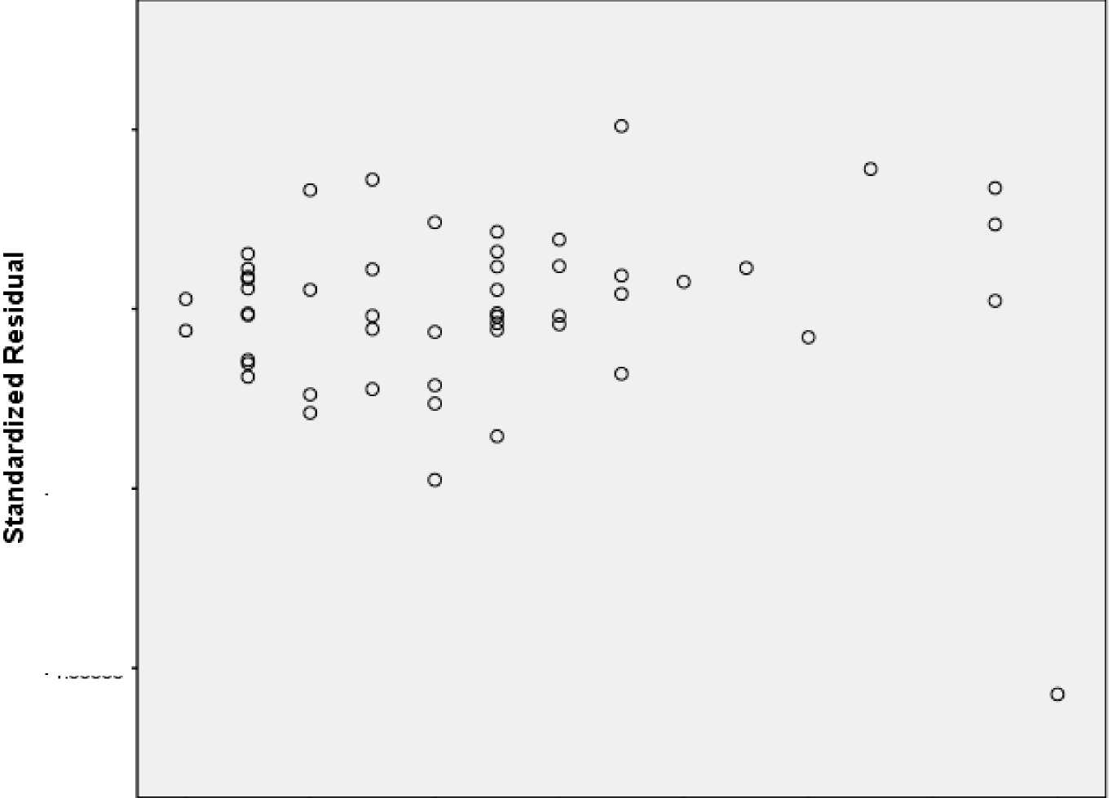
2.00000-
.00000-
-2.00000-
-4.00000-
0
2
4
8
10
12
14
工龄
- 残差正态性检验
Histogram
Dependent Variable:年薪

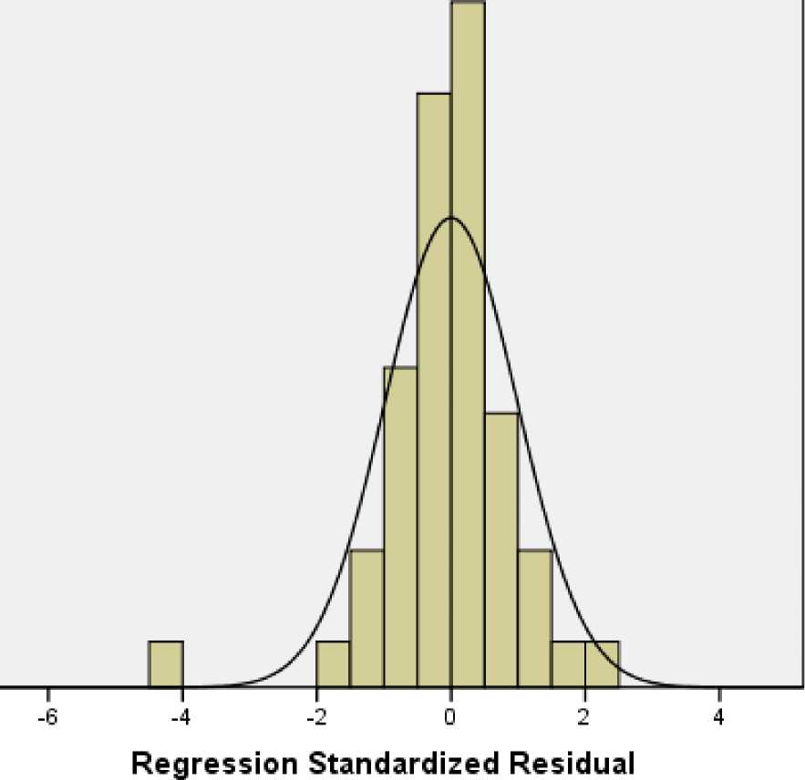
o
o
Aoll姑 nb«」u_
Mean = 2.48E-15
Std. Dev. = 0.990
N = 51

Normal P-P Plot of Regression Standardized Residual
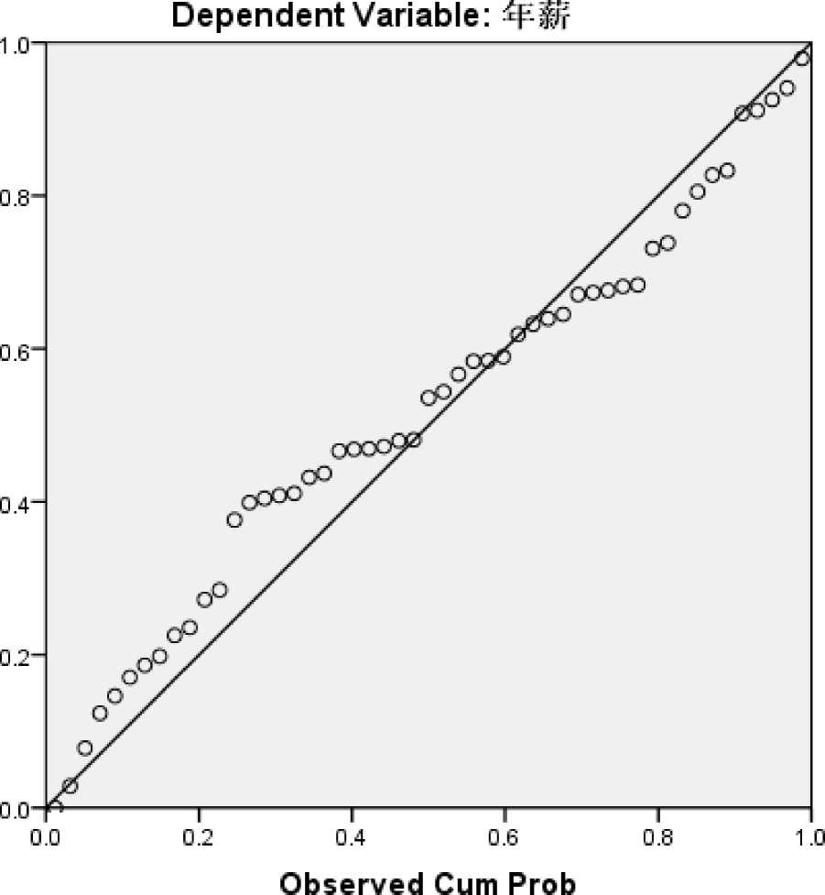

- 残差方差齐性检验 方法1：残差图分析法
Scatterplot
Dependent Variable:年薪
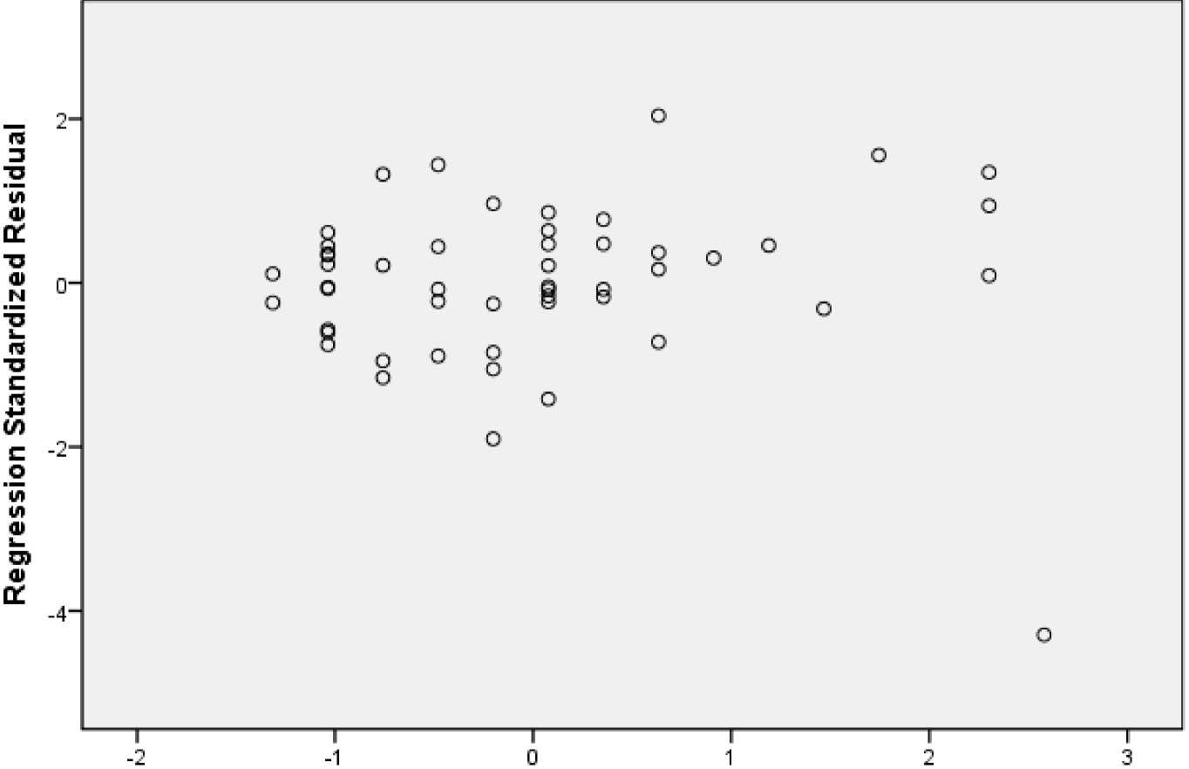

Regression Standardized Predicted Value
Scatterplot
Dependent Variable:年薪
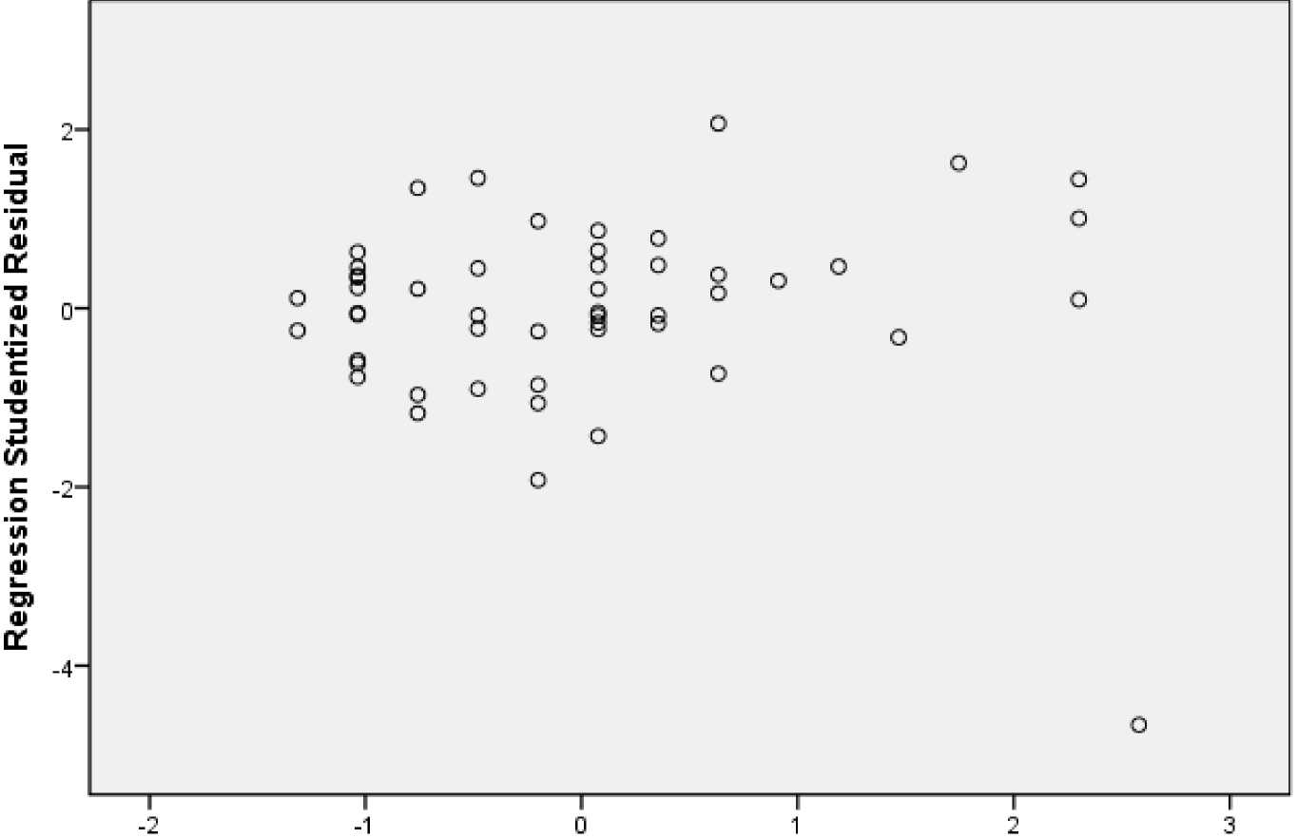
Regression Standardized Predicted Value
方法2：求Spearman等级相关系数
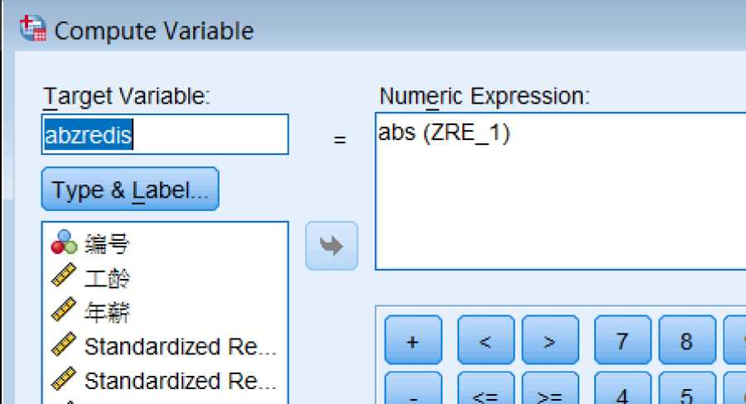

abzredis | R工龄 | Ra bzred i | var
.24 | 1.50D | 17.000
.11 | 1500 | 8.000
.75 | 7.50D | 34.000
.61 | 7 500 | 30.000
・ .57 | 7 500 | 29.000
.07 | 7 500 | 3.000
.23 | 7 500 | 15 一000
> .34 | 乙500 | 21.000
.45 | 7 500 | 25 000
・ .62 | 7.500 | 31.000
.36 | 7 500 | 22.000
.05 | 7 500 | 2.000
1.16 | 14 500 | 43.000
.95 | 14 500 | 40.000
> .21 | 14.500 | 13.000
1.32 | 14 500 | 44.000
.89 | 19.000 | 38.000
， .23 | 19.000 | 14.000
.08 | 19.000 | 4.000
.44 | 19.000 | 24.000
1.44 | 19.000 | 47.000
1.05 | 24.000 | 42.000
.85 | 24.000 | 36.000
1.90 | 24.000 | 49.000
残差不随自变量的变化而变化，

 | Kendall's tau-b | .120 | .096 | 1.247 | .212
 | Kendall's tau-c | .121 | .097 | 1.247 | .212
Ordinal by Ordinal | Gamma | .127 | .101 | 1.247 | .212
 | Spearman Correlation | .168 | .138 | 1.194 | .238c
Interval by Interval | Pearson's R | .168 | .132 | 1.194 | .238c
 |  | 51
- Not assuming the null hypothesis.
- Using the asymptotic standard error assuming the null hypothesis.
- Based on normal approximation.
P=0.238>0.05,不能拒绝原假设（H0：两者之间不相关），即残差与自变量之间没有显著的相关性，
残差的变化是随机的，具有方差齐性。
- 残差序列独立性判断
注意，不同的排序，结果完全不同。因此，做游程检验时，须遵循数据的原始的随机排序。
编号 | 工龄 | 年薪 | RES_1 | ZRE_1 | SRE_1
28 | 1 | 43.2 | 1.22290 | .22638 | .23118
30 | 1 | 43.8 | 1 82290 | 33745 | 34461
34 | 1 | 44.4 | 2.42290 | 44852 | .45803
38 | 1 | 45.3 | 3.32290 | .61513 | .62817
49 | 1 | 43.9 | 1.92290 | .35596 | .36351
50 | 1 | 41.7 | -.2771 0 | -.05130 | -.05238
1 | 2 | 37.2 | -6.24693 | -1.15642 | -1.17484
3 | 2 | 38.3 | -5.14693 | -.95279 | -.96797
27 | 2 | 44.6 | 1.15307 | .21345 | .21685
44 | 2 | 50 6 | 7.15307 | 1.32417 | 1 34525
4 | 3 | 40.1 | -4.81676 | -.89167 | -.90267
14 | 3 | 43.7 | -1.21676 | -.22525 | -.22802
19 | 3 | 44.5 | -.41676 | -.07715 | -.0781 0
33 | 3 | 47.3 | 2.38324 | .44118 | .44662
46 | 3 | 52.7 | 7.78324 | 1.44082 | 1.45859
2 | 4 | 40.7 | -5.68659 | -1.05269 | -1.06361
5 | 4 | 41 8 | 458659 | -.84906 | -.85787
31 | 4 | 36.1 | -10 28659 | -1.90424 | -1 92399
43 | 4 | 51.6 | 5.21341 | .96510 | .97511
51 | 4 | 45.0 | -1.38659 | -.25668 | -25935
13 | 5 | 46.6 | -1.25642 | -23259 | -23492
16 | 5 | 47.0 | -.85642 | -.15854 | -.16013
17 | 5 | 47.4 | -.45642 | -.08449 | -.08534
21 | 5 | 40.2 | -7.65642 | -1.41735 | -1.43153
22 | 5 | 47.6 | -.25642 | -.04747 | -.04794
26 | 5 | 49.0 | 1.14358 | .21170 | 21382
36 | 5 | 50.4 | 2.54358 | .47086 | .47558
39 | 5 | 51.3 | 3.44358 | .63747 | .64385
41 | 5 | 52.5 | 4.64358 | 85961 | 86822
15 | 6 | 48.4 | -.92625 | -.17147 | -.17340
18 | 6 | 48.9 | -.42625 | -.07891 | -.07980
37 | 6 | 51.9 | 2.57375 | .47645 | 48181
40 | 6 | 53 5 | 4.17375 | .77264 | .78133
1 | 1 | 46.9 | -3.89609 | -.72124 | -.73141
25 | 1 | 51.7 | .90391 | .16733 | .16969
32 | 7 | 52 8 | 2.00391 | .37096 | .37619
48 | 1 | 61 8 | 11.00391 | 2.03703 | 2.06575
29 | 8 | 53 9 | 1.63408 | .30250 | .30813
35 | 9 | 56.2 | 2.46425 | .45618 | .46751
10 | 10 | 53 5 | -1.70558 | -.31573 | -32612
47 | 11 | 65.1 | 8.42459 | 1.55955 | 1.62642
23 | 13 | 6D.1 | .48493 | .08977 | .09600
42 | 13 | 64.7 | 5.08493 | .94132 | 1.00664
45 | 13 | 66.9 | 7.28493 | 1.34858 | 1.44216
11 | 14 | 37.9 | -23.18490 | -4.29196 | -4.66277

Diec T +
 | Standardized | Studentized

Test Valueª | .08977 | .09600
Cases < Test Value | 25 | 25

Cases >= Test Value | 26 | 26
Total Cases | 51 | 51
Number of Runs | 19 | 19
Z | -2.120 | -2.120
Asymp. Sig. (2-tailed) | .034 | .03^
a. Median

 | Standardized | Studentized
Test Valueª | .0000000 | -.0025569
Cases < Test Value | 25 | 25
Cases >= Test Value | 26 | 26
Total Cases | 51 | 51
Number of Runs | 19 | 19
Z | -2.120 | -2.120
Asymp. Sig. (2 tailed) | .034 | .034
a. Mean
 | 编号 | 工龄 | 年薪 | RES_1 | ZRE_1 | SRE_1 | var
 | 1 | 2 | 37.2 | -6.24693 | -1.1 5642 | -1.1 7484
 | 2 | 4 | 40.7 | -5,68659 | -1.05269 | -1.06361
 | 3 | 2 | 382. | -5.14693 | -.95279 | -.96797
 | 4 | 3 | 40.1 | -4.81676 | -.89167 | -.90267
 | 5 | 4 | 41.8 | -4.58659 | -84906 | -.85787
 | 6 | 1 | 37.9 | -4.07710 | -.75475 | -.77075
 | 1 | 1 | 46.9 | -3.89609 | -.72124 | -.73141
 | 8 | 1 | 387 | -3.27710 | -.60665 | -.61951
 | 9 | 1 | 38.9 | -3.07710 | -.56963 | -.58170
) | 10 | 10 | 53.5 | -1.70558 | -.31573 | -.32612
 | 11 | 14 | 37.9 | -23.18490 | -4.29196 | -4.66277
 | 12 | 0 | 39.2 | -1.30727 | -.24200 | -.24883
J | 13 | 5 | 46.6 | -1.25642 | -.23259 | -.23492
1 | 14 | 3 | 43.7 | -1.21676 | -.22525 | -.22802
 | 15 | 6 | 48.4 | -.92625 | -.17147 | -.1 7340
 | 16 | 5 | 47.0 | -.85642 | -.1 5854 | -.16013
7 | 17 | 5 | 47.4 | -.45642 | -.08449 | -.08534
3 | 18 | 6 | 48.9 | -.42625 | -.07891 | -.07980
) | 19 | 3 | 44.5 | -.41676 | -.07715 | -.07810
) | 20 | 1 | 41.6 | -.37710 | -.06981 | -.07129
 | 21 | 5 | 40.2 | -7.65642 | -1.41 735 | -1.43153
 | 22 | 5 | 47.6 | -.25642 | -.04747 | -.04794
J | 23 | 13 | 60.1 | 一 48493 | .08977 | .09600
1 | 24 | 0 | 41.1 | .59273 | .1 0973 | .11282
 | 25 | 1 | 51.7 | .90391 | .16733 | .16969
 | 26 | 5 | 49.0 | 1.14358 | .21170 | .21382
7 | 27 | 2 | 44.6 | 1.15307 | .21345 | .21685
3 | 28 | 1 | 43.2 | 1.22290 | .22638 | .23118
) | 29 | 8 | 53.9 | 1.63408 | .30250 | .30813
) | 30 | 1 | 43.8 | 1.82290 | .33745 | .34461
 | 31 | 4 | 36.1 | -1 0.28659 | -1.90424 | -1.92399
) | 32 | 1 | 52.8 | 2.00391 | .37096 | .37619
J | 33 | 3 | 47.3 | 2.38324 | .44118 | .44662
1 | 34 | 1 | 44.4 | 2.42290 | .44852 | .45803
 | 35 | 9 | 56.2 | 2.46425 | .45618 | .46751
 | 36 | 5 | 50.4 | 2.54358 | .47086 | .47558
7 | 37 | 6 | 51.9 | 2.57375 | .47645 | .48181
3 | 38 | 1 | 45,3 | 3.32290 | .61513 | .62817
) | 39 | 5 | 51.3 | 3.44358 | .63747 | .64385
) | 40 | 6 | 53.5 | 4.17375 | .77264 | .78133
 | 41 | 5 | 52.5 | 4.64358 | .85961 | 86822
) | 42 | 13 | 64.7 | 5.08493 | .94132 | 1.00664
J | 43 | 4 | 51.6 | 5,21341 | .96510 | .9751 1
1 | 44 | 2 | 50.6 | 7.15307 | 1.32417 | 1.34525
 | 45 | 13 | 66.9 | 7.28493 | 1.34858 | 1.44216
 | 46 | 3 | 527 | 7.78324 | 1.44082 | 1.45859
7 | 47 | 11 | 65,1 | 8.42459 | 1.55955 | 1.62642
3 | 48 | 1 | 61.8 | 11.00391 | 2.03703 | 2.06575
) | 49 | 1 | 43.9 | 1.92290 | .35596 | .36351
) | 50 | 1 | 41.7 | -.27710 | -.05130 | -.05238
 | 51 | 4 | 45,0 | -1.38659 | -.25668 | -.25935
麦


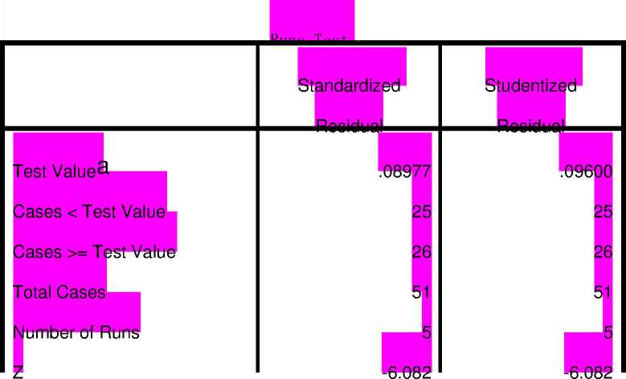

以上内容仅为本文档的试下载部分，为可阅读页数的一半内容。如要下载或阅读全文，请访问：https://d.book118.com/408050065071006023

