长泾第二中学2022-2023第二学期3月份随堂练习
初二英语
第I卷（客观题 共80分）
一、听力测试 (每小题1分，共20分)
听对话，回答下列小题。
1. What was the weather like last Sunday? 【此处可播放相关音频，请去附件查看】

A.  B.  C. 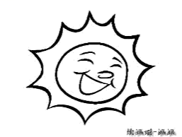
【答案】A
【解析】
【原文】略
2. What subject does Timmy like best? 【此处可播放相关音频，请去附件查看】

A. 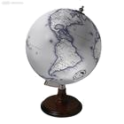 B. 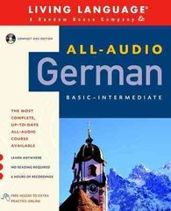 C. 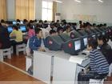
【答案】B
【解析】
【原文】略
3. Where does Kevin want to go during this Spring Festival? 【此处可播放相关音频，请去附件查看】

A. 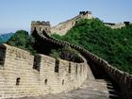 B. 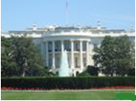 C. 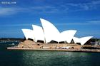
【答案】B
【解析】
【原文】略
4. How does the boy learn about the world?【此处可播放相关音频，请去附件查看】

A. 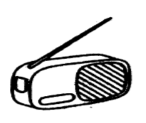 B. 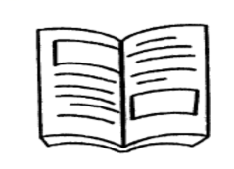 C. 
【答案】C
【解析】
【原文】略
5. When did the woman and Anna meet?【此处可播放相关音频，请去附件查看】

A. At 7: 53. B. At 7: 57. C. At 7: 58.
【答案】A
【解析】
【原文】略
6. Where is the conversation happening? 【此处可播放相关音频，请去附件查看】

A. In a drink shop. B. In an office. C. At the bus stop.
【答案】A
【解析】
【原文】略
7. What activity did John take part in? 【此处可播放相关音频，请去附件查看】

A. The chess competition. B. The speaking competition. C. The drawing competition.
【答案】C
【解析】
【原文】略
8. What is Daniel doing now? 【此处可播放相关音频，请去附件查看】

A. He’s buying cold drinks. B. He’s having a picnic. C. He’s cleaning his room.
【答案】C
【解析】
【原文】略
9. What does the woman ask the man to carry? 【此处可播放相关音频，请去附件查看】

A. Some books. B. A box. C. A bag.
【答案】C
【解析】
【原文】略
10. How does the woman feel about the test? 【此处可播放相关音频，请去附件查看】

A. Excited. B. Worried. C. Happy.
【答案】B
【解析】
【原文】略
听对话，回答下列小题。【此处可播放相关音频，请去附件查看】

11. How does Jenny improve her English?
A. By listening to English news.
B. By reading English newspapers.
C. By talking with her foreign friends.
12. What is Jenny?
A. A primary school student. B. A middle school student. C. A college student.
【答案】11. B 12. B
【解析】
【原文】略
听短文，回答下列小题。【此处可播放相关音频，请去附件查看】
Summer holiday in America
Place: New York | Time: From July 5th to ____13____.
He went there to learn English. | He lived with an American family.

The course includes: listening, speaking, reading and writing, mostly ____14____.
American classes are different from our class because the students are very ____15____.

13. A. 5th August B. 15th August C. 25th August
14. A. speaking B. writing C. listening
15. A. free B. few C. fun
【答案】13. C 14. A 15. A
【解析】
【原文】略
听短文，回答下列小题。【此处可播放相关音频，请去附件查看】

16. What did the boy want for his birthday?
A. Table tennis rackets. B. A computer game about sport. C. A table tennis DVD.
17. What does the boy say about Simon Smith?
A. He never seems to fall ill. B. He never loses a match. C. He never seems to get tired.
18. How many international competitions has Simon Smith won?
A. Six. B. Sixty. C. Sixteen.
19. Who does the boy play table tennis for?
A. His class team. B. His school team. C. The table tennis club in the city.
20. What did the boy’s parents do for his birthday?
A. They gave him a special DVD.
B. They took him to watch a table tennis match.
C. They invited Simon Smith to his party.
【答案】16. C 17. C 18. A 19. B 20. B
【解析】
【原文】略
二、单项选择（每小题 1 分，共10 分）
21. —Why did your family buy a second-hand car?
—We couldn’t afford a new one, but even an old one is better than ________.
A. no B. none C. either D. neither
【答案】B
【解析】
【详解】句意：——你们家为什么买一辆二手车？——我们买不起新的，但即使是旧的也比没有强。
考查代词。no没有；none一个也没有，没有任何东西，用于三者及以上；either两者中任何一个；neither两者都不。根据“but even an old one is better than...”可知，这里表示“旧车比没有一辆车好”，应用代词none。故选B。
22. The idiom “Mengzi’s mother makes three moves” tells us a mother who did all she could to provide the best ________ for her child.
A. information B. instruction C. experience D. environment
【答案】D
【解析】
【详解】句意：“孟母三迁”这个成语告诉我们，母亲尽其所能为孩子提供最好的环境。
考查名词辨析。information信息；instruction说明；experience经验；environment环境。根据“Mengzi’s mother makes three moves”及常识可知孟母三迁是为了给孩子提供好的环境。故选D。
23. —Jack, I haven’t seen your uncle for some time.
— He ________ Shanghai to attend a meeting for a week.
A. went to B. has gone to C. has been in D. has been to
【答案】C
【解析】
【详解】句意：——杰克，我有段时间没有见到你的叔叔了。——他去上海参加会议有一个星期了。
考查谓语动词时态。根据“for a week”可知句子应使用现在完成时的，结构为have/has+过去分词，主语为He，助动词用has，可排除选项A；has gone to表示去了某地，人没回来，但不能与时间段连用，与题干不符合，可排除B选项；has been in后接时间段，表示去某地多久了，符合题意；has been to表示去过某地，人已回来，与题干不符合，可排除D选项。故选C。
24. —You have been in Neijiang very long?
—Yeah. ________ my parents came here.
A. For B. As C. When D. Since
【答案】D
【解析】
【详解】句意：——你在内江住了很久了？——是的，自从我父母来这里。
考查连词的用法。For“因为”；As“作为”；When“当……的时候”；Since“自从……以来”。根据“have been in
Neijiang”以及“my parents came here”可知，自从过去的某个时间开始一直延续到现在，所以要用since。故选D。
25. People, especially the young, ________ online payment since 2008 because of its convenience (方便).
A. were used to B. have got used to C. have been used to D. got used to
【答案】C
【解析】
【详解】句意：自2008年以来，人们，尤其是年轻人，因其便利，已经习惯了网上支付。
考查时态。根据“since 2008”可知，句子时态为现在完成时，故排除A、D项。又根据空处应该用延续性动词可知，have been used to符合题意。故选C。
26. —Some Chinese government officers have turned into live streamers(网络主播).
—Yes. They’re trying their best to help local farmers to ________ sales（销售）.
A. receive B. improve C. return D. realize
【答案】B
【解析】
【详解】句意：——一些中国政府官员变成了网络主播。——是的。他们正在尽最大努力帮助当地农民提高销售额。
考查动词辨析。receive收到；improve提高；return归还；realize意识到。根据“Some Chinese government officers have turned into live streamers(网络主播).”可知政府官员当网络主播为了帮助当地农民提高产品销量，故选B。
27. — Excuse me, do you mind if I open the window?
— Well, if you , I can put on more clothes.
A. can B. may C. must D. shall
【答案】C
【解析】
【详解】句意：——对不起，我开窗你介意吗?——好吧，如果你偏要这么做，我可以多穿点衣服。
考查情态动词。can可能；may可以；must必须，偏要；shall将会；根据“I can put on more clothes.”可知我可以多穿点衣服，可推测出此处是如果你偏要这么做，所以此处是“偏要”，故选C。
28. “One belt, One road” will serve to ________ markets for China as well as other countries along.
A. put up B. look up C. take up D. open up
【答案】D
【解析】
【详解】句意：“一带一路”将为中国和其他国家开拓市场。
考查动词短语。put up张贴；look up向上看，查找；take up占据，开始从事；open up开门，张开，开拓。根据“One belt, One road”和“markets for China”可知， “一带一路”可以帮助开拓市场。open up markets“开拓市场”。故选D。
29. —Will you come to the party tomorrow?
—I’m afraid I can’t, but thanks for the invitation, ________.
A. however B. moreover C. anyway D. then
【答案】C
【解析】
【详解】句意：——你明天会来参加聚会吗？——恐怕不行，不过还是谢谢你的邀请。
考查副词辨析。however然而；moreover并且；anyway无论如何；then那时。根据“I’m afraid I can’t, but thanks for the invitation”可知，无论如何都要表示感谢，故选C。
30. —Do you mind me taking some photos here?
—________. You can just enjoy them with your eyes, I think.
A. Better not B. Of course not C. Never mind D. OK
【答案】A
【解析】
【详解】句意：——你介意我在这儿拍几张照片吗？——最好不要。我觉得你只能用眼睛欣赏它们。
考查情景交际。Better not最好不要；Of course not当然不会；Never mind不要紧；OK好的。根据“You can just enjoy them with your eyes, I think.”可知，此处是不同意拍照。故选A。
三、完形填空 （每小题1分，共10分）
先通读下面的短文，掌握其大意，然后在每小题所给的四个选项中，选出可以填入相应空白处的最佳选项，并将答案写在答题卷上。
Years ago, I celebrated my 40th birthday with friends in a two-floor restaurant. Many arrived ____31____ and waited outside the restaurant. As I was on the roadside, a homeless man came near to me and ____32____ money. I let him know I didn’t have any cash with me. With a quiet smile on his face, he moved on.
Just then a friend arrived and called out, “Happy Birthday!” Hearing this, the man turned and asked, “Hey, man, it’s your birthday?” “Yes,” I said. He walked ____33____, smiled and said, “Happy Birthday!” I was not completely ____34____ for what happened next. He took out a dollar from his dirty bag, and gave it to me, saying, “Here man, take this. Happy Birthday!” That’s ____35____! I expected he was making a joke!
His generosity (慷慨) deeply ____36____ me but accepting money from a homeless man was embarrassing (尴尬的) for me. I felt very uncomfortable. ____37____ I answered, “It’s very kind of you, but...” Looking directly into my eyes, he said, “God’s so good to me. Every night, I always end up with a place to sleep and enough food to eat. Please take this.” I held out my hand and said, “____38____”
This was one of my ____39____ life lessons—however poor we may feel, we always have something valuable to share with others. From then on I often helped people in need and treated everyone kindly and ____40____, spreading love and joy everywhere I went.
31. A. harder B. easier C. later D. earlier
32 A. asked for B. looked for C. paid for D. cared for
33. A. down B. along C. back D. ahead
34. A. ready B. good C. suitable D. sorry
35. A. terrible B. lucky C. impolite D. amazing
36 A. touched B. supported C. surprised D. interested
37. A. But B. As C. So D. Since
38. A. Great B. With pleasure C. It doesn’t matter D. Thank you
39. A. great B. greatest C. bad D. worst
40. A. wisely B. warmly C. carefully D. friendly
【答案】31. D 32. A 33. C 34. A 35. D 36. A 37. C 38. D 39. B 40. B
【解析】
【导语】本文讲述了作者过生日的时遇到一位流浪汉向他要钱却没有给他，而流浪汉得知作者过生日，却给了他一美元。这让作者明白：不管我们多么贫穷，我们总是有一些有价值的东西可以与他人分享。
【31题详解】
句意：许多人来得更早，在餐厅外等候。
harder更难；easier更容易；later更晚；earlier更早。根据“waited outside the restaurant”可知，许多人到得更早。故选D。
【32题详解】
句意：当我在路边时，一个无家可归的人向我走来要钱。
asked for请求，要求；looked for寻找；paid for为……付出代价；cared for照顾。根据“money”和“I let him know I didn’t have any cash with me.”可知，一个流浪汉找作者要钱。故选A。
【33题详解】
句意：他走回来，微笑着说：“生日快乐！”
down向下；along沿着；back返回；ahead在前面。根据上文“With a quiet smile on his face, he moved on.”可知，作者拒绝要钱的请求后，流浪汉离开了，但他听到有人对作者说生日快乐时，他又走回来，对作者说了句“生日快乐”。故选C。
【34题详解】
句意：我还没完全准备好接下来要发生的事。
ready准备好的；good好的；suitable合适的；sorry抱歉的。根据“I was not completely ... for what happened next.”可知，对于接下来发生的事情，作者还没有完全准备好；be ready for“为……做准备”。故选A。
【35题详解】
句意：这太令人惊讶了！
terrible糟糕的；lucky幸运的；impolite不礼貌的；amazing令人诧异的。根据“He took out a dollar from his dirty bag, and gave it to me”和“I expected he was making a joke!”可知，流浪汉给作者一美元，这使得作者感到很诧异。故选D。
【36题详解】
句意：他的慷慨深深打动了我，但接受一个无家可归的人的钱让我很尴尬。
touched触动；supported支持；surprised使惊讶；interested使感兴趣。根据“His generosity (慷慨) deeply ... me”和“It’s very kind of you,”可知，流浪汉的慷慨深深地打动了作者。故选A。
【37题详解】
句意：所以我回答说：“你真是太好了，但是……”。
But但是；As作为；So因此，所以；Since自从。根据“accepting money from a homeless man was embarrassing (尴尬的) for me ...”可知，此处与前文构成因果关系，属于前因后果，所以用so引导。故选C。
【38题详解】
句意：我伸出手说：“谢谢。”
Great好；With pleasure乐意效劳；It doesn’t matter没关系；Thank you谢谢。根据“I held out my hand and said ...”可知，作者伸手接了那一美元，并对这个流浪汉说了声“谢谢”。故选D。
【39题详解】
句意：这是我人生中最重要的一课——无论我们感到多么贫穷，我们总有一些宝贵的东西可以与他人分享。
great伟大的；greatest最好的；bad坏的；worst最糟的。根据“one of”可知，此处要用形容词最高级；再根据“however poor we may feel, we always have something valuable to share with
others”可知，此处指人生中最好的一课。故选B。
【40题详解】
句意：从那时起，我经常帮助需要帮助的人，和善热情地对待每个人，把爱和喜悦传播到每一个地方。
wisely明智地；warmly温暖地，热情地；carefully仔细地；friendly友好的。根据“treated everyone kindly and ...”可知，此处指善良热情地对待每一个人；修饰动词用副词warmly。故选B。
四、阅读理解 (每小题2分，共30分)
（A）
Gustave Eiffel designed the Eiffel Tower as the entrance to the 1889 Paris World’s Fair. Today, it is a symbol of France. Take a closer look at the country’s “Iron Lady”.
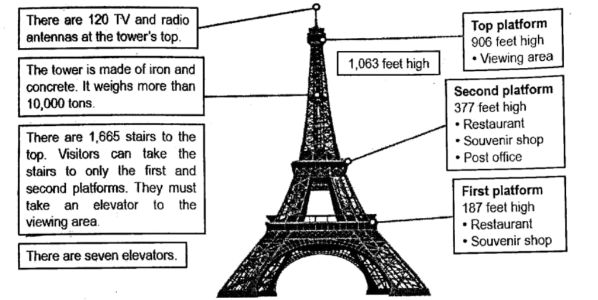
41. What is another name for the Eiffel Tower?
A. Iron Tower. B. Gustave Tower. C. Iron Lady. D. World’s Fair.
42. How high is the viewing area?
A. 1063 feet. B. 906 feet. C. 377 feet. D. 187 feet.
43. Which of the following is TRUE?
A. The tower is made of iron and glass.
B. There are four platforms in the Eiffel Tower.
C. Visitors can mail postcards on the second platform.
D. Visitors can take the stairs or an elevator to the top.
【答案】41. C 42. B 43. C
【解析】
【分析】本文主要介绍法国著名的建筑埃菲尔铁塔。
【41题详解】
细节理解题。根据“Take a closer look at the country’s ‘Iron Lady’.”可知埃菲尔铁塔又称为“铁娘子”。故选C。
【42题详解】
细节理解题。根据“Top platform 906 feet high ·Viewing area”可知观景台有906英尺高，故选B。
【43题详解】
细节判断题。根据“Second platform ·377 feet high ·Restaurant ·Souvenir shop ·Post office”可知第二站台有邮局，游客可在第二站台邮寄明信片，C项正确。故选C。
（B）
It was Day 1 of our vacation on Cortes, a beautiful quiet island. “iPhone, iPhone, iPhone,” my son kept moaning. In front of him was a big window facing the blue ocean. And a cool gentle wind was coming in from the door. Clearly, he saw and felt none of it.
Back at home, I’d soon give up and hand the phone over to him after five minutes of listening to this kind of moaning.
But not here, before we left, I had told my 10-year-old son the rule — no e-mails, no Facebook, no video games, and no iPhone. We came here to get away from them all. Here we were on our first day and already, he couldn’t stand it.
________ I walked down the grass road to the beach and looked out to the sea. My 6-year-old daughter and my husband were drawing on pieces of wood. They were doing just fine.
On Day 2, we spent the whole morning digging for shells. This time, my son joined us. He collected shellfish and other sea treasures. When we got back to our little wood house, I gave my son a book, and put him on the lovely garden chair. It was almost dinner when he looked up.
The next few days passed in peace (和平).
On Day 6, my son was lying beside me on the beach, watching the sun going down. He was playing with the sand. And there was something shining in his eyes. I realized how time slowed down for both of us. It was exactly what I wanted. Finally, we were able to sit quietly without thinking about screens, phone calls and e-mails.
A week away from all the electronics (电子产品) and life is good.
44. Which of the following can be put in “________” in Paragraph 4?
A. I felt really tired and went to bed.
B. I closed the door and stayed with him.
C. I just walked outside to leave him alone.
以上内容仅为本文档的试下载部分，为可阅读页数的一半内容。如要下载或阅读全文，请访问：https://d.book118.com/408064076115006025

