人教版八年级下册英语常考题型专项练习题汇编

(一)动词短语和动词不定式专练
(二)短文填空专练
(三)跨学科专练(一)
(四)跨学科专练(二)
(五)语篇补全专练
(六)主题语境写作
(七)状语从句及现在完成时专练

(一)动词短语和动词不定式专练
单项选择
动词短语
1.【人与社会·人际交往】(2023四川泸州中考)—I’m worried about leaving my friends and going to a new school.
—Take it easy. I’m sure you’ll your classmates if you are friendly to them.
A.get along with B.catch up with
C.get together with D.come up with
2.【人与自我·时间管理】(2023甘肃武威中考)I at 6 a.m. so I can leave for school at 7 a.m.
A.get up B.put up
C.take after D.get on
3.(2023云南中考)It’s a good habit to the lights when you leave a room.
A.turn down B.turn up
C.turn off D.turn on
4.【新素材·ChatGPT】(2023四川遂宁中考)—It’s said that ChatGPT has both good
and bad sides.
—Well, it all how you use it.
A.leads to B.sounds like
C.turns into D.depends on
5.(2023山东青岛五十九中期中)Could you give me a hand? I want to
the map on the wall.
A.put up B.pick up
C.clean up D.give up
6.【人与社会·传统节日】(2022浙江温州中考) In China, people usually their houses to sweep away bad luck before the Spring Festival.
A.clean up B.look up
C.make up D.put up
动词不定式
7.(2023四川泸州中考)— What are you going to do this summer vacation?
— I plan Hua Hua, a nearly 3-year-old lovely panda in Chengdu.
A.see B.saw
C.seeing D.to see
8.(2023湖南株洲中考)Today, we must continue working our skies blue, waters clean and lands clear.
A.keep B.to keep C.keeping
9.【人与自我·珍爱生命】(2023吉林长春榆树期中)Mr. Li asks the students in the river, because it’s too dangerous.
A.swim B.swimming
C.not to swim D.not swim
10.【人与自我·珍爱生命】(2022 广西贵港中考)
—Amy, don’t forget your mask(口罩) when you go out.
—Don’t worry, Mom. I will.
A.wear B.wears
C.to wear D.wearing
11.(2022内蒙古包头中考)Nancy didn’t know anyone in the new school, so she decided to join an after-school club some new friends.
A.to meet B.meet
C.met D.meets

(二)短文填空专练
A
【人与社会·志愿服务】(2023湖南衡阳中考)
阅读下面短文,在空白处填一个适当的词或填入括号中所给单词的正确形式。
Our family bought a new smart TV set last week. It is 1 (real) cool! But we didn’t know what we should do 2 the old one. Then I 3 (see) an advertisement(广告) for Tech-Help. Tech-Help donates smart TV sets to people who need them.
4 far, Tech-Help has donated(捐赠) 5 (many) than 2,000 smart TV sets to different families across the country. Last year they gave smart TV sets to poor families. 6 is very easy to donate smart TV sets to Tech-Help. Yesterday, my brother 7 I took the old smart TV set to a local shop. Two 8 (hour) later, Tech-Help collected it from the shop. They will clean the smart TV set and make it better.
Right now, Tech-Help is giving smart TV sets to families in Xinjiang. There are about 50 families on the 9 (wait) list. They believe they will get the smart TV sets soon. I’m 10 (excite) we could do something to help others!
1. 2. 3. 4. 5.
6. 7. 8. 9. 10.
B
【新考法·语篇盲填】
请用适当的词完成下面的短文。每个空只能填写一个形式正确、意义相符的单词。
Tom had a cold and he felt very bad. The doctor told him that there was no better
cure(疗法)for it, but he could 11 him some advice to help him feel better.
12 , if Tom has a fever, a sore throat or a headache, taking some medicine can make him feel better.
Second, he should drink enough water. A fever may let his body lack(缺乏) 13 . It can make him feel tired and have a headache. If he coughs, drink some hot tea 14 honey.
Third, let his room be humid(潮湿的), especially before he 15 to bed. It can help clear the nose and have a good sleep. If he has a stuffy nose(鼻塞), take some mints(薄荷糖). He can also put a few drops(滴)of salt water into the 16 .
The last thing, try to 17 more sleep. Having a bad cold can 18 people very sick. 19 is a very good way to refill the energy. If things still get 20 , he has to go to the hospital.
11. 12. 13. 14. 15.
16. 17. 18. 19. 20.
C
【人与社会·人际关系】(2023山西太原期中)
用方框中所给的单词或短语填空,使短文内容完整、通顺,每个单词或短语只用一次。
argued with; should; proper; your; until;
was doing; without; decisions; recently; to get
I am a reporter from Teens Magazine. 21 , we received many teenagers’ letters about their problems with parents. Jack is one of them.Last week, he 22 homework when his parents came into his room and asked him to have dinner. He got angry and 23 his parents. He said he would not talk to them 24 they started to talk to him. But is that OK? You often complain(抱怨) that your parents do not understand you. When something goes wrong,most parents think it’s all your mistakes 25 asking for any reasons. Many parents don’t allow you to make 26 or do things by yourselves. Relations between children and their parents are becoming worse and worse. Maybe you need to find more time to have 27 communication
with your parents. You need to try hard to find out a nicer way 28 what you want. If you want to stay out late,you 29 speak out what you want to do and why it is important for you to do so. Then they might just agree with 30 request(请求). So if all of us can be peaceful,communication will be easier.
21. 22. 23. 24. 25.
26. 27. 28. 29. 30.
D
【人与自我·健康生活】(2023山东青岛城阳区期中)
阅读短文,按照句子结构的语法和上下文连贯的要求,在空白处填入1个恰当的词或填入括号中词语的适当形式。
These years, more and more teenagers think they have too much stress. Some of the problems can make them feel very 31 (worry)and unhappy all day. Who can help them? A teacher from a college tried his best 32 (help)them. He thought of a lot of ways to help them. 33 Monday and Thursday, you can visit him. Here are some ideas about how to keep the young men much 34 (health) in every way.
Firstly, it is very important to keep healthy. To get enough sleep every day is also necessary. Try to have a healthy diet. 35 (two), maybe you are not the top student. It doesn’t 36 (问题). The most important thing is to work hard. If you do this,your teachers and parents 37 (understand) you. If you have some problems, you should communicate 38 your teachers and parents. They can help you. Remember to share your 39 (happy) and sadness with your good friends. Sometimes you can go out for a walk.
In a word, you can try to make 40 (自己) happy. I’m sure you can be happy every day.
31. 32. 33. 34. 35.
36. 37. 38. 39. 40.

(三)跨学科专练(一)

Ⅰ.单项选择
1.【跨学科·语文】(2023湖北武汉洪山区期末)—Which poem
you your hometown?
—Seeing Meng Haoran Off at Yellow Crane Tower. It makes me think about my family and friends back in Wuhan.
A.considers;as B.regards;with
C.reminds;of D.encourages;to
2.【跨学科·数学】(2023江苏泰州中考改编)Please look at the board. How long is Sunshine Science Museum open on Wednesday afternoon?
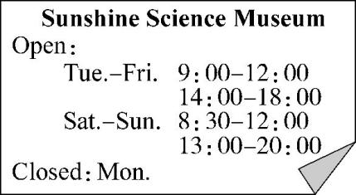
A.3 hours. B.7 hours.
C.3.5 hours. D.4 hours.
3.【人与社会·体育赛事】【跨学科·体育与健康】The 34th Olympic Summer Games in Los Angeles in 2028.
A.was held B.will hold
C.will be held
4.【跨学科·地理】(2023黑龙江绥化中考)As far as we know, China is
the Great Wall.
A.famous for B.popular with
C.regarded as
5.【跨学科·道德与法治】(2023黑龙江龙东地区中考)The 20th National Congress of the CPC was convened (召开) October 16th, 2022.
A.on B.in C.by
Ⅱ.阅读理解
【新体裁·图表】【跨学科·数学】(2023重庆潼南区期末)
Do you love fast food? Why? How often do you eat it?200 people joined the survey. According to(根据) the survey results by Xinhua Research(调查) Center, fast food is getting more popular among people. Let’s take a look at the results of the survey.
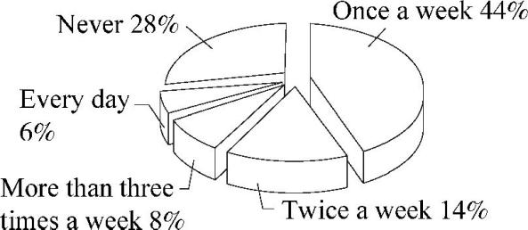
Chart 1
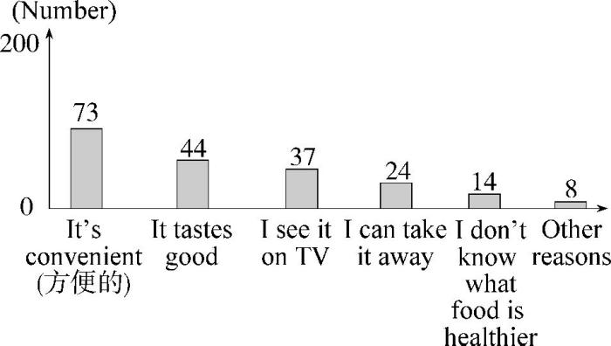
Chart 2
6. of the people eat fast food once a week.
A.14% B.28% C.44% D.8%
7.44 people love fast food because it’s .
A.delicious B.cheap
C.healthy D.convenient
8.What can we learn from the result?
A.All people love fast food.
B.Fast food makes people fat.
C.People eat fast food on weekends.
D.Some people don’t know what food is healthier.

(四)跨学科专练(二)

Ⅰ.单项选择
1.【跨学科·历史】(2023新疆中考)—Do you know ?
—It was introduced through the Silk Road.
A.why pepper was planted in China
B.what pepper was used for in China
C.when pepper was discovered in China
D.how pepper was introduced to China
2.【跨学科·语文】(2023四川乐山中考)Guo Moruo is a famous Chinese writer is popular around the world.
A.which B.whom C.who
3.【跨学科·地理】(2023黑龙江龙东地区中考改编)The population of Heilongjiang is than of Sichuan. The birth rate is low, so our government encourages a second or a third child.
A.smaller;those B.less;it
C.smaller;that
4.【人与社会·体育赛事】【跨学科·体育与健康】(2023江苏宿迁中考)—China won all the gold medals at the 2023 World Table Tennis Championships!
— exciting news!
A.What a B.How a
C.How D.What
Ⅱ.阅读理解
【新体裁·图表】【跨学科·数学】(2023吉林长春八十七中期中)
Do teenagers in small villages do chores at home? How about the teenagers in big cities? We made a survey last month. We asked 4,000 teenagers in China. Half of them come from big cities like Beijing, Shanghai and Guangzhou. The others are from small villages. We made a diagram (图表) according to our survey. Let’s have a look at it.
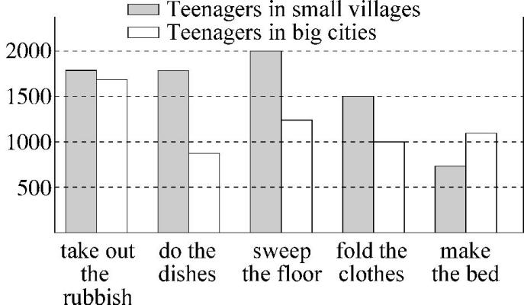
We can find out that teenagers in small villages do more chores than those in big cities. Maybe it is because they live a harder life. We will give our advice to parents in big cities. We think parents should give their children some chores to do because it’s a good chance for teenagers to learn how to take care of themselves.
5.They asked teenagers from small villages.
A.1,000 B.2,000 C.3,000 D.4,000
6.There are 1,000 teenagers from the cities who .
A.take out the rubbish B.do the dishes
C.make the bed D.fold the clothes
7.Fewer than teenagers in big cities sweep the floor.
A.500 B.800 C.1,000 D.1,500
8.The number of teenagers in big cities is bigger than that in small villages.
A.making the bed
B.taking out the rubbish
C.folding the clothes
D.doing the dishes

(五)语篇补全专练
A
【新考法·短文还原】(2023湖南衡阳中考)
根据短文内容从文后的六个选项中选择五个还原到文中,使短文内容完整、意思连贯。
Sometimes it may seem difficult to improve our health. 1
Eat breakfast every morning.
Research shows that if you eat a meal in the morning, you may not become too fat or eat too much during lunch. Eating breakfast can help people feel better through the day.
2
Poor sleep can influence our memory and learning. It can also cause traffic accidents! Studies show that people who don’t get enough sleep seem to get into more accidents. So get enough sleep and stay safe!
Take a walk every day.
Walking is an easy way to exercise. You’d better meet friends for a walk, not for a meal. 3 Once you try, you will find that adding a walk into your daily life is very easy.
Join social groups.
Social groups can provide support. They might include sports teams, art or music groups. The people in the group can offer advice and help each other in difficult times. 4 An active mind is a healthy mind!
Have a hobby.
A hobby could be running, reading or making something with your hands. Hobbies help people to relax and rest. 5
A.As you walk, you will see the beautiful world around you.
B.If so, the following healthy habits may help you.
C.Get enough sleep.
D.Get up early.
E.Hobbies bring us happiness as well.
F.Also, being in a group keeps your mind busy.
1. 2. 3. 4. 5.
B
【新考法·短文还原】(2023山东枣庄中考改编)
根据短文内容,从短文后的选项中选出能填入6~10小题横线上的最佳选项,选项中有两项为多余选项。
Maybe you want to exercise more or start going to bed earlier in the coming year. 6
·Make a detailed(详细的)plan.
If your New Year’s plan is to exercise five days each week, a plan like “I’ll exercise on weekdays” would not be clear. A detailed plan like “I’ll exercise at school on weekdays during my lunch break” would be better. 7
·Make it fun.
If it’s not fun to exercise or study, you won’t keep at it easily. 8 If you can only drink your favourite juice during study hours, you’ll look forward to studying.
· 9
Tell a few friends about your goals so you’ll feel a deep sense of shame if they check back later and find out you haven’t followed through.
·Give yourself more chances.
You planned to get to bed early every night, but one Friday you stayed up late. 10 But giving yourself one or two more chances can help you get better results.
A.Make more friends.
B.Get a little help from your friends.
C.Maybe you’re going to take up a hobby like painting.
D.Here is some advice that can help you achieve your goals.
E.After that, you may want to give up the early-to-bed plan.
F.But if you get fun from your exercise or study, you’ll keep longer.
G.All in all, you should give all the facts or information about something in your plan.
6. 7. 8. 9. 10.
C
【学习能力·学习策略】(2023云南中考)
根据短文内容,从短文后所给的选项中选出能填入空白处的最佳选项。选项中有两项为多余选项。
Reading is a lifelong journey. Put yourself into a world of books and get lost in another world—but where do you start? 11
♦Ask a librarian(图书管理员).
The best people to throw your questions are librarians! 12 If you tell a librarian what you’ve read before and what you liked or disliked about it, they will suggest some possible books for you to try.
♦Make a change.
13 You may get used to reading history books or you just take an interest in science fiction. What about the books about culture? You’ll never know until you try. Give a new style a chance and you may enter a whole new world of reading.
♦Read reviews.
Book reviews can help you decide if a book is for you. There are usually short reviews on the covers of books. 14 Some websites provide book suggestions from writers, parents and teachers. Some people’s opinions about the books are very interesting. Their ideas may help you get a right pick.
♦ 15
Reading something comfortable might be your first choice. But why not challenge yourself to read something more complicated(复杂的)? It is a good way of pushing yourself to improve your reading skills.
A.Challenge yourself.
B.They are cool book brains.
C.You can also read reviews online.
D.Let me tell you how to write book reviews.
E.Changing into a new style of book is not easy.
F.Here are some suggestions to pick a great book.
G.Developing good reading habits takes a long time.
11. 12. 13. 14. 15.

(六)主题语境写作

Writing 1
【人与自我·劳动实践】(2023山东临沂中考)
作为家庭的一员,每个人都有做家务的责任和义务。请以“My Experience of Doing Housework”为题,根据以下提示与要求,用英语写一篇短文。
提示:
1. What housework do you usually do?
2. Tell an experience of doing housework.
3. What have you learned from it?
要求:1.短文中不得出现任何真实人名、校名及其他相关信息,否则不予评分;2.不少于80词。
My Experience of Doing Housework

Writing 2
(2023新疆中考)
每个人的成长,都经历过很多次尝试,有成功、有失败、有欣喜、有泪水……请以“My First Try”为题,用英语写一篇短文,记录你成长中的第一次尝试。
要求:1.语句通顺,意思连贯,内容详实,语法正确,书写规范;
2.文中不得出现真实姓名、校名等信息;
3.词数80—120。开头已给出,不计入总词数。
My First Try
When it comes to the topic of “My First Try”,

Writing 3
【人与社会·文学作品】(2023陕西西安高陵区期末)
假如你是张琳,请你根据以下表格内容,写一篇英语短文,向大家介绍你最喜欢的书《西游记》,并简单介绍书中你最喜欢的角色及原因。
The name of your favorite book | Journey to the West
How long have you had it? | 5 years
How many times have you read it? | 3 times
The character you like best and the reasons | Sun Wukong, a normal monkey, never give up, keep fighting...

要求:(1)参考表格内容,可适当发挥;
(2)语句通顺,意思连贯,书写工整;
(3)文中不得出现你的任何真实信息(姓名、校名和地名等);
(4)词数:不少于60(开头已给出,但不计入总词数)。
My name is Zhang Lin. I like reading in my free time.

Writing 4
【人与自我·自我管理】(2022甘肃武威市区学校期中联考)
假如你的朋友Mike经常和父母吵架,请你写一封信给他提供建议,内容如下:
1.如果他遇到问题,应该和父母谈谈,父母会乐意帮助他;
2.在家经常帮忙做家务;
3.告诉父母自己的爱好;
4.少玩电脑游戏。
要求:词数不少于50,开头和结尾已给出,不计入总词数。
Dear Mike,
I’m sorry to know that you often argue with your parents. Well, I think I can provide you with some advice.

Love,
Kevin
Writing 5
(2022安徽岳西期末)
动物是人类的朋友,但是现在很多动物却濒临灭绝。请根据下面的中文提示写一篇关于如何保护野生动物的文章,可适当发挥。80词左右。
提示:
1.向人们宣传保护野生动物的重要性;
2.多建自然保护区;
3.不吃野生动物的肉,不穿野生动物皮毛做成的衣服。
可能会用到的词和短语:nature reserve 自然保护区;die out 灭绝;fur皮毛

以上内容仅为本文档的试下载部分，为可阅读页数的一半内容。如要下载或阅读全文，请访问：https://d.book118.com/426213100232010043

