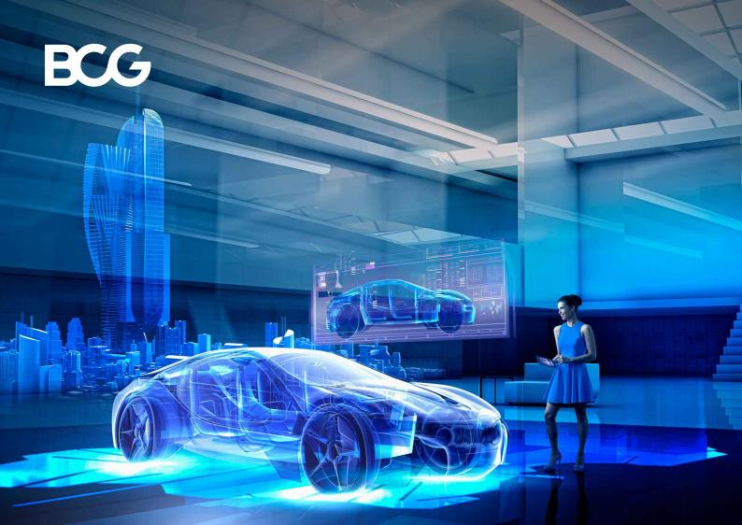

Innovation Has Transformed the Car but Not Yet the Car Buying Experience

JANUARY 09, 2024
By Andrej Levin, Alfred Wiederer, Karen Lellouche Tordjman, Christoph Heuser, and Lisa Bornschlegel

READING TIME: 12 MIN
Automotive companies are investing billions of dollars to radically change automobile technology, powertrains, connectivity, and design. In the longer term, these moves are intended to cut carbon
emissions and redeﬁne mobility, revolutionizing the in-car experience and making it an extension of personal space. But one aspect of the automobile landscape is barely changing at all, especially
among traditional OEMs: the car buying experience.

© 2024 Boston Consulting Group 1

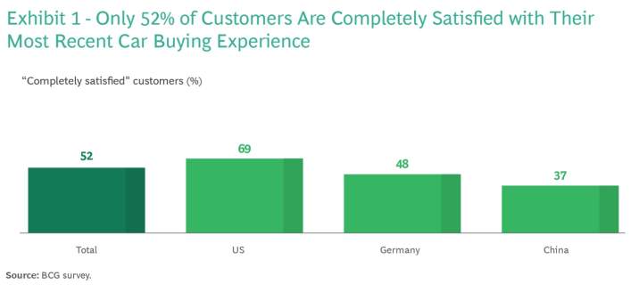

Only about half of car purchasers say that they were completely satisﬁed with their latest buying
experience, according to a BCG survey of nearly 2,000 consumers in China, Germany, and the US who had purchased a car within the past two years. (See Exhibit 1.) Notably, in China, the percentage of
completely satisﬁed buyers drops to 37%. Just 43% of respondents believe that their recent vehicle
purchasing experience surpassed the one they had eight years prior. Moreover, survey respondents identiﬁed the critical “awareness phase”—when car buyers are inspired to buy a new car and choose
the brands they favor— as the most disappointing part of the experience, fully satisfying the expectations of only 34% of customers overall and 20% of customers in the Chinese market.

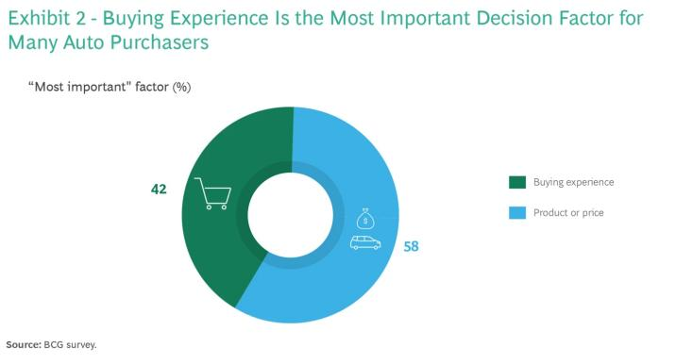

© 2024 Boston Consulting Group 2

以上内容仅为本文档的试下载部分，为可阅读页数的一半内容。如要下载或阅读全文，请访问：https://d.book118.com/436050010130010051

