安徽省统招专升本英语语法
表格示意图

一．冠词
冠词分为不定冠词（a, an），定冠词（the），和零冠词。
- 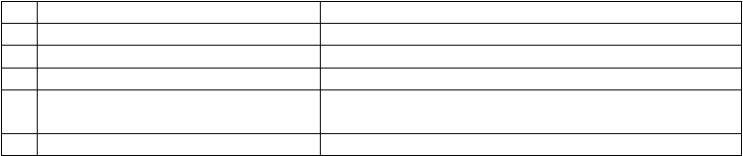不定冠词的用法：
1
2
3
4
指一类人或事，相当于a kind of
第一次提及某人某物，非特指表示“每一”相当于every，one
表示“相同”相当于the same
A plane is a machine that can. fly A boy is waiting for you.
We study eight hours a d. ay
We are nearly of an age.
◆用于人名前，表示不认识此人或与某名人A Mr. Smith came to visit you when you were out
5
6
有类似性质的人或事
◆用于固定词组中
That boy is rather a Lei Feng.
A couple of, a bit, once upon a time, in a, havrreya walk, in a word

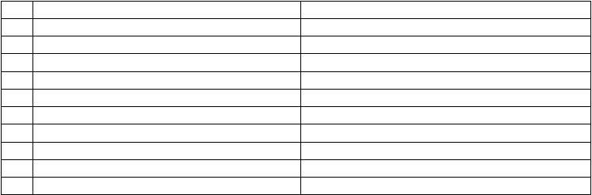
- 定冠词的用法：
  - 表示某一类人或物（这种泛指不需掌握） The horse is a useful animal.
  - 用于世上独一无二的事物名词前 the universe, the moon, the Pacific Ocean
  - 表示说话双方都了解的或上文提到过的人或事 Would you mind opening the door?
  - ◆用于乐器前面 play the violin, play the guitar
  - 用于形容词和分词前表示一类人 the reach, the living, the wounded
  - ◆表示“一家人”或“夫妇” the Greens, the aWngs
  - 用于序数词和形容词副词比较级最高级前 He is the taller of the two children.
  - 用于国家党派等以及江河湖海，山川群岛的名词前the United States, the Communist Party of China, the French
  - ◆在逢十的复数数词之前，指世纪的某个年代 in the 1990，’s 对比in the 1960和s in his 60s
  - ◆用于表示单位的名词前 I hired the cabry the hou.r(按小时计费)
  - ◆用于方位名词，身体部位名词，表示时间的词组前 He patted meon the should.e（r the不能换成my）
- 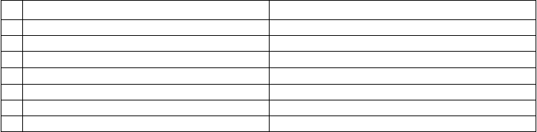零冠词的用法：
1
2
3
4
5
6
7
8
专有名词，物质名词，抽象名词，人名地名等名词B前eijing Universi,tJyack, China, love, air
名词前有this, m,ywhose, some, no, each, ev等ery限制
◆季节，月份，星期节，假日，一日三餐前
◆表示职位，身份，头衔的名词前
◆学科，语言，球类，棋类名词前
◆与by 连用表示交通工具的名词前以and连接的两个相对的名词并用时表示泛指的复数名词前
I want this book, not that oneW. / hose purse is this? March, Sunda,yNational Da,yspring但the Spring Festival Lincoln was made President of America.
He likes playing football/chess. by train, by air, by land
husband and wife, knife and fork, day and night
Horses are useful animals.

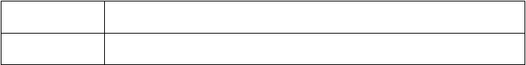
IV 有无冠词的词汇或词组的对比
不可数名词的具体 cloth（布料—不可数）与a table clot（h 桌布）；beer (啤酒)与a bee（r
化用作可数名词 璃）与a looking gla（ss 镜子）
◆相似词组的对比 in charge of / in the charge of; in case of / in the case of;
in front of / in the front of; out of question / out of the question

二、数词
- 序数词one two thre…e 与基数词first second third ...

一杯啤酒；）glass（玻

- 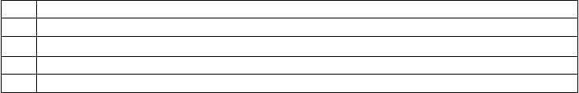分数one third三分之一/ two third三s III．数词的重要表达
1
2
3
4
5
Tens of millions o复f 数名词；thousands of复数名词；dozens of / scores o表f 示许多
Three dozen egg三s 打鸡蛋；three score studen六ts 十位学生（三个20）；
A ten-year-oldboy；a 300-wordcompositio；n a two-minutedrive；two minute’sdive In the sixties在六十年代/ in his sixtie在s 他六十多岁时
A great number o复f 数名词/ the number o复f 数名词/ a large amount o不f 可数名词
分之二…

三．代词：

- 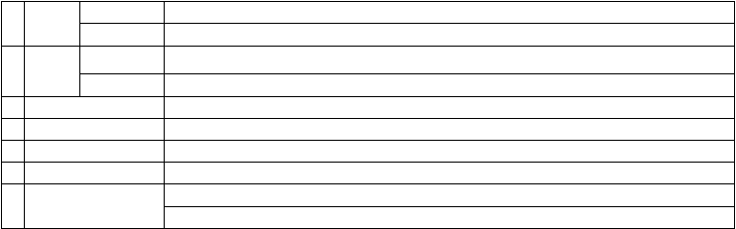代词可以分为以下七大类：
人称
- 代词物 主
- 代词
主格
宾格
形容词性名词性
- 反身代词
- 指示代词
- 疑问代词
- 关系代词◆
- 不定代词
I, you, he, she, it, we, you, they me, you, him, her, it, us, you, them my, your, his, her, its, our, their
mine, yours, his, hers, its, ours, theirs
myself, yourself, himself, herself, itself, ourselves, yourselves, themselves this, that, these, those, such, some
who, whom, whose, which, what, whoever, whichever, whatever that, which, who, whom, whose, as
one/ some/ an,yeach/ ever,ynone/ no, many/ much, few/ little/ a few/ a little,
other/ another, all/ both, neither/ either

- 不定代词用法注意点：◆

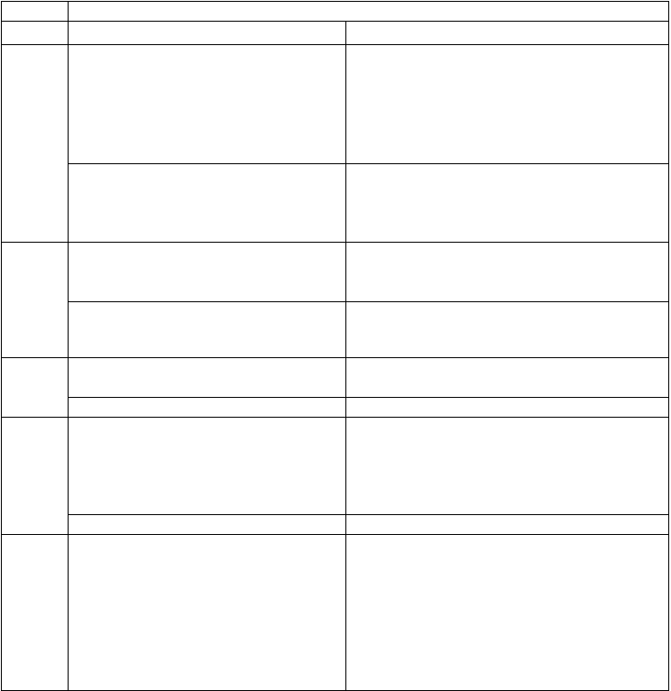
不定代词 用法 示例
one one可以泛指任何人，也可特指，复数o为nes。 One should learn to think of others.
  - some多用于肯定句 I have some questions to ask.
  - 也可用于疑问句中，表示盼望得到肯定的答Would you like some bananas?

some

any
复，或者表示建议，请求等。
  - some和any修饰可数名词单数时s，ome表示某个，any表示任何一个。
  - some和数词连用表示“大约”
- any多用于疑问句和否定句
- some和any修饰可数名词单数时s，ome表示某个，any表示任何一个。
- any可与比较级连用表示程度。
Could you give me some money?
I have read this article in some magazine. Please correct the mistakes, if. any
There are some 3,000 students in this school.
Have you any bookmarks? No, I don’t have any bookmarks.
Please correct the mistakes, if. any

Do you feel any better today?

each强调个别，代表的数可以是两个或两个以上Each student has a pocket dictio.nary

each
each可以单独使用，后面不跟名词
Each (of ush) asa dictionar.y We eachhavea dictionar.y

every强调整体，所指的数是三个或三个以上。Every student has strong and weak points.

every
every后接名词，every one可以后接of 结构
Every oneof us has strong and weak points.

none

no
none作主语或宾语，代替不可数名词，谓语用单数，代替可数名词，谓语单复数皆可以。 no 等于not any，作定语。
How much water is there in the bottle? None. None of the students are (is) afraid of difficulties. There is no water in the bottle.

other泛指“另外的，别的”常与其他词连用the other+单数名词，特指两者中的另外一个
如：the other da,yevery other week
He held a book in one hand and his notes in the other.

other
the other+复数名词=the other（s
表示在一定范围 Two studentsin our classfailed,but the otherspassedthe

中的其他…）
exam（.
our class是一个明确的范围）

another all
other+复数名词=others（没有范围的其他…） another指“又一个，另一个”无所指 all+复数名词，表示三个或以上概念
Some like football, while others like basketball.
The trousers are too long. Please give me another pair. All of the books are not written in English.

all表示不可数名词时，其谓语动词用单数。
All that glitters is not g（old发.
光的不都是金子）。

both either neither
both+复数名词，表示两个
either+单数名词，表示两个中的一个neither表示两个都不
Both of us are not teache我rs.们俩不都是教师。Either of the two answers is acceptable.
Neither of us is a teache我r.们俩都不是教师。

none
none表示三个或以上都不
全部否定用neither和none（.

表示“都不是）”
None of us is / are a teac我he们r.
都不是教师。

（both/all与not搭配表示“不都是）”

四．形容词和副词
- 形容词：
  - 形容词的位置：
- 形容词作定语通常前置，但在下列情况后置：

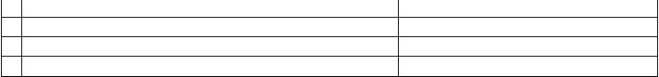
- 修饰some, an,yevery, no和body, thing, on等e 构成的复合不定代词时nobody absent, everything possible

- alive, alike, awake, aware, asl等ee可p
- 和空间、时间、单位连用时
- 形容词短语一般后置
以后置◆
the only person awake a bridge 50 meters long
a man difficult to get on with

- 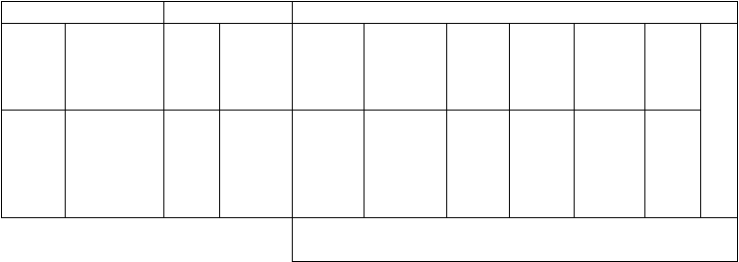多个形容词修饰同一个名词的顺序：
代词
数词
性状形容词
冠词前
的形容词
冠词
指示代词 不定代词 代词所有格the
a this
another
your
序数
词
基数词
性质
状态
大小
长短形状
新旧
温度
颜色
国籍
产地
材料
质地
名
all both
such
second
next
one
four
beautiful good
poor
large short
square
词
new
cool
black
yellow
Chinese
London
silk
stone
◆从抽象到具体
如：the beautiful small round new red Chinese wood table

- 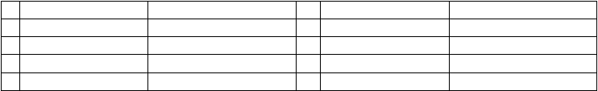复合形容词的构成：
- 形容词+名词+ed
- 形容词+形容词
- 形容词+现在分词
- 副词+现在分词
- 副词+过去分词
kind-hearted dark-blue ordinary-looking hard-working
newly-built
- 名词+形容词
- 名词+现在分词
- 名词+过去分词
- 数词+名词+ed
- 数词+名词
world-famous peace-loving snow-covered three-egged
twenty-year

- 副词
  - 副词的分类：
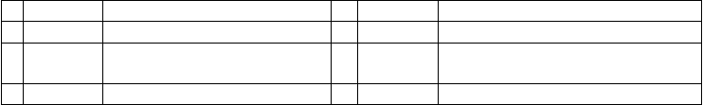
- 时间副词
- 地点副词
soon, now, early, finall,yonce, recently 5
here, nearb,youtside, upwards, above 6
频度副词
疑问副词
3 方式副词
hard, well, fast, slow, elyxcitedl,yreally 7
连接副词
4 程度副词
almost, near,lyvery, fairly, quite, rather 8
关系副词
always, often, frequen, tslyeldom, never how, where, when, why
how, when, where, why, whether,however, meanwhile
when, where, wh◆y
  - 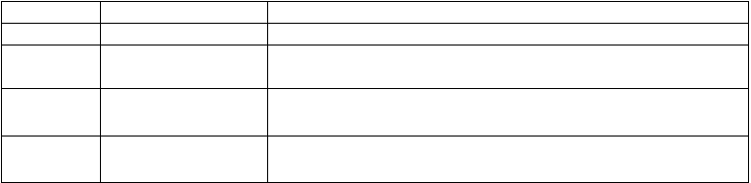几个副词的用法◆
so /how / too so / how / too + adj. /a. dv It isso hot a da.y/ How hot the weather is! / It is too difficult a question. what/ such what /such +(adj.) noun It issuch a hot day/.It issuch hot weathe. r/ What a hot day it is!
enough enough + noun I have enough money to buy a house. adj./adv. enough to do He is old enough to join the a.rmy
however 表“但是”，用逗号隔开 Some people agree. However, others disagree.
注意与while的区别 = Some people agree while others disagree.
almost not 与 high可测量的高度 too肯定句中的“也” not nearly highly抽象的高度 either否定句中的“也”

- ◆形容词和副词比较等级：
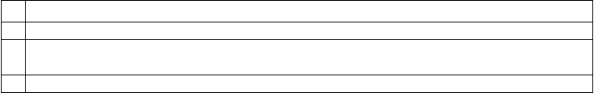形容词和副词的比较等级分为原级，比较级和最高级。比较级和最高级的构成一般是在形容词和-e副r 和词-e后st，加多音节和一些双音节词前加more 和most。
- 同级比较时常常用as…as…以及not so(as)…as…如：I am not so good a player as you are.
- 可以修饰比较级的词有m：uch, a lot, even, far, a bit, a little, still, yet, by, faagr,reaantydea。l
- 表示一方随另一方变化时用th“e more（主谓）the more（主谓）”句型。
- 如：The harder you work, the more progress you will make.
4 用比较级来表达最高级的意思。如I h：aveneverspent amoreworrying da.y

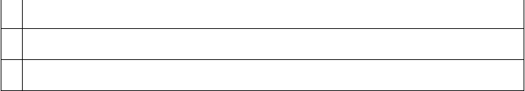
- 表示倍数的比较级有如下几种句型O：ur school itshree times larger thaynours./
- Our school ifsour times as large yaosurs. / Our schoolfiosur times the sizoef yours.
- –以or 结尾的形容词，本身含有比较的含义，所以不-能er或用more / less构成比较级，其后加to.如 be superior / inferior / junior /senior / major / minor / prior / posterior to
- 特殊结构not so much A as（B不是A，而是B）；no more than仅仅；as well as / as soon as / as (so) long as / as far as
- would rather do rather（do宁愿…而不愿意…）；rather than而不是/ other than除了；cannot (never…) too越…越好

五．介词
- 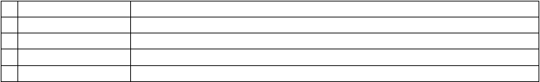介词分类：
- 简单介词 about, across, after, against, among, around, at, belyoownd, during, in, on
- 合成介词 inside, into, onto, out of, outside, throughout, upon, within, without
- 短语介词 according to, because of, instead of, up to, due to, owing to, thanks to
- 双重介词 from among, from behind, from under, till after, in between
- 分词转化成的介词◆ concernin（g 关于）, given（鉴于）

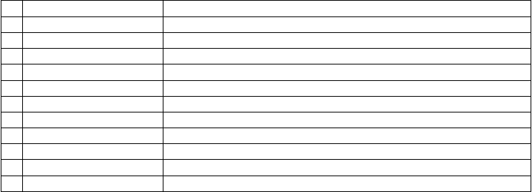
- 常用介词区别：
- 表示时间的in, on, at at 表示片刻的时间，in 表示一段的时间，on 总是与日子有关
- 表示时间的since, from since 指从过去到现在的一段时间，和完成时连f用ro，m指从时间的某一点开始
- 表示时间的in, after in 指在一段时间之后，after表示某一具体时间点之后或用在过去时的一段时间中
- 表示地理位置的in, on, to in 表示在某范围内，on 指与什么毗邻，to 指在某环境范围之外
- 表示“在…上”的on, in on 只表示在某物的表面上i，n 表示占去某物一部分
- 表示“穿过”的through, across through表示从内部通过，与in 有关，across表示在表面上通过，与on 有关◆
- 表示“关于”的about, on about指涉及到，on 指专门论述
- between与among的区别 between表示在两者之间，among用于三者或三者以上的中间
- besides与except的区别◆ besides指“除了，包括在内，”except指“除了，不包括在内，”beside在…旁边
- 表示“用”的in, with with表示具体的工具，in 表示材料，方式，方法，度量，单位，语言，声音
- as 与like的区别 as 意为“作为，以…地位或身份，”like为“象…一样”，指情形相似
- in 与into区别 in 通常表示位置（静态，）into表示动向，不表示目的地或位置

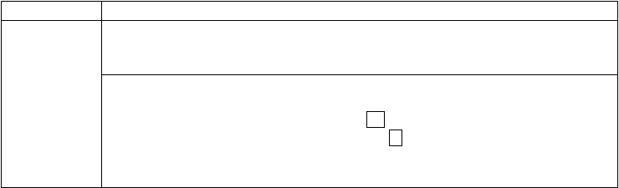
- 重要的介词
  - 介词的意思◆ across（穿过；在对面；）agains（t 反对、在…….衬托下、靠着；）beyond（超出）；等
result in导致/ result from由…导致；be famous for / as /；tobe familiar to / w；ithbe different from /；in be similar to / ；inin the morning / on Tuesday mor；nwinhgat fo；rprevent/ stop / keep sb from do；pinrgotect sb from doin；g 等等
  - 介词的搭配◆ On seeing the picture, he burst into teAartst.h/e sight of the picture, he burst into tears. He will be bacikn five days.A/ fterfive days, he received a reward from the government. it is important / necessary / easy / difficult / convfoernisebntto do；
it is kind / considerate / thoug（htf表ul示人性格的词汇）of sb to do
（= sb is kind / considerate / thoughtful to d）o sth.

六．名词（数、格、主谓一致）
- 名词的种类：
专有名词
国名地名人名，团体机构
名称
普通名词
可数名词
集体名词
不可数名词
个体名词
抽象名词
物质名词

- 名词的数：
  - 规则名词的复数形式：
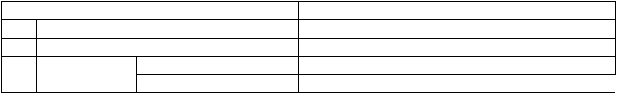
名词的复数形式，一般在单数形式后面-s 或加-es。现将构成方法与读音规则列表如下：
规则 例词
    - 一般情况在词尾加-s map-maps, sea-seas, girl-girls, day-days
    - 以s, x, ch, sh结尾的名词后加-es class-classes, box-boxes, watch-watches, dish-dishes

    - 以-f 或-fe 结尾的 变-f 和-fe为v 再加-es
leaf-leaves, thief-thieves, knife-knives, loaf-loaves, wife-wives

词 ◆加-s belief-beliefs, chief-chiefs, proof-proofs, roof-roofs, gulf-gulfs

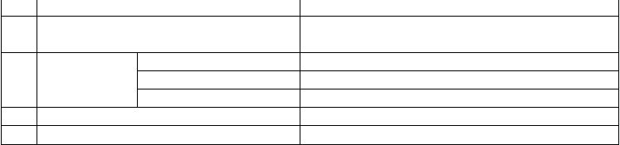
    - 以辅音字母加y 结尾的名词，变y 为i 加-es
以音辅字母加y 结尾的名词，或专有名词以y 结
    - 尾的，加-s
一般加-es
以辅音字母加-o
    - 结尾的名词 不少外来词加-s
两者皆可
    - 以元音字母加-o 结尾的名词加-s
    - 以-th结尾的名词加-s
party-parties, family-families, story-stories, city-cities toy-toys, boy-boys, day-days, ray-rays, Henry-Henrys
hero-heroes, Negro-Negroes, potato-potatoes, tomato-tomatoes piano-pianos, photo-photos, auto-autos, kilo-kilos, solo-solos zero-zeros/zeroes, volcano-volcanoes/ volcanos
radio-radios, bamboo-bamboos, zoo-zoos
truth-truths, mouth-mouths, month-months, path-paths,

  - 不规则名词复数：
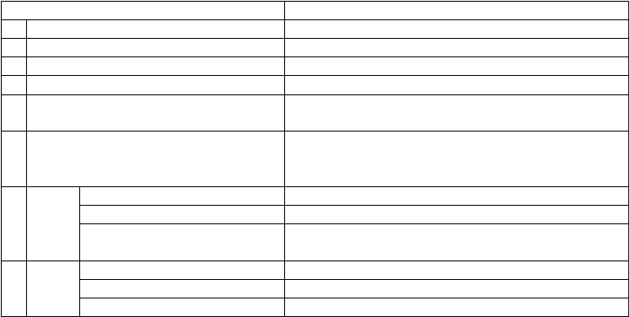
英语里有些名词的复数形式是不规则的，现归纳如下：
规则 例词
- 改变名词中的元音字母或其他形式 man-men, woman-women, foot-feet, goose-geese, mouse-mice
- ◆单复数相同 sheep, deers,eries, meansw, orks, fishs,pecies
- 只有复数形式 ashes, trousers, clothes, thanks, goods, glasses, compasses, contents
- ◆一些集体名词总是用作复数 people, police, cattle, staff
- ◆部分集体名词既可以作单数（整体）也可以audience, class, fam,ilcyrowd, couple, group, committee, government,
作复数（成员） population, crew, team, public, en, epmaryty

customs海(
关), forces军(
队), times(时代), spirits情(
绪), drinks饮(

- 复数形式表示特别含义 料), sands(沙滩), papers文(
件报纸), manners礼(
貌), looks(外表),

brains头(
脑智力), greens青(
菜), ruins废( 墟)

表 示
- “某国
加-s Americans, Australians, Germans, Greeks, Swedes, Europeans
单复数同形 Swiss, Portuguese, Chinese, Japanese

人” 以 -man 或 -woman 结尾的改为
-men,-women
Englishmen, Frenchwomen

◆合成
- 名词
将主体名词变为复数 sons-in-law, lookers-on, passers-, bsytory-tellers, boy friends
无主体名词时将最后一部分变为复数grown-ups, drawbacks, go-betweens
将两部分变为复数 women singers, men servants, women doctors

- 名词的所有格：
名词在句中表示所有关系的语法形式叫做名词所有格。所有格分两种：一是名词’s构词成尾，加二是由介词of 加名词构成。前者多表示有生命的东西，后者多表示无生命的东西。
- 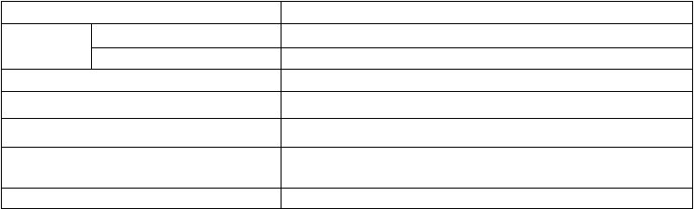’s所有格的构成：
单数名词在末尾加’s

复数名词
一般在末尾加’
不规则复数名词后加’s
以s 结尾的人名所有格加’s或者’
表示各自的所有关系,时各名词末尾均须加’s
◆表示共有的所有关系时在最后一词末’s 加
the boy’s father, Jack’s book, he-rins-olanw’s photo, the teachers’ room, the twins’ mother,
the children’s toys, women’s rights, Dickens’ novels, Charles’s job, the Smhiothuse
Japan’s and America’s problems, Jane’s and Mary’s bikes
Japan and America’s problems, Jane and Mary’s father
◆表示＂某人家＂＂店铺＂，所有格后名词省thedoctor’s, the barber’s, the tailor’s, my uncle’s
略 ◆call at the dent’isst与 call on the dentist
◆合成词最后加’s anyone els’es, who els’es, father-in-la’ws,

- 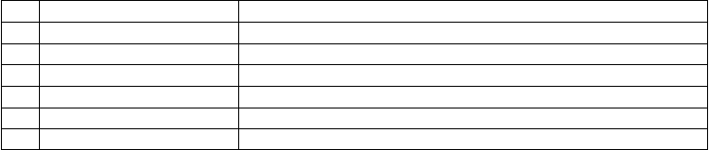’s所有格的用法：
6
7
与人类活动有特殊关系的名词 the life’s time, the play’s plot
某些固定词组
a bird’s eye vie,wa stone’s thro,wat one’s wit’s en不d(知所措)

１ | 表示时间 | today’s newspaper, five weeks’ holiday
2 | 表示自然现象 | the earth’s atmosphere, the tree’s branches
3 | 表示国家城市等地方的名词 | the country’s plan, the world’s population, China’syindustr
4 | 表示工作群体 | the ship’s cre,wmajority’s view, the team’s victory
5 | 表示度量衡及价值 | a mile’s journ,eyfive dollarsw’ orth of apples

- of所有格的用法：
1
用于无生命的东西：the legs of the chair, the cover of the book

2
3
用于有生命的东西，尤其是有较长定语时the：classrooms of the first-year students
◆双重所有格：a friend of mine, a portrait of Mr. B’rsow和na portrait of Mr. Brown
IV 主谓一致◆◆◆
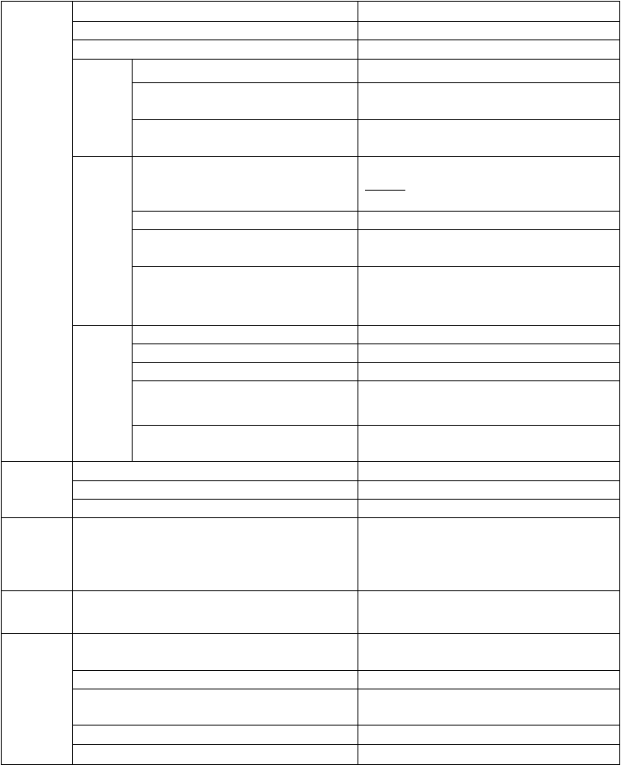
（语法一致；意义一致；就近原则）
A 为单数名词 A man is crossing the street.
A 为复数名词（the adj表. 示人，复数；物，为单数）Three men are crossing the street. /The ol…d are
A 为不可数名词 Water is essential to us.
以people, cattle, poli为ce代表，复数概念 Chinese people are very modest.
A 是集 以family, crew, government, class, team为 My family is a big fam.ily
A 体名词 代表，强调整体为单数，强调成员为复数 My family are now watching TV at home.
做主语
以information,equipment,furniture,news, Much information is contained in the book.
advice, machiner等y 为代表，不可数名词 但Three pieces of information are provided by him.

Statistics is a branch of ma统th计s.
学是数学分支。

A 是-s结 表示学科，是单数，如physics, economicsStatistics show that the population is on the rise.
尾的词 统计数据（是复数，不是学科概念） 组织机构等的名称，如 the United NationsThe Beijing Olympic Games is wonderful.
度量衡概念，强调整体概念是单数而，强 300 words is a requirement for this composition.
调个体概念是复数 300 words have been taught rece. ntly These shoes are made in Hefei.
以shoes, trousers, scisso为rs代表 This pair of shoes was made in Hefei.
These two pairs of shoes were made in Hefei.

A 前面
Many a / more than oneA+ 谓语单数 One of / Each of（A复数名词）+谓语单数
Many a student is diligen许t. 多( One of them is from Hefei.
学生很勤奋。)

有 修 饰
成分
The rest of /Most Aof+谓语（取决于A） The number of A +谓语单数
A number of A谓+语复数
None/ neither of复+ 数名词+谓语（单复数皆可）
Most of the earth is covered with water.
The number of college students is on the rise.
A number of college students are studying hard. Neither of them like/ likes music.

A and B
A and B通常表示复数概念，谓语用复数形式A and B表示整体概念谓语用单数
Each/every A and each/every谓B语用单数
He and I are going there.
Bread and butter is his favorite food. Each boy and each girl has a dictio.nary

with 可以替换为as well as, together with, along with,The teacher as well as the students is coming.

A with B
in addition to, but, exce等pt介词短语，或followed b,y surrounded by或定语从句，谓语取决于A.
The teacher, followed by the students, is coming. The teacher who is surrounded by the students is going to give us a lecture.

A or B
or 可以替换为either…or / neithe…r
nor/ not onl…y but Neither the students nor the teacher knows it.

also谓语动词采取就近原则 Has he or you taken my pen?

特殊句式
主语从句、to do、doing作主语，谓语一般用单数

What主语从句，谓语取决于表语的单复数情况定语从句

倒装句（包括there be），谓语取决于就近原则强调句
To go to bed early is a good habit.
To go to bed early and to get up early is a good habit. What he needs is a radio. / What he needs are books. He is one of the students who are absent.today
He is the (only) one of the students who is absent.
In the corner stands a chair and two benches. It is I that/who am going there.

七．动词
- 动词的时态：
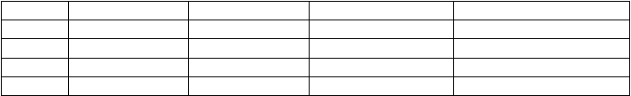
  - 动词的时态一共有16 种，以ask为例，将其各种时态的构成形式列表如下： 现在时 过去时 将来时
一般 ask / asks asked shall/will ask
进行 am/is/are asking was/were asking shall/will be asking
完成 have/has asked had asked shall/will have asked

过去将来时should/would ask should/would be asking should/would have asked

完成进行 have/has been asking had been asking shall/will have been askingshould/would have been asking

  - 现在完成时与一般过去时的区别：
- 现在完成时表示过去发生的动作或存在的状但况和，现在有联系，强调的是对现在造成的影响或结果它，不能同表示过去 的时间状语连用，汉译英时可加“已经”等词。简言之，利用过去，说明现在。如：
I have already read the novel written by the world-famous已w经rite看r.过( ，且了解这本书的内) 容
- 一般过去时只表示过去发生的动作或状和态现，在无关，它可和表示过去的时间状语连用汉，译英时可加“过”，“了”等词。简言之，仅谈过去，不关现在。如：
I read the novel last mont只h.说( 明上个月看了，不涉及现在是否记) 住
I lived in Beijing for ten ye（ar只s. 说明在北京住过十年，与现在无关）
  - 现在完成时与现在完成进行时的区别：
两者都可以表示“从过去开始一直持续到现在，在”含义上如着重表示动作的结果时多，用现在完成时，如着重表示动作一直 在进行，即动作的延续性时，则多用现在完成进行时。一般不能用于进行时的动词也不能用于现在完成进行时。I have read that boo我k.读过那本书了。
I have been reading that book all the morn我in早g.上一直在读那本书。
  - 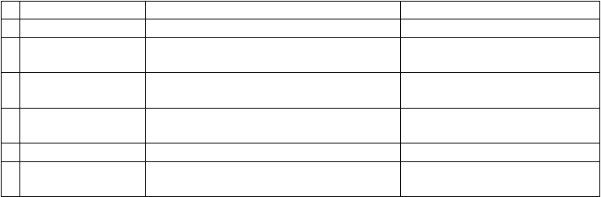一般将来时的表达方式：
将来时
1 will/shall动+ 词原形
用法
表示将来发生的动作或存在的状态
例句
My sister will be ten next year.
2
be going to动+ 词原形
含有“打算，计划，即将”做某事，或表示很I有t’s going to clear up.
可能要发生某事
We’re going to have a party tonight.
3
be + doing进行时表示 go, come, start, move, leave, arr等iv词e 可用进行时 He is moving to the south.
将来
表示按计划即将发生的动作
Are they leaving for Europe?
4
be about to +动词原形
表示安排或计划中的马上就要发生的动作，后I面was about to leave when the bell rang.
5 be to + 动词原形
一般不跟时间状语
表示按计划进行或征求对方意见
The meeting is about to close.
We’re to meet at the school gate at noon.
6
一般现在时表示将来
时刻表上或日程安排上早就定好的事情，可用T一he meetingstarts at five o’clock.
般现在时表示将来
The plane leaves at ten this evening.

  - 重要的时态用法◆◆◆

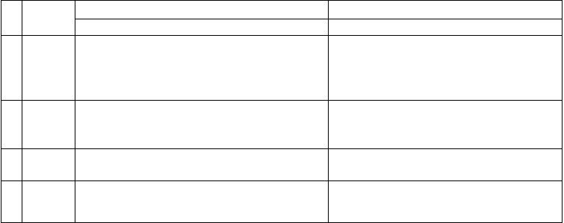
    - 现在时 在条件和时间状语从句中用现在时表示将来概念 If it rains tomorro, we will not go out.
从句中一般现在时表示客观真理不，受主句时态影响 The teacher said that the earth moves around the sun.
现在完 短暂性动词的现在完成时表示过去的动作对现在的He has got married.
    - 成时 影响，其动作不能和一段时间连接，但可以ha用ve (不能说he has got married for three months.)

been +adj表.
示一种状态，可以和时间段连接。
He has been married for three months.
He has left. / He has been away for a short while.

现 在 完 完成进行时强调“一直，”应试中这种题目往往有情--You look so tire（d! 情景）

    - 成 进 行 景介绍。时
    - 过 去 完 过去的过去成时
    - 将 来 完 在将来某个时间前完成的动作或状态成时
--I have been running for the whole morning. They had finished the task by the end of last year.
By the time they arrive in Hefei, we will have left for Beijing.（从句中arrive形式表示将来概念）。

- 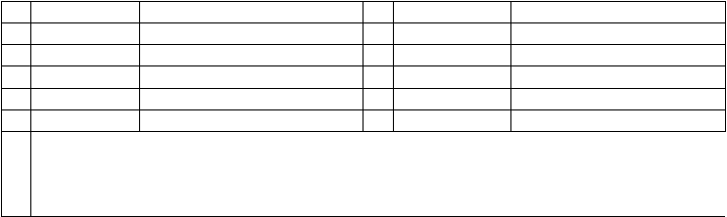动词的被动语态：

注 被动语态的否定式是在第一个助动词或情态动词n后ot，加短语动词的被动态不可漏掉其中介副词。固定b结e 构
going to, used to, have to, had be变tte为r 被动态时，只需将其后的动词变为被动态如。：意 Trees should not be planted in summer. / The boy was made fun of by his classmates.
Newspapers used to be sent here by the little girl.

 | 常用被动语态 | 构成 |  | 常用被动语态 | 构成
1 | 一般现在时 | am/is/are asked | 6 | 过去进行时 | was/were being asked
2 | 一般过去时 | was/were asked | 7 | 现在完成时 | have/has been asked
3 | 一般将来时 | shall/will be asked | 8 | 过去完成时 | had been asked
4 | 过去将来时 | should/would be asked | 9 | 将来完成时 | will/would have been asked
5 | 现在进行时 | am/is/are being asked | 10 | 含有情态动词的 | can/must/may be asked

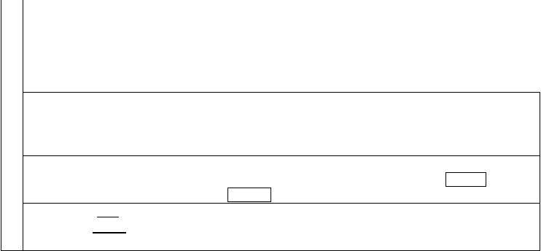
事 汉语有一类句子不出现主语，在英语中一般可用被动结构表示。如：
It is believed that… It is generally considered that… It is said that…
项 It is well known that… It must be pointed out that… It is supposed that… It is reported that… It must be admitted that… It is hoped that…
◆Sth is said / believed / reported / supposed（to将d来o ）/ to have don（e 已完成）
如：The book is said to be translated into foreign languages./The books is said to have been translated into foreign languag
下面主动形式常表示被动意义：如：
The window wants/needs/requires repairing. The book is worth reading twice.

The clothes washes well◆. /The book sells wel（l.
事物的内在属性，不强调具体的动作）

The dish tastes delicious. a/tWer feels very co（ld.系表结构）下面词或短语没有被动态：
leave, enter, reach, become, benefit, cost, equal, contain, last, lack, fit, fail, have, appear, hbapelpoenng, otoc, ctaukr,e place, break out, come about, agree with, keep upcwonitshi,st ofh, ave on, lose hea等rt 等
◆He was madeto dothe homework主. ( 动态His mother made him do the homework. )
◆He was seento enterthe room.（主动态Someone saw him enter the roo）m. (但Someone saw him entering the room. = He was seen entering th）e room.

七．情态动词

- 情态动词基本用法：
情态动词 用法 否定式 疑问式与简答

can
能力（体力，智力，技能）
can not / cannot /can’t do Can…do…?

允许或许可（口语中常用） Yes,…can.

could
可能性（表猜测，用于否定句或疑问句中）couldn’t do
No,…can’t.

may
可以（问句中表示请求）
may not do
May…do…? Yes,…may. No,…mustn’t/can’t.

可能，或许（表推测） Might…do…? eYs,…might

might
祝愿（用于倒装句中）
might not do No,…might not.

must
必须，应该（表主观要求）
must not/mustn’t do
Must…do…? Yes,…must.

肯定，想必（肯定句中表推测） No,…needn’t/don’t have to.
只好，不得不（客观的必须，有时态人称 Do…have to do…?

have to
变化）
don’t have to do
Yes,…do. No,…don’t.

ought to 应当（表示义务责任，口语中多s用hould 将要，会
ought not to/oughtn’tto Ought…to do…?
do Yes,…ought. No,…oughtn’t.

shall
用于一三人称征求对方意见
shall not/shan’t do
Shall…do…?

用于二三人称表示许诺、命令、警告、威 Yes,…shall. No,…shan’t.
胁等

should
应当，应该（表义务责任） 本该（含有责备意味）
should not/shouldn’t do Should…do…?

will
意愿，决心
will not/won’t do
Will…do…?

would 请求，建议，用在问句中would比较委婉 would not/wouldn’t do Yes,…will. No,…won’t.

dare 敢（常用于否定句和疑问句中） dare not/daren’t do
Dare…do…?
Yes,…dare. No,…daren’t.

需要
need
need not/needn’t do
Need…do…?

必须（常用于否定句和疑问句中） Yes,…must. No,…needn’t.
Used…to do…?
used not/usedn’t/usen’t to

used to 过去常常（现在已不再） do
didn’t use to do
- 情态动词must, ma,ymight, could, ca表n 示推测：◆◆◆
Yes,…used. No,…use(d)n’t. Did…use to do…?
Yes,…did. No,…didn’t.

以must为例。must + do(be是) 推测现在存在的一般状态进行m；ust + be doing推测可能正在进行的事情m；ust +have don是e
推测可能已经发生过的事情。

  - mus“t
肯定，一定”语气强，只用于肯定句中。

He must be a man from America. / He must be talking with his friend. / He must have already arrived there.
  - may和might“也许”，后者语气弱，更没有把握。可用于肯定句和否定句。

He may not be at home. / They might have finished their task.
  - can和could“可能”，could表示可疑的可能性，不及can’t语气强，用于肯定、否定、疑问句中。 The weather in that city could be cold. now
We could have walked there; it was so（ne推ar.测某事本来可能发生，但实际上没有发生）
Can he be in the office now? No, he can’t be there, for I saw him inythjuesltinboraw.r(语气很强，常用于疑问句和否定句) 中

- 情态动词注意点：
- can和be able to:都可以表示能力。但be able to可以表达“某事终于成功，”而can无法表达此意。Be able to有更多的时态。另外，两者不能重叠使用。
- used to和would: used to表示过去常常做现在已经不再有的习惯，wo而uld只表示过去的习惯或喜好，不涉及现在。
- need和dare作情态动词和实义动词的区别：
两者作情态动词时常用于否定句和疑问句。其形式ne为ed：n’t/daren’t d；oNeed/dare…do…?
做实义动词时可用于肯定句，否定句和疑问句。其形式n为ee：d(needs/needed)/dare(dares/darteod)do, don’t(doesn’t/didn’t)
need/dare to do

八．非谓语动词◆◆◆
  - 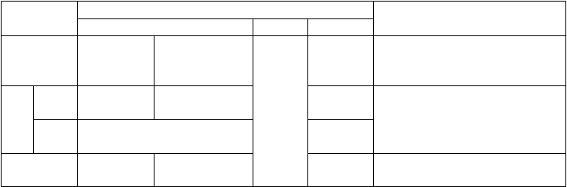非谓语动词的分类、意义及构成：
非谓语形式
构成
to do
时态和语态
to be done
否定式
复合结构
特征和作用
不定式
to be doing to have done doing
having done
to have been done
for sb. to do 具有名词，副词和形容词的作用
sth.
在句中做主、宾、定、表和状语
分
词
现在
分词
过去分词
being done having been done
done
在非谓
语前加
not
具有副词和形容词的作用
在句中做定、表、宾补和状语
动名词 doing being done sb’s doing 具有名词的作用
having done having been done 在句中做主、宾、定和表语

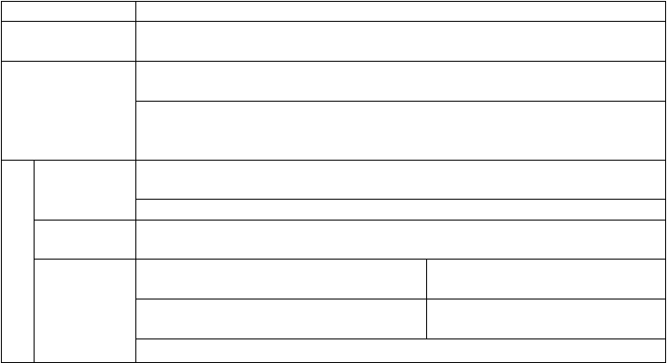
  - 做宾语的非谓语动词比较：
情况 常用动词
只接不定式做宾语的 hope, want, offer,long, fail, expect,wish, ask, decide, pretendm, anage,agree, afford,determine,
动词 promise, happe◆n
mind, miss, enjo, yimagine, practise, suggest, finish, escape, excuse, appreciate, admit, prevent, keep,
只接动名词做宾语的 dislike, avoid, risk, resist, con◆sider

动词或短语
can’t help, feel like, succeed in, be fond of, object to, get down to, be engaged in, insist on, think of, be

proud of, take pride in, set about, be afraid of, be tired of, look forward to, devote oneself to, be worth, be busy, pay attention to, stick◆to
begin, start, like, love, hate, prefer, con（ti接nu不e 定式多指具体的动作，接动名词多指一般或习
意义基本相同 惯行为）
两 need, want, requi（re接动名词主动形式表示被动意义，若接不定式则应用被动形式）者 stop to do停止手中事，去做另一件事

都 意义相反
stop doing停止正在做的事

可 remember/forget/regret to（do指动作尚未发生） go on to d（o
以 remember/forget/regret do（ing指动作已经发生） go on doin（g
接着做另外一件事） 接着做同一件事）

◆
意义不同
try to do（设法，努力去做，尽力） mean to d（o
打算做，企图做）

- try doing（试试去做，看有何结果） mean doing（意识是，意味着）
can’t help to d（o 不能帮忙做）can’t hepl doing（忍不住要做） III.非谓语动词做宾语补足语的区别：
常见动词
与宾语的逻辑关系及时间概念
例句
不定式 ask, beg, expect, get, order, tell, 主谓关系。强调动作将发生或已经I heard him call me several times. want, wish, encoura◆ge 完成，如see sb do sth

以上内容仅为本文档的试下载部分，为可阅读页数的一半内容。如要下载或阅读全文，请访问：https://d.book118.com/476213030215010100

