eBPF 专场

使用 eBPF 实现零侵扰的云原生可观测性

向阳 2023年05月28日


使用 eBPF 实现云原生可观测性



可观测性 挑战
DeepFlow 方案

DeepFlow 用例



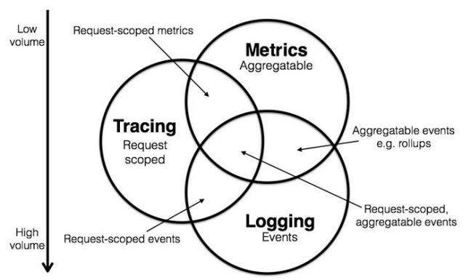
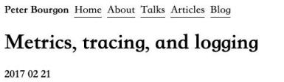 可观测性的灵魂，在于 Distributed Tracing



Honeycomb.io

You lose dimensionality as the more metric labels you add, the harder it is to maintain the backend as metrics systems aren ’t
Alert
built for it. Because of that, engineers tend to stick with some basic labels.
You lose the granularity of seeing what
individual requests or processing contexts are doing as they aggregate over time.
You ’re not, however, using them to
Observability
understand your system and users: you ’re using them to understand the infrastructure that supports them.

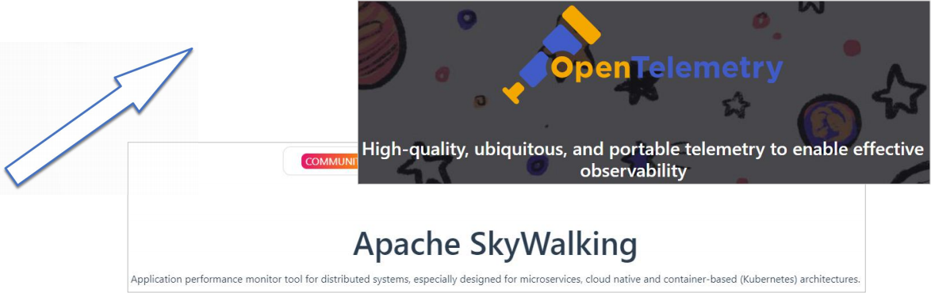
分布式追踪 15 年， 插桩的 15 年

2023

2008

以上内容仅为本文档的试下载部分，为可阅读页数的一半内容。如要下载或阅读全文，请访问：https://d.book118.com/487054043201006050

