#include <stdio.h>
#include <stdlib.h>
#include<string.h>
typedef struct Books/*图书信息结构体/

char bookName[21];
charauther[21];
char bookNumber[16];
char publisher[21];
int publitionTime;
float price;
int allNumber;
int availableNumber;

}Books;
void luru();/*录入函数*/
void liulan();/*浏览函数*/
void chaxunz();/*关键字搜索，如搜"线性代数"可用关键字"线代"*/
int bijiao(char a[],char b[]);/*关键字查询主要靠该函数/
void xiushan();/*修改删除函数*/
int main()

(
printf(" -----=-=图书信息管理系统======-\n");
int a;
charch='y';
/°执行主循环*/
while((ch=='y')||(ch==*Y"))

printf(" ===============================\n");
printf(" *1_信息水入====*====2_信息浏览*\n");
printf[" *=------------- *\n");
printf[" *3_信息查询====*====4_信息修删*\n"); printf(" ===============================\n"); printf(" 请选择需要的功能\n");
scanf("%d",&a)
switch(a)
{
case 1:luru();break;
case 2:liulan();break;
case 3:chaxunz();break;
case 4:xiushan();break;
default:;printf("输入错误\n");break;
}
printf("是否继续管理： yorn\n");

scanf("%c",&ch);
scanf("%c",&ch);

}

void luru()
{
Books lurua;
intc,b=0;
char fileName[31],*name=fileName;
printf(" 请输入管理图书文件名及路径\n");
scanf("%s",name);
FILE*fp;

fp=fopen(name,"a");
if(fp==NULL)
printf(" 错误请重新选择\n");
else
printf(" 请输入入库数量\n");
scanf("%d",&c);
while(b<c)

printf("请输入第%d 本图书书名\n",b+1);
scanf("%s",lurua.bookName);
printf("请输入第%d 本图书作者名\n",b+1);
scanfl"%s",lurua.auther);
printf(" 请输入第%d 本图书编号\n",b+1);
scanf("%s",lurua.bookNumber);
printf(" 请输入第%d 本图书出版单位\n",b+1);
scanf("%s",lurua.publisher);
printf(“请输入第%d 本图书出版时间\n”,b+1);
scanf("%d",&lurua.publitionTime);
printf("请输入第%d 本图书价格\n",b+1);
scanf("%f",&lurua.price);
printf(“请输入第%d 本图书总数量\n”,b+1);
scanf("%d",&lurua.allNumber);
printf" 请输入第%d 本图书可借出数量\n",b+1);
scanf("%d",&lurua.availableNumber);
fprintf( fp,"%-32s%-16s%-165%- 32s%d\t\t%.2f\t%d\t%d\n",lurua.bookName,lurua.auther,lurua.bookNumber,lurua.publisher,Jur
ua.publitionTime,lurua.price,lurua.allNumber,lurua.availableNumber);
b=b+1;

}

fclose(fp);
1 1

}
void liulan()

Books lurua;
char fileName[31],*name=fileName;
FILE*fp;
printf("请输入图书库文件及路径\n");
scanf("%s",name);
fp=fopen(name,"r");
if(fp!=NULL)
[
【
printf(“书名\t\t\t\t 作者\t\t 编号\t\t出版单位\tlt\t\t 出版时间\t\t 价格\t总数 量\t 可借出数量\n");
while(Ifeof(fp))
(
1

fscanf(fp,"%s%s%s%s%d%f%d%d\n",lurua.bookName,lurua.auther,lurua.bookNumber,lurua.publ isher,&lurua.publitionTime,&lurua.price,&lurua.allNumber,&lurua.availableNumber);
printf{"%-32s%-16s%-16s%-
32s%d\t\t%.2f\t%d\t%d\n",lurua.bookName,lurua.auther,lurua.bookNumber,lurua.publisher,lur ua.publitionTime,lurua.price,lurua.allNumber,Jurua.availableNumber);
}

else
{
printf(" 错误，请重新选择\n");
}
fclose(fp);

}
void chaxunz()

char filename[31];
printf(“请输入图书库文件名及路径(小于30个字符)\n”);
scanf("%s",filename);
FILE*fp;
fp=fopen(filename,"r");
Books book1;
char ch='y';
int a;
char duqu[21],wenjian[21];
/*查询次循环*/

while((ch=='y')l|(ch=='Y'))
{ printf(" … …*****\n");
printf" #1_按书名***2_按作**n"");
…………
printf("请选择?\n");
scanf("%d",&a)
printf("请输入关键词；\n");
scanf("%s",duqu);
printf("书名\t\t\t\t作者\t\t 编号\t\t出版单位\t\t\t\t出版时间\t\t价格\t总数量\t 可借出数量\n");
switch(a)
{
case 1:
{

while(lfeof(fp))
t

fscanf(fp,"%s%s%s%s%d%f%d%d\n",book1.bookName,book1.auther,book1.bookNumber,book1.
publisher,&book1.publitionTime,&book1.price,&book1.allNumber,&book1.availableNumber);
strcpy(wenjian,book1.bookName);
if((bijiao(duqu,wenjian))==1)
printf("%-32s%-16s%-16s%-
32s%d\t\t%.2f\t%d\t%d\n",book1.bookName,book1.auther,book1.bookNumber,book1.publishe r,book1.publitionTime,book1.price,book1.allNumber,book1.availableNumber);

}
};break;
case 2:
{
while(Ifeof(fp))
{

fscanf(fp,"%s%s%s%s%d%f%d%d\n",book1.bookName,book1.auther,book1.bookNumber,book1.
publisher,&book1.publitionTime,&book1.price,&book1.allNumber,&book1.availableNumber);
strcpy(wenjian,book1.auther);
if((bijiao(duqu,wenjian))==1)
printf("%-32s%-16s%-16s%-
32s%d\t\t%.2f\t%d\t%d\n",book1.bookName,book1.auther,book1.bookNumber,book1.publishe r,book1.publitionTime,book1.price,book1.allNumber,book1.availableNumber);

」
};break;
default:;break;
}

printf(“是否继续查询： y or n");
scanf("%c",&ch);
scanf("%c",&ch);
rewind(fp);

1
fclose(fp);

}
int bijiao(char a[],char b[])

char cha[2],chb[2];
cha[0]=chb[0]='';
cha[1]=chb[1]='\0';
int i=0,n=0,k=0;
cha[0]=a[0];
chb[0]=b[0];
while((cha[0]!=\0')&&{chb[0]!='\0'))

[
if((strcmp(cha,chb))==0)

{
i=1+1;
k=k+1;

}
else

{
n=n+1;

}
cha[0]=a[i],chb[0]=b[i+n];

i=0;
while(a[i]|="\0')
j=1+1;
if(i==k)
return 1;
else
return 0;

}
void xiushan()

I
FILE*fpa;
char bookNumbera[16];
int m=0,n,i;

Books lurua;
char filename[31];
printf("请输入库文件名及路径：\n");
scanf("%s",filename);
fpa=fopen(filename,"'");
if(fpa!=NULL)

{
while(Ifeof(fpa))/* 确定书本数/
{

fscanf(fpa,"%s%s%s%s%d%f%d%d\n",lurua.bookName,lurua,auther,lurua.bookNumber,lurua.pu blisher,&lurua.publitionTime,&lurua.price,&lurua.allNumber,&lurua.availableNumber);
m=m+1;
}
Books xiushana[m];
rewind(fpa);
/*全部读取至内存/
for(i=0;i<m;i++)
{

fscanf(fpa,"%s%s%s%s%d%f%d%d\n",xiushana[i].bookName,xiushana[i].auther,xiushana[i].book Number,xiushana[i].publisher,&xiushana[i].publitionTime,&xiushana[i].price,&xiushana[l].allNum ber,&xiushana[i].availableNumber);

J
/*具体操作*/
printf("
printf("
printf("
printf(" 请选择?\n");
scanf("%d",&i);
switch(i)
{
case 1:

… … **\n");
#1_修改****#\n));

{
printf(" 请输入需修改图书书名\n");
scanf("%s",lurua.bookName);
printf(“请输入需修改图书作者名\n”);
scanf(“%s”,lurua.auther);
printf(" 请输入需修改图书编号\n");
scanf("%s",lurua.bookNumber);
printf(" 请输入需修改图书出版单位\n");
scanf("%s",lurua.publisher);
printf(" 请输入需修改图书出版时间\n");

scanf("%d",&lurua.publitionTime);
printf("请输入第%d 本图书价格\n");
scanf("%f",&lurua.price);
printf(" 请输入需修改图书总数量\n");
scanf("%d",&lurua.allNumber);
printf("请输入需修改图书可借出数量\n");
scanf("%d",&lurua.availableNumber);
for(i=0;i<m;i++)

{
if((strcmp(lurua.bookNumber,xiushana[i].bookNumber))==0) n=i;
]
strcpy(xiushana[n].bookName,lurua.bookName);
strcpy(xiushana[n].bookNumber,lurua.bookNumber);
strcpy(xiushana[n].auther,lurua,auther);
strcpy(xiushana[n].publisher,lurua.publisher);
xiushana[n].publitionTime=lurua.publitionTime;
xiushana[n].price=lurua.price;
xlushana[n].allNumber=lurua.allNumber;
xiushana[n].availableNumber=lurua.availableNumber;
printf("修改成功\n");

);break;
case 2:

{
printf{"请输入需删图书编号：\n");
scanf("%s",bookNumbera);
for(i=0;i<m;i++)

{
if(strcmp(bookNumbera,xiushana[i].bookNumber)=0)
n=i;

}
for(i=n;i<m-1;i++)

{
strepy(xiushana[i].bookName,xiushana[j+1].bookName);
strcpy(xiushana[i].bookNumber,xiushana[i+1].bookNumber); strcpy(xiushana[i].auther,xiushana[i+1].auther);
strcpy(xiushana[i].publisher,xiushana[i+1].publisher); xiushana[i].publitionTime=xiushana[i+1].publitionTime; xiushana[l].price=xiushana[i+1].price;
xiushana[i].allNumber=xiushana[i+1].allNumber;
xiushana[].availableNumber=xiushana[i+1].availableNumber;

)
fclose(fpa);

fpa=fopen(filename,"w");
for(i=0;i<m-1;i++)
fprintf( fpa,"%-32s%-16s%-16s%- 32s%d\t\t%.2f\t%d\t%d\n",xiushana[i].bookName,xiushana[i].auther,xiushana[i].bookNumber,xi ushana[i].publisher,xiushana[i].publitionTime,xiushana[i].price,xiushana[i].allNumber,xiushana[i]. availableNumber);
printf("删除成功。\n");
fclose(fpa);
break;
default:;break;

else
printf("error\n");

system("cls");
printf("\n\n\n\n");
printf("
——\n\n\n”);
exit(0);
else

感谢使用图书管理系统

{

system("cls");
printf("\n\n\n\n
\n\n\n");
system("pause");
system("cls);
i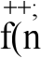=3)

printf("\n\n\n — \n\n\n");
printf("
— \n\n\n");
system("pause"); exit(0);
goto thore;

输入错误，请重新输入!

— 你错误次数太多，自动退出!

感谢使用图书管理系统

//

void

int

gfind)/*管理员查询(管理员可按一定的方式查询图书)*/
choice,n=0;

struct tushu *head; there:
system("cls");
printf("
printf("
printf("
printf("
printf("
printf("
printf("
printf("
printf("
printf("
printf("

图书借阅系统 | ;

●[0]返回  ●[1]按书名查找  ●[2]按作者查找  ●[3]按类别查找 |  | \n"); \n”); \n"); \n"); \n*); \n"); \n"); \n°);
J\n");

printf("
fflush(stdin);
head=create();
scanf("%d",&choice);
if(choice=1)
[
system("cls");
Findofname(head);
}
else if(choice==2)
f
system("cls");
Findofwriter(head);
else if(choice=3)

system("cls");
Findofkind(head);
else if{choice=-0)

system("cls");
mcnu();

else

system("cls");
printf("\n\n\n\n
\n\n\n “);
system("pause");
system("cls~);
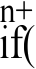n=3)
{
printf("\n\n\n
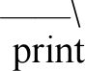f"\n");
——\n\n\n");
system("pause"):
exit(0);

请选择：“);

— 输入错误，请重新输入!

一 你错误次数太多，自动退出!
感谢使用图书管理系统

goto there;

// ---
void xfind()/*学生查询(学生可按一定的方式查询图书)*

{
struct tushu *head; int choice,n=0;
there:
system("cls");
printf("

printf("
printf("
printf("

printf("
printf("
printf("
printf("
printf("
printf("
printf("
printf("
fflush(stdin);
head=create():
scanf(“%d”,&chnice); if(choice=1)

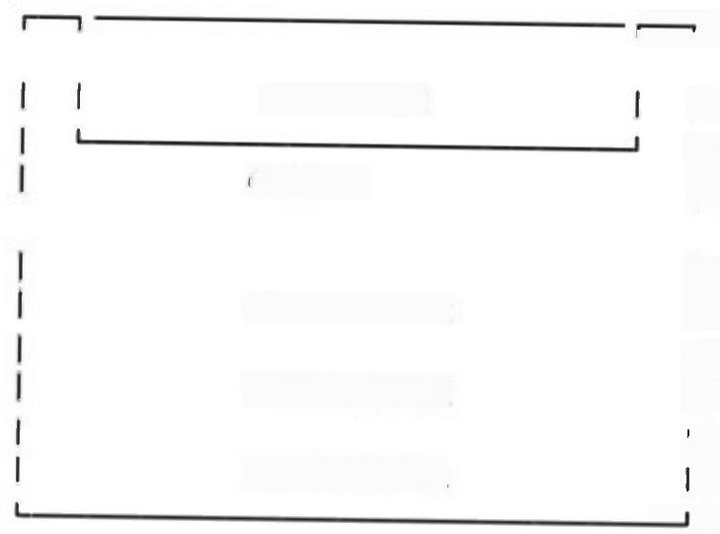
\n")

|\n*); |\n*); |\n*);

|\n*); |\n~); |\n*); |\n*); |\n"); |\n*); —\n");
●[1]按书名查找

●[2]按作者查找

●[3]按类别查找
图书借阅系统

●[0]返回
请选择：“):

system("cls");
xFindofname(head);

else if(choice=2)

system("cls");
xFindofwriter(head):
else if(choice==3)

system("cls");
xFindofkind(head);

else if(choice=0)

system("cls");
xmenu();

else
system("cls");
printf("\n\n\n\n
\n\n\n ");
system("pause");
system("cls");
n++;
if(n=3)
printf("\n\n\n
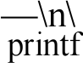n");
——-\n\n\n");
system("pause"); exit(0);

输入错误，请重新输入!

— 你错误次数太多，自动退出

感谢使用图书借阅系统

goto there;

//
void sort(struct tushu *head)

struct tushu *head2;
int choice,n=0;
there;
system("cls");
printf("

printf("
printf("
printf("

printf("
printf("
printf("
printf("
printf("
printf("
printf("
printf("
fflush(stdin);
head2=create();
scanf(“%d”,&choice);

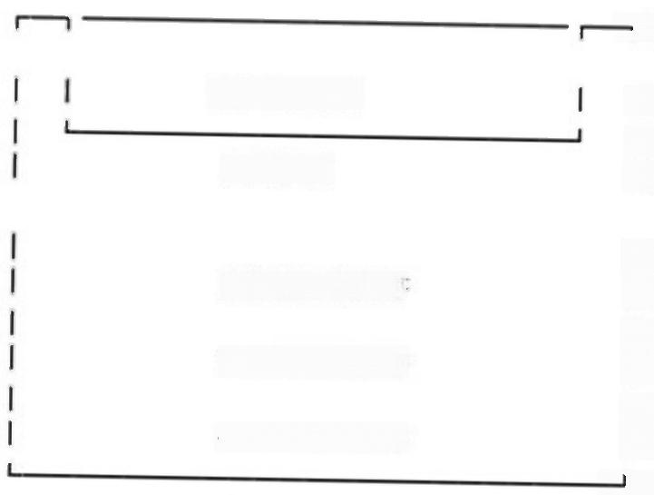
┐{n”)

|\n*);
图书借阅系统
●[0]返回

●[1]按时间排序 ●[2]按价格排序
●[3]按编号排序
|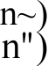;

|n°);
|\n");
|\n*); |\n"); |\n"); 一 \n");
请选择："):

if(choice=1)

system("cls");
Sort_time(head2);

else if(choice=2)

system("cls);
Sort_price(head2);
}
else if(choice=3)
system("cls");
Sort_num(head2);
}
else if(choice=0)

system("cls~)
menu();

else

system("cls")
printf("\n\n\n\n
\n\n\n")
system("pause");
system("cls");
n++;
if(n==3)

printf("\n\n\n
\n\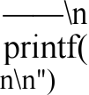\n");

输入错误，请重新输入!

—— 你错误次数太多，自动退出!

感谢使用图书借阅系统

system("pause");
exit(0);

goto there;

//
struct tushu *Input)
struct tushu *pl,*p2,*head,*ptr

char num;
int x,i=0;
system("cls");
pl=(struct tushu *)malloc(sizeof(struct tushu));
head=pl;
pl->price=-1;
while(i!=1)

printf( “请输入编号。若要结束图书信息录入，请输入’#*。\n”): scanf ("%s",pl->num):
if(strcmp(p1->num,"#")==0)
i=1;
while(i!=1)
printf( “请依次输入书名作者出版社类别出版年份价格：\n”);
scanf(“%s%s%s%s%Lf%1f”,pl->name,pl->writer,pl->press,pl->kind,&pl- >time,kpl->price);
p2=pl;
pl=(struct tushu *)malloc(sizeof(struct tushu))
p2->next=pl;
break;

if(pl->price!=-1)
p2->next=NULL; clse
head=NUL,l.;
systcm("cls");
printf(“\n\n\n\t\t\t
system("puuse")
system("cls");
printf(“\n\n\n\t\t\t
scanf(“%d”,&x);
if(x==1)
fprint(head) else

图书信息输入结束!\n\n\n”);

是否保存图书信息?(1.是/2.否):“);

system("cls");
printf("\n\n\n\t\t\t
system("pause);
system("cls");
menu();

文件没有被保存!\n\n\n\n");

//
void fprint(struct tushu *head)

struct tushu *pl;
if((fp=fopen("tushu_list.txt","a~))=NULL)
[
printf("File open error!\n");
system("pause");
exit(0);

if(head=NULL)

(
printf(" 没有图书保存!\n*);
system("pause");
system("cls");
menu():

for(pl=head:pl!=NULL;pl=pl->next)/* 遍历*/
fprintf(fp,"%-10s %-30s %-20s %-20s %-20s %.01f
%.21f\n”,pl-
将图书信息写
>num.pl->name,pl->writer,pl->press,pl->kind.pl->time,pl-price);/*
入文件*/
felose(fp);
system("cls");
printf(“\n 图书信息已成功保存到文件 tushu_list.txt 中 ! \n”);
system("pause");
system("cls~);
getchar();
menu();

//
void fprint_(struct tushu *head)
{
struct tushu *pl;
char a[31];
printf( “请输入你保存的文件!\n”);
scanf(“%s”,a);
if((fp=fopen(a,"w*))=NULL)
printf("File open error!\n*);
system("pause");
exit(0);
if(head==NULL)

system("cls");
printf( “没有图书!\n^);
system("pause");
system("cls");
menu();

for(pl=head;pl!=NULL;pl=pl->next)
fprintf(fp,"%-10s %-30s %-20s %-20s %-20s %.0lf
%.21f\n^,pl-
将图书信息写
>num,pl->name,p1->writer,pl->press,pl->kind,pl->time,pl->price);/*
入文件*/
fclose(fp);
system("cls")
printf(“\n 图书信息已成功保存到文件%s 中 ! \n”,a);
system("pause");
system("cls");
menu();

//——
void hfprint(struct tushu *head)

struct tushu *pl;
if((fp=fopen(tushu_list.txt*,"n~))==NULL)

printf("File open crror!\n");
system("pause");
cxit(0);
if(head==VILL)

printf( “没有还书!\n”);
xmenu();

for(pl=head;pl!=NULL;pl=pl->next)/* 遍历*/
fprintf(fp,"%-10s %-30s %-20s %-20s %-20s %.0lf
>num,pl->name,pl->writer,pl->press,pl->kind,pl->time,pl->price);/* 入文件*/
fclose(fp);
xmenu();

%.21f\n”,pl-
将图书信息写

//——--
void jfprint_(struct tushu *head)
{
struct tushu *pl;
if((fp=fopen("tushu_list.txt","w"))=NULL)

printf("File open error!\n");
system("pause");
exit(0);
}
if(head==NULL)
[
xmenu():

for(pl=head:p1!=NULL;pl=pl->next)
(
fprintf(fp,"%-10s %-30s %-20s %-20s %-20s %.01f >num,pl->name,pl->writer,pl->press,pl->kind,p1->time,pl->price);/*
入文件*/

%.21f\n”,pl- 将图书信息写

fclose(fp):
system("cls");
getchar():
xmenu();

//——--------
void jsprint(jieshu *h)

struct jieshu *pj;
if((fp3=fopen("jieshu_list.txt","a"))==NU).1)

printf("File npen error!\n");
system("pause");
exit(0);

for(pj=h;pj!=NULL;pj=pj->next)
fprintf(fp3,"%-10d %-10s %-30s %-20s %-20s %-20s %.01f
%.21f\n”,pj->xuehao,pj->num,pj->name,pj->writer,pj->press,pj->kind,pj->time,pj- >price);
fclose(fp3);

//
struct tushu*create()
{
struct tushu *head=NULL,*p,*pl,*p2;
if((fp=fopen("tushu_list.txt","r"))=NULL)/*先安全打开目录文件*/
{
printf("File open error!\n");
system("pause");

exit(0);

while(!feof(fp))/* 读取并创建链表*/

p=(struct tushu*)malloc(sizeof(struct tushu));
p->price=-1;
fscanf(fp,"%s%s%s%s%s%lf%lf, p->num,p->name,p->writer,p->press,p-
>kind,&p->time,&p->price);
if(p->price=-1)

free(p);
break;

)
if(head=NULL)

head=p;
pl=p;
pl->next=NULL;

else
(
pl->next=p;
p2=pl:
pl=p;
pl->next=NLI.I.;

fclose(fp);
return head;

//—-----
struct jieshu*jcreate()

struct jieshu *head=NULL,*p,*pl,*p2;
if((fp3=fopen("jieshu_list.txt",r"))=NULL)
[
printf("File open error!\n");
system("pause");
exit(0);

while(!feof(fp3))

p=(struct jieshu *)malloc(sizeof(struct jieshu));
p->price=-1

fscanf(fp3,“%d%sws%s%s%s%1f%1f”,&p->xuehao,p->num,p->name,p->writer,p- >press,p->kind,&p->time,&p->price);
if(p->price=-1)
(
free(p);
break;
)
if(head=NULL)
(
head=p:
p1=p;
p1->next=NULL;

else
(
pl->next=p;
p2=pl;
pl=p;
pl->next=NULL;

fclose(fp3):
return head:

// --
struct jicshu*horrowcreate(struct tushu *k,struct jieshu *h)

struct jieshu *head;
head=(struct jieshu *)malloc(sizcof(struct jicshu));
if'(h==NULL)

h=head;
h->xuehao=denglu;
strepy(h->num,k->num);
strcpy(h->name,k->name);
strcpy(h->writer,k->writer);
strcpy(h->press,k->press);
strcpy(h->kind,k->kind);
h->time=k->time;
h->price=k->price;
h->next=NULL;
return h;

else

以上内容仅为本文档的试下载部分，为可阅读页数的一半内容。如要下载或阅读全文，请访问：https://d.book118.com/488102130011006032

