

January 2024

IMF Country Report No. 24/12

AUSTRALIA
SELECTED ISSUES
This Selected Issues paper on Australia was prepared by a staff team of the International Monetary Fund as background documentation for the periodic consultation with the
member country. It is based on the information available at the time it was completed on December 6, 2023.

Copies of this report are available to the public from

International Monetary Fund • Publication Services PO Box 92780 • Washington, D.C. 20090
Telephone: (202) 623-7430 • Fax: (202) 623-7201
E-mail:publications@imf.org Web:http://www.imf.org

International Monetary Fund
Washington, D.C.

© 2024 International Monetary Fund

Approved By
Asia and Pacific Department

December 4, 2023

AUSTRALIA

SELECTED ISSUES

Prepared By Abdullah Alnasser, Pragyan Deb, and Nour Tawk (all APD).

CONTENTS

MACROECONOMIC IMPACT OF MIGRATION 2
A. Recent Trends in Migration 2
B. Migration in Australia in an International Context 4
C. Migrant Characteristics and Labor Market Outcomes 5
D. Impact of Migration 7
E. Conclusion 15

FIGURES
1. Effects of Migration Inflow Shocks on Output and Labour Outcomes 13
2. Effects of Migration Inflow Shocks on Inflation and Housing Prices 14

References 20

ANNEX
I. Effects of Migration Shocks on Selected Macroeconomic Outcomes – Robustness
Checks 16

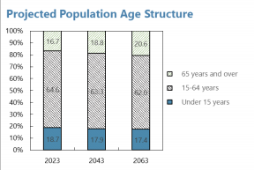

MACROECONOMIC IMPACT OF MIGRATION1

Migration in Australia has historically been a significant source of population growth, with a third of the population born overseas. Migration is set to become even more important as the population
natural growth rate declines. Australia attracts some of the best educated migrants to OECD countries who are mostly skilled workers and students, with high labor force participation rates and low
unemployment. Disentangling macroeconomic effects of migration from drivers of migration is
challenging, but within Australia, migration surges have historically been associated with higher
growth and favorable labor market outcomes, with negligible price pressures except in the housing
market. Cross-country analysis using instrumental variables confirms a positive impact of migration on macroeconomic outcomes—output, employment, and productivity—without significant inflationary
impact. While housing affordability is impacted at the margin, this could represent structural supply shortages and would be best addressed by boosting supply.

A. Recent Trends in Migration

1. Australia has a population of 26 million, with close to 90 percent living in a handful of urban areas around the eastern and southern seaboards. Average population density is therefore
one of the lowest in the world, at 3.5 persons
per square kilometer given the semi-arid and
desert geography of much of the interior of
the country. The median age of the population
is 37.5 years with a high life expectancy of
close to 84 years (the world’s tenth highest in
20232). The sex ratio is roughly balanced at
0.99 males per female and the old age
dependency ratio – number of individuals
aged 65 and over per 100 people of working
age (20 to 64) stood at 30, lower than the OECD average of 33, but has been increasing fast reflecting Australia’s increasing life expectancy and decreasing fertility rate (see below).

2. Overseas migration has historically played an important role in Australia. It has been a significant source of population growth, with variability over time due to changing domestic and
global factors. While several large increases were recorded before the global financial crisis and in the years before the COVID- 19 pandemic, migrants inflows surged in the last year and a half.
Roughly a third of the population aged 15 years and over is born overseas, with 23 percent arriving before 2010, while the rest represents more recent migration.

1 Prepared by Abdullah Alnasser, Pragyan Deb, Nour Tawk (all APD). We thank the Australian authorities for their valuable comments and suggestions.
2Life Expectancy by Country and in the World (2023) - Worldometer (worldometers.info)

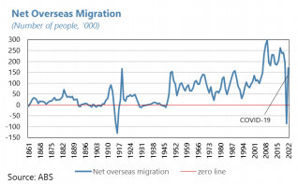
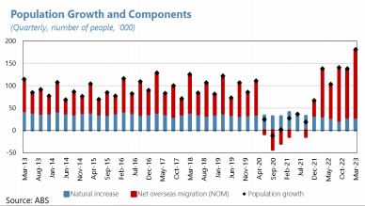

3. Net overseas migration is set to play an even larger role going forward as the rate of natural increase diminishes. After peaking at 3.55 babies per woman in 1961, Australia’s total
fertility rate (TFR) has fallen continuously,
reaching 1.66 in 2020-21, well below the
replacement rate of 2.1 (the rate needed for a
generation to replace itself). As a result, over
the last decade, net overseas migration’s
contributions to Australia’s population growth
increased to roughly 60 percent. After stalling
during the pandemic, which resulted in the
first recorded quarterly population decline in
Australia’s population, migration flows
returned quickly after borders re-opened in
2022. Net overseas migration was 152,000 people in the March 2023 quarter and 454,000 people
over the year to March 2023, which drove most of the annual population growth and was the largest net inflow of migrants on record, with potentially important macroeconomic effects.

4. Recent trends in migration were driven by higher arrivals, particularly students from India and China. There was a sharp increase in migrant arrivals in 2022 and in the first half of 2023, while departures remained subdued, in large part a consequence of fewer temporary migrants
having arrived during the pandemic. The largest share of new migrants were students, as has historically been the case, followed
by skilled permanent and
temporary migrants. The number
of working holiday maker arrivals –
a special visa that lets people 18 to
30 years old (35 years for some
countries) have an extended
holiday in Australia with the ability
to work to help fund their trip –
have also increased in 2022,
reflecting eased travel restrictions
in late 2021 and the seasonal
migration patterns of individuals on holiday visa. These should ease labor market constraints,
以上内容仅为本文档的试下载部分，为可阅读页数的一半内容。如要下载或阅读全文，请访问：https://d.book118.com/498122072040006032

