北京版小学英语六年级下册

Unit2 Can you tell me more about her?单元测试卷

题号 |  | 二 | 三 | 四 | 五 | 六 | 七 | 八 | 九 | 十 | 十一 | 总分
得分

听力部分(满分40 分)

一、 听录音，选择你所听到的单词或词组，将其序号填写在前面的括号内，
每个单词读两遍。 (每题1分，共10分)

( )1.A.arm B.shoulder C.leg D.knee

( )2.A.nervous B.worried C.upset D.happy

( )3.A.laugh B.smile C.feel D.live

( )4.A.pupil B.teacher C.student D.professor

( )5.A.worry B.wrong C.white D.worried

( )6.A.flower B.grass C.tree D.water

( )7.A.a pair of shoes B.a pair of socks

C.a black suit D.a pair of trousers

( )8.A.huge hands B.strong body

C.broad shoulders D.big eyes

( )9.A.feed the sheep B.feed the baby

C.live on D.feed the animals

( )10.A.winter vacation B.winter holiday

C.summer vacation D.summer holiday

二、 听对话，选择合适的图片，将其序号填写在前面的括号内，每段对话

读两遍。 (每题2分，共10分)
( )1.A. B.  ( )2.A.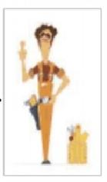 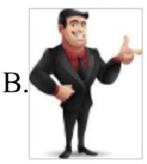
( )3.A. 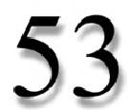 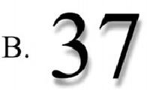


( )4.A. B.

( )5.A. 27$ B. 28$

C. 

C.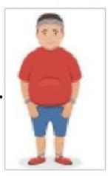

C 25
③ √

C 
c. 29$

三、 听录音，选择正确的答语，将其序号填写在前面的括号内，每个问题
读两遍。 (每题2分，共10分)

( )1.A.She is sad.

B.She is tall and thin.She was a professional football coach.
C.He is tall and strong,with big eyes and round face.

( )2.A.It's in front of the post office.

B.My parents and I often go to the park on Sundays.

C.It's beautiful.There are a lot of flowers and trees in the park.
( )3.A.It's five yuan.

B.It's in the shape of a pig.

C.My mum bought the eraser for me.
( )4.A.I was born in Canada.

B.I was born in January.

C.I am 35 years old.

( )5.A.I visited my grandparents.

B.Because I can't play ping-pong.

C.My mum gave me a little kitten last Sunday.

四、 听短文，根据所听内容选择正确的答案，将其序号填写在前面的括号
内。短文读三遍。 (每题2分，共10分)

( )1.Where did Amy go during this summer vacation?
A.Beijing. B.Shanghai. C.Guangzhou.

( )2.What did Amy do in the first few day?

A.Went fishing. B.Climbed trees. C.Feed the animals.

( )3.What did Amy's grandpa do?

A.Football coach. B.Swimming coach.C.Basketball coach.
( )4.What did Amy do in the last few days?

A.Climbed the trees.B.Went fishing. C.Both A and B.
( )5.What did Amy do every afternoon?

A.Went swimming. B.Went hiking. C.Went fishing

笔试部分(满分 60分)

五、 选择与图片相符的短语。 (每题1分，共8分)

A.summer vacation B.go fishing  E.feed the cat F.on March lst | C.a pair of socks  G.a new skirt | D.girl  H.live | students  on the farm

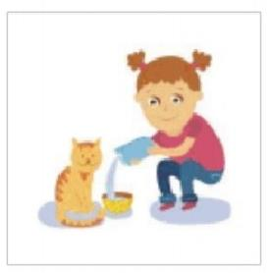

1.( )

5.( )

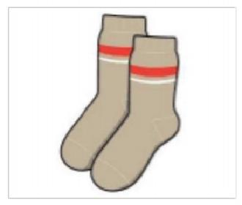

2.( )

6.( )



3.( )

7.( )

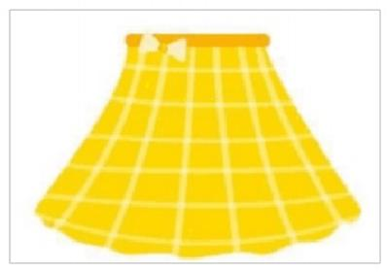

4.( )

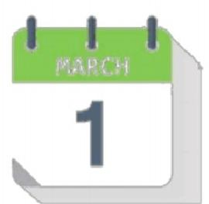
8.( )

六、 选择与图意相符的句子。 (每题1分，共5分)
A.Mike was born in Canada on March 7th.

B.My mum bought me a beautiful dress as a birthday gift.
C.This is my first ping-pong class.

D.Tom is good at Chinese.

E.Ms Wang is very kind.Don't worry.


1.( ) 2.( ) 3.( ) 4.( ) 5.( )

七、 单项选择。 (每题2分，共12分)

( )1.She is two years than my father.

A.old B.younger C.small D.little

( )2.My football coach is good at girl students.

A.teach B.to teach C.teaching D.teaches

( )3.Linda always her grandma the housework.
A.help,with B.helps,for C.helps,with D.helps,for

( )4.Can you tell more about ?

A.me,his B.me,him C.I,he D.me,he

( )5.I enjoy books.

A.reading B.reads C.read D.telling

( )6.The girl is tall longhair.

A.with B.in C.to D.with

八、 选择合适的单词补全短文，将其序号填写在横线上。 (每题1分，共
10分)

This summer vacation,I will go 1. (A.fish B.fishing)with

my dad.We usually go to the park 2. (A.on B.in)Sundays.My

dad is 453. (A.years B.year)old.He is two years 4. (A.old B.older)than my mother.He is tall and strong,with big 5. (A.eye B.eyes)and short hair.My dad 6. (A.have B.has)broad
shoulders and huge hands.He is 7. (A.a B.an)professional

football coach.He teaches football in No.1 High School.He enjoys 8.
(A.looking B.watching)movies in his spare time.

以上内容仅为本文档的试下载部分，为可阅读页数的一半内容。如要下载或阅读全文，请访问：https://d.book118.com/517036132064006044

