Unit 3 The art of painting Section Ⅰ Welcome to the unit & Reading
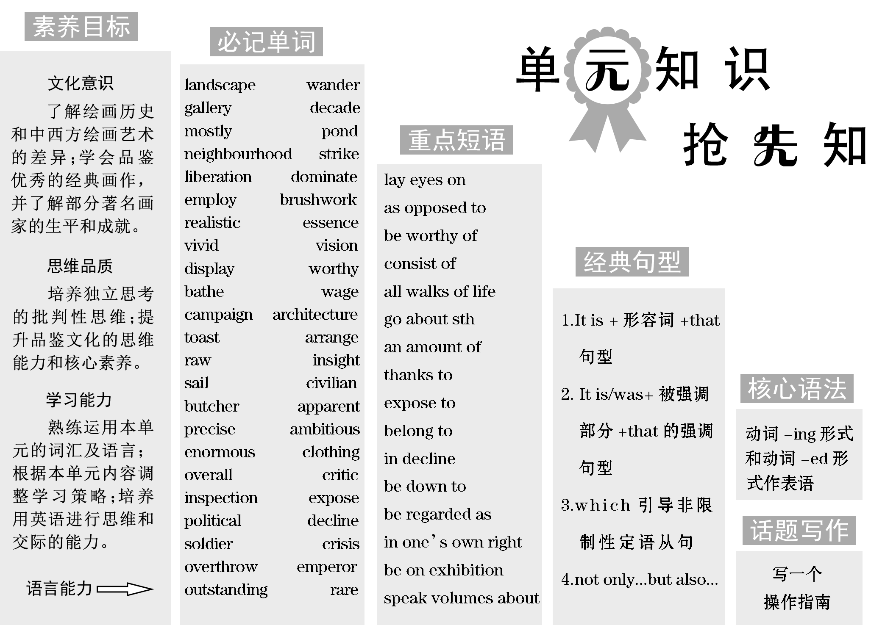
 | 里奥纳多·达·芬奇，是艺术家，又是科学家和发明家。这位奇才对各个领域的知识几乎是无师自通，是人类历史上绝无仅有的全才。下面一起来了解他。

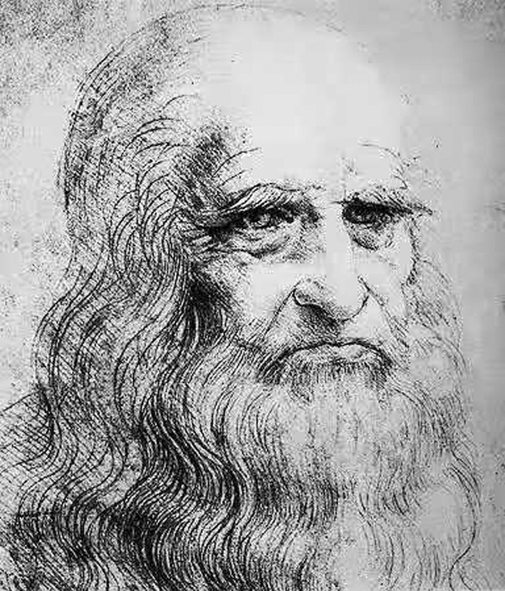Leonardo da Vinci (April 15, 1452－May 2, 1519) was an Italian Renaissance architect, musician, inventor, engineer and painter.He has been described as the archetype (原型) of the “Renaissance man” and as a universal genius.
He is also known for designing many inventions that anticipated (期望的) modern technology, although few of these designs were only constructed in his lifetime.In addition, he helped advance the study of astronomy and civil engineering.
Leonardo da Vinci had a keen eye and quick mind that led him to make important scientific discoveries, yet he never published his ideas.He was a gentle vegetarian who loved animals and hated war, yet he worked as a military engineer to invent
advanced and deadly weapons.
Leonardo da Vinci was one of the greatest painters of the Italian Renaissance, yet he left only a handful of completed paintings.Nevertheless, he is still famous for his masterly paintings, such as The Last Supper and Mona Lisa.
[阅读理解]
阅读文章，判断正(T)误(F)。
1．Leonardo da Vinci was born in Italy and later became an Italian Renaissance politician.(F)
2．Leonardo da Vinci was a genius in inventing, but few of his designs were published in his age.(T)
3．Leonardo da Vinci was regarded as one of the greatest painters of the Italian Renaissance for The Last Supper and Mona Lisa.(T)
[词汇积累]
1．architect n． 建筑师
2．be described as 被描述为……
3．astronomy n. 天文学
4．keen adj. 渴望的
5．a handful of 一把
Section_Ⅰ  Welcome_to_the_unit_&_Reading

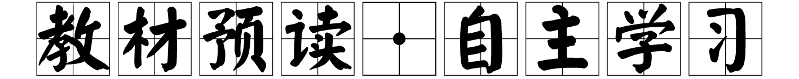

$\begin{matrix}[读文清障]\end{matrix}$
①look forward to 期待(其中to为介词)
②be housed in 安置于……；
设于……
③feature v. 以……为主要内容
④wander vi.&vt. 闲逛，漫步；走失；走神；蜿蜒曲折
⑤gallery n. 展览馆，画
廊；长廊，走廊；楼上旁听席
⑥lay eyes on 看见，见到
⑦make the deepest impression on 给……留下
最深刻的
印象
⑧inspire v. 激励，鼓励
inspire sb with ...＝inspire ...in sb 激起或唤起某人的感情、思想等
inspire sb to do sth
鼓励某人做某事
⑨decade n. 十年，十年期
mostly adv. 主要地，
一般地
⑪pond n. 池塘，水池
⑫canvas n. 画布，油画；
帆布
⑬unique adj. 独特的，独一无二的
in a unique way 以一种独特的方式
be unique to 是……特
有的
$\begin{matrix}[原文呈现]\end{matrix}$
First impressions
3 June
Paris, France
As a huge art fan, I knew exactly what I was looking forward to^{①} most about my trip to Paris: visiting the Musée d′Orsay.[1]Housed in^{②} an old railway building [2], this world­famous art museum features^{③} some of the best­known paintings from the Impressionist movement of the 19th century.
[1]本句为主从复合句。其中what I was looking forward to most about my trip to Paris: visiting the Musée d′Orsay是跟在谓语动词knew之后的宾语从句。
[2]Housed in an old railway building是过去分词作状语。
As I wandered^{④} through the Impressionist gallery^{⑤}[3], I appreciated masterpieces like The Ballet Class and The Card Players.Even though I had admired them hundreds of times on my computer screen, nothing could have prepared me for the wonder I felt when I finally laid eyes on^{⑥} the real thing.[4]While it was hard to pick a favourite painting out of so many amazing works, the artists who made the deepest impression on^{⑦} me were two of the greatest Impressionist painters, Claude Monet and Pierre­Auguste Renoir.[5]
[3]as引导时间状语从句，表示“当……的时候”。
[4]本句为主从复合句。even though引导让步状语从句，意为“即便，即使……”；I felt是定语从句，修饰先行词the wonder；when 引导时间状语从句。
[5]本句为主从复合句。while引导让步状语从句，表示“虽然……”； who made the deepest impression on me是定语从句，修饰先行词the artists；Claude Monet和Pierre­Auguste Renoir都是two of the greatest Impressionist painters的同位语。
I could see from Monet's works that he was greatly inspired^{⑧} by nature[6]．In the last three decades^{⑨} of his life he painted mostly scenes from his garden.One of these scenes is shown in the famous piece Blue Water Lilies, which I studied for quite a while in the gallery[7]．I couldn't believe it when I heard he did around 250 paintings of the same water lily pond^{⑪}， all in different colours and styles.It is amazing that every time Monet studied this simple scene, he brought the pond's beauty to the canvas^{⑫} in a unique^{⑬} way.[8]
[6]that he was greatly inspired by nature是跟在动词see后的宾语从句。
[7]which引导非限制性定语从句，修饰先行词the famous piece Blue Water Lilies。
[8]本句为主从复合句。其中It is amazing that ...中，it是形式主语，真正的主语是that引导的主语从句。 every time ...是在that引导的主语从句中的时间状语从句，表示“每一次……”。
$\begin{matrix}[译文参考]\end{matrix}$
第一印象
6月3日
法国巴黎
作为一位超级艺术迷，我很清楚我的巴黎之行最期待的是什么：参观奥赛博物馆。这座举世闻名的艺术博物馆设于一座古老的铁路建筑中，重点展出十九世纪印象派运动中最著名的一些画作。
当我在印象派画廊漫步时，我欣赏了《芭蕾舞课》和《玩纸牌者》之类的杰作。尽管我曾在电脑屏幕上欣赏过数百次这些画作了，但观看实物所感受到的震撼却是无法比拟的。虽然从这么多令人惊叹的作品中挑选出一幅最受欢迎的画绝非易事，但给我印象最深的是两位最伟大的印象派画家，克劳德·莫奈和皮埃尔­奥古斯特·雷诺阿。
从莫奈的作品中我可以看出他深受大自然的启发。在他生命的最后三十年里，他的画作大部分场景取自自家花园。其中一个场景在他著名的作品《蓝睡莲》中展示出来，在画廊里我细细地端详这幅画作很长时间。当我听说他画了大约250幅同一个睡莲池的画时，我简直不敢相信，所有的画都是不同的颜色和风格。令人惊奇的是，每次莫奈研究这个简单的场景时，他都以一种独特的方式在画布上展现池塘之美。
$\begin{matrix}[读文清障]\end{matrix}$
⑭prefer to do B rather than do A
与做A相比，更喜欢做B
⑮neighbourhood n.
街区，城区，邻近的地方
neighbour n. 邻居
⑯strike vt.& vi. 突然想到；撞，碰；打；突击；罢工；划(火柴)
n. 罢工；袭击；
击，打
be struck with/by
为……所袭击；被……所感动
⑰effect n. 作用，影响
have an effect on/upon
对……有效；对……有影响
come/go into effect
生效
⑱setting n. 环境，背景；情节背景
⑲like­minded adj. 想法相同的，志趣相投的
⑳liberation n. 解放，摆脱
liberate v. 解放，解脱
as opposed to (表示对比)而，相对于
dominate vt.& vi. 在……中具有最重要(或明显)的特色；支配，控制；占有优势；俯视
employ vt. 运用，使用；
雇用
employee n. 雇员；从业员工
employer n. 雇主；老板
brushwork n. (画家的)笔触，
画法
realistic adj. 逼真的，栩栩如
生的；现实的，
实际的；明智的
essence n. 本质，精髓；
香精，精油
vivid adj. 鲜明的，耀
眼的；生动的
vividly adv. 清晰地
$\begin{matrix}[原文呈现]\end{matrix}$
Renoir, I noticed, preferred^{⑭} to paint scenes of everyday life.For me, the most interesting of his paintings is his 1876 masterpiece Dance at Le Moulin de la Galette, which shows life in a busy neighbourhood^{⑮} of Paris on a Sunday afternoon[9]．When I saw it up close, I was struck^{⑯} by the small areas of light across the painting, and the way the soft edges of the figures seemed to mix together.[10]There's so much going on, but so little clear detail.This effect^{⑰} makes the lively movement of the dance almost jump out at the viewer.
[9]which引导非限制性定语从句，修饰先行词his 1876 masterpiece Dance at Le Moulin de la Galette, which在定语从句中作主语。
[10]本句为主从复合句。其中When I saw it up close是when引导的时间状语从句； and 连接两个并列结构，the small areas of light across the painting和the way，都是I was struck by 后的宾语，同时the soft edges of the figures seemed to mix together是定语从句，修饰先行词the way。
Although the paintings had very different settings^{⑱}， it was their similarities that stayed with me long after I left the Musée d′Orsay — similarities which can be seen throughout the Impressionists' paintings.[11]Monet and Renoir, along with other like­minded^{⑲} artists[12], sought liberation^{⑳} from the rules of the old style.Everyday subject matter was the main focus of their works, as opposed to the history paintings that had traditionally dominated European art.They employed free brushwork and used colours to show the effect of light on things, creating paintings that were far less realistic than the works that came before.[13]To me, these techniques are the essence of the Impressionist view of art.Impressionist artists did not try to paint every detail in a scene — just a brief “impression” they had at that moment, burning with vivid colours and light, before it disappeared.[14]
[11]本句为主从复合句。其中although引导让步状语从句；主句是it was ...that ...的强调句结构，被强调部分是 their similarities；after引导时间状语从句；同时which引导定语从句，修饰先行词similarities。
[12]along with other like­minded artists是介词结构，作插入语成分。
[13]本句为主从复合句。其中employed free brushwork and used colours to show the effect of light on things是and连接双谓语动词， 而creating paintings是现在分词作伴随状语； that引导定语从句，修饰先行词paintings。
[14]本句为主从复合句。其中主句是Impressionist artists did not try to paint every detail in a scene，破折号后的just a brief “impression” 是补充说明；they had at that moment是定语从句，修饰先行词just a brief “impression”；现在分词burning with vivid colours and light作伴随状语；before引导时间状语从句。
$\begin{matrix}[译文参考]\end{matrix}$
我发现，雷诺阿更喜欢描绘日常生活的场景。对我来说，他的画作中最有趣的是他1876年的杰作《煎饼磨坊的舞会》，这幅画作展示了周日下午巴黎繁忙街区的生活情景。我靠近观察，画面上遍布着小面积的光斑，人物柔和的轮廓好像融为一体，令我惊叹不已。画面里的内容丰富多彩，但又鲜有清晰的细节。这种效果使舞蹈的活泼动作跃然纸上。
虽然这些画背景各异，但在我离开奥赛博物馆很久之后，却还清楚地记得它们的相似之处——这些相似之处在印象派画家的画作中随处可见。莫奈和雷诺阿，以及其他志同道合的艺术家，寻求从旧风格的规则中解放出来。日常题材是他们作品的重点，这有别于传统上在欧洲艺术中占主导地位的历史题材画作。他们用自由的笔触，用色彩来表现光线对事物的影响，创作出的绘画远不如以前的作品逼真。对我来说，这些技巧是印象派艺术观的精髓。印象派艺术家并没有刻意去描绘一个场景中的每一个细节，而是着重展现他们在当下所拥有的一个短暂“印象”，在它消失之前，用生动的色彩和光进行记录。
vision n. 远见卓识；视
力，视野；想象
display vt. 陈列，展出；显示，表现
n. 陈列，展览；表现；展示
be on display 在展出中
worthy adj. 值得(或应得)……的；值得尊敬的，值得注意的
be worthy of 值得的
The Impressionists' vision inspired a whole new generation of Post­Impressionist painters such as Vincent van Gogh and Paul Gauguin, whose works
are also displayed at the Musée d′Orsay[15]．It is also worthy of note that Post­Impressionist painters were not the only ones to be influenced by Impressionism — the movement has had a lasting influence on modern art, encouraging artists to look at the world from an entirely new point of view.[16]It certainly left a lasting impression on me too!
[15]whose引导定语从句，修饰先行词Vincent van Gogh and Paul Gauguin。
[16]本句为主从复合句。that引导同位语从句，对note的内容作具体解释；不定式to be influenced by Impressionism作the only ones的后置定语；破折号后是对上文Impressionism的具体说明；现在分词短语encouraging artists to ...作伴随状语。, 印象派画家的远见卓识激发了文森特·凡·高和保罗·高更等新一代后印象派画家的灵感，他们的作品也在奥赛博物馆展出。同样值得注意的是，后印象派画家并不是唯一受印象派影响的画家——这一运动对现代艺术产生了深远的影响，鼓励艺术家从全新的角度看待世界。这当然也给我留下了持久的印象！
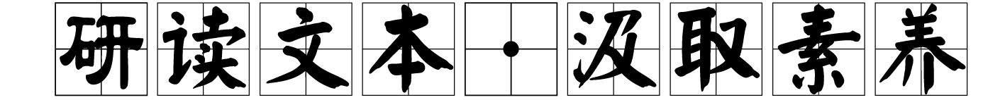
Step One：Pre­reading
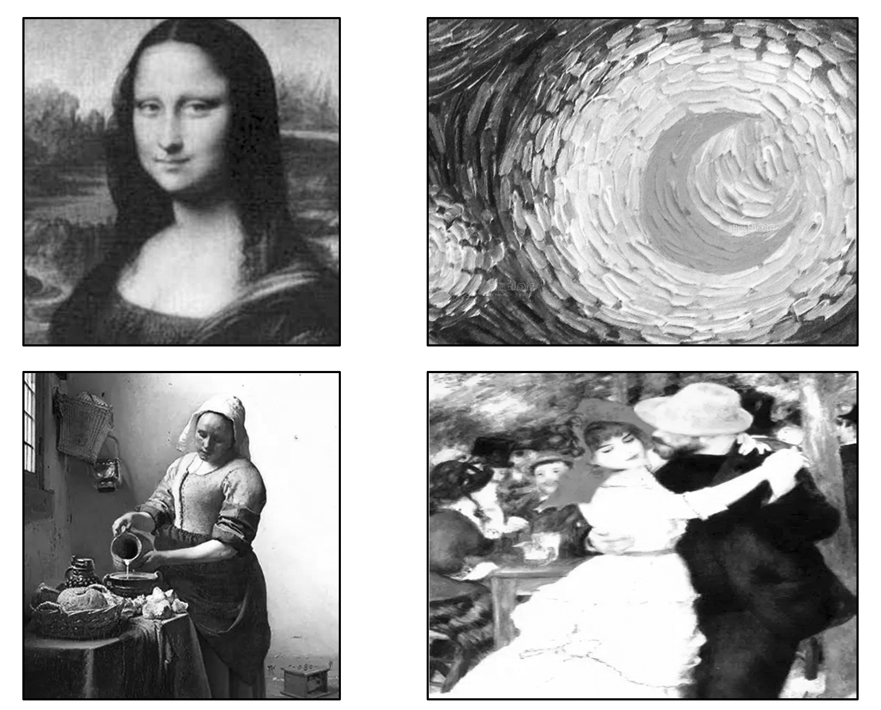
Have you ever been to some museums or art galleries to appreciate some paintings? Can you recognize the painting above? What do you think of them？(Answers may vary.)

Step Two: While­reading
Ⅰ.Read for the main idea
Read the passage quickly and choose the best answer.
Part 1(Para.1) A．Appreciation of Monet's and Renoir's paintings.
Part 2(Paras.2～4) B．The influences of the Impressionists' movement.
Part 3(Paras.5～6) C．The author's visit to the Musée d′Orsay.
答案：Parts 1～3 CAB
Ⅱ.Read for details
Read Part 1 (Para.1) and answer the following questions.
1．What's the author's purpose of visiting Paris?
To_visit_the_Musée_d′Orsay.
2．Where is the Musée d′Orsay?
It_is_located/housed_in_an_old_railway_building.
3．What features does the Musée d′Orsay have?
It_features_some_impressionist_paintings_of_the_19th_century.
Read Part 2 (Paras. 2～4) and decide whether the following statements are true (T) or false (F)．
4．The author was most impressed by Monet and Renoir.(T)
5．The author had not prepared to admire The Ballet Class and The Card Players because they didn't show the real thing.(F)
6．Monet's Blue Water Lilies was greatly influenced by the natural scenery.(T)
7．It is likely that Monet painted a large quantity of paintings with the theme of his water lily pond.(T)
8．Renoir's masterpiece Dance at Le Moulin de la Galette is very detailed.(F)
Read Part 3 (Paras. 5～6)and choose the best answer.
9．What impressed the author mostly of the paintings during his visit in the the Musée d′Orsay?
A．The different settings. B．The unique similarities.
C．The history paintings. D．The realistic techniques.
10．Why did the Impressionist painters seek liberation from the old style?
A．To create a more vivid colors and light.
B．To show their special painting techniques.
C．To make the paintings in a more detailed way.
以上内容仅为本文档的试下载部分，为可阅读页数的一半内容。如要下载或阅读全文，请访问：https://d.book118.com/518057000037006023

