牛津深圳版七年级上册英语期末考试复习资料
Unit1
一、必背单词变形
1．German n.德国人(pl．Germans)；德语adj. 德国人的；德语的；Germany n.德国
2．complete adj.完全的；完整的v．完成； completely adv.完全地
3．old adj. 年老的；古老的；older／elder；oldest／eldest；
elder adj.年龄较大的 n.长辈；年长者
【同类拓展】
longadj.长的→lengthn.长度
tall/highadj.高的→height n.高度
wide adj.宽的→widthn.宽度
deep adj.深的→depthn.深度
4．friend n.朋友
friendship n.友谊；友爱；友善
friendly adj.友爱的；友好的
【同类拓展】以-ly结尾的形容词有：
lovely adj.可爱的 lonely adj.孤单的
lively adj.活泼的 silly adj.愚蠢的
5．dream n.睡梦；梦想 v.做梦，梦见
dreamed/dreamt(动词过去式)
6．sound n.声音 v.听起来(＋adj.)
7．country n.国家→(复数)countries
8．engine n.发动机→(指人的名词)engineer
二、必背重点短语
1．接近，在附近 close to=near
2．来自 be from=come from
3．与……交朋友 make friends with sb.
4．全世界，在世界范围 all over the world
5．收到某人的来信 hear from sb.
6．远离…… far away from=not close to
7．在网上 on the Internet
8．关于某事给某人写信 write to sb. about sth.
9．对某人友好 be friendly to sb.
10．在……方面做得好 be good at=do well in
11．想要做…… would like to do= want to do
12．步行去上学 go to school on foot
13．某人最喜爱的学科 one’s favourite subject
14．与某人一起住 live with sb.
15．在某人的空闲时间 in one’s free time
16．欢迎来…… welcome to…
17．玩得开心 enjoy oneself
18．把……与……相匹配 match...with...
三、必背重点句子
1．I live with my family in a house close to some mountains.
我和家人住在山下的房子里。
2．Every day I go to school by school bus. 每天我乘校车上学。
3．My dad is a doctor. My dream is to be an engineer.
我的爸爸是一名医生。我的梦想是当一名工程师。
- I like my school because the teachers are all very friendly.
我喜欢我的学校，因为老师们都很友好。
5．I’m good at swimming and playing basketball. These are my favourite hobbies.
我擅长游泳和打篮球。这些都是我最喜欢的爱好。
6．I want to make friends with people from all over the world.
我想与全世界的人交朋友。
四、必背话题作文(自我情况介绍)
Dear Liu Xin,
How is everything going?
My name is Elisa. I come from the US and live in China now. I am twelve years old. I am not tall and a little fat. I have long hair.
My family is not big. There are four people in my family. I have a 5-year-old younger brother. My father is an English teacher. My mother doesn’t have a job. She does the housework and looks after my brother at home.
My school is not very big. There are about 300 students in our school. My home is far from school, so I go to school by bus every day.
My hobby is playing the guitar. I dream of being a music teacher one day. I also enjoy swimming and reading newspapers.
That’s all about me. Can you tell me something about yourself? I hope to hear from you soon.
Best wishes,
Elisa
U1练习
My name is Anna. I’m from _________(German). I am 11 years old. I’m tall and thin. I have long hair. I live with my family in a house close to some mountains. My mum is______ Art teacher. My dad is a doctor. I have an _________(old) sister and an elder brother.
Every day, I go to school by school bus. My favorite subjects are Math, Art and Science. I like my school _________ the teachers are all very friendly. My dream is ________(be)an engineer. I like many sports. I am good at ________(swim) and playing basketball. These are my favorite __________(hobby).
I want to make friends___________young people from all over the world! Email me, please!
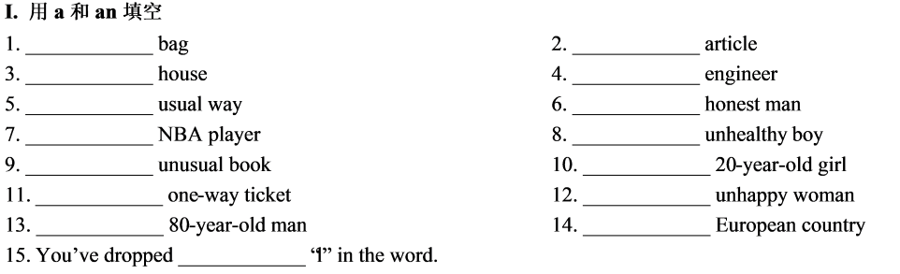
U2
一、必背单词变形
1．usually adv 通常地 usual adj.通常的 unusual adj.不寻常的；与众不同的
2．practice n.练习 practise v.练习；实践
3．one num.一；一个 once n.一次，一回
two num.二 twice n.两次
4．never adv.从未；决不 ever adv.在任何时候；曾经
5．junior adj.初级的；青少年的 senior adj.长辈的；高级的
6．different adj.不同的 difference n.差异；不同
7．ride v 骑；驾驶 rode—ridden
n.行程 a ten-minute ride 10分钟车程
8．ring v.发出铃声 rang—rung
9．break v.打破 broke—broken broken adj.打破的；打碎的
10．end n.结束；尽头v. 结束
at the end of 在……尽头
二、必背重点短语
1．daily life 日常生活
2．take a bath 洗澡
3．have a break 休息一下
4．lots of 许多
5．arrive at/in... 到达某地
6．help sb. with sth.帮助某人某事
7．go to sleep 入睡；睡着
8．ride a bicycle/bike 骑自行车
9．learn about了解
10．different places 不同地方
11．after-class activities课后活动
12．remember to do sth．记得去做某事
13．drink a glass of milk 喝一杯牛奶
14．once or twice a week 一周一次或两次
15．have classes 上课
16．cook dinner/supper 做晚餐
17．between...and... 在……与……之间
18．do morning exercises 做早操
19．compare...with... 把……与……比较
20．make great music 演奏动听的音乐
三、必背重点句子
1．My school is close to my home, so I always go to school on foot.
我的学校离我家很近，所以我总是步行去上学。
2．I enjoy learning about different places in the world.
我喜欢了解世界上不同的地方。
3．When the bell rings, I run to the playground with my best friends Tom and Jack.
当铃响的时候，我和我的好朋友汤姆和杰克跑去操场。
4．Lunch is from 11:50 a.m. to 12:30 p.m.
午餐从上午11:50到下午12:30。
5．Then Tom, Jack and I take part in the school band practice.
然后汤姆、杰克和我参加了学校的乐队排练。
6．She always arrives at school at 7:25 in the morning.
她总是在早上7：25到达学校。
7．After school, she plays volleyball with her students.
放学后，她和她的学生们打排球。
四、必背话题作文(介绍朋友日常生活)
Bill’s daily life
Bill is a student in Grade 7. He gets up at 6:30 a.m. every day. Then he brushes his teeth and washes his face. At 7:00 a. m., he has breakfast. He often eats an egg and some noodles.
Bill lives far away from his school, so he always goes to school by bike. He has classes from 8:00 a. m. to 4:30 p. m. He usually has seven classes a day.
After school, he often plays football with his friends. They play it twice a week. He goes home at 5:30 p.m.
Bill usually has supper at 6:30 p.m. He usually does his homework from 7 p.m. to 8 p.m. Sometimes he watches TV for a while after finishing his homework. At 9:30 p.m., he goes to bed.
U2练习
I am a junior high school student. I love _________(go) to school.
My school is close to my home, __________ I always go to school on foot. Classes start at 8 a.m., and I am seldom late. My favourite subject is Geography. I enjoy __________(learn) about different places in the world.
In the morning, we usually study Chinese, Maths and English. We have our morning break at 9:50 a. m. When the bell ________(ring）, I run to the playground with my best friends Tom and Jack. We often play games. Break ends at 10:10 a. m. __________short it is!
Lunch is from 11:50 a. m. _________12:30 p. m. Afternoon classes end at 3:30 p.m. Then Tom, Jack and I take part in the school band __________(practise). We make great music together.
I always have________ good time at school.
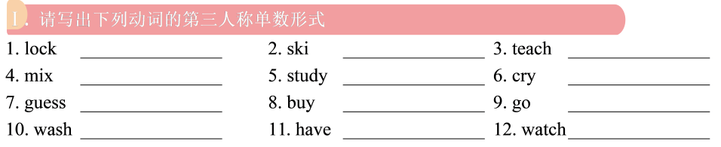
U3
一、必背单词变形
1．protect v.保护 protection n.保护
2．report v.／n.报告；报道 reporter n.记者
3．pollution n.污染 pollute v.污染 polluted adj.被污染的
4．energy n.能量；能源 energetic adj.精力充沛的
5．burn v.燃烧 burnt—burnt
burning adj.燃烧的；发热的 burnt adj.烧伤的；烧焦的
6．important adj.重要的 importance n.重要性 importantly adv.重要地
7．own adj.自己的 v.拥有 owner n.拥有者；主人
8．few—fewer—fewest 少(修饰可数名词)
little—less—least少(修饰不可数名词)
9．catch v.捕捉 caught 过去式
10．kill v.杀死 killer n.杀手
二、必背重点短语
1．protect...from... 保护……免于……
2．provide sth. for sb. 提供某物给某人
provide sb. with sth. 提供某人某物
3．throw away 扔掉
4．start to do/doing 开始做某事
5．start with 以……开始 end with 以……结束
6．at the start of=at the beginning of 在……的开始
7．of course = certainly 当然
8．one quarter/one fourth 四分之一
9．what else 别的什么事
10．a long time ago 很久以前
11．be covered by 被……所覆盖
12．for our future 为了我们的未来
13．make energy 获取能量
14．live on the land 生活在陆地上
15．stop doing sth. 停止正在做的事
stop to do sth. 停下来去做另一件事
16．fewer and fewer 越来越少(修饰可数名词)
17．shopping bags 购物袋
18．take a look at 看一下……
19．put...into...把……倒入……
=throw...into...
三、必背重点句子
1．About 70% of the Earth is covered by water.
大约70%的地球被水覆盖着。
2．The Earth provides us with air, water and food.
地球为我们提供空气、水和食物。
3．We put our rubbish into the sea and under the ground. This pollutes the Earth and kills animals and plants.
我们把我们的垃圾放入海洋和地下。这污染了地球，杀死了动植物。
4．It is important for us to protect the Earth for our future.
对我们来说，保护地球对我们的未来是很重要的。
5．We can ask people not to eat shark fin soup.
我们可以要求人们不要喝鱼翅汤。
6．We can take our own shopping bags to the supermarket.
我们可以带自己的购物袋去超市。
7．There are fewer and fewer fish in the sea each year.
每年海里的鱼越来越少。
四、必背话题作文(保护地球)
How to protect the Earth
The Earth is our home, and we should protect it. But people are doing something bad to the Earth.
First, people put waste water into the sea and the river. It makes the water become dirty. There are fewer and fewer fish in the sea. People burn things to make energy. This pollutes the air. Air pollution makes people become ill easily. Besides, people cut down many trees. It destroys the forest and the home of animals.
In order to protect the Earth, we must stop putting waste water into the river and burning things. We should plant more trees. What’s more, we must stop throwing away rubbish everywhere.

U3练习
_________ Earth is a beautiful place.
There are forests and rivers, mountains and fields. Some places are very hot, and some are very cold.
There are many different ________(plant). Some are large. Some are small. All plants need light_______ water. There are different animals in Earth too. Some live on the land. Some fly in the sky. Some live under the water.
There are also many people like you and me on Earth. The Earth provides us ________air, water and food. It is our home. Today, there________(be) a lot of pollution. We burn things _________(make)energy. This pollutes the air. We put our rubbish into the sea and under the ground. This __________(pollution) the Earth and kills animals and plants.
We must stop __________(do) these things. It is important for us_________(protect)the Earth
for our future.
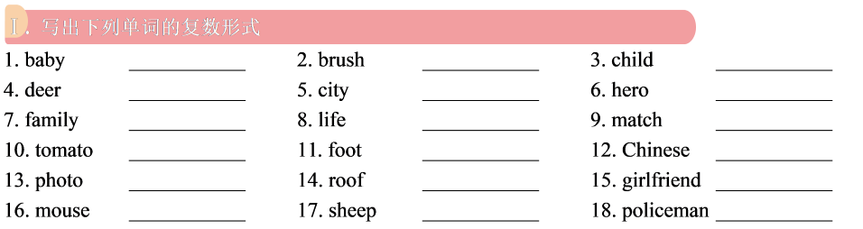
U4

一、必背单词变形
1．breath n.呼吸 breathe v.呼吸
2．Australia n.澳大利亚 Australian adj.澳大利亚(人)的 n.澳大利亚人
3．bright adj.明亮的 brightly adv.明亮地
4．snow n.／v.雪；下雪—snowy adj.下雪的
cloud n.云—cloudy adj.多云的
sand n.沙子—sandy adj.有沙子的
fog n.雾—foggy adj.有雾的
sun n. 太阳—sunny adj.晴朗的
ice n.冰—icy adj.结冰的
rain n.／v.雨；下雨—rainy adj.有雨的
wind n.风—windy adj.有风的
5．leaf n.叶子 leaves (leaf 的复数形式)叶子
6．gentle adj.温和的；文雅的 gently adv.轻轻地；温柔地
7．名词＋-1y，构成形容词
day—daily 每日的 love—lovely 可爱的
8．名词＋-y，构成形容词
fun n.乐趣—funny adj. 有趣的 noise n.噪音—noisy adj.吵闹的
luck n.幸运—lucky adj.幸运的 health n.健康—healthy adj.健康的
sleep n.睡觉—sleepy adj.欲睡的
9．名词＋-less，构成形容词，表否定，意为“没有……”
care n.小心 —careless adj.粗心的
hope n.希望—hopeless adj.无希望的
harm n.伤害—harmless adj.无害的
use n.用处—useless adj.无用的
home n.家—homeless adj.无家可归的
help n.帮助—helpless adj.无助的
10．shine v.照耀 shone(过去式)
shining(现在分词) shiny(形容词)
11．relative n.亲戚 relate v.使……有关联 relationship n.关系
二、必背重点短语
1．have/take/ go on a trip 去旅行
2．go on/go for a picnic 去野餐
3．use...to do/for doing sth. 用……做某事
4．have a lot of fun/ have a good time过得愉快
5．What／How about you？那么你呢？
6．at that time/moment在那时
7．knock on/at the door敲门
8．be made by 被……制成
9．spend time with sb． 与某人共度时光
10．at this time of year在每年的这个时候
11．on Monday morning 在周一早晨
12．during the Spring Festival 春节期间
13．in the north/south of 在……的北/南方
14．in March/April 在三/四月
15．an old umbrella 一把旧雨伞
16．the Mid-Autumn Festival中秋节17．the Dragon Boat Festival 端午节
18．play with toys 玩玩具
19．fly kites 放风筝
20．blow gently 轻轻地吹
三、必背重点句子
1．What is the weather like in spring?
春天的天气怎么样？
2．In spring, the weather starts to get warm. The wind blows gently. It’s exciting to take a trip.
在春天，天气开始变暖。风轻轻地吹着。去旅行是令人兴奋的。
3．It’s nice to go on a picnic at this time of year because the weather is cool and dry.
在一年的这个时候去野餐是很好的，因为天气凉爽干燥。
4．People usually spend time with their relatives during the Spring Festival.
春节期间，人们通常和他们的亲戚在一起。
5．In the north of China, it is very cold and very dry in winter.
在中国的北方，冬天非常寒冷和干燥。
6．It is comfortable to live there because summer is cool and winter is warm.
住在那里很舒服，因为夏天凉爽，冬天温暖。

四、必背话题作文(我最喜爱的季节)
My favourite season
Different people like different seasons. My favourite season is autumn.
In autumn, the weather is not too cold or too hot. Leaves turn yellow or red. It is interesting to see leaves falling from the trees. I like spending the weekend with my family and we always have a picnic and enjoy the autumn scenery in the mountains.
I really love the beautiful autumn and I always feel happy and relaxed in this season.
U4练习
In spring, the weather starts________(get) warm. The wind blows ______(gentle). It often rains. Plants start to grow. Everything________(turn) green. It is exciting________(take) a trip in spring.
The weather is hot in summer. The sun shines_________(bright). Many people like to go to the beach and swim in the sea. It is nice ________(eat) ice cream in the hot weather.
In autumn, everything changes. Leaves _______(turn)brown, red or yellow and start falling from the trees. It is nice_______(go) on a picnic at this time of year ________ the weather is
以上内容仅为本文档的试下载部分，为可阅读页数的一半内容。如要下载或阅读全文，请访问：https://d.book118.com/536035233204010031

