重庆市两江新区2023-2024学年七年级上学期期末英语试卷（解析版）
Ⅱ. 语法选择。 根据短文内容，从 A、B、C 三个选项中选出一个语法正确的答案，并把答题卡上对应题目的答案标号涂黑。
16．（10分）Hello，dear classmates!
Look at the old photo!The young woman（1） it is Qian Yuan.She is（2） English teacher.She is very great（3） her students like her very much.She（4） reading（读） books.Look!Some books（5） in the bookcase .
Qian Yuan's father is Qian Zhongshu.He is a writer（作家）.His book Fortress Besieged（《围城》） is very good.I want （6） it again（再次）.Her （7） name is Yang Jiang.She is a writer，（8） .And she is（9） favorite writer.This year，I read （10） books.They are all hers.
Do you think the family photo is great？
（1） | A.under | B.on | C.in
（2） | A.a | B.an | C.the
（3） | A.and | B.but | C.because
（4） | A.like | B.likes | C.doesn't like
（5） | A.are | B.am | C.is
（6） | A.read | B.reading | C.to read
（7） | A.mother | B.mothers | C.mother's
（8） | A.too | B.also | C.only
（9） | A.me | B.my | C.mine
（10） | A.thirteenth | B.third | C.three

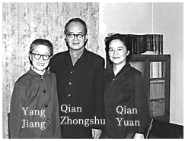
Ⅲ. 完形填空。（每小题1.5分， 共15分）根据短文内容，从A、B、C、D四个选项中选出一个能填入相应空格内的最佳答案，并把答题卡上对应题目的答案标号涂黑。
17．（15分）Frank is a student in Hongxing Middle School.He likes nice（1） But his parents don't have much money to （2） them for him.So he always goes to the（3） and look at the shoes.
One Sunday，Frank （4） to the shoe store again.He looks at his（5） shoes and he is not happy.His birthday is（6） Monday.He really wants to have a new pair of shoes for his birthday，but he knows that his parents can't buy them for him.
Frank doesn't go home because he doesn't want his（7） to see his unhappy face.He goes to the park near his home.He（8） a girl sitting in a wheelchair（轮椅）.Frank comes to the girl，and （9） has no feet（脚）!He looks at his feet and thinks，"It's much better（更好）
"Being（10） is one of the most important （重要） things for everyone "he says to his parents.
（1） | A.T﹣shirts | B.shoes | C.trousers | D.jackets
（2） | A.play | B.ask | C.find | D.buy
（3） | A.store | B.room | C.school | D.classroom
（4） | A.says | B.takes | C.sells | D.goes
（5） | A.new | B.cool | C.old | D.nice
（6） | A.in | B.on | C.at | D.for
（7） | A.classmates | B.parents | C.friends | D.teachers

（8） | A.looks | B.thinks | C.watches | D.sees
（9） | A.she | B.he | C.her | D.him
（10） | A.busy | B.free | C.happy | D.useful
IV. 阅读理解。阅读下列材料，从A、B、C、D 四个选项中选出最佳答案，并把答题卡上对应题目的答案标号涂黑。
18．（3分）Hello，I'm Alan.Here is a photo of my cousin，John Black.He is 13 years old
Today，he tells me a bad thing.He lost his bag this morning.His ID card，a blue pencil box and an English book are in it.Now he wants me to help him find it.So we write a notice：
Lost：
What：a blue and yellow bag
Where：in Classroom 8 E
Tel：023﹣7284896
E﹣mail：John Black@163.com
I must find it!Thank you!
John Black
（1）How old is John？
A.Eleven.
B.Twelve.
C.Thirteen.
D.Fourteen.
（2）What's in John's bag？
A.A black pencil box.
B.A yellow card.
C.A blue pen.
D.An English book.
（3）What's John's phone number？
A.023﹣7284689.
B.023﹣7284896 .
C.023﹣7288946 .
D.023﹣7268489 .
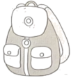

19．（8分）
NOTICE BOARD
School Trip  Our school trip is on Saturday March 16th..  In the morning，we go to the Science Museum（博物馆）.For lunch，we watch the basketball games.  Price：30 yuan  Meet in the school library at 8：00 a.m..  Don't be late.We come back to school at 5：40 p.m. | School Trip Update（更新）  Dear students，  I'm sorry that we can't go to the Science Museum next Saturday.But we can go to the History Museum and the tickets are free.So the price for the school trip is only 20 yuan.  Let's meet at 8：10.But the time to come back is the same.  We hope you can come to our school trip.
（1）Where do the students go on the school trip in the end？
A.The Science Museum.
B.The History Museum.
C.The Art Museum.
D.The Basketball Museum.
（2）How much is the school trip？
A.40 yuan.
B.30 yuan.
C.20 yuan.
D.10 yuan.
（3）What do the students do in the afternoon？
A.Watch the baseball games.
B.Watch the volleyball games.
C.Watch the basketball games.
D.Watch the football games.
（4）When do the students come back to school？
A.At 8：00 a.m..
B.At 8：10 p.m..
C.At 8：00 p.m..
D.At 5：40 p.m..
20．（8分）A young man wants to sell some apples in the town.He uses a horse to take the apples to the town.But he doesn't put the apples into the bags well.An old man looks at the apples and says，"If the horse runs slowly（慢），you can get there in 3 hours.If it runs fast （快），"How can that be？"So he makes his horse run fast，and the apples fall off（掉落）（捡起） the apples.
Then he goes on making the horse run fast.Some apples fall off again.He picks them up again and again.When he gets to the town，it is evening!No people buy his apples.He then knows the real meaning（意思） of the old man's words.

（1）What does the young man want to sell？
A.Some tomatoes.
B.Some pears.
C.Some carrots.
D.Some apples.
（2）When does the young man get to the town？
A.In the morning.
B.In the evening.
C.At 3：00 p.m..
D.At 6：00 a.m..
（3）What is the meaning of the old man's words in Chinese？
A.半途而废.
B.老马识途.
C.欲速则不达.
D.迷途知返.
（4）Where can we read this passage（文章）？
A.In a story book.
B.In an art book.
C.In a geography book.
D.In a music book.
21．（8分）①Colours are everywhere in our life.They have different meanings in different countries（国家）.Red is very important （重要的） in China.Chinese people think it is a color of good luck and happiness.So in China you can see many red things here and there.
②In the new year，Chinese parents always put some money in a red paper bag named hongbao.They give it to their children because they hope they can be healthy.People also write some good words on the red paper called chunlian as good wishes（愿望） for the new year.
③On birthdays，some Chinese people like wearing red clothes and eating red eggs.They hope they can be healthy and have a long life.
④For Chinese people，red is not just a name of the colour.In fact，it's a colour of Chinese spirit（精神）.

（1）In the new year，where do parents put the money？
A.In a red sock.
B.On red paper.
C.In a red paper bag.
D.In red clothes.
（2）What do Chinese people like eating on birthdays？
A.Red cakes.
B.Red eggs.
C.Red apples.
D.Red bread.
（3）What does the writer want to tell（告诉） us？
A.The colour of good luck.
B.The colour of happiness.
C.The meaning of hongbao in China.
D.The meaning of red in China.
（4）What's the structure （结构） of this passage？
A.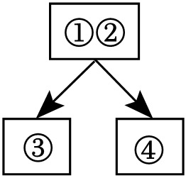
B.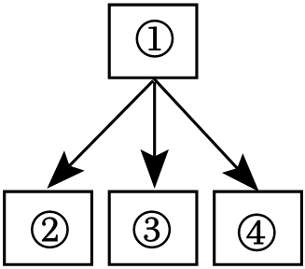
C.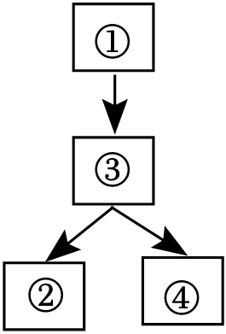
D.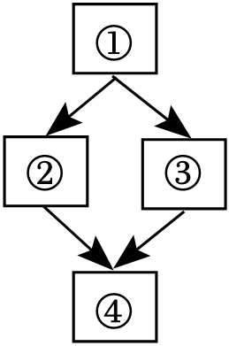
V. 口语应用。（每小题5分， 共5分）阅读下面对话，从方框内7 个选项中选择 5 个恰当的句子完成此对话，并把答题卡上对应题目的答案标号涂黑。
22．（5分）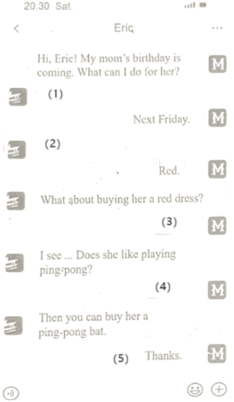

A.What's her favorite color？
B.No，she doesn't.
C.She doesn't like red.
D.When is her birthday？
E.But she has three red dresses.
F.That sounds good.
G.Yes，she does.
（1）
（2）
（3）
（4）
（5）
VI. 阅读信息归纳。（每小题2 分， 共10分）根据短文内容完成鱼骨图。每空一词，含缩略词。
23．（10分）Sam is my cousin.He likes eating lots of junk food （垃圾食品） every day.And he doesn't like sports.His mom thinks he is unhealthy.And she asks me for help.So I write a letter to him.
Dear Sam，
It's very important for us to be healthy.First，let me tell you how to eat well.You can eat some fruit every day，like bananas， "An apple a day keeps the doctor away." And you should have tomatoes and carrots often.That's because fruit and vegetables are good for your health.You can't always eat hamburgers or ice﹣cream.They can make you fat.Second，you can walk （散步）（遵循建议），you will be healthy very soon.Hope my letter can help you a lot.
Yours，
Frank
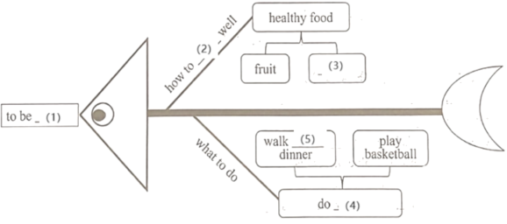

（1）
（2）
（3）
（4）
（5）
Ⅶ. 根据音标和句子，填写字母组合、音节或完整单词。 （每小题1分，共8分）
24．（1分） I like the_____ /waɪt/T﹣shirt.It's cool. ite
25．（1分） The red_____/'sweetə（r）/ is 15 dollars.sw ter
26．（1分） I have a good eating_____ /'hæbɪt/. bit
27．（1分） The art festival is in _____ /nəʊ 'vembə（r）/.No ber
28．（1分） My /'saɪəns/ teacher is Mr.Li.
29．（1分） There is a big /'laɪbrəri/ in my school.
30．（1分）Morning，morning，open the door.
Daughter，daughter，give me a /kɔ：1/.
31．（1分） A big black bug（虫子） bit（咬） a big black /dɔ：g/ on his big black nose.
VIII.完成句子。（ 共10分）根据所给提示，完成句子，75-78题，每空一词，含缩略词。
32．（2分） The art festival is on Thursday.（抄写句子）
33．（2分） They play volleyball at school.（改为否定句）
They volleyball at school
34．（2分） Those trousers are his.（改为一般疑问句）
trousers his？
35．（2分） My soccer ball is under the chair.（对划线部分提问）
is soccer ball？
36．（2分）我们有蓝色的短裙，只要10美元。
We have skirts for only 10 dollars
IX. 原文填空。（每空1分， 共4分）
37．（4分）Teacher：Hi，Anna.Are these your pencils？
Anna：No，they're Bob's.
Teacher：And is this his green（1） ？
Anna：No，it isn't.The blue pen is his.
Teacher：What（2） this dictionary？
Anna：It's Helen's.And the green pen is（3） ，too .
Teacher：And the eraser？Is that yours？
Anna：Yes，it is.
Teacher：Thank you for your help，Anna.
Anna：You're（4） .
X.改编课文填空。 （每空1分，共4分）
38．（4分）Kate and Gina are sisters.Kate is tidy，（1） Gina is not.In their room，Kate's books and tapes are in the bookcase.Her keys are in her schoolbag.She has a clock.（2） is on the desk Gina's books are（3） ﹣﹣on her bed，on the sofa and under the chair.Gina always（4） ，"Where are my keys？Where's my ruler？Where's my schoolbag？"
XI.短文填空， 写出完整单词。（每空1.5分， 共 12分）根据下面短文内容及部分首字母提示，在短文的空格处填上一个最恰当的词，使短文完整、通顺，并将完整的单词填写在答题卡对应的位置。
39．（12分）Hi，my name is Bill.I am a student in Grade 7.I want to tell you something about my school life.Our school begins （开始） at eight in the morning and （1） at five in the afternoon.We have some interesting （2）s ，Chinese，math，English，music and so on.I like P.E.best（3） it's very relaxing.Mr.Zhang is great fun.He plays basketball very（4） .He often helps （5） so we all like him very much.I have a good friend Jack，we are in the（6） class.I like playing ping pong（7） him after school.He likes Monday because we have history on that day.And he wants to be a（8） teacher.I like my school life，and I always have a good time in my school.
XII. 书面表达。（15分）
40．（15分）假设你所在的学校近期将开展Thank You Day（感谢日） 活动，请你依据下面的图片内容，介绍你最想感谢的一位老师。
要求：（1）词数 60 词左右，文章开头已给出；
（2）请先在开头句填入你所介绍的老师的称呼，如Mr.Liu，Miss Luo；
（3）可以适当增加细节，使行文连贯。
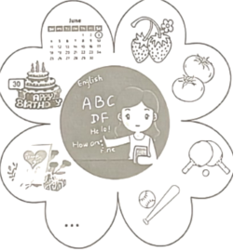

My Favorite Teacher
I want to thank my favorite teacher，___________
参考答案与试题解析
Ⅱ. 语法选择。 根据短文内容，从 A、B、C 三个选项中选出一个语法正确的答案，并把答题卡上对应题目的答案标号涂黑。
16．（10分）Hello，dear classmates!
Look at the old photo!The young woman（1） C it is Qian Yuan.She is（2） B English teacher.She is very great（3） A her students like her very much.She（4） B reading（读） books.Look!Some books（5） A in the bookcase .
Qian Yuan's father is Qian Zhongshu.He is a writer（作家）.His book Fortress Besieged（《围城》） is very good.I want （6） C it again（再次）.Her （7） C name is Yang Jiang.She is a writer，（8） A .And she is（9） B favorite writer.This year，I read （10） C books.They are all hers.
Do you think the family photo is great？
（1） | A.under | B.on | C.in
（2） | A.a | B.an | C.the
（3） | A.and | B.but | C.because
（4） | A.like | B.likes | C.doesn't like
（5） | A.are | B.am | C.is
（6） | A.read | B.reading | C.to read
（7） | A.mother | B.mothers | C.mother's
（8） | A.too | B.also | C.only
（9） | A.me | B.my | C.mine
（10） | A.thirteenth | B.third | C.three

【分析】短文主要写了一位英语老师钱媛和她的家庭。钱媛是一位受学生喜爱的英语老师，她喜欢阅读书籍。她的父亲是作家钱锺书，而母亲是作家杨绛。作者欣赏他们的作品，尤其是杨绛的作品。整个家庭都与文学有关。
【解答】（1）考查介词。句意：里面的年轻女子是钱媛；on在......上。根据上文Look the photo!）可知此处是指照片里面的女子，故选C。
（2）考查冠词。句意：她是一名英语老师；an用于以元音音素开头的单词前。根据English teacher，表示泛指，应用an。
（3）考查连词。句意：她很好。and和；because因为 is great.（她很好，前后句为并列关系。
（4）考查动词。句意：她喜欢读书，动词原形；doesn't like不喜欢。）可知她喜欢读书。
（5）考查be动词。句意：看。are复数形式；is单数形式，主语books为复数形式，应用are。
（6）考查不定式。句意：我想再读一遍，动词原形；to read不定式，表示"想要做某事"，故选C。
（7）考查名词所有格。句意：她妈妈的名字叫杨绛，单数名词；mother's妈妈的。根据name为名词，此处是指妈妈的名字，故选C。
（8）考查副词。句意：她也是一个作家，用于肯定句句末，用于肯定句句中。分析句子为肯定句，此处是指她也是一位作家，故选A。
（9）考查代词。句意：她是我最喜欢的作家，宾格，形容词性物主代词，名词性物主代词，表示"最喜欢的"，此处是指我最喜欢的作家，故选B。
（10）考查数词。句意：今年。thirteenth第十三；third第三；three三。根据空格后books，可知此处是指读了三本书，后加复数名词。
【点评】首先通读全文，了解文章大意，紧紧抓住上下文语境所提供的信息，然后明确词意，结合所学语法，运用排除法逐一选出答案，最后再通读全文核对答案。
以上内容仅为本文档的试下载部分，为可阅读页数的一半内容。如要下载或阅读全文，请访问：https://d.book118.com/557102100142006034

