题型17 图表作文

01 题型解读
02 答题模板构建
03 满分词汇模板
04 满分句型模板
05 满分作文模板
06 知识迁移强化


命题特点
图表作文一般是对某个具体问题的调查或统计，常常反映出一个普遍的问题。考生在描述内容时应过渡到普遍现象。
写作特点：需要介绍图表中见了什么，数据有什么变动，反映了哪些问题和趋势，并分析问题或数据背后的原因, 结合自己的看法谈谈解决措施或给出观点。
写作特点：1. 审读图表，提炼要点；
- 分析要点，确立主题；
- 灵活运用横向对比，即描述数据的变化；纵向说明，反映出问题。
- 谋篇成文，呈现亮点；


第一段 | 点明图表所反映的主题或引出话题，陈述图表主要信息。
第二段 | 分析图表展示内容的原因或进行评论，运用下表中逻辑关系词。

第三段 | 围绕主题展望未来或提出解决问题的方法、建议或希望等。

【满分词汇模板】

短语 | chart/graph/table图表； account for占比......  percentage百分比; stable稳定的；  rapidly迅速地； sharply急剧的；  dramatically戏剧性地； steadily稳定地；  slightly稍微地； increase增加；  decline下降； do harm to对......有害；  be of benefit to对......有益；
顺序 | First of all, Firstly/First; Secondly/Second，...； Finally， In the end, At last;
补充 | What’s more; Besides; Furthermore; In addition; Moreover; not only...but also... ; including;
转折 | However; on the contrary; but; although; in spite of; on the one hand..., on the other hand...; while;
因果 | Thus; so; as; because; therefore; as a result; as a consequence of; on account of;

【满分句型模板之开篇“风头”句】

- A survey on whether ...has been conducted recently, aiming to...
一项关于是否……最近进行的调查，目的是为了.......
- The chart provides data about...
该图表提供了关于......
- According to the charts, ...
根据图表显示，……
- The number of smokers decreased from 25% in 1976 to 21% in 2000.
吸烟者的人数从1976年的25%下降到2000年的21%
- As we can see from the graph above, great changes have taken place in...
正如我们从上面的图表中可以看到的，......
- Actually, some factors always stand out on top of others, if we take closer look into the
issue.
实际上，如果我们仔细研究这个问题，一些因素总是最突出的。
- Such phenomenon may be rooted in the following reasons.
这种现象可能源于以下原因。
- There is a phenomenon that...
有一种现象是......
- With the development of science and technology，...
随着科技的发展，......
- with the booming of the economy
随着人民生活水平的显著提高；
- As is clearly shown on the chart, the majority of the students surveyed...
从图表上可以清楚地显示出，大多数接受调查的学生。
- It can easily be seen that the percentage of A and B is respectively...and...
可以很容易地看出，A和B的百分比分别是……和……。
【满分句型模板之中间“猪肚”句】

- There are several reasons for...
有几个原因......。
- Due to the dramatic change in people’s notions, they realize benefits of doing part-time jobs.
由于人们观念的剧烈变化，他们意识到了做兼职的好处。
- It goes without saying that...
毋庸置疑......。
- Given the analyses above, it can be predicted that ...
根据以上的分析，我们可以预测......
- Only in this way can we solve this problem properly.
只有这样，我们才能适当地解决这个问题。
- However, those choosing reading English books and visiting English learning websites only account for 18% and 12%.
然而，那些选择阅读英语书籍和访问英语学习网站的人只占18%和12%。

【满分句型模板之结尾“豹尾”句】

1.The bar chart describes significant changes in the...
该柱形图描述了……的最重要的变化。
- From my perspective, ...
在我看来，......
- From where I stand...I hold the point of view that...
从我所处的位置。我持有这个观点......
- As far as I’m concerned, any way suits us best is a good choice.
就我而言，任何最适合我们的方式都是一个好的选择。

【满分作文模板】

As is shown in the chart, the percentage of A and B is respectively________%and________%. Another ________%________.(描述图表信息)
As we all know, ________do much harm to________, even causing people to ________. At the same time, ________.In addition, ___________（分析图表所反映现象带来的危害）How do we keep balance between ___________and____________？
As far as I’m concerned, I think we should_________. Do remember that_____________. (提出具体建议，以避免上述现象带来的危害)


1．你校在学生中开展调查，想了解学生对艺术鉴赏Art Appreciation这门课程是否感兴趣。请写一篇短文，给你校英文网站投稿，内容包括：
1. 描述图表(chart)；
2. 试分析产生该结果的原因；
3. 你的看法。
注意：
1. 写作词数应为80左右；
2. 请在答题卡的相应位置作答。
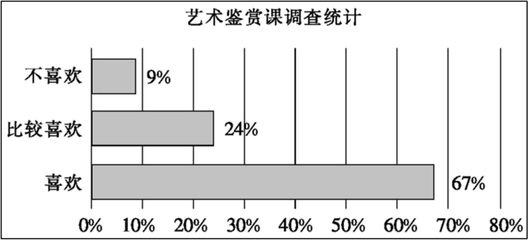
A survey on Art Appreciation
___________________________________________________________________________________________________________________________________________________________________________________________________________________________________________________________________________________________________________________________________________________________________________________________________________________________________________________________________________________________
【答案】
A survey on Art Appreciation
As is shown in the chart, 67.24 percent of the students fairly like it, while only 9 percent dislike it. It goes without saying that most students have fancy on Art Appreciation.
There are some reasons accounting for the result. For instance, it is the the multi-media approach to teaching that has made Art Appreciation classes more interesting, ranging from images to movies. What’s more, students are encouraged to engage in art exhibitions and artistic performances, which arouses their enthusiasm.
In my opinion, the result of the survey is a good beginning. Since art appreciation has played a vital role in our life, the importance of it can never be over-emphasized.
【导语】本篇书面表达属于应用文。要求考生给校英文网站投稿，就学生对艺术鉴Art Appreciation 这门课程是否感兴趣写一篇短文。
【详解】1.词汇积累
喜欢：like → be fond of
此外：what’s more → in addition
鼓励：encourage → inspire
重要性：importance → significance
2.句式拓展
简单句变复合句
原句：There are some reasons accounting for the result.
拓展句：There are some reasons which account for the result.
【点睛】【高分句型1】What’s more, students are encouraged to engage in art exhibitions and artistic performances, which arouses their enthusiasm. (运用了which引导的非限制性定语从句)
【高分句型2】Since art appreciation has played a vital role in our life, the importance of it can never be over-emphasized. (运用了since引导的原因状语从句)

2．学校英文报正在开展以“Gender information in UK educational institutions”为题的征文比赛。请使用下表中的信息写一篇短文投稿，内容包括：
1. 信息描述；
2. 小结规律。
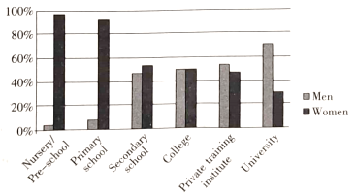
注意：
1. 写作词数应为80左右；
2. 请按如下格式在相应位置作答。
Gender information in UK educational institutions
The chart gives information about the gender of teachers in six types of educational institutions in the UK.
____________________________________________________________________________________________
__________________________________________________________________________________________________________________________________________________________________________________________________________________________________________________________________________________________________________________
【答案】
Gender information in UK educational institutions
The chart gives information about the gender of teachers in six types of educational institutions in the UK. It shows what percentage of teachers is male and what percentage is female.
Women dominate the teaching profession in nurseries or preschools, where the share of female teachers is above 90%, but less so at secondary education.
At college level this pattern is different, where there are nearly equal numbers of male and female teachers. On the other hand, male teachers outnumber female teachers at university level, where the proportion of men is twice that of women.
Overall, the higher the level of education, the more male teachers there are.
【导语】本篇书面表达属于应用文。要求考生以“Gender information in UK educational institutions”为题，使用表中的信息写一篇短文投稿参加学校的征文比赛。
【详解】1.词汇积累
种类：type→kind/sort
显示：show→reveal
不同的：different→of difference
总的来说：overall→on the whole
2.句式拓展
使用定语从句合并句子
原句：The chart gives information about the gender of teachers in six types of educational institutions in the UK. It shows what percentage of teachers is male and what percentage is female.
拓展句：The chart gives information about the gender of teachers in six types of educational institutions in the UK, which shows what percentage of teachers is male and what percentage is female.
【点睛】【高分句型1】It shows what percentage of teachers is male and what percentage is female.（运用了what引导的宾语从句）
【高分句型2】At college level this pattern is different, where there are nearly equal numbers of male and female
teachers.（运用了where引导的非限制性定语从句）

3．最近你校进行了一次健康调查。请你根据下图写一篇短文为英文报投稿， 内容包括：
1. 概述调查结果；
2. 简单分析原因；
3. 你的观点。
注意：1. 写作词数应为80左右；
2. 开头已给出， 不计入总词数。
How Often Meals Are Skipped (略过、不吃)
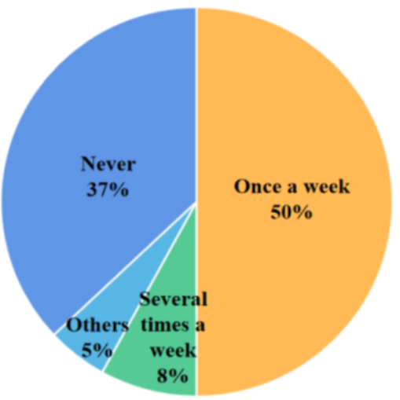
From the chart, we can see how often the students in our school skip their meals.
_______________________________________________________________________________________________________________________________________________________________________________________________________________________________________________________________________________________________________________________________________________________________________________________________________________________________________________________________________
【答案】
From the chart, we can see how often the students in our school skip their meals. What delights us is that 50% of the students surveyed only skip meals once a week and 37% never. But 8% skip meals several times a week. The remaining 5% give no definite answer.
What contributes to the result? Nowadays most students are aware of the importance of health, so they seldom or never skip meals. However, facing heavy study load, some students skip meals to save some time for study. Undoubtedly, there are a few students doing so to lose weight.
Personally, we shouldn’t skip meals. After all, health is a guarantee to make life better.
【导语】本篇书面表达属于图表作文。要求考生就学校组织的一次健康调查，写一篇短文为英文报投稿, 介绍调查结果，简单分析原因，并谈一下自己的观点。
【详解】1.词汇积累
肯定的：definite → certain
促成、导致：contribute to → lead to
意识到：be aware of → be conscious of
毫无疑问：undoubtedly→ without doubt
2.句式拓展
同义句转换
原句：Undoubtedly, there are a few students doing so to lose weight.
拓展句：There is no doubt that some students skip meals to lose weight.
【点睛】【高分句型1】What delights us is that 50% of the students surveyed only skip meals once a week and 37% never.（运用了what引导的主语从句，that引导的表语从句）
【高分句型2】However, facing heavy study load, some students skip meals to save some time for study.（运用了现在分词作状语，动词不定式作目的状语）

4．请阅读图表 Main difficulty experienced when learning a new language，结合个人英语学习经历，选取其中一个或两个方面，写一篇英语短文，谈谈你的困难以及你是如何战胜困难的。
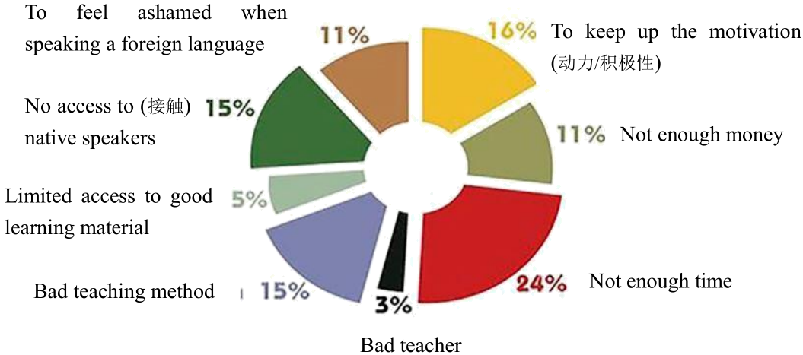
注意：
1.词数100左右；
2.不得透露任何与个人和学校相关的真实信息。
3.开头已给出，不计入总词数。
As the chart shows, people encounter various difficulties when learning a new language. As for me,…
___________________________________________________________________________________________________________________________________________________________________________________________________________________________________________________________________________________________________________________________________________________________________________________________________________________________________________________________________________________________
【答案】范例1：
As the chart shows, people encounter various difficulties when learning a new language. As for me, “no access to native speakers” required more efforts to deal with, since no foreign teachers were available in our school. In order to find native speakers to communicate with, I joined the English Corner in Shandong University (Weihai), where some foreign students hoped to learn Chinese. We taught each other not only when we gathered at the English Corner but also when we had time to talk via Wechat. What excited us was that we all made great progress in language learning and had a better understanding of another culture. (90)
范例2：
As the chart shows, people encounter various difficulties when learning a new language. As for me, always keeping up the motivation was a hard nut. Frequent failures and unexpected challenges always wore out my passion, throwing me into frustration and depression. To tackle it, I had my motto stuck where I can see it easily, reminding myself that they are ladders to success. Additionally, I gave myself a reward every time I picked up motivation and kept moving. By doing so, I have made progress not only in learning a new language but being a better self. (81)
【导语】本篇书面表达是图表作文。要求考生阅读图表 Main difficulty experienced when learning a new language，并结合个人英语学习经历，选取其中一个或两个方面，写一篇英语短文，谈谈遇到的困难以及是如何战胜困难的。
【详解】1. 词汇积累
艰难的：hard→ difficult
消磨：wear out→ wear down
沮丧：frustration→ upset
解决：tackle→ handle
2.句式拓展
以上内容仅为本文档的试下载部分，为可阅读页数的一半内容。如要下载或阅读全文，请访问：https://d.book118.com/587065000061006033

