
小学部：英语 年班： 四年级 任课教师：——
单元  课题 | 第三单元：My friends
单  元  总  目  录 | 第一课时: Part A Let’s learn & Let’s chant  第二课时: Part A Let’s talk & Let’s play  第三课时: Part A Let’s spell  第四课时: Part B Let’s learn & Say and draw  第五课时: Part B Let’s talk & Let’s play  第六课时: Part B Read and write & Let’s check & Story time
单  元  总  目  标 | 知识与能力目标:  句型  · 能够听、说、认读句型“—What’s his name? —His name is Zhang Peng.”“He’s tall and strong.”“Who’s he?”“He has glasses and his shoes are blue.”  ·能够在情景中运用句型“—What’s his/her name?—His/ Her name is…”“—Who’s he/ she?—He/ She is…”询问他人的姓名或身份并做出回答  ·能够在情景中运用句型“He’s/ She’s…”“He/ She has…”描述人物的性格或外貌特征  ·能够按照意群朗读“He has short hair. He has a big green bag. What is his name?”等四组句子  词汇  ·能够听、说、认读单词“strong, friendly, quiet, hair, shoe,

glasses”
·能够正确使用上述单词描述人物的性格或外貌特征
·能够在有意义的语境中抄写上述话题词汇
语音
·能够掌握o-e的发音规则，即o-e在单词中发长音/əʊ/
·能够读出符合o-e发音规则的单词，并能根据发音拼写出符合o-e发音规则的单词
情感态度､文化意识､学习策略目标:
·能够了解外貌描述中的文化禁忌，如：不要对同学长得胖或戴眼镜等有歧视性语言
·能够根据o-e的发音规则拼读单词，并能够根据o与o-e的发音规则拼写单词
重点  难点 | 本单元学习的主题是向他人介绍自己的好朋友，对好友的性格和外貌特征进行描述。教学内容主要是通过展示学生们介绍好友的情景来展开的。教学重点是能够听、说、认读核心句型“—What’s his name? —His name is Zhang Peng.”“He’s tall and strong.”“Who’s he?”“He has glasses and his shoes are blue.”；能够听、说、认读单词“strong, friendly, quiet, hair, shoe, glasses”。

课题 | - Part A Let’s learn &let’s chant
课时  目标 | Let’s learn:  ·能够听、说、认读单词“tall, strong, short, thin, friendly, quiet”。  ·能够在情景中熟练运用句型“He’s/ She’s…”介绍人物的性格和外貌特征。  ·能够运用句型“Who is he/ she?”询问他人的姓名，并能回答。  Let’s chant:  ·能够通过有节奏的说唱强化单词的音义联系，并增加课堂的趣味性。  ·能理解歌谣中对人物外貌和性格特征的描述，并能创编新的歌谣描述自己的朋友。
重点  难点 | 1. 能够在情景中熟练运用句型“He’s…”介绍人物的性格和外貌特征。  2. 能够掌握单词“friendly, quiet”的发音。
教学  准备 | PPT课件､课文录音、视频、单词卡片等。
教学过程 |  | 分析与总结

Step 1: Warm-up & Revision & Lead-in  1. Greetings.  2. Revision.^{①}  (1) Point to a boy and ask his name in rhyme. Ask students to answer in rhyme, too.  T:（Clap hands.）What’s his name? What’s his name?  Ss: His name is… His name is…  T: What’s her name? What’s her name?（Clap hands and point to a girl.）  Ss: Her name is… Her name is…  (2) Play a game—“I say, you do”. (课件出示：一段有节奏的背景音乐)  T: Boys and girls, now I say, you do. Make yourself tall.  Ss: Tall, tall, tall. (Students stand up and say while they do it.)  T: Make yourself short. / Make your arms long. / Make your eyes big. /…  Ss: Short, short, short! / Long, long, long! / Big, big, big! /…  3. Watch and act.^{②}  Play the video of “Let’s talk”. (课件出示：教材P24 Let’s talk板块的视频) Let students watch it and act out the dialogue in pairs.  4. Lead-in.  T: John has a good friend. I have a good friend, too. Do you want to know what his/ her name is?  Step 2: Presentation  1. Learn the sentences.  T: I have a good friend in our class. He is a boy. He’s tall and strong. He’s in Group 4. Guess! What’s his name?  Describe the appearance of a student in the class simply. If other students can’t guess who he is, lead them to ask, “What’s his name?”  T: You can also ask me, “Who is he?”  Write down the sentences “What’s his name?” “Who is he?” on the blackboard.  2. Let’s learn.^{③}  （1）Learn the words “tall, strong, short, thin”.  Ask a student to come to the front of the classroom and introduce him as a good friend.  Then invite another student who is completely different from the boy before. Ask other students to observe their differences in figure. Lead in the words “tall, strong, short, thin”.  Show the word cards in turn. Teach these words. Ask students to read after the teacher. | Teaching purpose^{②}  Teaching purpose^{②}  通过对上一节课内容的角色扮演，复习旧知识，为导入新课做好准备。  通过呈现生活中的教室来创设情境，引出本课的主题。  Teaching purpose^{③}  教师播放录音，学生听录音跟读，训练其认真倾听且在倾听过程中获取重要信息的能力。让学生跟读，以掌握单词的正确读音。

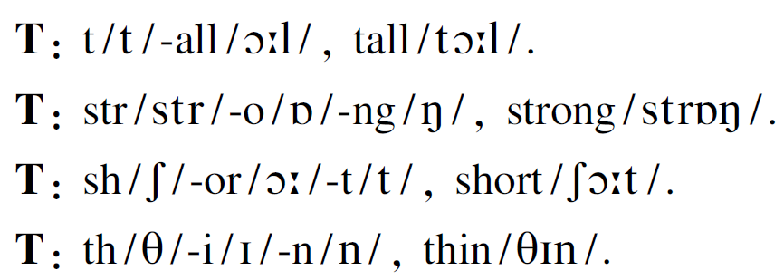
Let students point to the classmates and use the sentence structure “He’s/ She’s…” to describe others.
（2）Learn the phrases “tall and strong, short and thin”.
Point to the tall and strong boy on the podium. Lead students to say the sentences “He’s tall.” and “He’s strong.”
Then the teacher says “He’s tall and strong.” Ask students to read the sentence after the teacher.
Practice the sentence “He’s short and thin.” in the same way.
(3) Learn the word “quiet”.
The teacher makes a gesture with the index finger to keep students quiet and says the sentence “Be quiet!” Then show the word card “quiet” and read it, qu/kw/-i/aɪ/-e/ə/-t/t/, quiet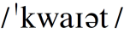. Then paste the card onto the blackboard. Help students understand the meaning of the word “quiet”. Lead students to use the word “quiet” to make sentences in the real situations.
(4) Learn the word “friendly”.
Show pictures of some activities on the PPT and ask, “Who is friendly?”
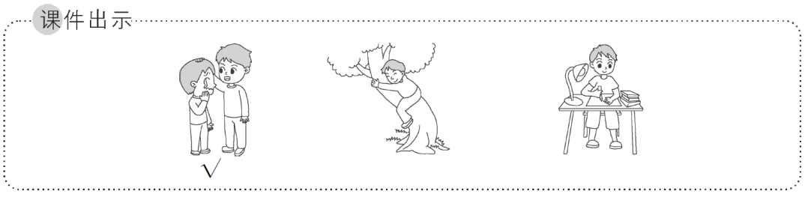
Teaching purpose^{④}
三组活动不断升级，将新词的词义、词形及读音相统一，保证学生能够正确认读单词。这些活动会不断地重复操练新词的读音，这有助于他们熟练地掌握单词。
Explain the exact meaning of the word “friendly” through the movement or the expression.
(5) Play and watch.
Play the video of “Let’s learn” on the PPT.（课件出示：教材P25 Let’s learn板块的视频）Let students watch it.
Play it again. Ask students to imitate after it and read the words and the sentences over and over again.
The teacher describes John with the sentences “I have a good friend. He’s short and thin.”
Lead boys to ask, “Who is he?” Lead girls to guess who he is and use the sentence “His name is John.” to answer.
Ask students to choose a person from the pictures of this section and practice the dialogue in pairs. Then let students act it out.

Step 3: Practice^{④}
1. I point, you say.
Show the words at random on the PPT. (出示课件) Ask students to say out the words quickly.
T: I will point to the words one by one on the PPT. Please say out the words quickly. Let’s go! What’s this?
Ss: …
Teaching purpose^{⑤}
通过观察人物的特征，选择正确的词汇来形容他们，帮助学生正确理解并使用新学的词汇。
2. I say, you do.
The teacher speaks the words and asks students to perform corresponding actions.
T: This time, I say, you do. When I say the word “tall”, please do like this.（Raise the arms up.）When I say the word “short”, please do

like this.（Put the arms down.）When I say the word “strong”, please do like this.（Raise the fists up.）And this is for “thin”. (Put the hands on the both sides of cheeks.) Are you ready? Let’s play.
3. I do, you say.
T: Now let’s exchange. I do, you say.
4. Let’s chant.^{⑤}
Show the pictures of Lily and Tim in the chant on the PPT. (课件出示：教材P25 Let’s chant板块中的人物图片) Help students describe Lily and Tim with the words they have learned and the sentence structure “He/She is…”
Play the chant separately.（出示课件）Let students read the chant after the recording.

Step 4: Consolidation & Extension
1. Make a competition.
Let students chant in different ways to make a competition. Remind students to do some actions while they’re chanting.
2. Create a new chant.^{⑥}
Encourage students to replace the adjectives in the chant according to the true situations of friends. Create a new chant and perform it in class.
Homework :
1. Copy the words learned in this lesson five times in four lines and three grids.
2. Draw your parents and describe them in English.
3. Do the exercises.（做同步练习册相应练习题）

Blackboard design:
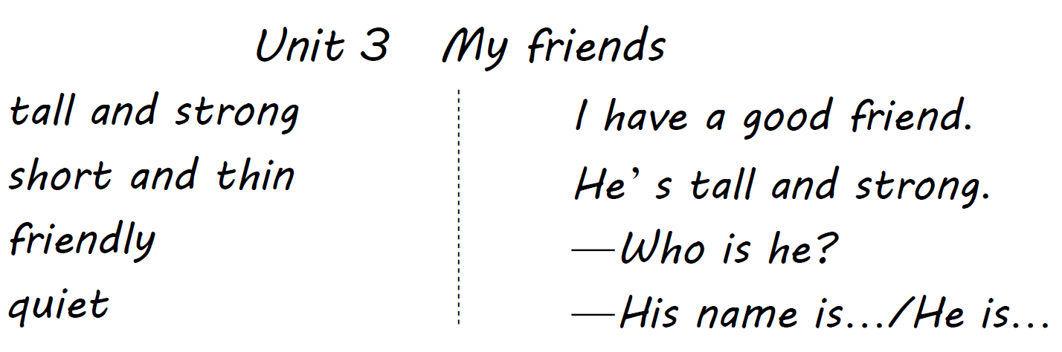

教学反思：
1. 在韵句中，复习上一课的句型，极大地激发了学生的学习兴趣。
2. “我指你说”“我说你做”等一连串的活动贯穿授新和操练过程，尽可能地让学生的多种感官参与到此学习过程中来，大大提高了学习效率。
3. 学习单词的目的就是能把单词灵活地运用到句子中去，使表达更加完整，同时把单词运用到句子中也能巩固所学的单词，两者之间相辅相成，相互促进。

课题 | 第二课时 Part A Let’s talk & Let’s play
课时  目标 | Let's talk：  ·能够在图片、PPT和教师的帮助下理解对话大意  ·能够用正确的语音、语调朗读对话，并能够在小组中进行角色扮演  ·能够在情景中运用句型“—What’s his/ her name? —His/ Her name is...”询问他人姓名并能够回答；能够在情景中运用句型“He’s/She’s...”“He/ She has…”描述人物的性格和外貌特征

·能够在语境中借助图片等理解新词“friendly, strong, his”的意思，并能够正确发音。
Let's play：
·通过观察Let’s play板块的图片，能够依照语言示范简单描述人物的外貌特征。
·能够进一步巩固对核心句型“He’s/She’s...”“—What’s his/her name? —His/ Her name is...”的理解与运用。
重点  难点 | 重点：1. 能够在情景中运用句型“—What’s his/ her name? —His/ Her name is…”询问他人姓名并能够回答。  - 能够在情景中运用句型“He’s/ She’s…”“He/ She has…”描述他人的性格和外貌特征。  难点：1. 能够在情景中灵活运用核心句型询问他人姓名并回答。  2. 能够熟练描述他人的性格和外貌特征。  3. 能够正确读出“Chinese, his”的尾音。
教学  准备 | PPT课件､PPT课件、卡片、一块幕布
教学过程 |  | 分析与总结

Step 1: Warm-up & Lead-in^{①}
1. Greetings.
T: Good afternoon, boys and girls. Today let’s be good friends, OK?
Ss: OK.
The teacher shakes hands with a student and says, “Friends, friends, good friends.” Then students shake hands with each other and say what the teacher says.
Ss: Friends, friends, good friends.
T: Now, tell me, “Who is your good friend?”
S1: He/ She is…
S2: …
2. Let’s do.
Show the chant on the PPT. Play the music and chant with students. （出示课件）
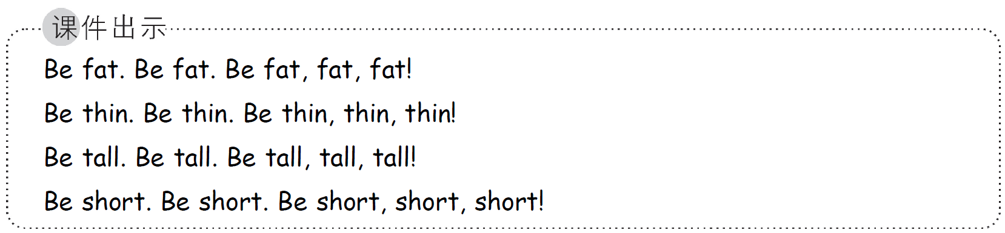
3. Play a guessing game.
Pull up a curtain. Ask some students to hide behind the curtain and put their arms or legs out of the curtain in turn. Point to one of them and let the other students guess who he/ she is.
T: Who’s he/ she?
Ss: He/ She is…

Step 2: Presentation^{②}
1. Learn the new sentences.^{③}
(1) The teacher makes a self-introduction with the sentence “My name’s…” and asks a boy.
T: What’s your name?
Boy: My name is…
After the boy answers the question, the teacher introduces the boy.
T: His name is… He is…
(2) The teacher asks students, “What’s his name?”
(3) The teacher inspires other students to answer the question and writes down the sentence structure “His name is…” on the blackboard.
Ask students to pay attention to the ending sound of the word “his/hɪz/”.
(4) The teacher points to other boys one by one and lets students do more exercises to master the language points.
T: What’s his name?

Ss: His name is…
(5) The teacher points to a girl and says, “She’s… Her name is…”
Then the teacher asks students, “What’s her name?”.
Let students try to answer the question. Write down the sentence structure “Her name is…” on the blackboard.
Ask students to pay attention to the ending sound of the word “her/hə (r)/”.
The teacher points to another girl and asks, “What’s her name?”

Let students ask and answer in pairs with the sentence structures “—What’s her name? —Her name is…”
2. Practice the new sentences.
（1）Show fuzzy pictures of the two people on the PPT. (课件出示：学生熟悉的两个人的模糊图片，这两个人分别是男人和女人或者男孩和女孩)
T: Look! He’s/ She’s my new friend.
Let students guess the names of the two people.
Lead students to ask the question “What’s his/her name?” Show clear pictures of the two people and reveal the names.（出示课件） Write down the sentence “What’s his/ her name?” on the blackboard. And emphasize the distinction between “his” and “her”.
（2）Show some students’ pictures collected in advance on the PPT. (出示课件)^{④}
T: Look! I have some pictures. Look at this picture. Who can tell me his/her name?
Lead students to use the sentence structure “His/ Her name is…” to answer.
Ss: His/ Her name is…
T: Is he/ she tall/ short?
Ss: Yes.
T: Is he/ she thin?
Ss: No, he/ she is…
Do the action to show “strong”. Then write down the word “strong” and teach it.
T: str/str/-o/ɒ/-ng/ŋ/, strong/strɒŋ/.
T: He’s/ She’s tall and strong/short and thin. And he/she is friendly.
Write down the word “friendly” on the blackboard. Mark “-ly” with red chalk. Teach the word.
T: friend/frend/-ly/li/, friendly.
Ask students to read it and pronounce it correctly.
Introduce the etiquette of appearance description: Replace “fat” with “strong”.
T: We usually don’t say he/ she is fat, but he/ she is strong.

3. Let’s talk.^{⑤}
（1）Show a picture of John on the PPT. (出示课件)
T: What’s his name?
Ss: His name is John.
Show a picture of John’s mum on the PPT. (出示课件)
T: She is John’s mother. What are they talking about?
Ss: … （Guess.）
T: They are talking about John’s new friend. Who is he/she?
（2）Show the questions one by one on the PPT.
①Does John have a Chinese friend?
T: We are all Chinese, because we are all from China.
Point to the Chinese flag on the wall to help students understand the word “Chinese”.
Then teach the word “Chinese”.
T: Ch/tʃ/-i/aɪ/-nese/ni:z/, Chinese.
②What’s John’s friend’s name?
③Is John’s friend tall and strong?
（3）Play the video of “Let’s talk” on the PPT. Let students watch the video with questions. （课件出示：教材P24 Let’s talk板块的视频）
Ask students to underline the sentences about the answers in their books and answer the questions in class. Then check the answers together.
4. Listen, read and act.^{⑥}
(1) Let students listen to the recording and read after it.（出示课件）
(2) Lead students to act out the dialogue in pairs.
Step 3: Practice^{⑦}
1. Let’s play.
Show the picture of “Let’s play” on the PPT. (出示课件)
T: We have four new friends today. Can you introduce them to me?
Ss: His name is… He’s…/ Her name is… She’s…
T: Good. Now let me describe them, and you say out the names. She’s tall and thin. What’s her name?
Ss: Her name is Lucy.
T: Where is she?
Ss: …
T: Yes, there she is. (Do the action to point at Lucy on the screen.)
Let students quickly name the characters according to the teacher’s description. Finally point to the character and say the sentence “Oh, there she/ he is.”
Then lead students to ask and answer in pairs. One describes and asks, the other answers.
2. Play a game—“Find a friend.”
Divide students into groups of four. Let each student write down a

classmate’s name on the card. The back of the card is facing up. Let a student in each group pick a card randomly and describe the student on
the card one by one. The rest of the group guess who the student is according to the description.
Make a model:
A: My friend is a boy. He’s thin. He has short hair. He likes maths. Who’s he?
B & C & D: His name is…

Step 4: Consolidation & Extension^{⑧}
Play a game—“Draw my friend.”
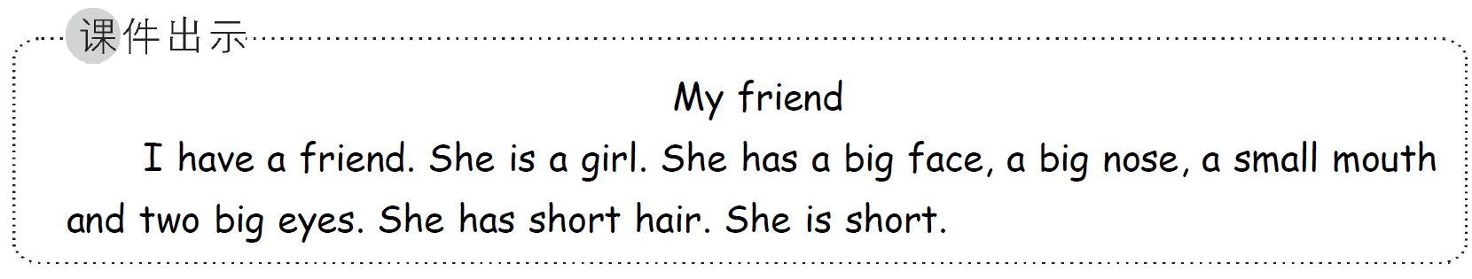
Present a passage on the PPT. Lead students to read the passage. Then ask students to draw a portrait on the blackboard one by one. Each one draws a brushstroke to complete the portrait.

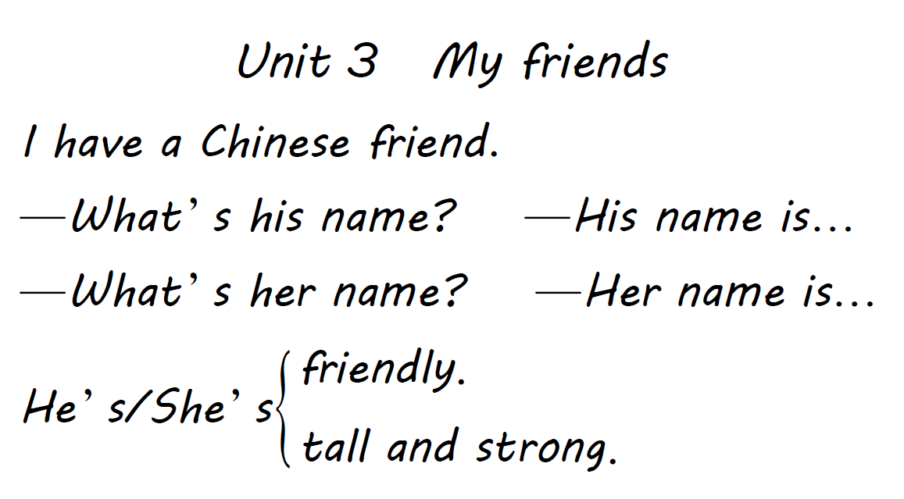
Homework:

1. Practice the dialogue.
2. Introduce the friend to parents with the key sentence structures.
3. Do the exercises.（完成同步相应练习题）

教学反思：
1. 本课时主要学习描述他人的性格和外貌特征。课程开始，通过复习和巩固句型“My name is…”导入新词“his, her”并稍加练习，学生能很快地掌握句型“What’s his/ her name?”并用句型“His/ Her name is…”进行作答。
2. 活动设计丰富，易操作，且具备层次感，有效地提升了学生的核心素养。
3. 猜人和绘画活动活跃了课堂氛围，调动了学生的学习积极性，加强了师生交流。活动既有合作又有竞争，取得了不错的教学效果。

课题 | 第三课时 Let’s spell
课时  目标 | ·能够感知并归纳o-e在单词中的发音规则  ·能够读出符合o-e发音规则的单词  ·能够根据单词的读音拼写出符合o-e发音规则的单词
重点  难点 | 重点：  1. 能够感知并归纳o-e在单词中的发音规则。  2. 能够读出符合o-e发音规则的单词。  难点：  能够根据单词的读音拼写出符合o-e发音规则的单词。
教学  准备 | PPT课件、语音例词单词卡等。

教学过程 | 分析与总结

Step 1: Warm-up & Lead-in^{①}
1. Enjoy a song.
Play the song—Friends. Ask students to sing after the recording. （出示课件）
2. Let’s chant.
Play the chant for “i-e” in Unit 2 on the PPT. Get students to chant together. （课件出示：教材P16 Let’s spell板块中Read, listen and chant部分的chant内容）
Play the chant for short sound of “o” on the PPT. Get students to chant together. （课件出示：PEP三下教材P40 Let’s spell板块中Listen，repeat and chant部分的chant内容）

Step 2: Presentation
1. Read the words.^{②}
T: Today, we have a new friend. Look!
Show the picture of Mr Jones on the PPT.（课件出示：教材P26 Mr Jones的图片）Lead in the words of this section.
T: Who is he?
Ss: He is Mr Jones.
T: Yes, he is Mr Jones. “j” sounds /dʒ/, “o-e” sounds /əʊ/, “n” sounds /n/, “s” sounds /z/. Read after me.
Ss: …
Write down “Mr Jones” on the blackboard.
T: (Point at Mr Jones’ nose.) What’s this?
Ss: It is Mr Jones’ nose.
T: Yes, it’s his nose, nose, nose. n/n/-o/əʊ/-s/z/. Write down the word “nose” on the blackboard.
T: Touch your nose, please.

Let students do the action.
Show another picture on the PPT.

以上内容仅为本文档的试下载部分，为可阅读页数的一半内容。如要下载或阅读全文，请访问：https://d.book118.com/595304241341011033

