长春外国语学校2023-2024学年第二学期
期初测试初三年级英语试卷
本试卷由两部分组成，六道大题，97道小题，共6页。全卷满分120分。考试时间为100分钟。考试结束后，将答题卡交回。
注意事项：
1. 答题前，考生先将自己的姓名、准考证号填写清楚，将条形码准确粘贴在考生信息条形码粘贴区。
2. 选择题必须使用2B铅笔填涂；非选择题必须使用0.5毫米黑色字迹的签字笔书写，字体工整、笔迹清楚。
3. 请按照题号顺序在各题目的答题区域内作答，超出答题区域书写的答案无效；在草稿纸、试题卷上答题无效。
4. 作图可先使用铅笔画出，确定后必须用黑色字迹的签字笔描黑。
5. 保持卡面清洁，不要折叠，不要弄破、弄皱，不准使用涂改液、修正带、刮纸刀。
听力部分（共25分）
Ⅰ. 听句子，选择正确的答语, 每题读两遍。(5分)
1. A. Pretty good. B. It’s a pleasure. C. Sorry to hear that.
2. A. Yes, I do. B. I like it very much. C. I like music that I can dance to.
3. A. You can't miss it. B. Don't ask me. C. It's on Green Street.
4. A. Yes, I'd love to. B. No, please don't. C. Help yourself.
5. A. I’ll clean the city. B. That’s a good idea. C. It’ll be expensive.
Ⅱ. 听简短对话和对话后的问题，选择正确答案，每题读两遍。(5分)
6. A. No, she doesn't. B. Yes, she does. C. I don't know.
7. A. The restaurant. B. The post office. C. The restroom.
8. A. Seven twenty. B. Seven thirty. C. Seven forty.
9. A. Take math lessons. B. Play basketball. C. Go to the library.
10. A. Because they are tall. B. Because they are funny. C. Because they are young.
Ⅲ. 听描述，选出与其相符的图片。其中有一幅图片是多余的，每题读两遍。(5分)
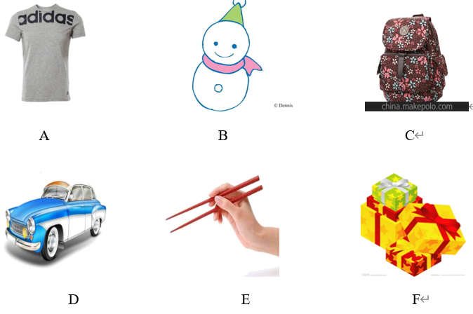
11.________ 12._________ 13.__________ 14.________ 15._________
Ⅳ. 听较长对话，选择最佳答案。每段对话读两遍。(5分)
听第一段对话，回答16-17题。
16. What will the speakers do this evening?
A. Tell stories. B. See a movie. C. Meet a famous director.
17. When will the speakers meet?
A. At 6:00. B. At 6:30. C. At 8:00.
听第二段对话，回答18-20题。
18. The girl is going to buy a present for her uncle because _________.
A. he is leaving B. he is ill C. he is back
19. The girl doesn’t want to buy a watch because _________.
A. it’s expensive B. it’s too big C. her uncle has got one
20. The girl decides to buy _________at last.
A some books. B. an electric dictionary C. a tie.
V. 听短文，根据所听到的内容选择正确答案。短文读两遍。（5分）
21. What did the writer use to like?
A. Vegetables. B. Junk food. C. Ice cream.
22. What did the writer order in KFC?
A. Fries and hamburgers. B. Fries and iced cola. C. Pies and iced cola.
23. What's wrong with him after the meal?
A. He had a stomachache. B. He had a fever. C. A and B.
24. Who took the writer to the hospital?
A. His mother. B. His father. C. His parents.
25 What does the writer think of junk food?
A. Healthy. B. Unhealthy. C. Expensive.
笔试部分（共95分）
一、基础知识（共15分）
I.单项选择。（15分）
1. Diana is ________ energetic girl. She always gives her power to the people around her.
A. a B. an C. the D. /
【答案】B
【解析】
句意：戴安娜是一个精力充沛的女孩。她总是把她的力量给她周围的人。
考查冠词。此处泛指“一个精力充沛的女孩”，energetic以元音音素开头，其前用an。故选B。
2. —I think we should care ________ the disabled people.
—Yes, and it can make a great difference ________ our society.
A. about; up B. for; to C. with; to D. of; in
【答案】B
【解析】
句意：——我认为我们应该关心残疾人。——是的，它可以对我们的社会产生很大的影响。
考查固定搭配。care for照料，关心；make a great difference to“对……有很大的影响”。故选B。
3. It’s believed that everyone must get a good education ________ get a good job in the future.
A. in order to B. so that C. as soon as D. as long as
【答案】A
【解析】
句意：人们相信每个人都必须接受良好的教育才能在未来找到一份好工作。
考查短语辨析。in order to为了；so that以便；as soon as一……就；as long as只要。“在未来找到一份好工作”是目的，空后是动词短语，用in order to。故选A。
4. __ of the two boys likes watching soap operas. They think they are meaningless.
A. Neither B. Both C. None D. All
【答案】A
【解析】
句意：这两个男孩都不喜欢看肥皂剧，他们认为他们是没有意义的。Neither两者都不；Both两者凑；None三者以上都不；All三者以上都。根据句中of the two boys可知，这里提到的是两个男孩，再根据句意They think they are meaningless可知，这里表示否定的意思，故应选A。
5. I’m used to _________ in the house which _________ to keep books and magazines.
Aliving; uses B. live; was used C. live; used D. living; was used
【答案】D
【解析】
句意：我已经习惯了住在过去用来放书和杂志的房子里。
考查非谓语动词及被动语态。be used to doing sth.“习惯做某事”；be used to do sth.“被用来做某事”。第一空表示“习惯了住在”这个房子里；which引导定语从句，先行词the house与动词use之间是动宾关系，第二空用一般过去时的被动语态was used。故选D。
6. The movie reminds me of the days _________ I spent with my classmates in primary school.
A. who B. what C. which D. where
【答案】C
【解析】
句意：这部电影让我想起了在小学与同学度过的日子。
考查关系词辨析。who指人，在定语从句中作主语和宾语；what不能引导定语从句；which指物，在定语从句中作主语或宾语；where指地点，在定语从句中作状语。句中先行词the days指物，关系词在定语从句中作宾语，应用which引导，故选C。
7. —There is thick haze in our city this spring. What do you think of it?
—I think _________ cars we drive, _________ pollution our city will have.
A. the fewer; the fewer B. the fewer; the less
C. the more; the fewer D. the more; the less
【答案】B
【解析】
句意：——今年春天我们城市有厚厚的雾霾。你觉得怎么样？——我认为我们开的车越少，我们城市的污染就越少。
考查比较级。“the+比较级 ..., the+比较级 ...”表示“越……就越……”，结合常识可知越少开车污染就越少，修饰cars用the fewer，修饰pollution用the less。故选B。
8. —What were you and your parents talking about?
—They wondered_________.
A. why did I stay up late last night B. what I have done
C. when the school would start D. how could I finish my work
【答案】C
【解析】
句意：——你和你父母在谈论什么？——他们想知道学校什么时候开学。
考查宾语从句。根据空前的“They wondered”可知，此处是宾语从句，宾语从句应用陈述句语序，排除A，D选项；主句是一般过去时，宾语从句要用过去的某种时态，排除B。故选C。
9. --My cousin is ill in hospital.
-- Sorry to hear that. Let’s go and __.
Aput up him B. cheer up him
C. put him up D. cheer him up
【答案】D
【解析】
句意：-我的表哥生病住院了。-听到那个我很伤心，让我们去使他振作起来吧。put up 张贴，搭建，跟代词做宾语的时候，代词应位于中间；cheer sb. up使某人振作起来，代词应放在中间。根据对话的意思My cousin is ill in hospital可知，这里应表达的意思是“使他振作起来”，故应选D。
10. —Excuse me, sir, smoking _______ in the gas station.
—Oh, I’m awfully sorry.
A. doesn’t allow B. is allowed C. aren’t allowed D. isn’t allowed
【答案】D
【解析】
句意：——打扰一下，先生，加油站不允许吸烟。——哦，非常抱歉。
考查被动语态。分析句子可知，主语和动词allow之间是被动关系，应用被动语态：be done。主语是动名词，be用is。结合语境可知，加油站不允许吸烟。故选D。
11. Parents should their children a good environment.
A. offer; / B. offer; with
C. provide; with D. both A and C
【答案】D
【解析】
句意：父母应该给孩子提供一个好的环境。
考查动词短语。根据语意可知，父母应该给孩子提供一个好的环境。offer sb sth和provide sb with sth皆意为
“提供给某人某物”。故选D。
12. —Mr. Li has taught ________ English for over 3 years.
—You are lucky. He is a very nice teacher.
A. our B. us C. we D. ours
【答案】B
【解析】
句意：——Mr. Li教我们英语已经三年多了。——你很幸运。他是一位非常好的老师。
考查代词辨析。our我们的，形容词性物主代词；us我们，人称代词宾格；we我们，人称代词主格；ours我们的，名词性物主代词。teach sb. sth.“教某人某物”，此处作宾语用代词宾格us。故选B。
13. — The plane won’t take off ________ the thick clouds move away.
— Let’s wait patiently for the announcement from the airport.
A. since B. though C. while D. until
【答案】D
【解析】
句意：——直到乌云散去，飞机才会起飞。——让我们耐心地等待机场的广播。
考查连词辨析。since自从；though虽然；while当……时；until直到。此处表示“直到乌云散去，飞机才会起飞”，应用not...until...结构，意为“直到……才”。故选D。
14. ________ the instructions before using the machine and you’ll know how to use it.
A. Reading B. Read C. To read D. Reads
【答案】B
【解析】
句意：使用机器前先阅读说明书，你就会知道怎么用了。
考查祈使句。空前没有主语，此句是“祈使句+and+陈述句”句型，祈使句用动词原形开头。故选B。
15. —Mom, can we have a pet at home?
—_________. Our house is too small.
A. Why not B. I hope so C. I’m afraid not D. Anything else
【答案】C
【解析】
句意：——妈妈，我们能在家里养宠物吗？——恐怕不行。我们的房子太小了。
考查情景交际。Why not为什么不；I hope so我希望如此；I’m afraid not恐怕不行；Anything else还有别的事吗。根据“Our house is too small.”可知房子太小，恐怕不能养宠物。故选C。
二、交际运用（共5分）
根据对话内容，用下面所给句子补全对话。选项中有一项是多余的。
John: Hi, Mary, what’s up?
Mary: ____16____
John: What will you do with it?
Mary: ____17____
John: Don’t throw away electronic waste. It’s dangerous to the environment.
Mary: You mean I should keep these useless things at home?
John: Not really. But do you know useless mobile phones are harmful to the earth?
Mary: Oh, I see. ____18____
John: Why don’t you sell the phone, and it can be recycled then.
Mary: That’s a great idea. ____19____
John: You can go to the second-hand market.
Mary: ____20____
John: Of course. Let’s go!
A. Where can I sell the phone?
B. So what do you think I should do then?
C. I will do that. Would you like to go with me?
D. It’s good to the earth.
E. I will throw it away.
F. My mobile phone is broken. I don’t need it anymore.
【答案】16. F17. E18. B19. A20. C
【解析】
【导语】本文是一则对话，对话的主要内容谈论Mary的坏手机应如何处理的问题。
【16题】
根据“Hi, Mary, what’s up?”可知，此处是回答发生的事情，选项F“我的手机坏了。我不再需要它了。”符合语境。故选F。
【17题】
根据“What will you do with it?”及“Don’t throw away electronic waste.”可知，此处是回答要扔掉坏了的手机，选项E“我会把它扔了。”符合语境。故选E。
【18题】
根据“Why don’t you sell the phone, and it can be recycled then.”可知，此处是问怎么做，选项B“那你觉得我该怎么做？”符合语境。故选B。
【19题】
根据“You can go to the second-hand market.”可知，此处是问地点，选项A“我在哪里可以卖手机？”符合语境。故选A。
【20题】
根据“Of course. Let’s go!”可知，此处是问对方可以一起去吗，选项C“我会的。你愿意和我一起去吗？”符合语境。故选C。
三、阅读（共45分）
III. 完形填空。（15分）
阅读短文，掌握其大意，然后从每小题所给的四个选项中选出一个最佳答案。
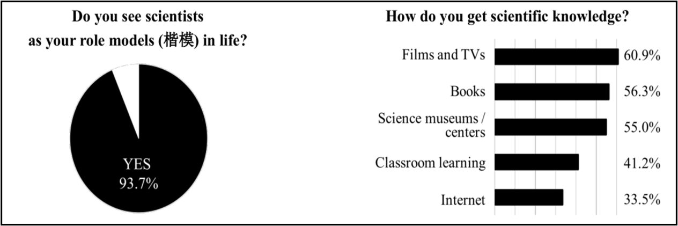
My family often had a get-together with friends in my childhood. As I was smart, there was always _____21_____who would come up to mention my cleverness, and ask what I was going to do when I grow up.
It started with being a teacher or a hero. ____22____it was a fireman, an artist... But as I grew older, my dreams of the future _____23_____. When I was going to college, my relatives and friends asked me again what I would major in. They wanted to ____24____what I would be when I grew up.
But then I made up my mind to become a computer programmer. So I was studying software for much of my life. I strongly believed as long as I _____25_____myself with knowledge, I could achieve my dream. Finally, I am _____26_____that I could realize my dream. The realization of my life purpose ____27____me to help others to succeed in their own lives.
However, for many, there is a “thief” which goes around stealing our _____28_____and robbing us of the power to achieve our goals. Sometimes, the thief will come as a parent, a relative, _____29_____ a friend. But the greatest thief is just ourselves.
Usually when we are about to ____30____the goal, a small voice inside will say, “You will never succeed.”
“Very few have ever done this _____31_____.” And on and on the small voice makes us ____32____heart and fail.
____33____, failure may help our dreams to come true. It is one of the most important ____34____we have, because it teaches us valuable lessons. And when we learn these lessons well, we are ____35____ for success.
There are no “overnight” successes, but with perseverance, they will come. So just don’t give up. Let dreams stay in your life.
21.
A. anybody B. somebody C. nobody D. everybody
22.
A. Later B. Before C. Recently D. Now
23.
A. changed B. remained C. fell D. disappeared
24.
A. work out B. try out C. take out D. find out
25.
A. hurt B. stopped C. armed D. introduced
26.
A. happy B. angry C. worried D. painful
27.
A. advises B. encourages C. invites D. warns
28.
A. heads B. police C. dreams D. money
29.
A. but B. so C. and D. or
30.
A. divide B. regret C. reach D. forget
31.
A. unluckily B. carelessly C. successfully D. politely
32.
A. lose B. break C. take D. give
33.
A. Again B. However C. Firstly D. Already
34.
A. purposes B. habits C. tools D. decisions
35.
A. ready B. late C. sorry D. famous
【答案】21. B22. A23. A24. D25. C26. A27. B28. C29. D30. C31. C32. A33. B34. C35. A
【解析】
【导语】本文主要讲述了作者实现梦想的过程，并告诉我们，失败可以帮助我们实现梦想，要坚持不懈，梦想才会实现。
【21题】
句意：因为我很聪明，总有人会上来夸奖我的聪明，问我长大后打算做什么。
anybody任何人；somebody某人；nobody没有人；everybody每个人。根据“who would come up to mention my cleverness, and ask what I was going to do when I grow up.”可知，应说总有人来夸奖作者，这里泛指的某个人。故选B。
【22题】
句意：后来是消防员，艺术家……
Later后来；Before在……之前；Recently最近；Now现在。根据“It started with being a teacher or a hero.”可知，应说后来是想做什么。故选A。
【23题】
句意：但随着年龄的增长，我对未来的梦想改变了。
changed改变；remained保持；fell跌倒；disappeared消失。根据“But as I grew older, my dreams of the future”可知，应说随着年龄的增长，对未来的梦想改变了。故选A。
【24题】
句意：他们想知道我长大后会成为什么样的人。
work out算出；try out参加选拔；take out拿出；find out查明。根据“what I would be when I grew up.”可知，应说想知道作者长大后成为什么样的人，其他选项与语境不符。故选D。
【25题】
句意：我坚信只要我用知识武装自己，我就能实现我的梦想。
hurt伤害；stopped停止；armed武装； introduced介绍。根据“myself with knowledge,”可知，应说用知识武装自己。故选C。
【26题】
句意：最后，我很高兴我能实现我的梦想。
以上内容仅为本文档的试下载部分，为可阅读页数的一半内容。如要下载或阅读全文，请访问：https://d.book118.com/595321032341011123

