题型18 图画作文

01 题型解读
02 答题模板构建
03 满分词汇模板
04 满分句型模板
05 满分作文模板
06 知识迁移强化

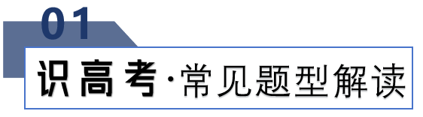
命题特点
图画作文也称看图作文。是高考英语书面表达常见的考查类型之一，也是最能体现考生语言水平的一种写作模式。
命题特点：1.话题弘扬正确的价值观，体现中华优秀传统文化。
- 材料贴近中学生的生活实际，充满时代气息。
- 培养学生的逻辑思维能力和创新能力。
4.要点突出，细节清晰。
时态与人称：这种文体通常用第三人称，时态以一般现在时为主。
写作类型：看图叙事、看图说理。
写作步骤：1. 审题定文体、人称和时态。整体把握图画，明确题目要求。
- 归纳要点、扩充句子，描述细节内容。
- 添加关联词和过渡句，连句成文。

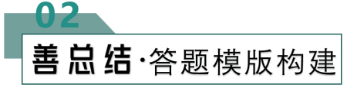

第一段 | 语言精炼、开门见山，简介何时何人经历的事件。
第二段 | 运用多种句式，和过渡词，按照时间或事件的发展顺序分层次展开要点。
第三段 | 归纳总结，有感而发，写出得到的体会或看法。

【满分词汇模板】

短语 | be interested in...对......感兴趣； take an active part in...积极参加......  be crazy about...痴迷于......； be good at擅长于......；  be poor at...某方面薄弱； be weak in...某方面薄弱；  succeed in...成功做某事； get 95 marks for...在考试中获得95分；  get an“A”in the exam考生得优； enjoy doing sth喜欢做某事；  enjoy a family trip to.享受全家旅游； go swimming/camping去游泳/露营；  have dancing lessons上舞蹈课； go for a picnic去野餐；  go for an outing去远足； have a party举办一场晚会；  hold a sports meeting举办一场运动会； spend one’s time in .........度过时间；

【满分句型模板之开篇“风头”句】

- Last Saturday, We invited a craftsman to show us how to make dough figurines.
上周六，我们邀请了一位工匠教我们如何制作面团小雕像。
- Last Friday, the English was going on when suddenly our teacher, Miss Liu slippered and fell off the stage.
上星期五，英语课始了，突然我们的老师刘老师从讲台台上摔了下来。
- It can be seen from the pictures that ice in Arctic is disappearing fast and...
从图片上可以看出，北极的冰正在迅速消失。
- As is depicted in the picture, a young man, reluctant to teach...
正如图中所描述的那样，一个年轻人，不愿教.....
- As is shown in the pictures, some students helped clean up the rubbish on the ground to beautify our surroundings, while others warmly showed the way to the children who lost their way.
如图所示，一些学生帮助清理地上的垃圾，美化我们周围的环境，而另一些学生则热情地给迷路的孩子们指路。

【满分句型模板之中间“猪肚”句】

- After the new teacher came into the classroom, we gave him warm welcome.
在新老师进入教室之后，我们热烈地欢迎他。
- Impressed by what we did, we had photos taken with the craftsman.
我们所做的一切给我们留下了深刻的印象，我们和工匠拍了照片。
- Meanwhile, two boys offered timely help.
与此同时，两个男孩及时提供了帮助。
- At the beginning of the party, our monitor made a short speech.
聚会一开始，班长做了一个简短的发言。

【满分句型模板之结尾“豹尾”句】

- What a meaningful day!
多么有意义的一天啊！
- Only from this experience did I realize that it was a pleasure as well as our duty to inherit our cultural treasures.
只有从这次经历中，我才意识到，继承我们的文化宝藏既是一种快乐，也是我们的责任。
- It was a meaningful day for all of us because we had done a good deed.
这对我们所有人来说都是有意义的一天，因为我们已经做了一件好事。
- Never shall I forget the race.我
将永远不会忘记那次比赛。
- Today is an unforgettable day for me, for it is the first time that I have taken part in our school sports meeting and I have got the first place.
今天对我来说是难忘的一天，因为这是我第一次参加校运会并且取得了第一名。
- Since then I have been keeping the lesson in mind: To be polite to everyone.
从那以后，我一直铭记着这个教训：礼貌对待每个人。
- Personally, everyone should and can do something like turning off electric.
就我个人而言，每个人都应该也可以做一些事情，比如关掉电动设备.

【满分作文模板】

As is vividly shown in the picture,___.(描述图画内容)The picture/cartoon informs us of the phenomenon that________________.(图画反映的现象) These may/might be several factors contributing to/responsible for the phenomenon/problem.
To start with,________________. Secondly,________________.What's more,________________. Last but not least,________________.(说明原因) In my opinion, the government/the school/we should take measures to/something must be done to________________.（应对措施）
Only in this way can the problem be really solved. / Only when everyone can do so will our world become more and more beautiful.(解决问题的方法)

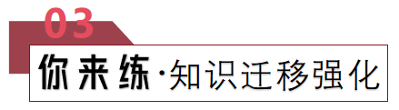
- （2023·内蒙古赤峰·高三赤峰二中校考阶段练习）
请观察下图两幅漫画，完成一篇作文。
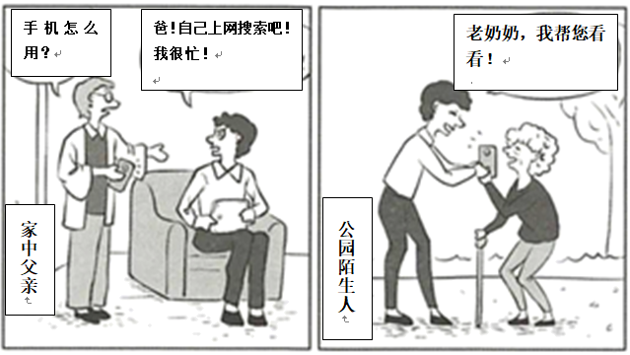
1. 描述漫画内容；
2. 解读漫画含义；
3. 表述你的观点。
注意： 1. 词数 100 左右；
2. 可以适当增加细节，以使行文连贯。
_______________________________________________________________________________________________________________________________________________________________________________________________________________________________________________________________________________________________________________________________________________________________________________________________________________________________________________________________________
【答案】
As is depicted in the picture, a young man, reluctant to teach his father to use the cell phone, is very warm-hearted to help an old lady he meets in the park. The purpose of this cartoon is to reveal an alarming fact that people may be generous to others only for the sake of social image.
Love, responsibility, and social image are the three primary motivations for people to help others. Helping strangers in public enables people to establish a favorable social image.( and provides them with excellent self-satisfaction and a sense of pride.) While we should not deny its importance in building positive social connections, this motivation is indeed not that selfless in nature. Taking care of one’s parents, on the other hand, is an action out of love and responsibility, which requires people to put aside their own benefits.( and be entirely devoted to others.)
In conclusion, being kind to one’s parents is a selfless deed without material or reputational reward. Therefore, it can always serve as a criterion for individuals to judge others and, more importantly, reflect on their own behaviors.
【导语】本篇书面表达属于图画作文。要求考生描述漫画内容、解读漫画含义并表述自己的观点。
【详解】1.词汇积累
遇见：meet→encounter
目的：purpose→aim
建立：establish→build
照顾：take care of→look after
2.句式拓展
简单句变复合句
原句：Love, responsibility, and social image are the three primary motivations for people to help others.
拓展句：There are three primary motivations for people to help others, which are love, responsibility, and social image.
【点睛】【高分句型1】The purpose of this cartoon is to reveal an alarming fact that people may be generous to others only for the sake of social image.（运用了that引导的同位语从句）
【高分句型2】While we should not deny its importance in building positive social connections, this motivation is indeed not that selfless in nature.（运用了while引导的让步状语从句）
【高分句型3】Taking care of one’s parents, on the other hand, is an action out of love and responsibility, which requires people to put aside their own benefits.( and be entirely devoted to others.)（运用了which引导的非限制性定语从句）

- （2023·广东佛山·高三佛山市顺德区均安中学校考阶段练习）
假设你是李华，请按照下列几幅图画提示写一篇英文日记，叙述自己某一天的尴尬遭遇。
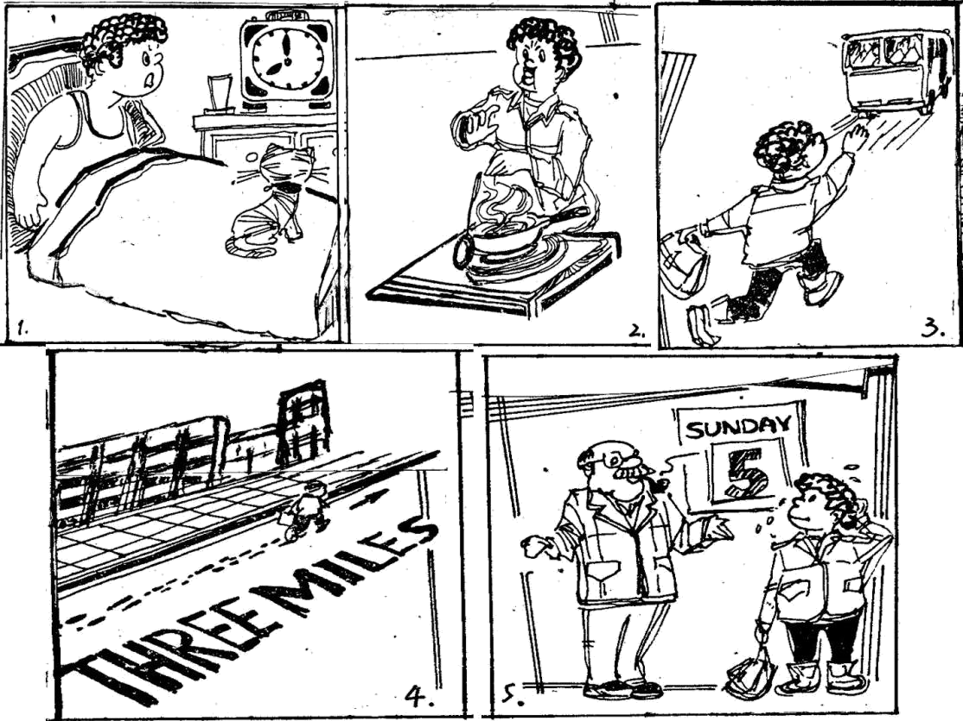
注意：(1)词数：80词左右;
(2)内容连贯，语句通顺。
________________________________________________________________________________________________________________________________________________________________________________________________________________________________________________________________________________________________________________________________________________________________________________________________________________________________________________________________________
【答案】
May 18th cloudy
In the morning, my alarm clock didn’t ring so I woke up an hour late. I was in such a hurry that I burnt my hand when I was cooking breakfast. Then I ran out of the house to catch the 8:30 bus, but of course I missed it. I was very unhappy because I knew my teacher got angry if anyone was late for class. So I ran three miles to the school. But when I arrived there in the end, I found that it was Sunday.
【导语】本篇书面表达属于应用文。要求考生就给出的图片写一篇英文日记，描述自己一天的尴尬遭遇。
【详解】1.词汇积累
烧伤我的手：burn my hand→have my hand burned
不开心的：unhappy → displeased,
到达：arrive→reach/get
最后：in the end→ eventually/finally
2.句式拓展
简单句变复合句
原句：So I ran three miles to the school.
拓展句：So I ran three miles to the school, which made me greatly exhausted.
【点睛】【高分句型1】I was in such a hurry that I burnt my hand when I was cooking breakfast. （运用了such...that引导的结果状语从句）
【高分句型2】 I was very unhappy because I knew my teacher got angry if anyone was late for class. （运用了if引导的条件状语从句）

- （2023·陕西西安·陕西师大附中校考二模）
假设你是光明中学高三（1）班的学生李华，今天学校组织了消防演习。请根据以下四幅图的先后顺序，写一篇英语日记，叙述整个演习过程，并谈谈自己的感想。
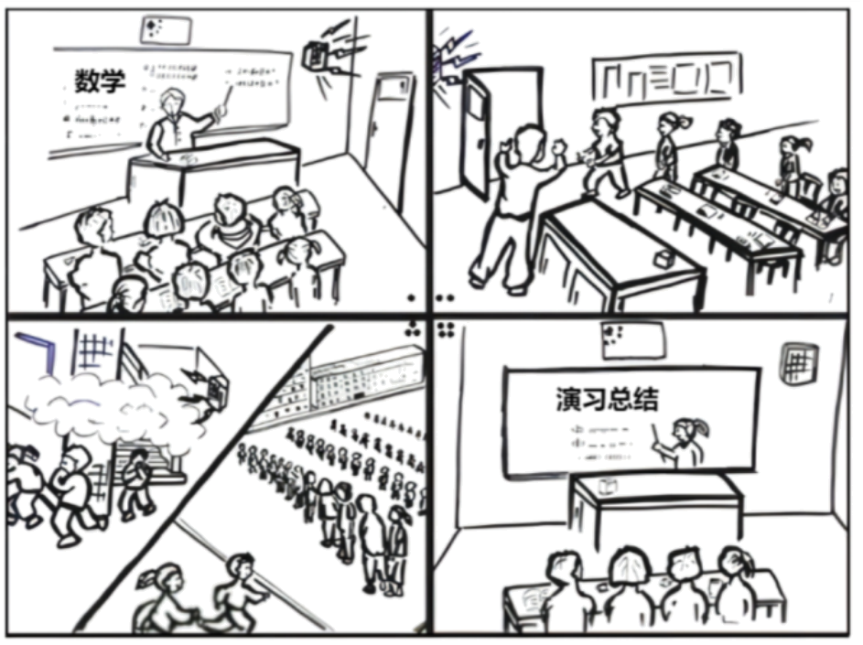
注意：（1）日记的开头已为你写好；
（2）词数100词左右；
（3）可适当增加细节，以使行文连贯。
This morning, our school held a fire drill.
____________________________________________________________________________________________________________________________________________________________________________________________________________________________________________________________________________________
_______________________________________________________________
【答案】
This morning, our school held a fire drill.
We were listening to the teacher attentively in the math class when we heard the fire alarm from the speaker on the wall. The teacher stopped teaching immediately and instructed us to exit the classroom in order. When we got into the passageway, we found we were surrounded by smoke everywhere. It was choking and our tears ran down. We students bent down, covered our mouth with handkerchiefs, and ran downstairs rapidly into the open on the playground, just as we had been taught before.
When we came back to our classroom, we students gave a summary of this fire drill. I think fire disasters are often seen on TV and read about in the newspaper. We should know the skill to escape from a fire in case of emergency.
【导语】本篇书面表达是一篇记叙文，要求考生写一篇英语日记，叙述整个消防演练过程，并谈谈自己的感想。
【详解】1.词汇积累
立刻：immediately→instantly
指导：instruct→guide
经常：often→frequently
应该：should→be supposed to
2.句式拓展
简单句变复合句
原句：It was choking and our tears ran down.
拓展句：It was choking, which made our tears run down.
【点睛】[高分句型1]
We were listening to the teacher attentively in the math class when we heard the fire alarm from the speaker on the wall. (运用了固定句型)
[高分句型2]
When we got into the passageway, we found we were surrounded by smoke everywhere. (运用了when引导时间状语从句和省略了that的宾语从句)

4.（2023·新疆·统考一模）
请根据图片内容和要求用英语写一篇短文。
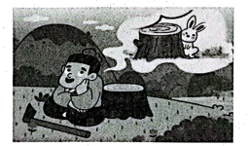
内容要求：
1. 描述画面（守株待兔）；
2. 概述其寓意；
3. 谈谈个人感想。
注意：
1. 词数100左右；
2. 可以适当增加细节, 以使行文连贯。
参考词汇： stump 树桩
______________________________________________________________________________________________________________________________________________________________________________________________________________________________________________________________________________________________________________________________________________________________________________________________________________________________________________________________________
【答案】
In the picture, a man is staying by a stump waiting for hares to come and dash themselves against it.
Legend has it that a farmer was one day working in the fields when he saw a hare bump into a stump accidentally and break its neck. From then on, he gave up farming and simply sat by the stump waiting for more hares to come and run into it. However, there is no such thing as something for nothing. It’s also foolish of those who don’t work through their own efforts, but still want to be rewarded.
We should not wait for unexpected gains by trusting chance and luck. It’s hard work that pays off.
【导语】本篇书面表达属于图画作文。要求考生根据图片内容和要求用英语写一篇短文。
【详解】1.词汇积累
意外地：accidentally→by chance
以上内容仅为本文档的试下载部分，为可阅读页数的一半内容。如要下载或阅读全文，请访问：https://d.book118.com/608057010053006030

