2015---2016 学年第一学期

二年级英语教案

教学计划：

从学习者的角度来讲，基础教育最重要的任务是学会学习。发展学习策略，培养学生学习能力，是素质教育的重要组成部分。教师要用生动简单，通俗易懂的方式把学习策略介绍给不同年龄段的孩子， 逐渐培养开发他们的自主学习能力，养成良好的学习习惯。
一、 教学目的

激发学生学习英语的积极态度，使他们建立初步的学习英语的自信心，培养学生一定的语感和良好的的语音语调，并初步打下良好的英语基础，培养良好学习习惯，培养他们初步用英语进行简单日常交际的能力。同时，注重培养学生的观察、记忆、想象和创造能力。
二、 教学内容目标听、做：
1、能根据听到的词语，识别或指认图片或实物。
2、能听懂课堂指令并做相互相应的反应。
3、能根据指令做事情，如：画图、涂色、做动作、做手工等。
4、能在图片和动作的提示下听懂小故事，并作出反应。说、唱：
1、能听录音并进行模仿
2、能根据图片或实物说出单词。
3、能根据表演猜意思，说词语。
4、能根据表演情况要求说出最基本的话语。玩、演

1、能在教师的指导下，用英语做游戏，在游戏过程中，能根据 情景需要，用简单的英语进行交流。
2、能表演歌谣和歌曲
3、能根据故事情节进行角色表演。
力求使教学面向全体学生，为学生提供自主学习和相互交流的机会，以及充分表现和自我发展的空间，鼓励学生通过体验、实践、讨论、合作等方式，发展语言技能。

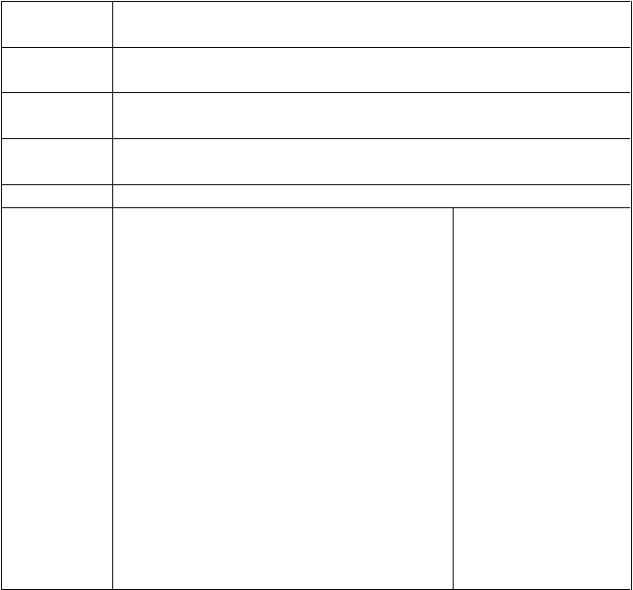
Teaching contents
Teaching

aims Teaching
points

Teaching materials
period

Teaching Procedure
Unit1 My Family Lesson 1
To learn the new words and new sentences.

New words. Sentence patterns.

Flash cards, tape and recorder. Students cards.
Lesson 1
- warm-up Teaching
  - Daily oral practice characteristics:
T: Good morning ! Ss: good morning! 2.Review the words.
T: Show me the pencil (ruler, book…) Ss: Listen and do.
II.Presentation Step1.Part A
- T: Present the flash cards: “What’s this?”
Teach Ss to read the new words.
- Ask little teacher to lead Ss read the new words.
- T: Say, Ss point and read after me. T point, Ss look and say.
- Divide them into six groups.(grandpa, grandma,brother, sister, mom, dad)or S1

Teaching Reflection
say, team listen and tap.

T: Present the word cards, team read and tap.
- T: Write the chant on the blackboard, teach then to read.
- Play the tape, listen and chant. Step2: PartB
- Ss: Look and read the sentences: I have a happy family.
- T：teach them to read, Study the words:
me.
- Point and read.
- T and Ss: ask and answer. Listen to the tape, read after it. Teaching characteristics:
1、
2、
3、

Improve link: 1、
2、
3

教学反思：


Teaching contents

Teaching
aims Teaching

points
Teaching materials

period
Unit1 My Family Lesson 2
To learn the new words and new sentences.

New words. Sentence patterns.

Flash cards, tape and recorder. Students cards.
Lesson 1


  - warm-up
    - Daily oral practice T: How are you?
Ss: Fine, thank tyou! 2.Review the words. T: Who is he/she?
Ss: Listen and answer. II.Presentation Step1.Part A
- T: Write the new sentence: Who is he/she? Teach Ss to read,
- Chant and match. Who’s he ?
Teaching Who’s he?
Procedure Dad, mom, family.
Who’s he? Who’s she?
Brother, sister, family.
- Read the words with jections. Say quickly and quickly.
- T: Say. S1 do and say in Chinese .Others judge yes or no.
- Set the situation to practise. 6.Play the tape, listen and read.
7. Dialogue Step2: PartB Draw and talk. Listen and draw.
Teaching characteristics: 1、
2、
3、
Teaching characteristics:

Teaching
Reflection Improve link:
1、
2、
3

教学反思：


Teaching contents

Teaching
aims Teaching

points
Teaching materials

period
Unit1 My Family Lesson 3
To learn the new words and new sentences.

New words. Sentence patterns.

Flash cards, tape and recorder. Students cards.
Lesson 1

Teaching Procedure
- warm-up
  - Daily oral practice T: Who is he/she?
Ss: He/She is …
  - Review the words about animals/ T: What’s this?
Ss: It’s ….. II.Presentation Step1.Part A Let's talk
- Set a situation to teach sentences.
Who’s he? He is my dad.
Where is your sister? She is at home.
Angle, this is my grandma. Nice to meet you!
- Look at the book to teach it.
- Let the Ss look for something and answer.
T: Who is he? S1: He is my dad. S1: Ask.
S2: Answer.
- Read the sentences..
- Play the tape . Ss: Listen and sing. Step2: PartB Let’s act
1.Review the dialogue. 2.Group work
3. Ask and answer .
Teaching characteristics:

Teaching Reflection
Teaching characteristics: 1、

2、
3、

Improve link: 1、
2、
3

教学反思：


Teaching contents

Teaching
aims Teaching

points
Teaching materials

period
Unit1 My Family Lesson 4
To learn the new words and new sentences.

New words. Sentence patterns.

Flash cards, tape and recorder. Students cards.
Lesson 1

Teaching Procedure
- warm up.
  - Read the words.
  - Daily oral practice.(How are you. H ow many …?)
II.Presentation Step1:Part A
- Review the words of family.
Write it on the board. Explain. Teach them to read.
- Teach new words by flash cards. 3.Different ways to practise the new words.
- Teacher say and students do. Step2: Part B
T:Present the letters.
Teaching characteristics:


Teach them to learn the letters. Read.

Teaching Reflection
Teaching characteristics: 1、
2、
3、

Improve link: 1、
2、
3

教学反思：

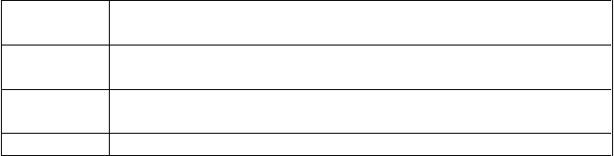
Teaching contents

Teaching
aims Teaching

points
Teaching

Unit1 My Family Lesson 5
Consolidate the Language knowledge.

New words. Sentence patterns. Flash cards, tape and recorder.


materials Students cards. period Lesson 1
  - Warm up
TPR Listen and do. II.Presentation Step1:Part A
- Look at each picture carefully.
- Listen and number.

Teaching characteristics:

Teaching Procedure
- Check. Step2: Part B
1. Discribe your family. 2.Practice each other. 3.Draw your family. 4.Shareing it.

Teaching Reflection
Teaching characteristics: 1、
2、
3、

Improve link: 1、
2、
3

教学反思：


Teaching contents

Teaching
aims Teaching

points
Teaching materials

period

Teaching Procedure

Unit1 My Family Lesson 6
To learn the story.

New words. Sentence patterns.

Flash cards, tape and recorder. Students cards.
Lesson 1 I.Warm up
Daily oral practice.
How are you? II.Presentation
- Objective the pictures.
- Talk about the pictures.
- T:Tell them the story.
- Play the tape. Ss: Listen and read.
Tell the story each other.
- Try to act it out.
- Listen to the tape.

Teaching characteristics:

Teaching Reflection
Teaching characteristics: 1、
2、
3、

Improve link: 1、
2、
3

教学反思：

Unit 2 Boys and Girls (第一课时) Lesson 1

Teaching Aims
Knowledge Aims: A .Pupils can understand and read the new words of this unit.
B Pupils can read a rhyme.

Language input and Key points
- Words: classmate, friend, woman, man, girl, boy
- Sentence: He/ She is a ….
- A rhyme

Difficult points
Pupils can understand “woman” and “man” refer to adults and girl and boy refer to child. Then they can use “he” and “she” to describe these words correctly.

Teaching Aids
pictures video tape

Teaching procedure

1.Warming-up
Ask Ss to read the rhyme and sing the song of Unit 1.

Lead in and presentation
  - Let Ss look at the picture on page 12 and ask “Who is he/she? ” to lead in the new lesson.
  - Show Ss the video of the rhyme.
  - Show some pictures and teach the new words.

Practice
- Show some pictures and words then ask Ss to draw lines to match them.
- Ask them to match the words “woman, man, girl, boy” with “he” and “she”.

A rhyme
Let Ss listen to the tape for 2 times. Guide and ask the pupils to clap hands while

listening to the tape. Read and repeat the rhyme. After they can recite the rhyme, ask
some pupils to perform in class.

Sum up
A.T says the words in Chinese and Ss translate into English
- Ss read the rhyme together

6.Homework
Review the words learned this class and read the rhyme.
7. Blackboard


Unit 2 Boys and Girls
Lesson 1
classmate
friend
girl → woman
boy → man
1
2
3
4

Unit 2 Boys and Girls (第二课时) Lesson 1

Teaching Aims
Knowledge Aims: A .Pupils can understand and read the new words of this unit.
B Pupils can read a rhyme.
C Pupils can use the sentences “He/ She is a ….” to describe a person.

Language input and Key points

- Words: classmate, friend, woman, man, girl, boy
- Sentence: He/ She is a ….
C. A rhyme

Difficult points
Pupils can understand “woman” and “man” refer to adults and girl and boy refer to child. Then they can use “he” and “she” to describe these words correctly.

Teaching Aids
pictures video tape

Teaching procedure

Warming-up
  - Greet the Ss and review what they learnt in the last class.
  - Play a game: Sharp eyes.

Lead in and presentation
Show the pictures and lead Ss to use “ He/ She is a ….” to describe them. T gives the example first, and then leads Ss to describe by themselves.

Practice
Review the words of family they learnt in the last unit. Show Ss some pictures and ask them use “He /She is a …..He/ She is my…..” to describe the pictures.

A rhyme
Ask Ss to read the rhyme and try to recite it. Then have a group competition.

Sum up
A.T says the words in Chinese and Ss translate into English
B. Ss recite the rhyme together

Homework
Review what they learn this class.
- Blackboard

Unit 2 Boys and Girls
Lesson 1
She is a girl/ woman.
He is a boy/ man.
1
2
3
4

以上内容仅为本文档的试下载部分，为可阅读页数的一半内容。如要下载或阅读全文，请访问：https://d.book118.com/618006076061006040

