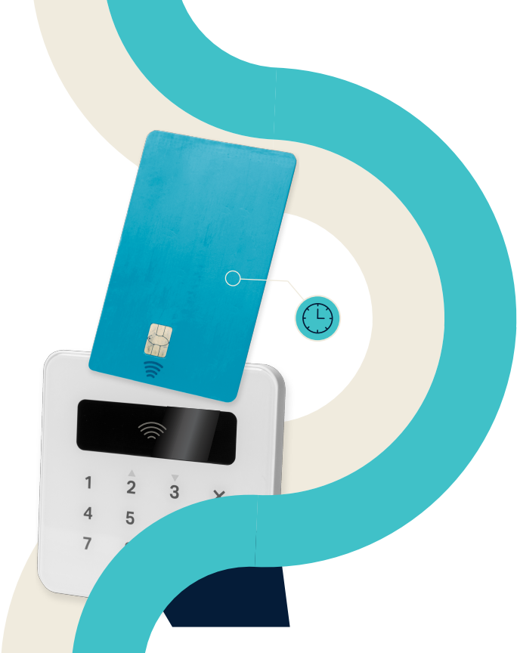
Q4
2023



EMERGING TECH RESEARCH

Retail Fintech Report

VC trends and emerging opportunities

REPORT PREVIEW
The full report is available through the PitchBook Platform.


Institutional Research Group
Analysis
Rudy Yang Senior Analyst, Emerging Technology rudy.yang@pitchbook.com
pbinstitutionalresearch@pitchbook.com
Data

Matthew Nacionales Senior Data Analyst

Publishing
Report designed by Jenna O’Malley
Published on March 7, 2024
CONFIDENTIAL. NOT FOR REDISTRIBUTION . PG 2


Contents

Vertical update
Q4 2023 timeline
Retail fintech landscape
Retail fintech VC ecosystem market
VC activity
Emerging opportunity
Buy now, pay later
Select company highlights

Klarna
Tabby

Kueski

Appendix

Q4 2023 Retail Fintech Report

map

3

5

6

7

8

19

20

27

28

31

34

36

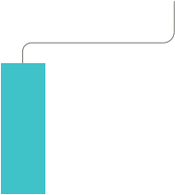



VC exit
News
M&A
Oct 1
Nov 1
Nov 30
News
News
VC deal

October 31
Intuit announces it will shutdown Mint, a personal financial management platform that it acquired in 2009 for $170.0 million.

November 23
Stock trading platform Webull acquires Mexican- based digital broker Flink to expand into
Mexico’s market.

148
total deals
-10.8%
QoQ growth
-32.1%
YoY growth
-36.0%
YTD growth

Q4 VC deal value summary

$2.6B
total deal value
5.0%
QoQ growth
-18.2%
YoY growth
-57.5%
YTD growth

November 1
Middle-East-based BNPL provider Tabby secures
$250.0 million in equity and $700.0 million in debt for its Series D. The round values the startup at $1.3 billion in pre-money, compared with $602.0 million from its Series C.

November 28
Apple ends its credit card partnership with
Goldman Sachs.1 The news suggests that banking- as-a-service models and launching consumer-
facing products may be difficult for large banks working with Big Tech companies.
Q4 2023 timeline
Q4 VC deal count summary



October 13
Asia-based wealthtech firm MoneyHero debuts on the Nasdaq via SPAC Bridgetown Holdings. Shares of the company then close down 48.7% from its debut at the end of 2023.



October 19
The CFPB formally proposes open banking
rulemaking in the US, invoking Section 1033 of the Dodd-Frank Act.

1: “Apple Pulls Plug on Goldman Credit-Card Partnership,” The Wall Street Journal, AnnaMaria Andriotis, November 28, 2023.

CONFIDENTIAL. NOT FOR REDISTRIBUTION . PG 5
Q4 2023 Retail Fintech Report

$XXXXX.
BNPL
$X,XXX
$X,XXX
$X,XXX
$X,XXX
$X,XXX
$XXX,XXX

Retail fintech
landscape

Alternative lending

Credit & banking

Consumer payments

Wealthtech

CONFIDENTIAL. NOT FOR REDISTRIBUTION . PG 6
Q4 2023 Retail Fintech Report

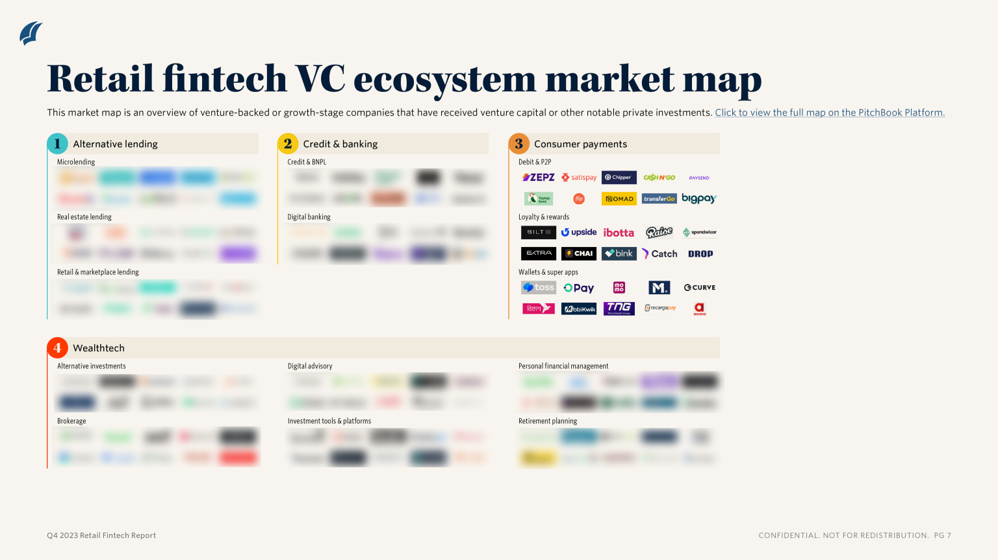

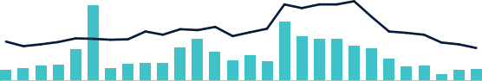
Retail fintech VC deal activity
1,093
757 899 904
699
677

$23.6
$10.0
$12.1 $30.8 $25.1 $21.3

$42.6

1,373

2017 2018 2019 2020 2021 2022 2023*
Deal value ($B) Deal count

Source: PitchBook • Geography: Global • *As of December 31, 2023
Retail fintech VC deal activity by quarter

$20
$15
$10
$5
$0
Q1 Q2 Q3 Q4 Q1 Q2 Q3 Q4 Q1 Q2 Q3 Q4 Q1 Q2 Q3 Q4 Q1 Q2 Q3 Q4 Q1 Q2 Q3 Q4 Q1 Q2 Q3 Q4
2017 2018 2019 2020 2021 2022 2023*
Deal value ($B) Deal count
400
300
200
100
0
Source: PitchBook • Geography: Global • *As of December 31, 2023
CONFIDENTIAL. NOT FOR REDISTRIBUTION . PG 8

VC activity
Deal value: Retail fintech VC deal value rose 5.0% QoQ to $2.6 billion in Q4 2023, though deal
value remained down by 18.2% YoY. While this represents the third quarter in a row where VC deal value increased QoQ, quarterly deal value continues to sit at its lowest level since Q1 2017. For the full year, retail fintech companies secured $10.0 billion in venture capital, down 57.5% from the
$23.6 billion seen in 2022.

Deal count: In Q4, retail fintech companies recorded 148 VC deals. Compared with the 166 deals seen in Q3, this denotes a 36.0% QoQ decrease. On a YoY basis, deal count this quarter was down by 32.1% compared with the 218 deals seen in the prior year period. 699 deals were logged for
2023, representing a 36.0% drop from 1,093 deals in 2022.

Key deals: Top deals in Q4 were primarily seen in credit & banking companies. These include
Tamara’s $340.0 million Series C, KOHO’s $277.8 million Series D, and Tabby ’s $250.0 million
equity and $700.0 million debt Series D. Other notable deals came from wealthtech and consumer payments; Scalable Capital raised a $227.8 million Series E; Stash closed a $40.0 million late-stage round; PaySend raised $65.0 million in a late-stage round; and YouTrip secured $50.0 million for
its Series B.

Q4 2023 Retail Fintech Report

以上内容仅为本文档的试下载部分，为可阅读页数的一半内容。如要下载或阅读全文，请访问：https://d.book118.com/625243124001011124

