2020-2021学年上海市黄浦区八年级上学期期末英语试卷
学校:___________姓名：___________班级：___________考号：___________

一、其他
1．He threwaway his cup and became even happier. Which of the following is correct for the underlined word in the sentence?
A．/ θrəʊ / B．/ θru: /
C．/ θri: / D．/ θrɔ: /

二、单选题
2．Japan attacked Pearl Harbor (珍珠港) of the united States December, 1941.
A．in B．on C．at D．of
3．The play was not interesting, so there were ________ people in the theatre.
A． a little B． few C． many D． much
4．As soon as you come back from the airport, please give a call.
A．my B．mine C．I D．me
5．I don't like this kind of cell phone. Will you show me ?
A． other B． the other C． another D． others
6．The film "Taking Tiger Mountain by Strategy" is , so it is welcomed by people.
A． amazing B． bad C． boring D． bored
7．When he heard a cry for help, he ran out as______ as he could.
A． hardly B． finally C． quickly D． slowly
8．They haven't won the championship (冠军) in the World Cup Final , ?
A． didn't they B． did they
C． haven't they D． have they
9．Which T-shirt would you like to buy, a blue one an orange one ?
A．so B．or C．but D．and
10．Many young people an active part in the third season of The Voice of China last year.
A．take B．took
C．will take D．have taken
11．If I the driving test, I will have an another try.
A．will fail B．am failing
C．fail D．failed
12．—Must I wash these plates?
—No, you . The machine can do it.
A．mustn't B．can't C．may not D．needn't
13．After the interview, the reporter decided an article on school buses in China.
A． write B． writing C． wrote D． to write
14．— We're going to see a film with our parents tonight.
— .
A．Enjoy your time. B．That's all right.
C．You're welcome. D．It's a pleasure.
15．— You look so beautiful in your new dress.
— _________.
A．I agree with you. B．No, I don’t.
C．Thank you. D．I don’t think so.

三、用单词的正确形式完成句子
Complete the following passage with the words or phrases in the box. Each can only be used once (将下列单词或词组填入空格，每词只能填一次)
A．seriously B．necessary C．returning D．ask for
E. all right F. beginning G. excuse

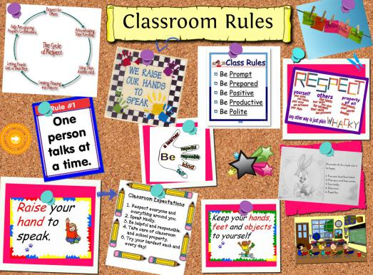
Here are some American classroom rules:
If the teacher asks a question, you are expected to give an answer. If you don’t
understand the question or don’t know the answer, it’s __ 16．__ to tell the teacher that you don’t know. Then he or she knows that you need to learn.
There is no ___17．___ for not doing your homework. If you are absent, you should call your teachers or your classmate and ___18．____ homework. It is your duty to find out what homework you have missed. It is not the teacher’s responsibility to tell students about the homework they’ve missed.
You must not be absent on a test day. If you are ___19．___ill, call and let the teacher know you will not be there for the test. If you teacher allows you to take a make-up(补考), you should take the test within one or two days after __20．___ to class. Serious illness is the only reason for missing a test.
Be on time! It is rude to be late. Also, it disturbs other students. If you come late, be sure to do it quietly. Have your books and paper out of your bags before you enter the classroom. Then go to your seat and sit quietly. In the US it is not __21．__ to knock before you enter the classroom. If you have to leave during the class, do it quietly.

四、根据句意填空
Complete the sentences with the given words in their proper forms (用括号中所给单词的适当形式完成下列句子。每空格限填一词)
22．Kitty was tired yesterday. She went to bed early and soon fell ________. ( sleep)
23．The monster was moving __________ towards the house. (silent)
24．Smoking is _____________ to our health. (harm )
25．His flat is on the __________ floor of the building. (twenty)
26．Children have the _________ to choose their own hobby. (free)
27．Disneyland is an _________ park loved by people from all over the world. (amuse)
28．Think of your _____ as well as others’ when you drive across the road. (safe)
29．Make sure that there are no ________ in your kitchen. (mouse)

Complete the sentences with the given words in their proper forms (用括号中所给单词的适当形式完成下列句子。每空格限填一词)
30．Our library is on the ________ floor of that building. (six)
31．Now the river is 200 metres ______. (long)
32．There we saw ________ of vegetables and fruit. (variety)
33．I’m _________ sorry. I’ll return your magazine this afternoon. (true)
34．My teacher told me the ________ of the idiom.(mean)
35．Please wait for me at the _________ to the People’s Square.(enter)
36．Dogs can save us when we are in __________. (dangerous)
37．The poor old man felt lonely because of his wife’s ___________. (die)

五、句型转换
Complete the following sentences as required(根据所给要求，完成下列句子。1-5题每空格限填一词)
38．Disney sold newspaper after leaving school.(改为一般疑问句)
__________Disney __________ newspaper after leaving school?
39．Gork is having a bad dream.（改为感叹句）
_______ _______ bad dream Gork is having!
40．Tom is so weak that he can’t carry the heavy box by himself. (保持原句意思不变)
Tom is _______ weak _______ carry the heavy box by himself.
41．My father has been in Shanghaisince 1998.(对划线部分提问)
________ ________ has your father been in Shanghai?
42．something forest we in saw the really (连词成句)
____________________________________________.

Complete the following sentences as required(根据所给要求，完成下列句子。1-5题每空格限填一词)
43．They started their discussion about English idioms after the English class .（改为一般疑问句）
_______ they _______ their discussion about English idioms after the English class ?
44．They are modern agricultural parks.（改为感叹句）
______ ______ agricultural parks they are!
45．The little boy is so short that he can’t open the door.(保持原句意思不变)
The little boy is _______ short _______ open the door.
46．My father has been in Shanghaisince 1998.(对划线部分提问)
______ ______ has your father been in Shanghai?
47．encourage we keep pets to should people (连词成句)
____________________________________________.

六、阅读单选
Choose the best answer (根据短文内容，选择最恰当的答案)
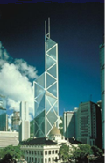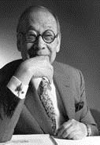
I. M. Pei (贝聿铭，华裔美籍建筑设计师)is one of the world’s greatest architects. People admire his buildings in cities around the world. He is famous for his ability tocombineold and new architecture. Ieoh Ming Pei was born in 1917 in Canton, China. He was the oldest son of a rich banker. He received a good education at the best schools in Shanghai. At the age of 17, Pei went to the United States. He studied engineering and architecture at the Massachusetts Institute of Technology (M.I.T). World War II had started before he graduated. Pei’s father told him it was safer to stay in the United States.
Pei stayed in the United Sates and worked for a building company in New York City. During this time, he designed homes, office buildings, parks, and shopping centers. Some of these buildings became famous.
In 1955, I.M.T Pei started his own company. He designed many buildings for M.I.T. He also designed the Museum of Fine Arts in Boston. He became well known for creating buildings that looked like the things around them. This was very unusual.
In 1974, he visited China for the first time in 40 years. He designed a hotel in Beijing. He also designed the 72-story Bank of China building in Hong Kong. This is one of the tallest building in Asia.
One of Pei’s most famous works is the National Gallery of Art in Washington, D．C．It was a big challenge because he added a new part to an old building. His design was a big success. I.M.Pei is someone who has truly influenced the modern world. He is a great success among
architects.
48．When he was a child, I.M.Pei ______.
A．had a difficult life
B．didn’t have much chance to be successful
C．didn’t have a good education
D．had a good start in life
49．In 1940, Pei didn’t return to China because ______.
A．it was at war
B．he didn’t have the money for the trip
C．his family moved to the United States
D．he wanted to work abroad
50．The underline wordcombinein the first paragraph probably means ___________.
A．design B．put together
C．add to D．build
51．Pei did not visit China for forty years after______.
A．1917 B．1974 C．1955 D．1934
52．Pei’s great achievements have truly ______ the modern world.
A．beautified B．influenced
C．developed D．made
53．This passage is mainly about _______________.
A．I. M. Pei and his family.
B．how I. M. Pei became a great architect.
C．the brief introduction of I. M. Pei and his great success in architecture.
D．I. M. Pei’s success in education.

七、完型填空
Choose the best words and complete the passage (选择最恰当的单词完成短文)
Have you ever been to a desert? A desert is a place full of sand.
Death Valley is one of the most ______ deserts in the United States. It covers a wide area with its bright sand. Almost 20 percent of this area is well below sea level, and Badwater, a salt water lake, is about 280 feet below sea level and the ______ place in the United Sates.
Long ago the Indians there called this place “Tomesha”. It means the land of fire. Death
Valley’s name now dates back to 1849. At that time a group of miners came across the desert from Nevada, but they became _______ in this desert. They were hungry and thirsty. Their journey was certainly a sad story.
Today Death Valley is made a National Monument and people can cross it along several well-marked roads. They can _______ water and drinks in the roadside bars when thirsty, and they can have meals in the restaurants, too. Luckily with so many people traveling and living there, this desert’s special beauty has not been ruined.
Here you’ll have a lot of surprises. It is ________ like what you can see on the moon. The sight changes as the wind moves the sand about, showing the most unusual colors. One of the most unusual and surprising _______ of Death Valley is 54 (魔鬼的高尔夫球场). If one goes there, it seems you are in some terrible dreams. Sand sculptures stand on a ________ ground, and their long shadows moves in the darkness of the night.
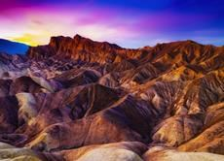
54．A．brave B．famous C．careful D．successful
55．A．lowest B．highest C．farthest D．longest
56．A．angry B．excited C．lost D．surprised
57．A．keep B．stop C．practice D．enjoy
58．A．almost B．hardly C．also D．ever
59．A．copies B．pieces C．parts D．covers
60．A．bright B．frightening C．beautiful D．clean

八、单词填空
Read the passage and fill in the blanks with proper words (在短文的空格内填入适当的词，使其内容通顺。每空格限填一词，首字母已给)
When you laugh，you will open your mouth and show your teeth．The healthier those teeth are，the happier you l___61．____. Why is that?
It’s because your teeth are important in many ways．If you take care of them，they’ll help to take care of you．S____62．___ and healthy teeth help you eat
the right food to help you grow．They also help you speak clearly．
You can take care of your teeth by doing like these：
Brush your teeth t___63．____ a day---after breakfast and before bedtime. If you can, rush after l___64．___ or after eating sweet cakes.
Brush all of your teeth，not just the front ones．Spend some time on the teeth along the sides and in the back．Take your time while brushing．Spend at l___65．____ 3 minutes each time you brush.,
Be sure your toothbrush is soft．Ask your parent to help you get a new toothbrush every three month．
Learn how to floss (用牙线清理) your teeth, which is a very important way to keep them healthy. It feels strange when you do it at first, but soon you'll be u____66．__ to doing it. The floss gets rid of food that's hidden between your teeth.
Brushing and flossing keep your teeth healthy. You also need to care about what you eat and drink. Eat a lot of fruits and vegetables and drink water i_67．__ of drinks.
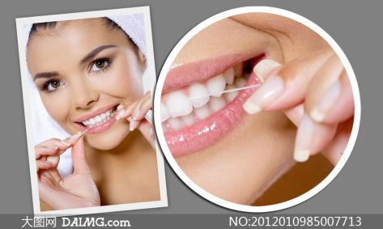

九、填空
Answer the questions (根据短文内容回答下列问题)
This is a story about a boy called Sparky. For Sparky, school was all but impossible. He failed every subject in the eighth grade. He got a zero in physics. It made him the worst physics student in the school’s history. He didn’t do much better in sports. Although he tried to join the school’s golf team, he quickly lost the only important match.
He didn’t have friends, either. Other kids didn’t care about him. If a classmate said “hello” to Sparky outside the school, he would feel very
surprised.
Sparky was a loser and everyone knew it. So he accepted it.
But one thing was important to Sparky – drawing. He was proud of his artwork. In senior high school, he sent some cartoons to the editors of the yearbook (年鉴) but got turned down. Sparky was hurt. But he didn’t lose hope because he believed in his ability. He decided to become a professional artist.
He wrote a letter to the Walt Disney Studios (工作室) after graduating high school. The studio asked him to draw some cartoons on a certain subject. Sparky spent a lot of time on the cartoons. Finally, the reply came from Disney Studios: they didn’t like his cartoons.
Was it time to stop drawing? Sparky didn’t think so. He started to put his own life in the cartoons. He created his childhood self – a little boy loser: Charlie Brown. He wasn’t good at football. But Charlie Brown would soon become famous worldwide. Sparky, the boy who used to fail school and who was rejected again and again, was Charles Schulz. He created the Peanuts comic strip and the world-famous cartoon characters Charlie Brown and Snoopy.
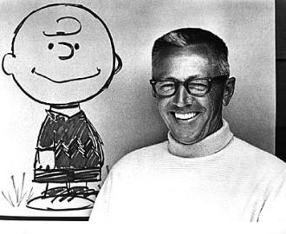

68．Sparky didn’t do well in physics, did he?
________, ________________________.
69．Was Sparky good at making friends with others?
_____________________________________________________________.
70．Who did he send some cartoons to in senior school?
_____________________________________________________________.
71．What did the Walt Disney Studios ask him to do?
_____________________________________________________________.
72．What was Sparky’s real name?
_____________________________________________________________.
73．Why could a little loser become a world-famous cartoonist?
以上内容仅为本文档的试下载部分，为可阅读页数的一半内容。如要下载或阅读全文，请访问：https://d.book118.com/626040225033010033

