Simon’s IELTS Writing Task 1.
.
Question types .
.
Numbers
Describe
Compare
Changes/trends

- Line graph .
- Bar chart.
- Pie chart.
- Table.
.
- Diagram-comparing.
- Diagram-process.
.
Essay structure (4 paragraphs ).
- Introduction .
One sentence : Paraphrase the question.
.
- Overview.
2 sentences :The main , general things.
.
- Details.
- Details.
3+4: Why 2 paragraphs ?.
This makes you organize or ‘group’ the information better.
.
(or put the overview at the end).
No conclusion!!.
.
.
.
.
.
.
.
.
.
.
.
.
.
.
Line graph ( Line graph show numbers changing over a period of time ).
You will not see a graph with only one line ..
You will almost definitely see 2/3/4/5 lines..
Your job is to compare the lines , not describe them separately..
Frist , make a very general comparison .( Summary / overview paragraph ).
Second , compare the lines at specific point . (‘details’ paragraphs ) .
For example ：4 lines.
You can’t describe everything.
Write at least one thing about each line..
你看不到只有一条线的图形。.
你会看到2/3/4/5条线。.
你要对这些线条进行比较，而不是单独描述它们。.
首先，做一个非常一般的比较。（总结/概述段落）.
第二，比较这些线条的特定的节点。（‘细节’段落）.
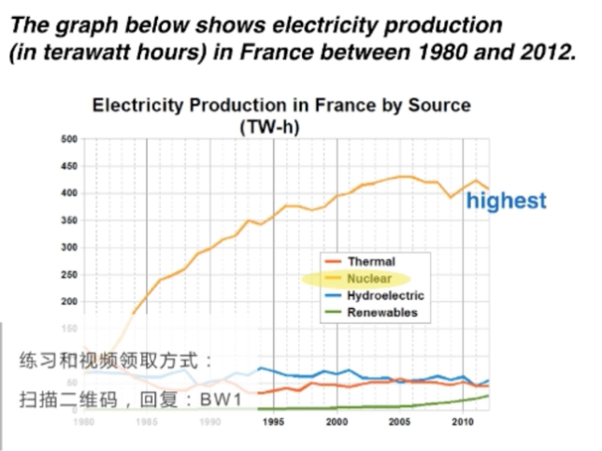.
Paragraph 1 : Introduction.
.
The graph below shows electricity production (in terawatt hours ) in France between 1980 and 2012 ..
改写：The line graph compares the amount of electricity produced in France using four differdent sources of power over a period of 32 years..
这个折线图比较了法国在32年间使用四种不同电源的发电量。.
.
Paragraph 2 :Overview—2 sentences , 2 main points..
.
It is clear that nuclear power was by far the most important means of electricity generation over the period shown . renewables provided the lowest amount of electricity in each year..
很明显，在所示期间，核能是迄今为止最重要的发电方式，可再生能源每年提供的电力量最低。.
Paragraph 3 : Detail — 2 paragraphs , compare the lines.
In 1980 , thermal power stations were the main source of electricity in France, generating around 120 terawatt hours of power . Nuclear and hydroelectric power stations produced just under 75 terawatt hours of electricity each, and renewables provided a negligible amount . Just one year later , nuclear power overtook thermal power as the primary source of electricity ..
1980年，法国的主要电力来源是火力发电站，发电量约为120太瓦每时。核电站和水力发电站每台发电量不到75太瓦每时，可再生能源的发电量微不足道。仅仅一年后，核电就取代了火电成为主要的电力来源。.
Important tip when describing numbers:.
You can’t write : Nuclear was 75 terawatt hours of electricity..
Nuclear produced 75 terawatt hours of electricity.
You must write : Nuclear power was used to produce 75 terawatt hours of electricity..
Nuclear power station produced 75 terawatt hours of electricity..
.
Paragraph 4 .
Between 1980 and 2005 , electricity production from nuclear power rose dramatically to a peak of 430 terawatt hours . By contrast , the figure for thermal power fell to only 50 terawatt hours in 1985 , and remained at this level for the rest of the period . Hydroelectric power generation remained relatively stable , at between 50 and 80 terawatt hours , for the whole 35 year period , but renewable electricity production saw only a small rise to approximately 25 terawatt hours by 2012 ..
从1980年到2005年，核能发电量急剧上升到430太瓦时的峰值。相比之下，在1985年，火力发电的数字下降到只有50太瓦时，并在之后保持在这个水平。水力发电在整个35年期间保持相对稳定，在50至80太瓦时之间，但可再生电力产量到2012年，仅小幅上升至约25太瓦时。.
.
Vocabulary： paraphrasing改写 comparing比较 describing changes描述变化.
Amount of electricity produced 发电量.
Source of / provided / generating来源/提供/产生.
Means of electricity generation发电方式.
Over a period of / over the period shown在所示期间内.
By far the most important到目前为止最重要的.
a negligible amount可忽略的数量.
nuclear power overtook thermal power核电超过火电.
as the primary source of electricity作为主要的电力来源.
rose dramatically to a peak of急剧上升到.
by contrast相比之下 the figure for……的数字.
remained at this level,remained stable 保持在这个水平，保持稳定.
saw only a small rise只看到一个小的上升.
Bar chart .
Bar chart can show numbers changing over a period of time .This type of bar chart is the same as line graph..
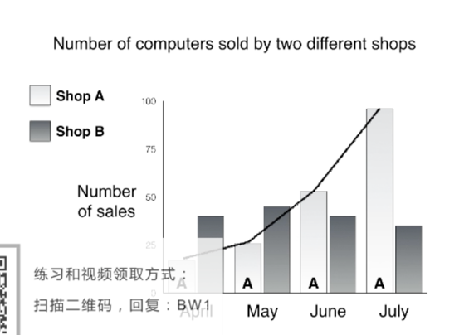.
However! Bar chart don’t always show time….
They often only compare numbers.
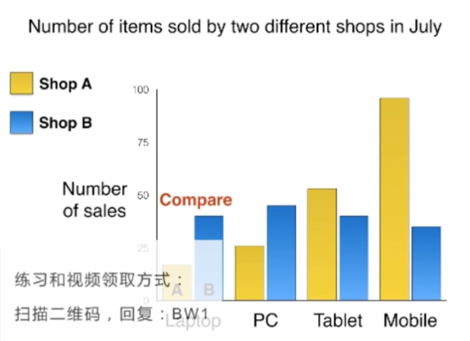.
So , your job is to compare the bars..
First , make a very general comparison ( summary / overview paragraph ).
Second , compare specific numbers ( ‘details’ paragraphs ).
.
Bar chart question .
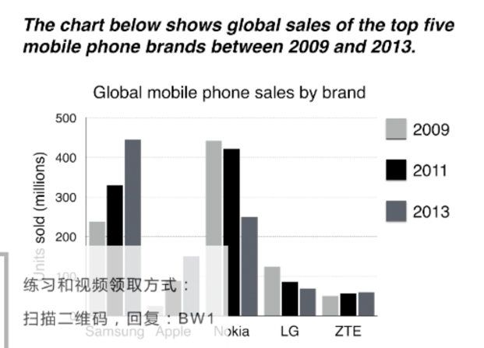.
.
.
.
4 paragraphs :.
- Introduction .
- Overview.
- Details.
- Details.
.
Paragraph 1 : Introduction—paraphrase the question第1段：引言.
.
The chart below shows global sales of the top five mobile phone brands between 2009 and 2013..
改写：The bar chart compares the number of mobile phones sold worldwide by the five most popular manufacturers in the years 2009 , 2011 and 2013..
这张条形图比较了2009年、2011年和2013年五大最受欢迎制造商在全球销售的手机数量。.
.
Paragraph 2 ：Overview—2 sentences ，2 main points概述.
.
It is clear that Nokia sold the most mobile phones between 2009 and 2011 , but Samsung became the best selling brand in 2013 . Samsung and Apple saw the biggest rises in sales over the 5-year period..
很明显，诺基亚在2009年至2011年期间销售了最多的手机，但三星在2013年成为最畅销的品牌。三星和苹果的销售额在5年内增长最大。.
.
Paragraph 3 : comparisons , changes over time比较.
.
In 2009 , Nokia sold close to 450 million mobile phones, which was almost double the number of handsets sold by the second most successful manufacturer , Samsung. Over the following four years, however , Nokia’s sales figures fell by approximately 200 million units, whereas Samsung saw sales rise by a similar amount . by 2013 , Samsung had become the market leader with sales reaching 450 million units..
2009年，诺基亚销售了近4.5亿部手机，几乎是第二大成功制造商三星销售手机数量的两倍。然而，在接下来的四年里，诺基亚的销售额下降了约2亿台，而三星的销售额也增长了同样的数量。到2013年，三星已成为市场领导者，销量达到4.5亿台。.
.
.
.
Paragraph 4 : comparisons , changes over time比较.
.
The other three top selling mobile phone brands between 2009 and 2013 were LG，ZTE and Apple . In 2009 , these companies sold around 125 million , 50 million and 25 million mobile handsets respectively , but Apple overtook the other two vendors in 2011 . In 2013 , purchases of Apple hand sets reached 150 million units , while LG saw declining sales and the figures for ZTE rose only slightly..
2009年至2013年间，其他三大畅销手机品牌分别是LG、中兴和苹果。2009年，这些公司分别售出了1.25亿部、5千万部和2.5亿部手机，但2011年，苹果超过了其他两家手机供应商。2013年，苹果手持设备的采购量达到1.5亿台，而LG的销量下降，中兴通讯的数据仅略有上升。.
.
Vocabulary： paraphrasing改写 comparing比较 describing changes描述变化.
sold worldwide销往世界各地.
sales figures ， puchases销售数量，采购.
most popular , best selling brand , top selling最受欢迎，最畅销的品牌，最畅销的.
second most successful manufacturer第二大成功制造商.
market leader市场领导者.
mobiles phones , handsets , units手机、手机、台（个，计量单位）.
brands , manufacturers , companies , vendors品牌、制造商、公司、供应商.
saw the biggest rises , saw declining sales增长最大，销售额下降.
close to , almost , approximately , around接近，几乎，大约，大约.
double the number双倍的数量.
rise by a similar amount增加同样数量.
respectively分别地.
overtook the other two vendors超过了其他两个供应商.
.
.
.
.
.
.
.
.
.
.
.
.
.
.
.
Pie chart.
Pie chart can show numbers, but they always show percentages.
.
The favourite sports of a class of 20 children.
1.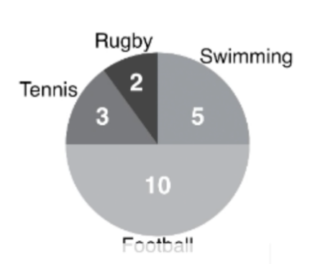 2. 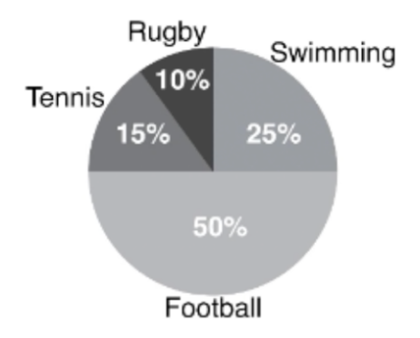.
- Football is the favourite sport of 10 children in the class..
- 50% of the children in the class prefer football to any other sports..
Half of the class said that football was their favourite sports..
.
Remember : the full pie is always 100%.
Pie charts can show changes over time (e.g. years) .
But pie charts don’t always show change over time.
Your job is to compare the percentages ( and numbers ).
First , make a very general comparison ( summary / overview paragraph ).
Second , compare specific figures (‘details’ paragraphs ).
.
Pie chart question.
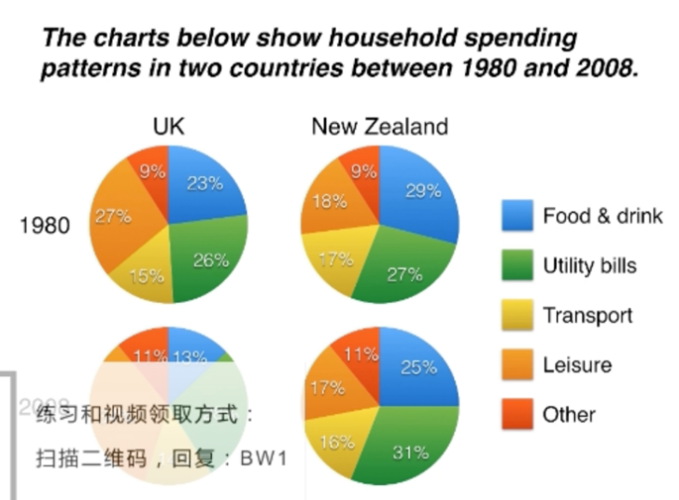.
.
- paragraphs :.
- Introduction .
- Overview.
- Details.
- Details.
Paragraph 1 : Introduction—paraphrase the question第1段：引言.
.
The charts below show household spending patterns in two countries between 1980
and 2008..
改写：The pie charts compare five categories of household expenditure in the UK and New Zealand in the years 1980 and 2008..
饼图比较了英国和新西兰1980年和2008年的五类家庭支出。.
Paragraph 2 ：Overview—2 sentences ，2 main points概述.
.
It is noticeable that the proportion of spending on food and drink fell in both countries over the 28 year period , while spending on utility bills rose . Also , UK residents spent a significantly larger percentage of their household budgets on leisure than their New Zealand counterparts..
值得注意的是，在过去28年中，两国在食品和饮料方面的支出比例都有所下降，而在公用事业账单上的支出却有所上升。此外，英国居民在家庭休闲方面的花费比例明显高于新西兰居民。.
.
Paragraph 3 : 2 categories.
.
In 1980 , 29% of an average New Zealand household budget went on food and drink , while the equivalent figure for a UK home was 23% . By 2008 , expenditure on food and drink had fallen by 4% in New Zealand , and by a full 10% in the UK . By contrast , both countries saw an increase in expenditure on utility bills for the average home , from 27% to 31% in New Zealand and from 26% to 28% in the UK ..
1980年，新西兰家庭平均预算的29%用于食品和饮料，而英国家庭的等效数字为23%。到2008年，新西兰的食品和饮料支出下降了4%，英国下降了整整10%。相比之下，新西兰和英国的公用事业费用支出平均从27%上升到31%，英国从26%上升到28%。.
.
Paragraph 4 : 3 categories.
.
Leisure activities accounted for the highest proportion of UK household spending in both years , but only the third highest proportion in New Zealand . In fact , in 2008 , New Zealanders spent only half as much in relative terms on recreation (17%) as UK residents (34%) . In both countries , transport costs and other costs took roughly 15% and 10% of household budgets respectively ..
休闲活动在这两年中占英国家庭支出的比例最高，但在新西兰只有第三高的比例。事实上，2008年，新西兰人在娱乐方面的花费仅为英国居民（34%）的一半（17%）。在这两个国家，运输费用和其他费用分别约占家庭预算的15%和10%。.
.
.
Tips.
Don’t describe each country separately 不要分别描述每个国家.
Don’t describe each year separately不要单独描述每年.
Compare countries and years together比较国家和年份.
Mention all 5 categories (food & drink etc.)提及所有5个类别（食物和饮料等）.
Divide the categories into two groups for the two ‘details’ paragraphs将两个“细节”段落的类别分为两组.
The category called ‘other’ is not important称为“其他”的类别不重要.
Don’t write “Leisure was 34%”不要写“休闲占34%”.
Write “ Households spent 34% of their money on leisure ” 写下“家庭把34%的钱花在休闲上”.
.
Vocabulary：.
Spending , expenditure , spent , costs支出，支出，支出，花费.
Proportion of spending支出比例.
percentage of household budget家庭预算百分比.
the equivalent figure for a UK home英国家庭的等效数据.
fell , rose , saw an increase in下降，上升，看到增加.
by 2008 , expenditure had fallen到2008年，支出已经下降.
spent a significantly larger percentage花费了相当大的百分比.
than their New Zealand counterparts比他们的新西兰这个参照物.
29% of an average New Zealand household budget went on.
新西兰家庭平均预算的29%用于.
while , by contrast然而，相比之下.
Leisure accounted for the highest proportion休闲占比最高.
spent half as much in relative terms相对花费的一半.
recreation娱乐.
.
.
.
.
.
.
.
.
.
.
.
.
.
.
Tables.
Tables can show :.
any kind of number.
the same information as a line graph , bar chart or pie chart.
comparisons.
changes over time ( increase , decrease ).
a lot of information ( too much ).
.
A key skill is ‘selecting’ which information to mention.
Your job is to select , describe and compare the key numbers.
First , look for main or general features ( summary / overview paragraph ).
Second , describe specific numbers ( ‘details’ paragraphs ).
.
Table question.
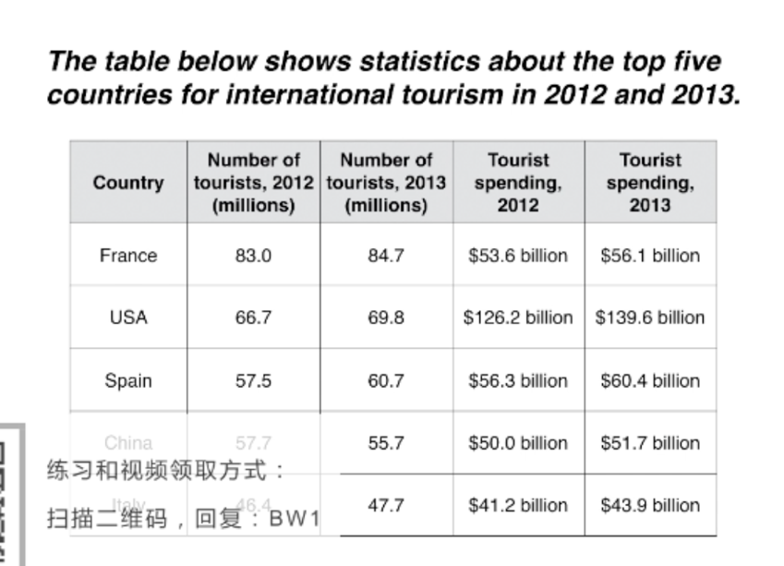.
Paragraph 1 : Introduction—paraphrase the question.
The table below shows statistics about the top five countries for international tourism in 2012 and 2013 ..
改写：The table compares the five highest ranking countries in terms of the numbers of visits and the money spent by tourists over a period of two years ..
该表比较了五个在两年内的旅游人数和旅游者的花费排名最高的国家。.
.
Paragraph 2 ：Overview—2 sentences ，2 main points.
.
It is clear that France was the word’s most popular tourist destination in the years 2012 and 2013 . However , the USA earned by far the most revenue from tourism over the same period ..
很明显，法国是2012年和2013年世界上最受欢迎的旅游目的地。然而，美国在同一时期从旅游业获得的收入最多。.
Paragraph 3 :.
In 2012 , 83 million tourists visited France , and the USA was the second most visited
country , with 66.7 million tourists . Spain and China each received just under 58 million visitors , while Italy was ranked fifth with 46.4 million tourists . 2013 saw a rise of between 1 and 4 million tourist visits to each country , with the exception of China , which received 2 million fewer visitors than in the previous year ..
2012年，法国游客达8300万人次，美国游客达6670万人次，位居第二。西班牙和中国的游客数量都不到5800万，意大利则以4640万的游客名列第五。2013年，除中国外，每个国家的游客数量增加了100万至400万人次，中国的游客数量比去年减少了200万人次。.
Paragraph 4 : 3 sentences.
Spending by tourists visiting the USA increased from $126.2 billion in 2012 to $139.6 billion in 2013 , and these figures were well over twice as high as those for any other country . Spain received the second highest amounts of tourist revenue , rising from $56.3 billion to $60.4 billion , followed by France , China and Italy . Interestingly , despite falling numbers of tourists , Chinese revenue from tourism rose by $1,7 billion in 2013 . .
美国游客的消费从2012年的1262亿美元增加到2013年的1396亿美元，这些数字是其他国家的两倍多。西班牙的旅游收入位居第二，从563亿美元升至604亿美元，其次是法国、中国和意大利。有趣的是，尽管游客数量有所下降，但2013年中国旅游业收入增长了17亿美元。.
Key skill ： selecting information关键技能：选择信息.
You can’t mention every number你不能说每个号码.
I chose around 10 out of the total 20 numbers in the table 20个数字选择大约10个.
Vocabulary：.
five highest ranking countries五个排名最高的国家.
the world's most popular tourist destination世界上最受欢迎的旅游目的地.
earned by far the most赚得最多的.
revenue from tourism旅游收入.
the second most visited country第二大访问国.
received... visitors接收…游客.
ranked fifth排名第五.
2013 saw a rise of 2013年增长了.
fewer visitors than in the previous year游客比去年少.
these figures were well over twice as high as这些数字高于…两倍多.
amounts of tourist revenue旅游收入金额.
despite falling numbers尽管数据在下降.
saw , arise , increased , rising from , rose by看见、上升、增多、从…升至、增长了.
2 different chart.
.
以上内容仅为本文档的试下载部分，为可阅读页数的一半内容。如要下载或阅读全文，请访问：https://d.book118.com/628020005072006033

