Design Optimization

Introduction

This tutorial was completed using ANSYS 7.0 The purpose of this tutorial is to introduce a method of solving design optimization problems using ANSYS. This will involve creating the geometry utilizing parameters for all the variables, deciding which variables to use as design, state and objective variables and setting the correct tolerances for the problem to obtain an accurately converged solution in a minimal amount of time. The use of hardpoints to apply forces/constraints in the middle of lines will also be covered in this tutorial.
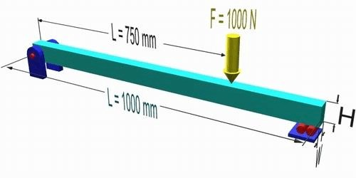
A beam has a force of 1000N applied as shown below. The purpose of this optimization problem is to minimize the weight of the beam without exceeding the allowable stress. It is necessary to find the cross sectional dimensions of the beam in order to minimize the weight of the beam. However, the width and height of the beam cannot be smaller than 10mm. The maximum stress anywhere in the beam cannot exceed 200 MPa. The beam is to be made of steel with a modulus of elasticity of 200 GPa.

Preprocessing: Defining the Problem

Give example a Title

Utility Menu > File > Change Title ...

/title, Design Optimization

- Enter initial estimates for variables

To solve an optimization problem in ANSYS, parameters need to be defined for all design variables.

Select: Utility Menu > Parameters > Scalar Parameters...
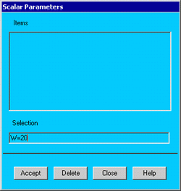
    - In the window that appears (shown below), type W=20 in the ‘Selection’ section
    - Click ‘Accept’. The 'Scalar Parameters'
window will stay open.

    - Now type H=20 in the ‘Selection’ section
    - Click ‘Accept'
    - Click ‘Close’ in the ‘Scalar Parameters’
window.

NOTE: None of the variables defined in ANSYS are allowed to have negative values

- Define Keypoints

Preprocessor > Modeling > Create > Keypoints > In Active CS...

K,#,x,y

We are going to define 2 Keypoints for this beam as given in the following table:

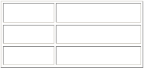
Keypoints Coordinates (x,y)
1
2
(0,0)
(1000,0)

- Create Lines

Preprocessor > Modeling > Create > Lines > Lines > In Active Coord

L,1,2

Create a line joining Keypoints 1 and 2

- Create Hard Keypoints

Hardpoints are often used when you need to apply a constraint or load at a location where a keypoint does not exist. For this case, we want to apply a force 3/4 of the way down the beam. Since there are not any keypoints here and we can't be certain that one of the nodes will be here we will need to specify a hardpoint

  - Select Preprocessor > Modeling > Create > Keypoints > Hard PT on line > Hard PT by ratio. This will allow us to create a hardpoint on the line by defining
the ratio of the location of the point to the size of the line
  - Select the line when prompted
  - Enter a ratio of 0.75 in the 'Create HardPT by Ratio window which appears.

You have now created a keypoint labelled 'Keypoint 3' 3/4 of the way down the beam.

- Define Element Types

Preprocessor > Element Type > Add/Edit/Delete...

For this problem we will use the BEAM3 (Beam 2D elastic) element. This element has 3 degrees of freedom (translation along the X and Y axes, and rotation about the Z axis).

- Define Real Constants

Preprocessor > Real Constants... > Add...

In the 'Real Constants for BEAM3' window, enter the following geometric properties: (Note that '**' is used instead '^' for exponents)
- Cross-sectional area AREA: W*H
- Area moment of inertia IZZ: (W*H**3)/12
- Thickness along Y axis: H

NOTE: It is important to use independent variables to define dependent variables such as the moment of inertia. During the optimization, the width and height will change for each iteration. As a result, the other variables must be defined in relation to the width and height.
- Define Element Material Properties

Preprocessor > Material Props > Material Models > Structural > Linear > Elastic > Isotropic

In the window that appears, enter the following geometric properties for steel:

- Young's modulus EX: 200000
- Poisson's Ratio PRXY: 0.3

- Define Mesh Size

Preprocessor > Meshing > Size Cntrls > ManualSize > Lines > All Lines...

For this example we will specify an element edge length of 100 mm (10 element divisions along the line).
- Mesh the frame

Preprocessor > Meshing > Mesh > Lines > click 'Pick All'

LMESH,ALL

Solution Phase: Assigning Loads and Solving

Define Analysis Type

Solution > Analysis Type > New Analysis > Static

ANTYPE,0

- Apply Constraints

Solution > Define Loads > Apply > Structural > Displacement > On Keypoints

Pin Keypoint 1 (ie UX, UY constrained) and constrain Keypoint 2 in the Y direction.

- Apply Loads

Solution > Define Loads > Apply > Structural > Force/Moment > On Keypoints

Apply a vertical (FY) point load of -2000N at Keypoint 3

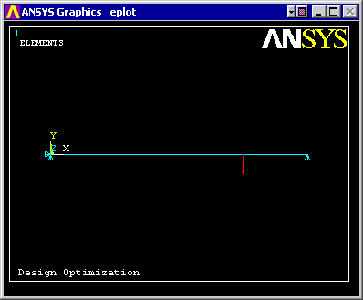
The applied loads and constraints should now appear as shown in the figure below.

- Solve the System

Solution > Solve > Current LS

SOLVE

Postprocessing: Viewing the Results

Extracting Information as Parameters:

To perform an optimization, we must extract the required information.
In this problem, we would like to find the maximum stress in the beam and the volume as a result of the width and height variables.

Define the volume

  - Select General Postproc > Element Table > Define Table... > Add...
  - The following window will appear. Fill it in as shown to obtain the volume of the beam.

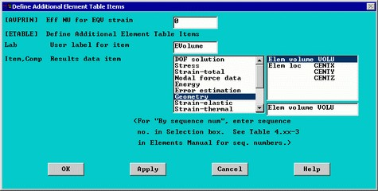

Note that this is the volume of each element. If you were to list the element table you would get a volume for each element. Therefore, you have to sum the element values together to obtain the total volume of the beam. Follow the instructions below to do this.
  - Select General Postproc > Element Table > Sum of Each Item...
  - A little window will appear notifying you that the tabular sum of each element table will be calculated. Click 'OK'

You will obtain a window notifying you that the EVolume is now 400000 mm2

- Store the data (Volume) as a parameter

Select Utility Menu > Parameters > Get Scalar Data...
  - In the window which appears select 'Results Data' and 'Elem table sums'
  - the following window will appear. Select the items shown to store the Volume as a parameter.

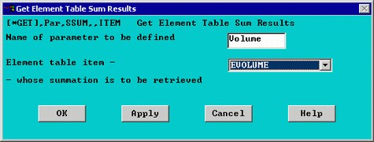

Now if you view the parameters (Utility Menu > Parameters > Scalar Parameters...) you will see that Volume has been added.
- Define the maximum stress at the i node of each element in the beam

Select General Postproc > Element Table > Define Table... > Add...
  - The following window will appear. Fill it in as shown to obtain the maximum stress at the i node of each element and store it as 'SMAX_I'.

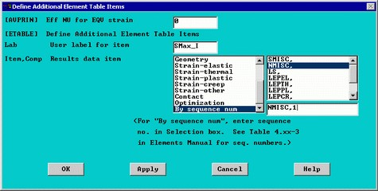

Note that nmisc,1 is the maximum stress. For further information type Help beam3 into the command line

Now we will need to sort the stresses in descending order to find the maximum stress
  - Select General Postproc > List Results > Sorted Listing > Sort Elems
  - Complete the window as shown below to sort the data from 'SMAX_I' in descending order

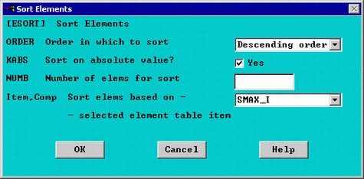

- Store the data (Max Stress) as a parameter

Select Utility Menu > Parameters > Get Scalar Data...
  - In the window which appears select 'Results Data' and 'Other operations'
  - In the that appears, fill it in as shown to obtain the maximum value.

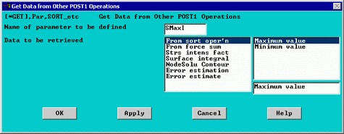

- Define maximum stress at the j node of each element for the beam

Select General Postproc > Element Table > Define Table... > Add...
  - Fill this table as done previously, however make the following changes:
    - save the data as 'SMAX_J' (instead of 'SMAX_I')
    - The element table data enter NMISC,3 (instead of NMISC,1). This will give you the max stress at the j node.
  - Select General Postproc > List Results > Sorted Listing > Sort Elems to sort the stresses in descending order.

  - However, select 'SMAX_J' in the Item, Comp selection box
- Store the data (Max Stress) as a parameter

Select Utility Menu > Parameters > Get Scalar Data...
  - In the window which appears select 'Results Data' and 'Other operations'
  - In the that appears, fill it in as shown previously , however, name the parameter 'SMaxJ'.
- Select the largest of SMAXJ and SMAXI
  - Type SMAX=SMAXI>SMAXJ into the command line

This will set the largest of the 2 values equal to SMAX. In this case the maximum values for each are the same. However, this is not always the case.
- View the parametric data

Utility Menu > Parameters > Scalar Parameters

Note that the maximum stress is 281.25 which is much larger than the allowable stress of 200MPa

Design Optimization

Now that we have parametrically set up our problem in ANSYS based on our initial width and height dimensions, we can now solve the optimization problem.

Write the command file

It is necessary to write the outline of our problem to an ANSYS command file. This is so that ANSYS can iteratively run solutions to our problem based on different values for the variables that we will define.
  - Select Utility Menu > File > Write DB Log File...
  - In the window that appears type a name for the command file such as ‘optimize.txt’
  - Click ‘OK’.

If you open the command file in a text editor such as Notepad, it should similar to this:

/BATCH

! /COM,ANSYS RELEASE 7.0 UP20021010 16:10:03 05/26/2003

/input,start70,ans,'C:\Program Files\Ansys Inc\v70\ANSYS\apdl\',,,,,,,,,,,,,,,,1

/title, Design Optimization

*SET,W , 20

*SET,H , 20

/PREP7 K,1,0,0,,
K,2,1000,0,,
L, 1, 2
HPTCREATE,LINE,1,0,RATI,0.75, ET,1,BEAM3 R,1,W*H,(W*H**3)/12,H, , , ,
MPTEMP,,,,,,,, MPTEMP,1,0 MPDATA,EX,1,,200000 MPDATA,PRXY,1,,.3 LESIZE,ALL,100, , , ,1, , ,1,
LMESH, 1
FINISH
/SOL

以上内容仅为本文档的试下载部分，为可阅读页数的一半内容。如要下载或阅读全文，请访问：https://d.book118.com/657056061026006032

